Comments on the Provisional Registration of the Former Kingston Post Office, Kingston.

***please note that only comments received during the public consultation period will be valid for certain provisions under section 13 and/or review under part 17 of the Heritage Act 2004. This includes comments received no earlier than 12am on 18 August 2023 and no later than 11:59pm on 14 September 2023 ***

The Council has provisionally registered the Former Kingston Post Office as a way to indicate that it intends to make a decision on whether or not to permanently put it on the ACT Heritage Register. The provisional registration sets out what it is about the place that the Council thinks is important to the ACT and why. This public consultation aims to find out the views of the ACT community.

Please read the Provisional Registration Decision and the Background Information documents before starting.

Privacy Statement
This survey fulfils the role of public consultation under section 37 of the Heritage Act 2004 (the Act), and the collection of personal information as authorised by the Act. If you make a comment using this form, you will be considered an interested person under section 13 of the Act. For this reason, the survey requires respondents to provide contact details so functions under the Act relating to notification of interested persons can be fulfilled. If you do not provide your identity or contact details then the ACT Heritage Council will be unable to give you notice of decisions as an interested person under the Act. Also, you may not be able to be identified as an interested person entitled to appeal rights under the Act.
The personal information on this survey is collected by the Environment, Planning and Sustainable Development Directorate (EPSDD) and provided to the ACT Heritage Council. All personal information provided will be collected, used and stored in accordance with the Information Privacy Act 2014 and EPSDD’s Information Privacy Policy, which contains information about how you may access or seek to correct your personal information held by EPSDD and how you may complain about an alleged breach of the Territory Privacy Principles.

Section 1 - ACT Heritage Council considerations - place
The boundary on the map (Figure 1) and the attributes listed below are what the ACT Heritage Council considers to capture the proposed heritage significance of the Former Kingston Post Office. Do you agree or do you have suggested changes you want the Council to consider?
the Former Kingston Post Office has the following attributes:
- The original Kingston Post Office Building, as indicated in Image 1, including of:
  - Punchbowl orange facebrick
  - Cream tiles around major openings, windows and parapet roof line
  - Vent grilles and rainwater heads
  - Inter-war stripped classical overall design with minor art deco embellishments, including:
    - Elements arranged symmetrically;
    - Cylindrical mullions used in the main window, alluding to vestigial classical columns and emphasising verticality;
    - Stepped end bay along the building’s western external wall implying a classical portico;
    - Ornamental metal windows;
    - Coloured glazed terracotta (faience) facing; and,
    - Low relief ornamental details.
  - Scale and massing of the original single storey form
  - The flagpole, either in its current position above the entrance or in its original position extending horizontally from top of the centre of the western facade
- The rest of the physical material of the place, e.g. the extension and vehicular access as well as interiors, are not considered to be significant heritage features. The larger registered boundary is considered an appropriate heritage curtilage for conserving the scale and massing of the original building while allowing controlled complimentary development.

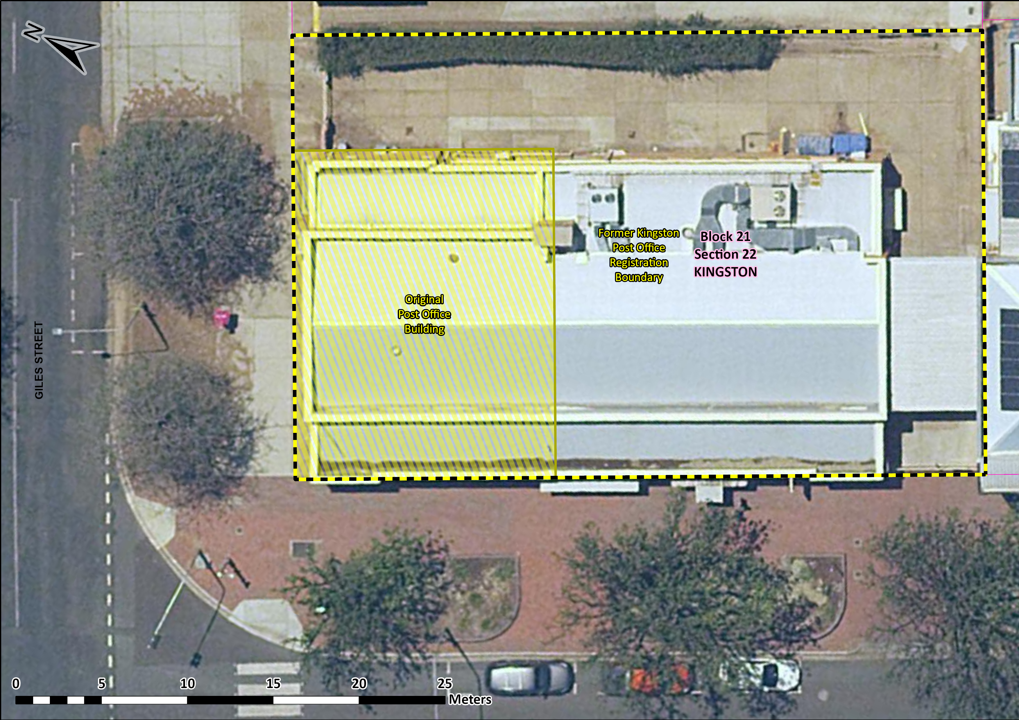
Image 1 – Proposed Heritage Boundary
Your Comments on the proposed boundary and features that describe the significant attributes of the place:
Click here to enter text.

Section 2 - ACT Heritage Council considerations - significance
A place or object has heritage significance if it meets with one or more of the eight heritage significance criteria as defined under section 10 of the Heritage Act 2004.
The heritage significance criteria are labelled (a) to (h), and your comments are most useful when addressed against each of these criteria, or you could focus on the ones relevant to your argument. However, you may choose to only leave a general comment by skipping to the General Comments section.
The ACT Heritage Council has determined that the Former Kingston Post Office is likely to have heritage significance under criterion (a) only. The criteria that are not met can also be commented on.
While the Council will independently assess and research any claims you make against the criteria, it may be helpful to refer to the Heritage Assessment Policy as a guide to providing the strongest argument with appropriate evidence.

(a) importance to the course or pattern of the ACT’s cultural or natural history;
The Council has assessed the Former Kingston Post Office against criterion (a) and is satisfied that the place is likely to meet this criterion.
The Kingston Shopping Precinct was the first shopping precinct developed for the ACT and was the premier shopping destination in the new capital for many decades, providing a central hub for services, socialising and business development in Canberra. The Former Kingston Post Office was integral to the continuing success of businesses in the Precinct during the period of growth following WWII, as it was needed to process a predicted increase in business transactions, as well as being an effective drawcard service to attract people to the area. Its predecessor had outgrown its location in one of the shopfronts in the Precinct along Giles Street, and before that, the first post office in the Kingston area had opened in a house in 1918 at Eastlake, near to the power station, but neither was suitable to the task and a purpose-built facility was needed.
Development in the ACT was severely restricted during the 1930s and the early years of the Second World War. After the end of the War, the Former Kingston Post Office Building was the first official purpose-built post office constructed in the ACT. While it was not the first post office established, it is the oldest surviving post office building designed for the federal capital and was the first significant post-war project for the NSW Post Master General, making it a testament to the faith in the importance of the developing capital.
The high-quality building was the NSW Post Master General’s first significant investment since the start of WWII. The commitment of resources and faith in its establishment of significant services in the ACT is demonstrated in the Inter-war Stripped Classical style of architecture and the solid building material of brick and concrete. While other important buildings of the time were using modernist designs, classicism was still seen as prestigious and emblematic of permanent and institutional buildings as evidenced by such examples as Old Parliament House (J. S. Murdoch’s design that influenced elements of his concept plans for early Kingston Shopping Precinct along Giles and Kennedy Streets), the Former Institute of Anatomy, the Former Patent Office as well as the Late Twentieth-Century Stripped Classical examples that followed such as the National Library. The high-quality build is an important contribution to the character of the area recognised later by the NCDC stipulating that the rest of the Jardine Street Banking and Commercial Row had to use the same Punchbowl Orange brick as the Post Office as one of the key unifying features. The choice of architectural style and the materials used are significant, not just as evidence of the post-war recovery and investment in the region, but also for its enduring effect on the surrounding architecture that has continued to this day with nearby modern developments referencing the original post office following community consultation.
In a time of economic recovery, the Kingston area, including the Precinct and the surrounding industrial areas, was one of the main business centres in the ACT and there was a high reliance on the Former Kingston Post Office for delivering and receiving orders, invoices, cheques, legal documents, and various other services that businesses of the day depended on.
Your Comments on criterion (a):
Click here to enter text.

(b) has uncommon, rare or endangered aspects of the ACT’s cultural or natural history;
The Council has assessed the Former Kingston Post Office against criterion (b) and is satisfied that the place is not likely to meet this criterion.
The Former Kingston Post Office is not considered to be uncommon, rare or endangered as a post office, a stripped classical building, or as a government building. All of these types are represented across the ACT and from a wide range of dates.
Your Comments on criterion (b):
Click here to enter text.

(c) potential to yield important information that will contribute to an understanding of the ACT’s cultural or natural history;
The Council has assessed the Former Kingston Post Office against criterion (c) and is satisfied that the place is not likely to meet this criterion.
As a well-documented built place, it is unlikely that any new information will be garnered from the material fabric of the place that would be considered a significant contribution to our existing knowledge. The Former Kingston Post Office does not have the potential to yield important information that will contribute to an understanding of the ACT’s cultural history.
Your Comments on criterion (c):
Click here to enter text.

(d) importance in demonstrating the principal characteristics of a class of cultural or natural places or objects;
The Council has assessed the Former Kingston Post Office against criterion (d) and is satisfied that the place is not likely to meet this criterion.
The Former Kingston Post Office is not considered to demonstrate the principal characteristics of a post office as all of these functions have now moved into the new extension and the original interior post office section retains no evidence of its past use. As a type of architecture, it does demonstrate the principal characteristics of the Inter-War Stripped Classical style (although it was built post-war, the style was most prevalent and synonymous with the inter-war period) with its symmetrical massing and classical composition with a minimum of classical motifs and Art Deco decorative elements; however, as a late (i.e. it was built after the style was falling out of favour) and relatively small (for a style that is exemplified by large institutional buildings that allow a greater expression of the style) example of this kind it is not considered to be important for demonstrating these characteristics. Significant examples of the Inter-War Stripped Classical style include the Former Institute of Anatomy, the Robert Garran Offices, formerly the Patent Office, Barton and Old Parliament House. The Former Kingston Post Office does not meet the threshold for inclusion under this criterion as either a post office or an example of the Inter-War Stripped Classical style of architecture.
Your Comments on criterion (d):
Click here to enter text.

(e) importance in exhibiting particular aesthetic characteristics valued by the ACT community or a cultural group in the ACT;
The Council has assessed the Former Kingston Post Office against criterion (e) and is satisfied that the place is not likely to meet this criterion.
Whilst the Council recognises that the Former Kingston Post Office Building is an example of the Inter-War Stripped Classical Style with Art Deco characteristics, there is insufficient evidence before the Council at this time to indicate that this exhibits outstanding design or aesthetic qualities that are valued by the community or a cultural group. It does contribute to the character of the Kingston Shopping Precinct, but there is not enough existing evidence of the building being aesthetically valued in and of itself.
Your Comments on criterion (e):
Click here to enter text.

(f) importance in demonstrating a high degree of creative or technical achievement for a particular period;
The Council has assessed the Former Kingston Post Office against criterion (f) and is satisfied that the place is not likely to meet this criterion.
The Former Kingston Post Office was built in a solid, standard, method of construction for its time. It is a brick and timber frame construction. Its design includes provision for movement and loading of postal vehicles, although these features have not been retained in the extant structure of the original building. While the stripped classical design testifies to its government origins, there is nothing that distinguishes it as a post office or shows any special achievement beyond being a well-made building of considered and classical design. There is no evidence at this time that the design meets the threshold demonstrating a high degree of creative or technical achievement for the period.
Your Comments on criterion (f):
Click here to enter text.

(g) has a strong or special association with the ACT community, or a cultural group in the ACT for social, cultural or spiritual reasons;
The Council has assessed the Former Kingston Post Office against criterion (g) and is satisfied that the place is not likely to meet this criterion.
In its heyday, the Former Kingston Post Office had an important role to play in supporting businesses and attracting shoppers to the Kingston Shopping Precinct, which was the premier shopping destination in the ACT in the period immediately after WWII. As such it would certainly have had a strong and special association with the ACT community as a social and economic hub at that time, but as the city has expanded, the Precinct has been relegated to a smaller role servicing its local neighbourhood. This smaller, local role is consistent with the original planning intention. The original post office building has also not been functioning as a post office since 1989, when that role was moved into the extension. As a consequence of the local role of both the precinct and the original post office building today, the latter does not have a strong or special association to the broader ACT community.
Your Comments on criterion (g):
Click here to enter text.

(h) has a special association with the life or work of a person, or people, important to the history of the ACT.
The Council has assessed the Former Kingston Post Office against criterion (h) and is satisfied that the place is not likely to meet this criterion.
The Former Kingston Post Office building is associated with the National Capital Planning and Development Committee (the NCPDC), the NSW Post Master General (PMG) and Australia Post, but not in a way that could be considered a special association, i.e. above the ordinary carrying out of their duties, that would satisfy the threshold for meeting this criterion.
The NCPDC was the advisory body to the Minister for the Interior that helped the planning and development of the ACT. They had a role in the development of the Post Office, but there is nothing to suggest that it was a special association above and beyond their usual involvement in any other planning and development issue in the ACT at the time.
The PMG and more recently the Australian Postal Corporation as the owner and developer of the Post Office certainly have an association with the place and are important to the history of the ACT. To meet this criterion, that association would have to be special, i.e. above and beyond the ordinary, however, there is no evidence that the association is special.
Your Comments on criterion (h):
Click here to enter text.

Section 3 – General Comments
I support the proposed heritage registration? Choose an item.
Please include any further comments to your submission:
Click here to enter text.

Section 4 - Demographics
Your personal details are confidential and will not be publicly visible, but this is required for you to be kept informed and to be counted as an ‘interested person’ (refer to the Privacy Statement at the beginning of the document).
If you do not provide your identity or contact details then the ACT Heritage Council will be unable to give you notice of decisions as an interested person under the Act. Also, you may not be able to be identified as an interested person entitled to appeal rights under the Act.
First Name: Click here to enter given name.
Last Name: Click here to enter surname.
Preferred contact details (phone, email, postal address):
Click here to enter address.
Age range: Click to choose an age range.
Relationship to the place: Click to choose a category.
Have you ever provided comments on other heritage registrations? Click to select.

What next?
After you are happy with your comments and have saved this form it can be emailed to heritage@act.gov.au or printed out and mailed to:
The Secretary
ACT Heritage Council
GPO Box 158
Canberra City ACT 2601

