BACKGROUND INFORMATION
Former Kingston Post Office
(Block 21, Section 22, Kingston)
At its meeting of 15 August 2023 the ACT Heritage Council decided that the Former Kingston Post Office was eligible for provisional registration.
The information contained in this report was considered by the ACT Heritage Council in assessing the nomination for the Former Kingston Post Office against the heritage significance criteria outlined in s10 of the Heritage Act 2004.
HISTORY

The Kingston Post Office has existed in four locations and has had three different designations. While this document covers its movement over time, the focus is on the original purpose-built facility that was used from 1947 until 1989.
Date | Name | Location
1918 | Eastlake | a detached house near the power house
1927 | Canberra East | Eastlake (later Kingston) Shopping Precinct
1944 | Kingston | Kingston Shopping Precinct
1947 | Kingston | Original building / Former Kingston Post Office on the corner of Giles and Jardine Streets
1989 | Kingston | New extension attached to the Former Kingston Post Office
Table 1 Timeline of the Kingston Post Office names and locations
Postal Services in Canberra
The first post office in Canberra was established in Ginninderra in 1859 (Dale 1958). Other offices were established shortly after by NSW postal authorities: these included Duntroon (1863), Lanyon (1860) and Canberra (1863), situated at the corner of Limestone Avenue and Allambee Street (Dale 1958).
From Federation in 1901, the Postmaster General’s Department (PMG), a Commonwealth Department, was responsible for communication services and systems throughout Australia, including postal services, telegraph and telephone systems (Australia Post 1975:17). A decade later, the PMG provided an allocation for a postal office in Duntroon to service the employees working at the Royal Military College, while also opening the Acton Post Office. In 1913, the name of the Acton Post Office was changed to Canberra and the original Canberra office was changed to Ainslie (Dale 1958). The Acton Post Office, comprising a weather board building with a corrugated iron roof, was demolished in 1926 (Canberra Times, 5 December 1953:4).
As the capital’s population grew, there was increasing demand for postal services and the post office emerged as a vital administrative and business hub for local communities and critical to its long-term development. By the late 1920s, there were at least four post offices in Canberra and these included Westlake (Yarralumla), Molonglo (Queanbeyan), Canberra and Eastlake (Kingston) (Mercury, 27 May 1927, p 10). Once Parliament moved to Canberra, the Canberra post office was moved from Acton to the East Block of the Government Offices in Parkes, serving both the public and Parliament (Dale 1958). Meanwhile, constant submissions were made by residents and community groups to the PMG to allocate provisions and establish new permanent offices in other suburbs, such as Ainslie (Canberra Times, 6 March 1947:3; 22 April 1950:3). Where the PMG refused to establish post offices, temporary, non-official post offices were opened.
When the Second World War broke out in 1939, the Postmaster General’s Department accepted the responsibility of carrying out specialised tasks for the Defence Force and as a result, they limited their works and projects (Australia Post 1975: 18; Commonwealth of Australia 1958: 44). Once the war ended, the Department faced much pressure to provide services in Canberra and throughout Australia “…at a rate sufficient to overtake arrears created by the low rate of development which necessarily occurred during the war years…” and meet the rapid industrial, commercial and population growth (Chippindall 1958:5). Their response included establishing more buildings, of “…various sizes and types…” to accommodate “…additional staff, equipment and stores…” (Chippindall 1958:44). In Canberra, the PMG constructed and relocated post offices as well as established many non-official offices in suburbs during this period, including Narrabundah, O’Connor and Griffith. By 1954, the Department employed more than 70,000 full-time official staff, making it the largest business in Australia (Commonwealth of Australia 1954).
The chronological sequence of the opening of non-official and official post offices in Canberra after Federation and up to 1957 can be summarized through the following timeline (after Dale 1958):
16th December 1911 | Duntroon
1st November 1912 | Canberra City (formerly Acton)
c.1918 | Eastlake (Kingston, ACT)
1922 | Molonglo Workmen’s Settlement
1st of May 1923 | Yarralumla (formerly Westridge)
6th April 1925 | Westlake
1927 | Eastlake, Kingston Shopping Centre and East Block Office
1935 | Manuka
22nd June 1943 | Harman Navy Station
30th June 1947 | R.A.A.F Station
1947 | Kingston Post Office, Jardine and Giles Street
1st August 1949 | Narrabundah
1st May 1950 | Ainslie
1st August 1950 | O’Connor
15th July 1957 | Throsby Crescent, Griffith
In 1975, the PMG was split into two groups, the Australia Postal and Telecommunication (Telecom) Commissions, and were later privatised. In recent times, the importance of suburban post offices has been substantially diminished as rationalisation of Australia Post properties and their outlets throughout the country has occurred.
The 1947 Kingston Post Office (Section 22 Block 21)
The Eastlake (renamed Kingston post-1928) Post Office, being located in the preeminent shopping area, was the most important post office outlet for business and for residents of south Canberra during the urban development of the capital, and in particular the post-World War II period. The first post office was established at the end of the First World War and operated in premises close to the Kingston Power Station, providing telephone facilities (Dale 1958). By 1924, its status was elevated to ‘allowance post office’ and money order and banking facilities were installed. However, it continued to operate as a ‘subsidiary office’ until the PMG’s office created an official post office in 1925, when it became one of two offices that conveyed mail in the capital (the other was Acton), a function previously carried out by the office at Queanbeyan (Canberra Times, 11 November 1926:1). In 1927, the post office was moved to a shop front along Giles Street within the recently built Precinct (Dale 1958). In 1944, the post office received its official title, Kingston ACT (Canberra Times, 6 October 1944:2).
In the following years, there was significant population growth and number of business transactions at the Kingston Post Office. Meanwhile, Manuka shopkeepers and residents alongside of residents from Forrest and Griffith made repeated submissions over two years to the PMG, requesting that a post office be established in the Manuka shopping precinct, as the Kingston Post Office was too far for them to travel in order to carry out their transactions (Hyslop 1985:9; Canberra Times, 4 January 1935:6, 14 September 1935:2; 27 September 1935:4). Until 1945, the PMG office refused the request, stating that the Manuka area was “…adequately served from the Canberra East Office.” (Canberra Times, 31 October 1933:2). A non-permanent office was opened in the Newsagent’s Shop 1935 and received banking facilities (Canberra Times, 2 May 1935:1; Dale 1958). However, by 1943, a request was made to relocate the Manuka Post Office as the non-official postmaster was experiencing great difficulty in gaining staff (Dale 1958). In 1945, the Manuka post office finally obtained official status.
After the Second World War the PMG officially announced plans to relocate the Kingston Post Office to the corner of Giles and Jardine Streets, opposite the shopping centre, determining that the premises along Giles Street were too small and limited the number of employees required to process the transactions (Canberra Times, 18 January 1949:2). In 1951, the Canberra Times reported that this was the “…first permanent post office erected by the N.S.W [sic.] postal authorities since the early war years.” (Canberra Times, 7 June 1951:3). At the same time, the PMG department conducted a ‘survey’ of the block adjacent to the Capitol Theatre in Manuka, finally proposing to erect a new post office building there (Canberra Times, 18 January 1949:2).
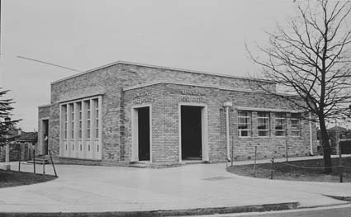
Figure 1 Photograph of the Former Kingston Post Office, Giles and Jardine St, 1951 (National Library of Australia).
The Kingston Post Office was erected on the block that had been provisionally allocated for a public hall in the 1920s. Completed in 1947, the present building is in a Stripped Classical style with Art Deco details and was designed by G. Edward of the Department of Works and Housing for the PMG’s Department (Garnett & Hyndes 1992:112). During this period, Canberra’s architectural development was influenced by the National Capital Planning and Development Committee (NCPDC) which was formed in 1940. This advisory committee guided growth in the Territory until it was abolished in 1957 when the National Capital Development Commission (NCDC) was formed.
Soon after the opening of the new Kingston Post Office other offices were established in adjacent suburbs; for example, the permanent Manuka Post Office, adjacent to the Capitol Theatre, was built after 1949 (Canberra Times, 4 May 1949:4). Non-official post offices were opened in Narrabundah in 1949 and Griffith in 1957.
In February 1989, the crown lease held by the Australian Postal Commission was surrendered to the ACT and plans for the building’s development into a health care center and post office were approved. This development involved the refurbishment of the interior for the health care facility and an extension to the east in the same style to house the post office. The Post Office still leases the eastern extension as of 2021.
DESCRIPTION
The Post Office
The Former Kingston Post Office Building is situated on the corner of Giles Street and Jardine Street, opposite the Kingston Shopping Precinct. The site has access from both streets for postal vehicles and a large paved area at the rear.
The original section, built in 1947, is a rectangular single storey brick building, 18.75m long by 13.75m wide. The exterior consists of a simple colour scheme comprising Punchbowl orange bricks (setting the standard for the rest of the Jardine Street buildings through the 1950s) with cream tiles placed around major openings and the roof line. The main entrances of this building are situated on the southern and western walls of the building, facing Giles and Jardine Streets.
The building is a late example the Inter-War Stripped Classical Style featuring some decorative elements derived from the Art Deco Style (Apperly et al. 1989: 164-167). Following the principles of the style, the building features components of symmetrical planning; for example, the corner porches that are placed equidistantly around a central space. The windows feature large, simple panes of glass. The building also comprises features that have some resemblance to the Classical Style. For example, along the western wall, the mullions of the main large window are cylindrical, alluding to vestigial classical columns and also emphasise verticality, while the stepped end bay along the building’s western external wall implies a classical portico. The building is decorated with ornamental metal windows, extensively uses coloured glazed terracotta (faience) facing and low relief ornamental detail, and these are all principal components of the Art Deco Style (Apperly et al. 1989: 167,190). Details such as vent grilles and downpipe heads are an attractive design consistent with the style of the building. Originally, the building also featured stylised signage.
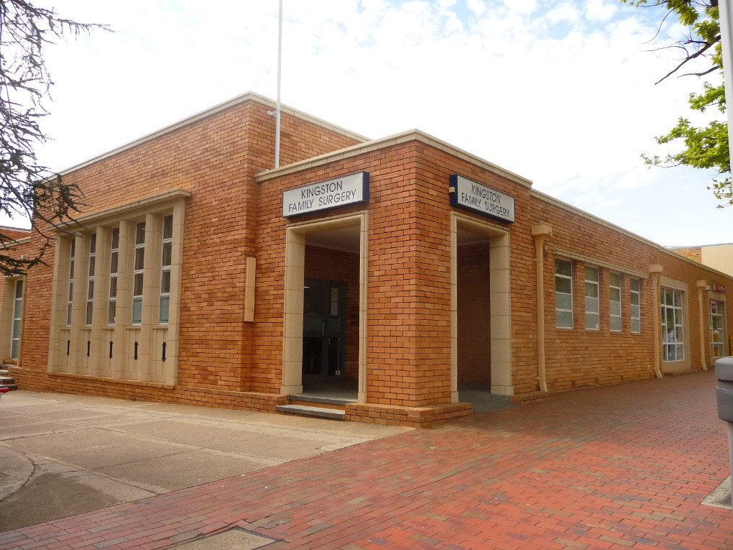
Figure 2 Former Kingston Post Office building as seen from the corner of Giles and Jardine Street. Minor modifications to the building are observable, including the replacement of the stylised lettering (ACT Heritage Unit, October 2021).
Since 1988, the building has been modified and extended (Garnett and Hyndes 1992: 112). The north-west porch has been filled in and a 10.5m by 18.75m extension was built to the east. These have been done in a sympathetic manner; matching bricks and feature cream tiles around the windows are used. Other minor changes include the installation of a ramped entry, repositioning the flagpole vertically above the corner entrance, and the removal of the original signage. The original large (~2.2x1.2m) chimney remains in the eastern corner of the original building, but now appears to sit centrally on that wall due to the extension. The extension is not included in this registration.
Physical condition and integrity
The Former Kingston Post Office is in excellent condition and retains most of its integrity. All changes and modification have been completed in a sympathetic manner and the original material of the building has been retained with only minor changes as noted above.
SITE PLAN
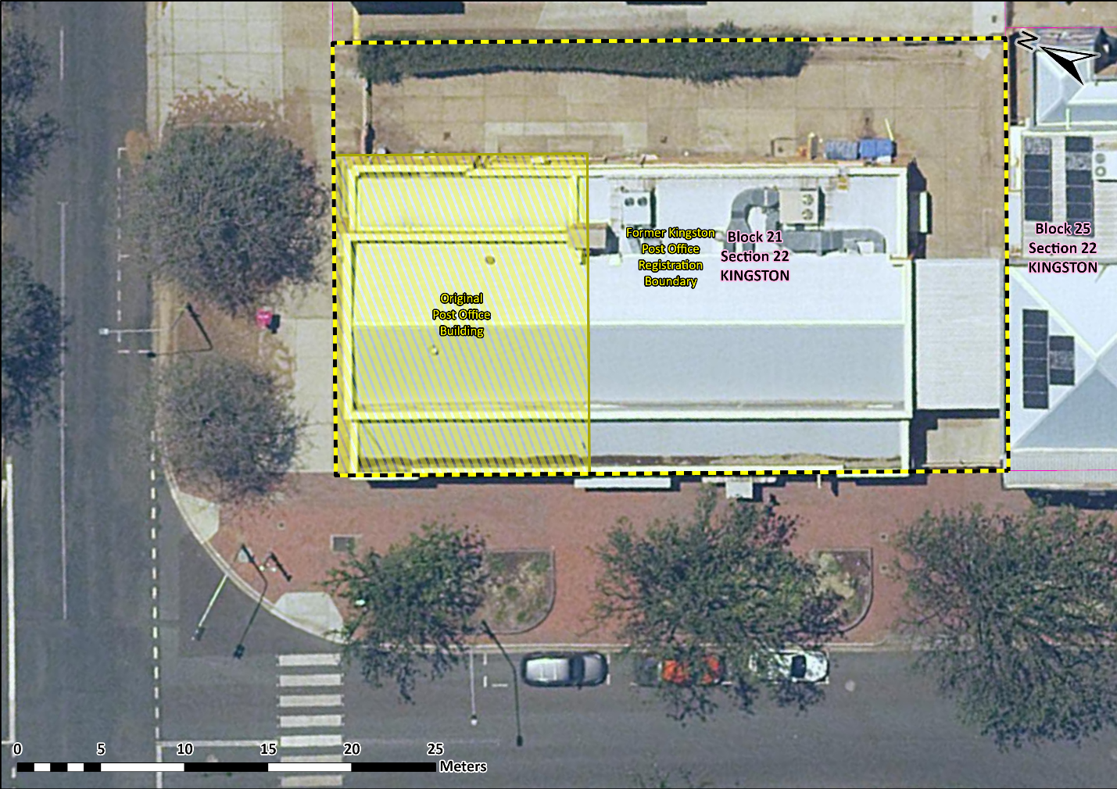
Image 1 Former Kingston Post Office site boundary
REFERENCES
Apperly, R., Irving, R and P. Reynolds. 1989. A Pictorial guide to Identifying Australian Architecture. Angus and Robertson, Australia.
Australian Post. 1975. A Brief History: 1809-1975. The Australia Post Office.
Chippindall, G. 1958. Letter to the Hon. C.W. Davidson, M.P dated 17th March 1958 from the Postmaster General’s Office. In the Commonwealth of Australia 1958. The Australian Post Office. Ten Years of Progress. A report by the Director-General, Post and Telegraphs by Giles Chippindall, Canberra.
Commonwealth of Australia 1958. The Australian Post Office. Ten Years of Progress. A report by the Director-General, Post and Telegraphs by Giles Chippindall, Canberra.
Commonwealth of Australia 1954. The Australian Post Office. Five Year’s Development to 31st December, 1954. A report submitted by the Postmaster General, Hon. H.L. Anthony, M.P, Canberra.
Dale, R.C.M. 1958. Postal History of the Australian Capital Territory, an unpublished paper delivered to the Canberra and District Historical Society on the 12th of February, 1958.
Garnett R. & Hyndes D. 1992. The Heritage of the Australian Capital Territory, National Trust of Australia [ACT].
Hyslop, F. 1985. A study of Manuka and Kingston 1926-1936. ANU student research report.
Mercury, The. 1927. Canberra. Transfer of post office inconvenience caused, Friday 27th May 1927, p 10, Hobart, Tasmania.

