Aboriginal and Torres Strait Islander Action Plan 2023–2025
Under the National Plan to End Violence against Women and Children 2022–2032

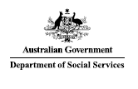
© Commonwealth of Australia 2023
ISBN: 978-1-920851-81-1
This document Aboriginal and Torres Strait Islander Action Plan to End Violence against Women and Children is licensed under the Creative Commons Attribution
4.0 International Licence: https://creativecommons.org/licenses/by/4.0/legalcode
Licence URL: https://creativecommons.org/licenses/by/4.0/legalcode
Please attribute: © Commonwealth of Australia (Department of Social Services) 2023
Report design: Dreamtime Creative Action Plan artwork: Jordan Lovegrove
Notice:
- If you create a derivative of this document, the Department of Social Services requests the following notice be placed on your derivative: Based on Commonwealth of Australia (Department of Social Services) data.
- Enquiries regarding this licence or any other use of this document are welcome. Please contact: Branch Manager, Communication Services Branch, Department of Social Services.
Phone: 1300 653 227
Email: communication@dss.gov.au
Notice identifying other material or rights in this publication: Certain images and photographs (as marked) – not licensed under Creative Commons

The Healing Tree
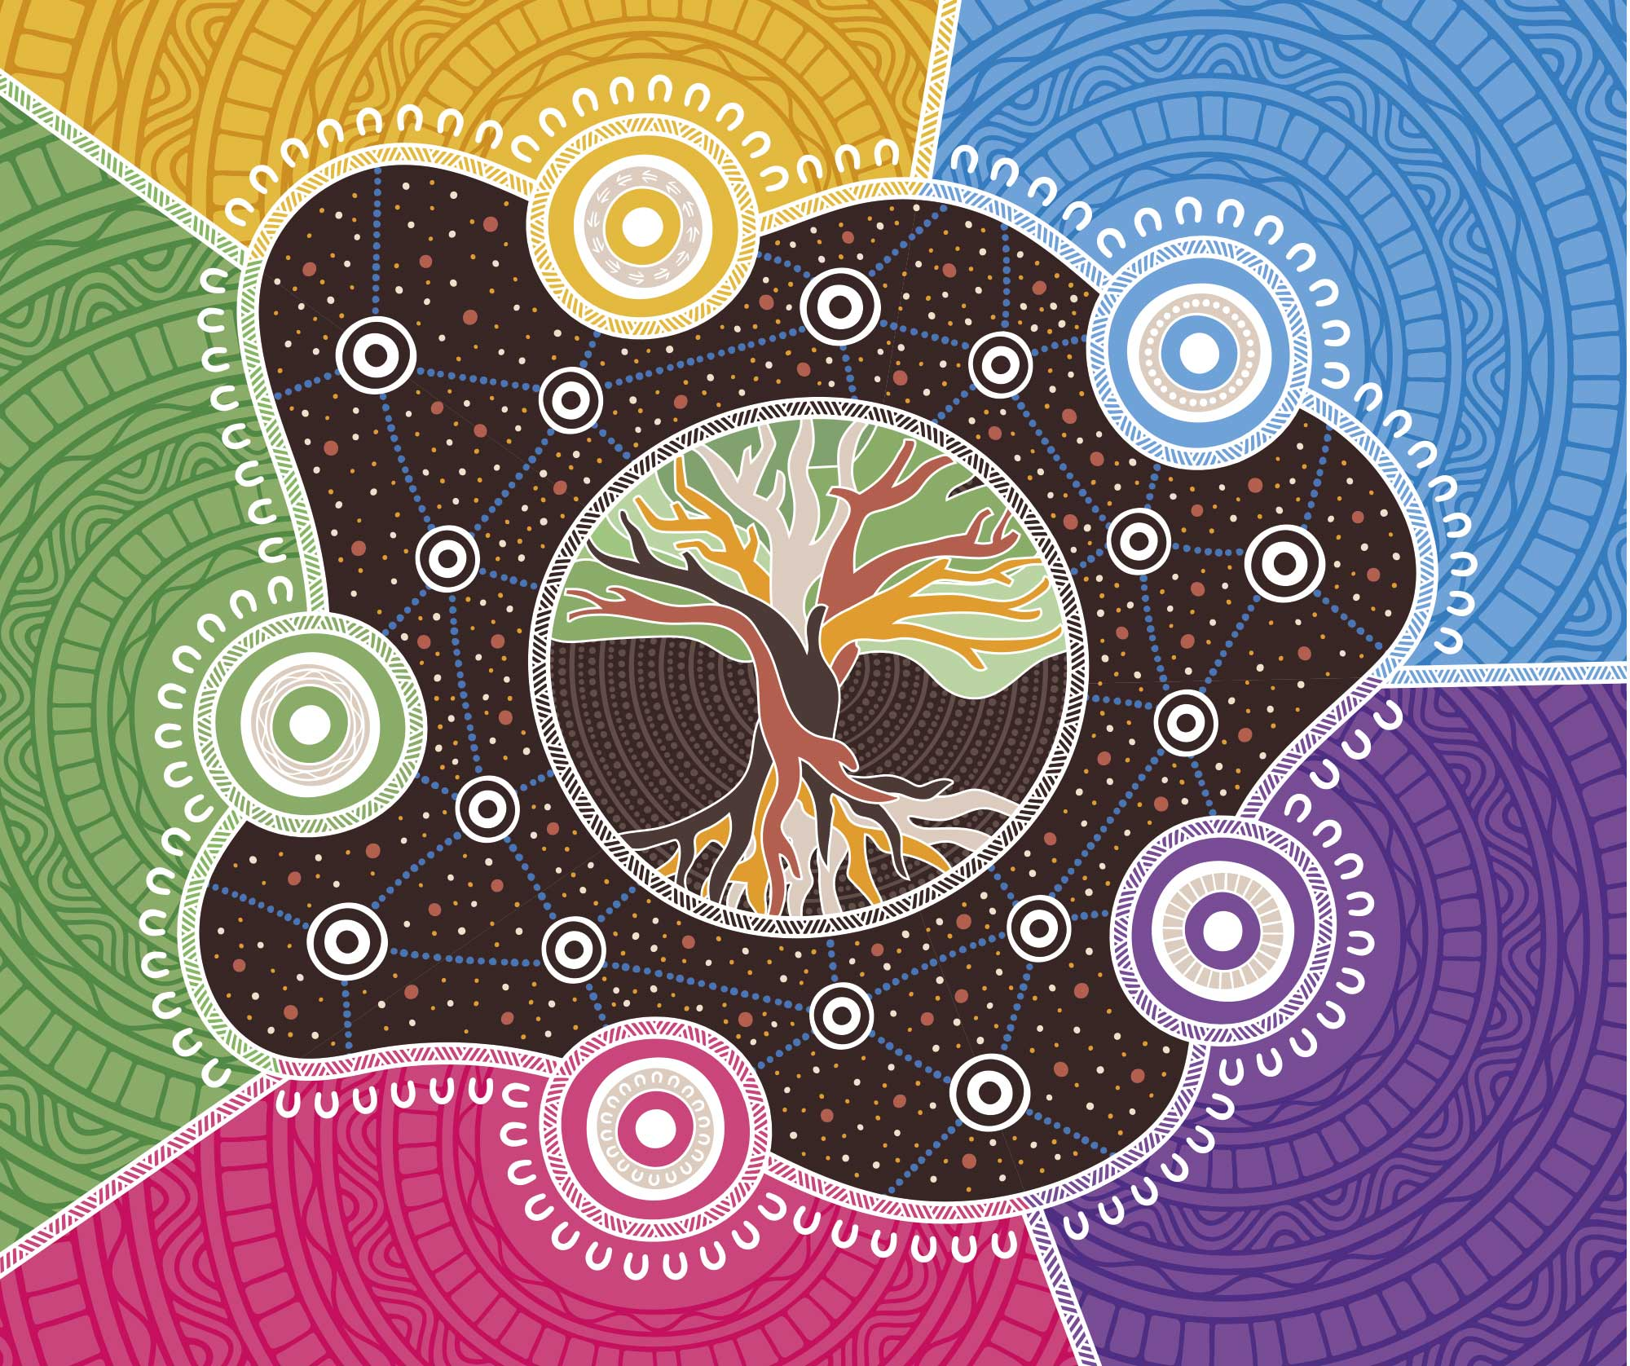
The artwork by Jordan Lovegrove, Ngarrindjeri, of Dreamtime Creative is centred around a healing tree which brings together every community and family through interconnection within Australia’s diverse spirituality and cultures. The roots of the tree represent strong family and community structures that are valued, reciprocal, and respected. The five meeting places around the outside are the reform areas of the Department of Social Services’ Aboriginal and Torres Strait Islander Action Plan under the National Plan to End Violence against Women and Children 2022-2032 through Voice, Strength, Reform, Inclusion, and Statistical Evidence. The meeting places in the centre depict families and communities, and the pathways between show support, learning, and sharing knowledge. The different coloured backgrounds are the diverse nature of Australia’s families and communities, places and country.
Jordan Lovegrove is a Ngarrindjeri Artist who grew up in Adelaide, South Australia. His family is from Raukkan, an Aboriginal community situated on the south-eastern shore of Lake Alexandrina in Narrung, 80km southeast of Adelaide. Raukkan is the home and heartland of Ngarrindjeri country. Jordan is one of the first Aboriginal artists to do Aboriginal and Torres Strait Islander vector art, and has perfected this skill over many years.

Contents
Acknowledgement 5
Dedication 5
Truth-Telling 6
Aboriginal and Torres Strait Islander Advisory Council 8
Advisory Council Statement 10
Message from the Women’s Safety Ministers 12
Support Services 14
Introduction 16
The First Action Plan 17
Dedicated Aboriginal and Torres Strait Islander Action Plan 18
First Nations National Plan 20
How the Action Plan was developed 22
Closing the Gap 23
National initiatives 24
Alignment to existing family, domestic and sexual violence strategies 25
Wiyi Yani U Thangani (Women’s Voices) 26
Why a dedicated Action Plan is needed 28
The Human Rights Context 30
Sexual Violence 31
Social Determinants 31
Judicial System 32
Housing, homelessness and overcrowding 32
Geographic disadvantage 33
Coercive control 33
Digital divide and digital safety 34
Financial abuse 34
Aboriginal and Torres Strait Islander priority groups 36
Women 36
Children and young people 37
People with disability 37
LGBTIQA+ Sistergirl and Brotherboy 38
Men 39
Implementing the Action Plan 40
Implementation timeframes 41
Action Plan Framework 42
Reform Area 1: Voice, self- determination, and agency 44
Reform Area 2: Strength, resilience and therapeutic healing 46
Reform Area 3: Reform institutions and systems 50
Reform Area 4: Evidence and data eco-systems 53
Reform Area 5: Inclusion and intersectionality 56
Accountability 59
Governance structure 59
Monitoring and reporting 62
Public reporting 62
Outcomes Framework 63
Appendix A: State Support Services 66
Appendix B: Glossary of Terms 70
Appendix C: References 76

Acknowledgement
We acknowledge all Aboriginal and Torres Strait Islander peoples throughout Australia, their unique and continuing cultural and spiritual relationship and connection to the land, waters and community.
We listen to and pay respect to all Elders, past and present, for they keep families, traditions and culture connected, and give strength to Aboriginal and Torres Strait Islander voices. We also acknowledge the broader Aboriginal and Torres Strait Islander contributions to building this nation, in particular Aboriginal and Torres Strait Islander peoples who were the first to establish medical, legal and health services in this country.
We especially recognise the Aboriginal and Torres Strait Islander women working to end violence, and whose efforts have led to the creation of this dedicated Aboriginal and Torres Strait Islander Action Plan (Action Plan). We acknowledge the leadership of Aboriginal and Torres Strait Islander peoples in developing the dedicated Action Plan, and the vital role they will play in its implementation and monitoring across Aboriginal and Torres Strait Islander lands and communities.

Dedication
We dedicate the Action Plan to Aboriginal and Torres Strait Islander victim-survivors of family, domestic and sexual violence. We have heard the voices of women, men, young people and families who have experienced violence across their life course, and we recognise their strength and resilience.
Aboriginal and Torres Strait Islander peoples also bring immense strength and resilience through their connection to culture, community, ancestry and land. We acknowledge the role of Aboriginal and Torres Strait Islander women as leaders in working to combat the disproportionate levels of violence directed against them, their children and their communities. It is their commitment to human rights and the fundamental right to live free of all forms of violence, including family, domestic, and sexual violence, racial violence, and institutional discrimination, wherever they live. Aboriginal and Torres Strait Islander peoples endure disproportionate rates of violence, assault, and murder. The national crisis of family violence stems from and is perpetuated by persistent structural marginalisation, discrimination, inequalities, and inherited trauma. We also acknowledge the important contribution of Aboriginal and Torres Strait Islander peoples in redefining ‘family violence’ in Australia, which can include violence outside of the bounds of intimate partner violence.
The pages of this Action Plan speak to the lives and aspirations of our women and children, while also recognising the many deaths that have occurred and lives seriously harmed by violence that should have been prevented. We mourn the absence of those lost and the profound impact they had on our interconnected kinship structures, communities, and the hearts of those who loved them. Our grief is intensified by the systemic shortcomings and the inadequacies of current systems and processes to prevent their deaths and guarantee the protection and safety of our women and children. Nevertheless, their memory remains, leaving indelible impressions in this world and in our memories. We hope this Action Plan will contribute to the healing of Aboriginal and Torres Strait Islander families suffering from loss, violence and trauma. Together, we can and will strive for a better future.
We acknowledge the tireless collective advocacy and determination of our women, working alongside countless individuals and organisations, who have paved the way for the creation of this Action Plan.
We also dedicate the Action Plan to the individuals, groups and organisations who work tirelessly to end violence and to improve the lives of Aboriginal and Torres Strait Islander peoples. Their collective commitment and advocacy over many years has raised the voices of women and children and paved the way for the launch of this plan.

Truth-Telling
Truth-telling is a foundational stone within Aboriginal and Torres Strait Islander peoples’ healing practices. Establishing an honest account of events and processes, both historical and contemporary, is essential to forming mutual understanding between non-Indigenous people and Aboriginal and Torres Strait Islander peoples.
We must ensure that an honest account of violence against Aboriginal and Torres Strait Islander peoples, including women and children and both historical and contemporary, is forthcoming. This includes the sexual violence that was a part of Australia’s treatment of Aboriginal and Torres Strait Islander women.
Truth-telling has also been identified as one key component in the Uluru Statement from the Heart.
Truth-telling means speaking and listening to truth after periods of conflict, so that relationships can be rebuilt on justice and human rights.
It is essential that truth-telling includes all forms of violence against Aboriginal and Torres Strait Islander women and children. Without honest dialogue of violence impacting Aboriginal and Torres Strait Islander peoples, efforts to address violence will fail. Family, domestic, and sexual violence causes trauma and sorrow for Aboriginal and Torres Strait Islander peoples. So too does the lack of access to culturally safe responses in existing mainstream family violence services. The widespread ongoing existence of systemic and structural racism and discrimination in the justice system, and the lack of recognition of Aboriginal women’s leadership, are all contributing to the endemic violence we are witnessing and leading to the suffering of too many women and children.
Truth-telling also involves celebrating the strength and resilience of Aboriginal and Torres Strait Islander peoples who have led actions across this country to end violence. Throughout this Action Plan, we strive to do both: honour the strength and resilience within Aboriginal and Torres Strait Islander communities and acknowledge the prevalence and destructive nature of family, domestic and sexual violence.
This Action Plan builds on existing initiatives, whether through redress, reparations or civil action, to acknowledge the past, build greater understanding of the strength of Aboriginal and Torres Strait Islander peoples, and promote healing from trauma.
It is important to highlight that Aboriginal and Torres Strait Islander cultures and knowledge possess many of the essential components/methods and tools for healing. However, much needs to be done across broader structures and by stakeholders to stop trauma from happening and to also provide support services and invest in the healing approaches of Aboriginal and Torres Strait Islander peoples.

Aboriginal and Torres Strait Islander Advisory Council
The Aboriginal and Torres Strait Islander Action Plan is an initiative of the Australian Government in collaboration with the Aboriginal and Torres Strait Islander Advisory Council on family, domestic, and sexual violence (Advisory Council). The Advisory Council led the development of this Action Plan and worked in formal partnership with the Commonwealth to develop policies and measures to reduce violence against Aboriginal and Torres Strait Islander women and children.
Advisory Council Members are recognised and respected Aboriginal and Torres Strait Islander sector leaders and selected to reflect the diversity of Aboriginal and Torres Strait Islander peoples, perspective, experiences and expertise.
Members reflect gender and sexual diversity, the voices of Elders and young people, community, cultural and geographic diversity and representation from a variety of political, academic and professional backgrounds.
Members have a strong foundational understanding of the complexity and intersecting nature of the ways in which family, domestic and sexual violence is experienced by Aboriginal and Torres Strait Islander peoples and communities and the ability to work effectively with government.
Advisory Council Chair
- Professor Sandra Creamer AM – Adjunct Professor of Public Health at the University of Queensland
Advisory Council Co-deputy Chairs
- Ms Donnella Mills – Chair, National Aboriginal Community Controlled Health Organisation (NACCHO); Chair, Wuchopperen Health Service; First Nations lead for King and Wood Mallesons
- Mr Robert Skeen – General Manager: Special Projects, Queensland Aboriginal and Islander Health Council
Advisory Council Data and research sub-committee chair
- Professor Victoria Hovane – psychologist and professor, Centre for Indigenous Peoples and Community Justice, University of Western Australia, and Australian Centre for Child Protection

Advisory Council members
- Adjunct Professor Muriel Bamblett Hon DLitt SW AO – CEO, Victorian Aboriginal Child Care Agency; Chair, SNAICC, National Voice for our Children
- Ms Shirleen Campbell – Coordinator, Tangentyere Women’s Family Safety Group
- Professor Bronwyn Carlson – Head of the Department of Indigenous Studies, Macquarie University
- Ms Emily Carter – CEO, Marninwarntikura Women’s Resource Centre
- Ms Susan Cook – Financial counsellor, Salvation Army, and Indigenous Consumer Assistance Network
- Ms Fiona Cornforth – CEO, Healing Foundation
- Ms Rachel Dunn – CEO, Karadi Aboriginal Corporation
- Mr Damian Griffis – CEO, First Peoples Disability Network Australia
- Mr Craig Rigney – CEO, Kornar Winmil Yunti Aboriginal Corporation (KWY)
- Mr Phillip Sariago – Community Development Coordinator, Brisbane City Council
- Ms Geiza Stow – Board Member, Mura Kosker Sorority (Torres Strait Islands)
- Mr Michael Torres – Counsellor, Darwin Indigenous Men’s Service, Darwin Aboriginal and Islander Women’s Shelter
Appointed Special Advisors
- Professor Marcia Langton AO, Associate Provost at the University of Melbourne
- Ms June Oscar AO, Aboriginal and Torres Strait Islander Social Justice Commissioner
  - Special Advisory support on the Action Plan has been provided by key Wiyi Yani U Thangani signatories

Advisory Council Statement
The Advisory Council is pleased to present the dedicated Aboriginal and Torres Strait Islander Action Plan (Action Plan), under the National Plan to End Violence against Women and Children 2022–2032 (National Plan).
The Advisory Council has a vision that ‘Our people no matter where they live, are culturally safe and strong, and live free from violence.’ This vision extends into this Action Plan which is designed to be culturally informed, to address the current needs of the community, and to lay a strong foundation for long-term change for Aboriginal and Torres Strait Islander peoples.
This 3-year Action Plan is fundamental to addressing Target 13 of the National Agreement on Closing the Gap – By 2031, the rate of all forms of family violence and abuse against Aboriginal and Torres Strait Islander women and children is reduced by at least 50%, as progress towards zero.
The Action Plan defines shared decision-making, leadership, accountability, transparency and mechanism to transitions for funding to Aboriginal and Torres Strait Islander organisations and capacity building as well as being community-led.
The Action Plan recognises the need for adequate, sustained long-term funding to Aboriginal and Torres Strait Islander organisations responding to family, domestic and sexual violence, early interventions, prevention programs and working with young people. The Advisory Council recognises the important need to improve collection and data sharing as evidence to support outcomes, economic structure, decisions, and funding so we can uphold our rights to develop our communities.
This Action Plan is designed to make changes to where the decision-making sits with the community and their lived experience. Community governance should equal community control and be culturally appropriate. Such a shift will require government and other decision makers to place Aboriginal and Torres Strait Islander peoples and their community services at the centre of decision-making and sustainable solutions to enhance their empowerment and self-determination in reducing violence in their communities. Cultural and social competence is needed to operate safely; as well as good values, morals and protection for stability in strengthening relationships, families and communities.
The Action Plan aims to ensure the safety of women and children not just short-term but long-term. It aims to secure a safe environment so women and children can live free from domestic, family and sexual violence. Protecting women and children is also about restoring the wellbeing of men, which will reduce incarceration and uplift the health and wellbeing of families and communities. By providing housing, resources and safety, this then will in the long-term support the associated reduce the targets as part of Closing the Gap.
The Advisory Council is pleased to work with the Department of Social Services and other agencies at the Commonwealth level, as well as with state and territory Ministers and departments. We would particularly like to thank the Hon Amanda Rishworth MP, Minister for Social Services, for her leadership in this important work.
The Advisory Council logo comprises 2 main elements: the Coolamon and the Minalay Waku.
The Coolamon is the Creator and Healer for the issues highlighted by DSS and the
Advisory Council. The issues are placed upon the Coolamon which will then be added with the items from Mother Earth to create the Sacred fire. The Symbols that are placed onto the Coolamon are sacred to the Women’s body, mind, and spirit. This creates the Aura of smoke which is the Sacred healer.
The ‘Minalay waku’ (thin strips finely and neatly woven island mat) shows the preparation, the planning and the start of the many pandanus mat strips getting put together – many layers, many roads, many people, many feelings, many trails and the resilience to overcome and continue with the work at hand.

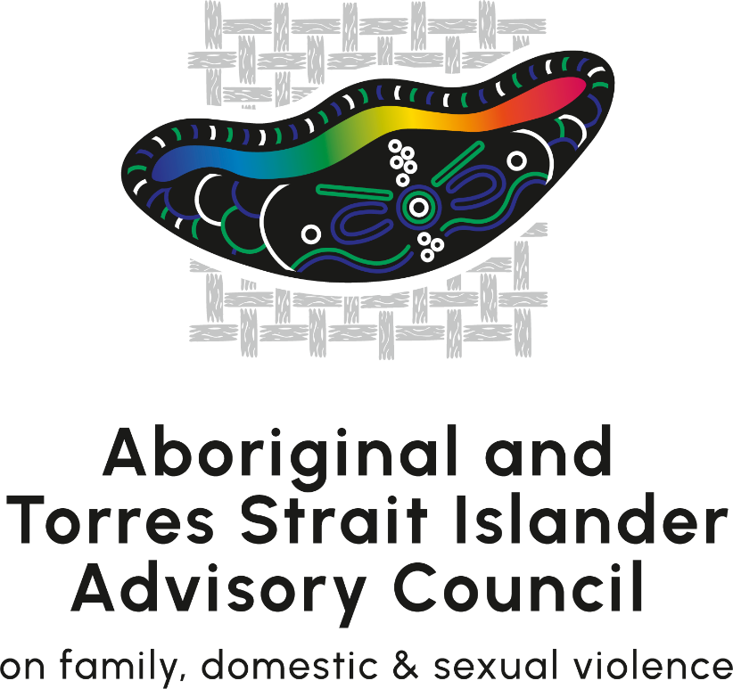

Message from the Women’s Safety Ministers
The Australian Government, state and territory governments and the Aboriginal and Torres Strait Islander Advisory Council on family, domestic and sexual violence (Advisory Council), are proud to launch Australia’s first dedicated Aboriginal and Torres Strait Islander Action Plan (Action Plan) under the National Plan the End Violence against Women and Children 2022–2032.
Ending violence against women and children is a national priority. Aboriginal and Torres Strait Islander women are 6 times more likely to be victims of homicide due to domestic violence than non-Indigenous women. They are also 33 times more likely to be hospitalised as a result of the domestic violence they face. These statistics must change so that Indigenous women and children are able enjoy their right to live in safety.
We mourn the lives that have been stolen, often by people they loved or trusted. We thank the victim-survivors who continue to turn trauma into action and advocacy, who share their lived experiences despite the heavy emotional toll and help us all be better at addressing the issue. We acknowledge the invaluable contributions that Indigenous communities continue to make nationally.
Recognising that solutions need to be led by Aboriginal and Torres Strait Islander peoples, the Advisory Council has worked in partnership with many Indigenous people and service providers to ensure the full diversity of Indigenous voices are being heard and effectively incorporated.
This Action Plan delivers a mix of initiatives to address the current safety needs of Aboriginal and Torres Strait Islander women, children and families, as well as lay a strong foundation for longer-term structural change. It has been informed by extensive community engagement and consultation. The Australian Government and all states and territories have responsibilities in implementing these initiatives. We all acknowledge that the wellbeing of Indigenous peoples is not just a matter for Aboriginal and Torres Strait Islander communities; it is everybody’s business.
Current efforts will be guided by this Action Plan. Further direction will be provided through the development of a standalone First Nations National Plan for Family Safety.
All Action Plans under the National Plan will provide the framework for the Australian Government’s ongoing response to Target 13 of the National Agreement on Closing the Gap, which is to reduce the rate of all forms of family violence and abuse against Aboriginal and Torres Strait Islander women and children by at least by 50%, as progress towards zero by 2031.
We commend this Action Plan and welcome your support in its implementation.
The Hon Amanda Rishworth MP
Minister for Social Services
The Hon Justine Elliot MP
Assistant Minister for Social Services
Assistant Minister for the Prevention of Family Violence
Yvette Berry MLA
Australian Capital Territory
Minister for Women
Minister for the Prevention of Domestic and Family Violence
The Hon Jodie Harrison MP
New South Wales
Minister for Women
Minister for the Prevention of Domestic Violence and Sexual Assault
The Hon Kate Worden MLA
Northern Territory
Minister for Prevention of Domestic, Family and Sexual Violence
The Hon Yvette d’Ath MP
Queensland
Minister for the Prevention of Domestic and Family Violence
The Hon Katrine Hildyard MP
South Australia
Minister for Women and the Prevention of Domestic and Family Violence
The Hon Madeleine Ogilvie MP
Tasmania
Minister for Women and the Prevention of Family Violence
The Hon Ros Spence MP
Victoria
Minister for Prevention of Family Violence
Hon Sabine Winton BA BPS MLA
Western Australia
Minister for Prevention of Family and Domestic Violence

Support Services
Violence against women and children can be hard to discuss and reading this document may cause distress. Help is available.
If you or someone close to you is experiencing, or at risk of, distress and immediate danger, please call 000.
For information, family, domestic and sexual violence support services, support and counselling, you can contact:
Aboriginal and Torres Strait Islander Services
Support service | Support offered | Contact details
13 YARN | Support line for mob who are feeling overwhelmed or having difficulty coping. Available 24/7. | 13 92 76  13 YARN
Well Mob | Social, emotional and cultural wellbeing online resources for Aboriginal and Torres Strait Islander peoples. | Well Mob
Brother to Brother Crisis Support Line | Brother to Brother is Australia's first 24-hour hotline assisting Aboriginal men, staffed by Aboriginal men, including Elders, to promote a culturally safe service. Available 24/7. | 1800 435 799  Brother to Brother Crisis Support Line
National Services
Support service | Support offered | Contact details
1800RESPECT | National sexual assault, domestic and family violence counselling service. This service is free and confidential. Available 24/7. | 1800 737 732  1800respect
Kids helpline | Australia’s only free (even from a mobile), confidential 24/7 online and phone counselling service for young people aged 5 to 25. | 1800 551 800  Kids Helpline
National Elder Abuse Hotline | Free call phone number that redirects callers seeking information and advice on Elder abuse with the phone line service in their jurisdiction. Elder abuse phone lines are not crisis support services, and operating hours and services vary across jurisdictions. | 1800 ELDERHelp  (1800 353 374)  National Elder Abuse Hotline
The National Disability Abuse and Neglect Hotline | The National Disability Abuse and Neglect Hotline (The Hotline), is a free, independent and confidential service for reporting abuse and neglect of people with disability. | 1800 880 052  National Disability Abuse and Neglect Hotline
Disability Gateway | The Disability Gateway is a free Australian-wide service to help people with disability, their families and carers find trusted information and services. | 1800 643 787  Disability Gateway
QLife | QLife provides anonymous and free LGBTIQ+ peer support and referral for people in Australia wanting to talk about sexuality, identity, gender, bodies, feelings or relationships. | 1800 184 527  QLife
Men’s Referral Service | The Men’s Referral Service is a men’s family violence telephone counselling, information and referral service operating around the country and is the central point of contact for men taking responsibility for their violent behaviour. | 1300 766 491  Men’s Referral Service
eSafety Commissioner | Australia’s national regulator of online safety, with reporting schemes to help people who experience online abuse.  Culturally tailored materials, including stories from mob in language and tips to help you be deadly online. | eSafety report  eSafety First Nations
Additional support services by state and territory can be found in Appendix A

Introduction
The Australian Government is committed to upholding and protecting the rights of Aboriginal and Torres Strait Islander women, children and families to be safe and free from all forms of violence including family, domestic and sexual violence, racial violence, and institutional violence, wherever they live.
The Commonwealth, state and territory governments, Aboriginal and Torres Strait Islander representatives and the non-government sector are working together towards the shared goal of ending all forms of violence and abuse towards Aboriginal and Torres Strait Islander women and children. While the National Plan to End Violence against Women and Children 2022-2032 (National Plan) recognised the disproportionate rates of violence against Aboriginal and Torres Strait Islander women and children as an urgent national priority, this is the first dedicated Action Plan to provide targeted action to address the disproportionate rates of violence experienced by Aboriginal and Torres Strait Islander women and children.
All governments have committed to ending violence against women and children in Australia in one generation through the National Plan. This signifies a collective agreement that all women and children have the right to live free from fear and violence, and to be safe in their homes, workplaces, schools, community and online.
This Action Plan acknowledges the complexity of family, domestic and sexual violence across all jurisdictions and given the diversity of Aboriginal and Torres Strait Islander peoples across the nation, activities in the Action Plan do not assume a one size fits all approach. Activities are set at the national level; the implementation of these activities will be different across this diverse nation.
Successful implementation will be dependent on the Commonwealth, state and territory governments adopting key principles in implementing these activities: allocations of funding through Commonwealth and state/territory budgetary mechanisms, engagement with state/territory agencies and key Indigenous bodies, such as those in the health and community services sector, that may be impacted by these actions. It is vital that these decisions are tested for suitability at a local Aboriginal and/or Torres Strait Islander community level and are not intended to pre-empt the outcome of these government processes.
The National Plan is a long-term collaboration for action by Commonwealth, state and territory governments. It establishes the overarching national policy framework that will guide actions towards ending violence against women and children over the next 10 years. The National Plan includes the first 5-year Action Plans (2023-2027), the second 5-year Action Plan (2028-2032), a dedicated Aboriginal and Torres Strait Islander Action Plan (2023–2025), and an Outcomes Framework. These action plans detail the Commonwealth, state and territory government efforts towards implementing the National Plan.

Figure 1: A holistic and multi-sectorial approach
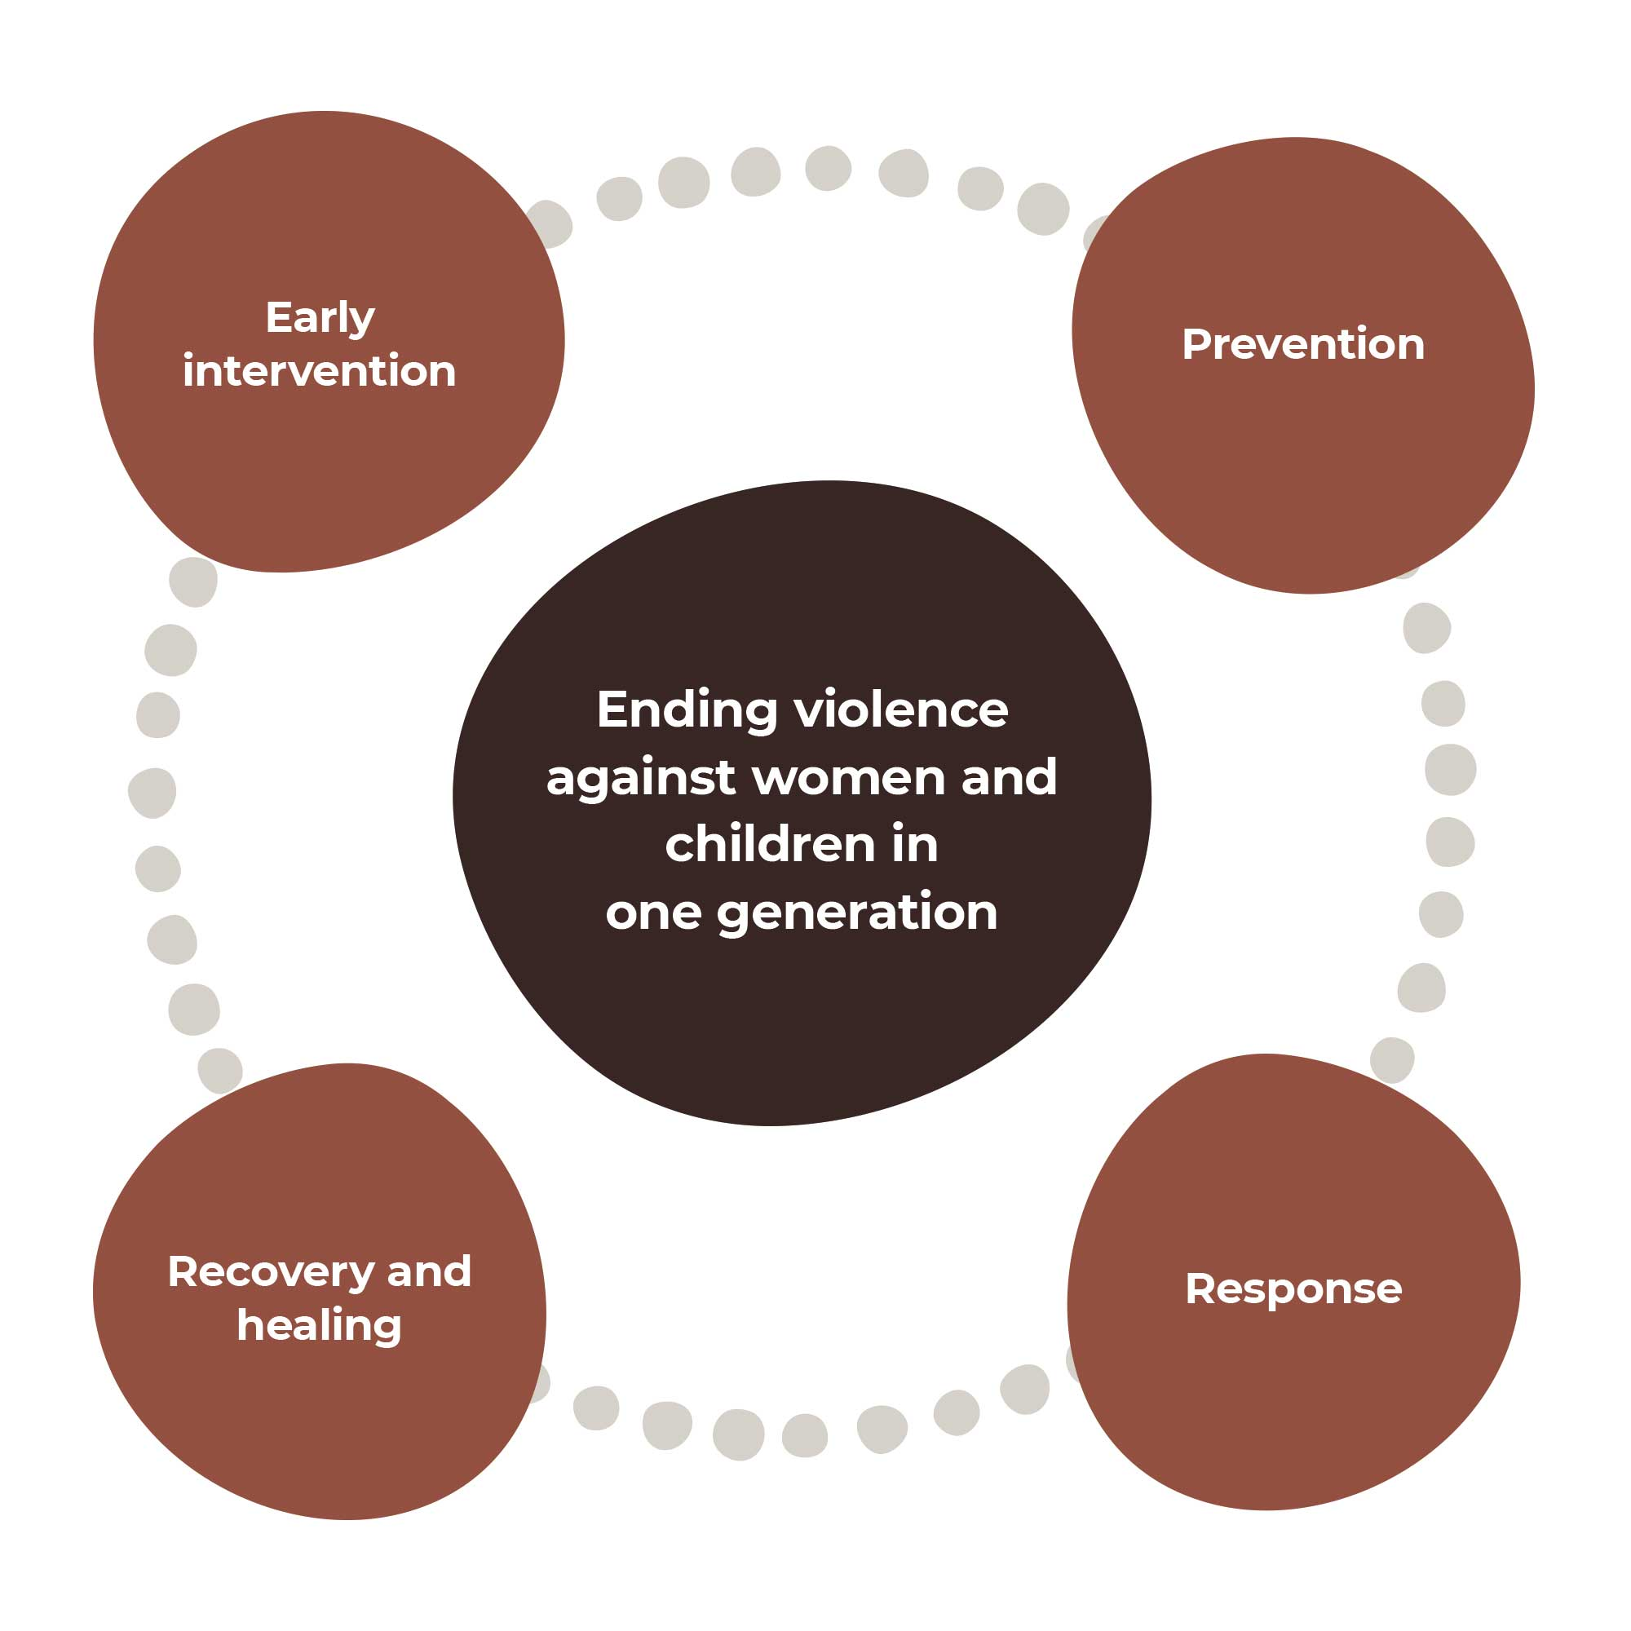
“The way we are, the way we do things is a practice that restores wellbeing together.” – Consultation participant.

The First Action Plan
The First Action Plan intends to improve the safety of all Australians through universal cross-cutting actions alongside the dedicated Aboriginal and Torres Strait Islander Action Plan.
This First Action Plan is for governments; policy makers; businesses and workplaces; specialist organisations; family, domestic and sexual violence organisations and workers; communities; and people affected by family, domestic and sexual violence. It provides an overview of the national policy response to ending violence against women and children in one generation.
Actions outlined in the First Action Plan span across the 4 domains of the National Plan – prevention, early intervention, response, and recovery and healing, to drive a holistic and multi-sectoral approach to ending violence against women and children in one generation.
It includes actions and activities to ensure mainstream services and specialist services and programs are culturally appropriate, accessible, safe and trauma-informed and meet the needs of a diverse cohort of victim-survivors.

Dedicated Aboriginal and Torres Strait Islander Action Plan
This is the first dedicated Action Plan created to provide targeted action to address the disproportionate rates of violence experienced by Aboriginal and Torres Strait Islander women and children.
The Action Plan is aligned with the National Agreement on Closing the Gap, the 4 Priority Reforms and 17 socio-economic outcomes. Specifically, with a focus on outcome area and Target 13, by 2031, the rate of all forms of family violence and abuse against Aboriginal and Torres Strait Islander women and children is reduced by at least 50%, as progress towards zero.
The Action Plan also corresponds with other existing strategies and targets for realising the rights of Aboriginal and Torres Strait Islander women and children at the Commonwealth and state/territory levels. Its activities will occur alongside a range of initiatives already being implemented by states and territories under their individual plans.
Self-determination or empowerment and Aboriginal and Torres Strait Islander cultural resources are key to ending violence against Aboriginal and Torres Strait Islander women and children; these solutions are distinct from the mainstream cultural approaches that underpin the National Plan and the family, domestic and sexual violence sector.
This dedicated Action Plan has been developed using a wealth of community, sector and academic knowledge. Activities within the Action Plan acknowledge the underlying causes of violence against Aboriginal and Torres Strait peoples are different to that of non-Indigenous Australians. In particular, some of the underlying causes are based on the ongoing impacts of colonisation, including the forced removal of children and intergenerational trauma, which manifest at both an individual, community and structural level and include institutional and systemic racialised abuse and marginalisation.
Activities within the Action Plan have been developed in partnership with the Advisory Council in response to the voices of Aboriginal and Torres Strait Islander women, men, children, young people and communities that were heard throughout a comprehensive 9-month consultation period.
The Action Plan takes an intersectional approach to meet the different needs of Aboriginal and Torres Strait Islander peoples with diverse experiences, with a focus on those who face disproportionate risk of family, domestic and sexual violence, such as children and young people, women, Elders, people with disabilities, people in regional and remote areas, and LGBTIQA+ Sistergirl and Brotherboy community. It also considers the ways in which Aboriginal and Torres Strait Islander women and others may experience intersecting and compounding forms of violence and oppression, such as racialised sexism and cis-hetero sexism. Intersectional discrimination is a major contributor of the issues and harms that Aboriginal and Torres Strait Islander women and girls experience. Above all, it must be recognised that the safety of Aboriginal and Torres Strait Islander women and children experiencing violence is paramount.
There is a significant body of research about how structures and hierarchies of power overlap, causing intersectional discrimination and oppression or marginalisation of people who are minorities and have multiple intersecting identity markers. The result is the ongoing exclusion of Aboriginal and Torres Strait Islander women and children in all their diversity from the policies, programs and structures that impact their lives, which has continued since colonisation. This can cause situations and environments that heighten the vulnerability of women and children to violence and can entrench the barriers that make it difficult, if not impossible, to leave violent situations.
Figure 2: Intersectionality – A summary of overlapping oppressions and identity markers

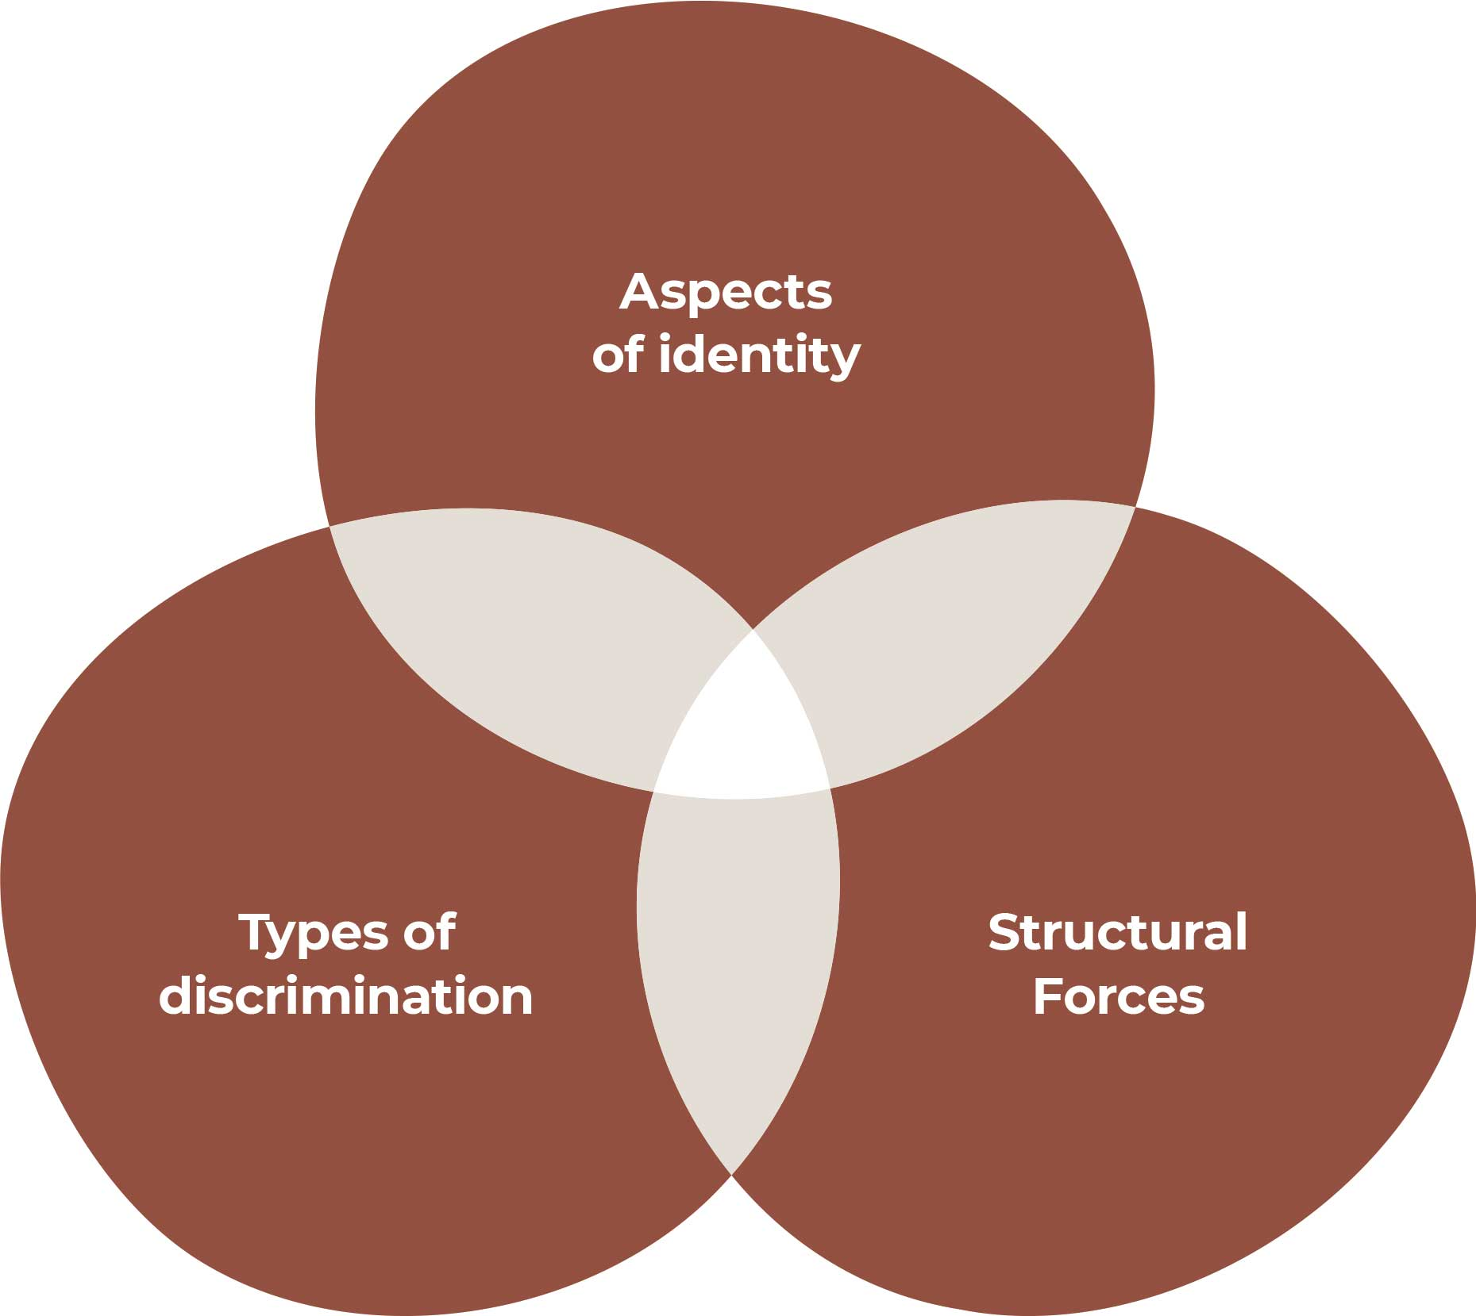

Aspects of identity
  - Language/ family/ Nation/ Mob/ Clan/ Tribe/ Community
  - Kinship location/ Family status
  - Totem, Skin, Moiety, Name
  - Intercultural knowledges and skills
  - First language(s)
  - Community and family roles and responsibilities
  - Political, Spiritual and religious beliefs
  - Geographic location
  - Gender identity / Sexual orientation
  - Socio-economic status
  - Kupai Omasker and traditional adoption
Structural forces
- Colonisation (historic and ongoing)
- Patriarchy
- Social, political and economic marginalisation
- Media and Stereotyping
- Institutions and structures that harm rather than heal
- Lack of recognition and representation
Types of discrimination
  - Racism
  - Sexism
  - Ableism
  - Classism
  - Ageism
  - Homophobia / Transphobia
  - Economic, political and social exclusion
  - Geographic based discrimination
  - Physical, emotional and spiritual violence / Lateral violence
  - Linguistic discrimination
  - Colourism
Figure 2: Understanding intersectional discrimination and overlapping oppressions in the lives of Aboriginal and Torres Strait Islander women and girls, adapted from: Reclaiming Power and Place: The Final Report of the National Inquiry into Missing and Murdered Indigenous Women and Girls
This Action Plan recognises the different forms and aspects of traditional healing and recovery in Aboriginal and Torres Strait Islander cultures and the impact this can have in addressing intersecting barriers. This includes the ongoing use of traditional men’s and women’s business in some Aboriginal and Torres Strait Islander communities in overcoming cultural barriers and this Action Plan recognises the strengths this can provide.
This Action Plan has been developed to achieve 2 critical outcomes. Firstly, it aims to address current safety needs as identified by examining the existing evidence base and built on through the consultation process. Secondly, it aims to build the foundations for long-term change. Consistent with that ambition, and in order to not pre-empt future policy directions that may emerge through development of the standalone First Nations National Plan, this Action Plan has a 3-year span. The standalone First Nations National Plan will set the policy reform agenda over the longer term, building on what works from this Action Plan.
This Action Plan precedes the standalone First Nations National Plan. The Action Plan, including its activities, will be reviewed in line with the standalone First Nations National Plan once it is developed.

First Nations National Plan
Acknowledging the need to listen and work together with Aboriginal and Torres Strait Islander peoples, with a willingness and commitment to doing things differently, the National Plan to End Violence against Women and Children 2022-2032 is committed to delivering Australia’s first standalone National Plan for First Nations family safety.
The First Nations National Plan will guide a whole of society approach to addressing the unacceptable rates of violence against First Nations women and children. It will provide the framework for all governments’ ongoing commitment to the National Agreement on Closing the Gap 2020-2030 (Closing the Gap), specifically Target 13 which states that by 2031, the rate of all forms of family violence and abuse against Aboriginal and Torres Strait Islander women and children is reduced by at least 50%, as progress towards zero. It will be established within the context of other priority policy agendas.
Development and delivery of the First Nations National Plan will require extensive consultation and engagement that supports genuine partnership and shared decision-making in alignment with the Priority Reforms under Closing the Gap – in particular, Priority Reform One: Formal Partnerships and Shared Decision Making. This First Nations National Plan will commit to the key principle of the Wiyi Yani U Thangani Outcomes Report – to ground the development of the plans in self-determination.
An Aboriginal and Torres Strait Islander organisation will be engaged to lead community engagement to support drafting of this National Plan from mid-2023. The development of this National Plan will be supported by a formal partnership with an expert Steering Committee, including independent resources to align with Priority Reform One. It is envisaged that at the commencement of the First Nations National Plan, expected in 2024, this Action Plan will be reviewed to ensure alignment to the First Nations National Plan. Future actions by government will also align to the First Nations National Plan.

How the Action Plan was developed
This Action Plan could not be possible without the generosity of the Aboriginal and Torres Strait Islander peoples across the country who shared their experiences, views and knowledge about family, domestic and sexual violence.
These contributions were invaluable in informing the development of this Action Plan on what is a complex, distressing and often very painful set of issues for the community. Participating in consultations took great courage, heart and spirit. While efforts were taken to consult widely, they do not represent all Aboriginal and Torres Strait Islander voices and experiences.
The Action Plan was developed through stakeholder engagement, targeted consultations and the expert knowledge of the Advisory Council. Hearing the stories of those who have suffered violence and tried to seek help strengthened the resolve to improve access to justice and access to services.
Throughout 2022 and 2023, the Advisory Council and Department of Social Services travelled to locations in urban, regional and remote areas across every state and territory and met over 1,800 people including Aboriginal and Torres Strait Islander community members, Aboriginal Community-Controlled Organisations and the broader Indigenous sector, victim-survivors, Elders, people with disability, and LGBTIQA+ Sistergirl and Brotherboy community. Hundreds of DSS Engage survey responses were received on the Action Plan framework to inform drafting, and Action Plan drafts were shared with a range of community leaders and stakeholders for further feedback to be incorporated. It is with the support of these organisations, services, agencies, and academics that the Action Plan is able to stand strong.

Closing the Gap
The National Agreement on Closing the Gap 2020–2030 (Closing the Gap) commenced in July 2020, arising from a commitment from all Australian governments and Aboriginal and Torres Strait Islander representatives. Closing the Gap sets out a 10-year agreement across 19 socio-economic targets in areas that have an impact on life outcomes for Aboriginal and Torres Strait Islander peoples. Central to Closing the Gap are 4 Priority Reforms, these focus on changing the way government works with Aboriginal and Torres Strait Islander peoples.
Closing the Gap is underpinned by the research that shows that when Aboriginal and Torres Strait Islander peoples have a genuine say in the design and delivery of policies, programs and services that affect them, better life outcomes are achieved. It also recognises that structural change in the way governments work with Aboriginal and Torres Strait Islander peoples is needed to close the gap. All levels of government (Commonwealth and state/territory governments, and the Australian Local Government Association) are held accountable for progress on these targets as well as the 4 Priority Reforms through reporting led by the Productivity Commission.
This Action Plan is a key mechanism for both Commonwealth and state/territory activities to achieve Target 13. The Advisory Council and all levels of government recognise that Aboriginal and Torres Strait Islander peoples and governments must work together in genuine partnership to address all forms of violence against Aboriginal and Torres Strait Islander women and children.
Target 13 of the National Agreement on Closing the Gap states that: By 2031, the rate of all forms of family violence and abuse against Aboriginal and Torres Strait Islander women and children is reduced by at least 50%, as progress towards zero.
Recognising that there is a high level of diversity within Aboriginal and Torres Strait Islander peoples and communities, Closing the Gap has 4 cross-cutting areas: disability, gender and sexuality, ageing populations, and remote Australia. Without tailored actions to meet the intersectional needs of Aboriginal and Torres Strait Islander communities, the Government will find it difficult to reach the Closing the Gap targets and outcomes.
The Action Plan directly supports Closing the Gap targets contributing to addressing over-representation in the justice and out-of-home care systems, improving social and emotional wellbeing, as well as digital inclusion (i.e. Targets 9a, 10, 11, 12, 14 and 17).

The Action Plan seeks to embed all 4 of the Priority Reforms under Closing the Gap:
- Partnership and shared decision-making between Aboriginal and Torres Strait Islander peoples and governments
- Building the Aboriginal and Torres Strait Islander community-controlled service sector in agreed outcome areas
- Transforming mainstream government services to work better for Aboriginal and Torres Strait Islander peoples
- Building better data and sharing access to the right data to support Indigenous communities to make informed decisions.
The Commonwealth Closing the Gap Implementation Plan sets out additional commitments to meet the needs of all Aboriginal and Torres Strait Islander peoples through improvements in cross-cutting policy areas of disability, gender and sexuality, and aged care.
Key plans in this area include the Closing the Gap – The Early Childhood Care and Development Sector Strengthening Plan; the Disability Sector Strengthening Plan; the Health Sector Strengthening Plan; the Housing Sector Strengthening Plan; the Early Childhood Care and Development Policy Partnership; the Social and Emotional Wellbeing Policy Partnership; and the Justice Policy Partnership.
The Action Plan builds on these initiatives and signals that the voices of Aboriginal and Torres Strait Islander peoples have been heard and Aboriginal and Torres Strait Islander women and children’s experiences of violence are now acknowledged in the national agenda. The Action Plan demonstrates this by addressing multiple, intersecting and systemic forms of violence against Aboriginal and Torres Strait women and children. Moreover, this Action Plan is ambitious, and seeks to align with the vision to end all forms of gendered violence in one generation.

National initiatives
Reflecting the complex drivers and consequences of violence against Aboriginal and Torres Strait Islander women and children, the Action Plan will intersect with work under way for other national initiatives to support Aboriginal and Torres Strait Islander family safety, including:
  - National Agreement on Closing the Gap 2020-2030
  - Safe and Supported: the National Framework for Protecting Australia’s Children 2021–2031 and Safe and Supported: Aboriginal and Torres Strait Islander First Action Plan 2023–2026
  - National Strategy to Prevent and Respond to Child Sexual Abuse 2021–2030
  - Australia’s Disability Strategy 2021–2031; and
  - National Principles to Address Coercive Control in Family and Domestic Violence (under development)
  - National Strategy to Achieve Gender Equality (under development)
  - National Housing and Homelessness Agreement
- National Housing and Homelessness Plan (under development)

Alignment to existing family, domestic and sexual violence strategies
All governments have a role to play in addressing the correlative and causal drivers of violence – including improving rates of economic participation, education and housing security – to support victims and perpetrators and their communities and families and in turn accelerate reductions in violence against women and children.
The Action Plan recognises that it is essential to partner with local communities, their leaders and organisations in prioritising, designing and implementing the actions outlined in the Action Plan; to promote local empowerment and self-determination, and implement the actions in line with existing state/territory investment and plans.
The Action Plan will intersect with initiatives already being implemented by jurisdictions under their individual plans. These include:
State/Territory | Strategy
Australian Capital Territory | ACT Domestic and Family Violence Risk Assessment and Management Framework  ACT Government Domestic and Family Violence Training Strategy  ACT Government Response to the Listen, Take Action to Prevent, Believe and Heal Report
New South Wales | NSW Sexual Violence Plan 2022–2027  NSW Domestic and Family Violence Plan 2022–2027  NSW Women’s Strategy 2023–2026
Northern Territory | Northern Territory’s Domestic, Family and Sexual Violence Reduction Framework Safe, Respected and Free from Violence 2018–2028  Northern Territory Sexual Violence Prevention and Response Framework 2020–2028  10-Year Generational Strategy for Children and Families  Northern Territory Domestic, Family and Sexual Violence Workforce and Sector Development Plan  Northern Territory Domestic and Family Violence Risk Assessment and Management Plan
Queensland | Domestic and family violence prevention strategy 2016–2026  Prevent. Support. Believe. Queensland's framework to address sexual violence - 2021  Queensland Women’s Strategy 2022–27  ‘Our Way’ Strategy Launched by Queensland Government - May 2017  Queensland’s framework for action—Reshaping our approach to Aboriginal and Torres Strait Islander domestic and family violence  Women’s Safety and Justice Taskforce  Independent Commission of Inquiry into Queensland Police Service responses to domestic and family violence
South Australia | South Australia FDSV Strategy (currently under development)  South Australia’s Women’s Equality Blueprint 2023–2026
Tasmania | Tasmania's Third Family and Sexual Violence Action Plan 2022–2027: Survivors at the Centre – November 2022
Victoria | Ending Family Violence – Victoria’s 10-year plan for change  Dhelk Dja: Safe Our Way – Strong Culture, Strong Peoples, Strong Families – October 2018  Wungurilwil Gapgapduir – Aboriginal Children and Families Agreement – April 2018
Western Australia | Path to Safety: Western Australia’s Strategy to Reduce Family and Domestic Violence 2020–2030  Aboriginal Family Safety Strategy 2022–2032  Aboriginal Empowerment Strategy – Western Australia 2021–2029

Wiyi Yani U Thangani (Women’s Voices)
The Closing the Gap National Agreement and the Wiyi Yani U Thangani Project, supported by evidence from many other important inquiries and research, set the context, principles and targets considered in the development of the Action Plan. The multi-year Wiyi Yani U Thangani (Women’s Voices) Project led by Aboriginal and Torres Strait Islander Social Justice Commissioner June Oscar AO in partnership with the Australian Human Rights Commission (AHRC) and the National Indigenous Australians Agency (NIAA) promotes the importance of strengths-based, community-driven approaches that address the inequalities and celebrates the strengths experienced by First Nations women and girls.
From 2017 to 2023, the Wiyi Yani U Thangani Project engaged First Nations community members, practitioners, researchers, specialist experts and government participants. This included input from 2,294 First Nations women and girls to capture what Aboriginal and Torres Strait Islander women and girls consider to be their key strengths and concerns, what principles they think ought to be enshrined in the design of policies, programs and services, and what measure they recommend to effectively promote the enjoyment of their human rights in the future. The 2022 Wiyi Yani U Thangani Safety Policy Forum specifically considered how to address the root causes and drivers of violence to inform the Action Plan and forthcoming standalone National Plan.
Wiyi Yani U Thangani Project amplified the need for a dedicated approach to address Aboriginal and Torres Strait Islander family violence, recognising that some of the drivers of violence are different from those that affect non-Indigenous people, resulting in inadequate investment and development of culturally specific responses to addressing family violence.⁷
As part of the Wiyi Yani U Thangani First Nations Women’s Safety Policy Forum Outcomes Report, community-based research shows that policy and service responses must include:⁷
- an integrated, whole-of-system response to family, domestic and sexual violence within government and across all jurisdictions
- recognition and responses to the systemic intersectional drivers of violence for First Nations people, which include the consequences of colonisation, intergenerational trauma, multiple racialised and gendered inequalities and discrimination
- improved data collection on the causes, consequences and responses to violence against First Nations women and children, and rigorous evaluations of policies, programs and legislations to be designed and led by First Nations people
- recognition that systems and approaches, from policy design to service delivery, can cause and perpetuate violence, and systems need significant reform at all levels to continuously respond to, and incorporate, community-controlled approaches and best practice
- investment into national coverage of holistic family-oriented healing approaches and services that can ensure the safety of women and children while responding to the wider family, including men
- a national approach to embed trauma and healing informed practices across all services responding to family and sexual violence including child protection, justice, health and housing
- the development of programs and existing services and responses to be culturally grounded, informed, and secure
- the development and support of mechanisms to guarantee First Nations women and children co-design policies, legislation and programs that impact their lives.

Why a dedicated Action Plan is needed
Across Australia, Aboriginal and Torres Strait Islander women, children and gender diverse people suffer disproportionate levels of violence, harm, and trauma. Aboriginal and Torres Strait Islander women are 33 times more likely to be hospitalised and 6 times more likely to die from domestic violence than non-Indigenous women in Australia.
The high rate of murder and sexual violence of Aboriginal and Torres Strait Islander women and girls across Australia is gaining increasing attention, consistent with the international recognition of Missing and Murdered Indigenous Women and Girls (MMIWG). This important movement led by Indigenous women is shining a light on the responsibilities of the nation state to prevent violence, ensure perpetrator accountability, and justice and healing for Aboriginal and Torres Strait Islander women and girls.
The drivers of violence experienced by Aboriginal and Torres Strait Islander women and children are complex and do not have one causal factor. Therefore, responses developed should reflect that one size does not fit all and, rather, holistic, culturally safe and appropriate, whole-of-family, community and society approaches should be taken when working with families impacted by family, domestic and sexual violence. This includes working with the perpetrator who, in many cases, will have ongoing contact with their partner, children, family networks and the community. Self-determination, empowerment, an increased sense of agency and Indigenous cultural resources are key to preventing and ending violence against women and children in Aboriginal and Torres Strait Islander communities. These solutions are distinct from the mainstream cultural approaches because of the often very different culturally defined marriage, kinship, gender roles and family life.
Data, evidence and information sharing from evaluated measures to address family, domestic and sexual violence against Aboriginal and Torres Strait Islander peoples are limited, as consistent reporting measures are not established across the states and territories.
What we do know is that Aboriginal and Torres Strait Islander women are less likely to seek help or report violence because of racism, including past government practices, and a mistrust of police and mainstream services often arising from previous experiences of reporting violence, misidentification of victims as perpetrators, lack of services availability, and experiences of incarceration and child removal. Family violence is a significant factor contributing to the over-representation of Aboriginal and Torres Strait Islander children in out-of-home care. Fear of child removal remains one of the greatest deterrents for Aboriginal and Torres Strait Islander women to report violence or seek assistance. This fear is strengthened by previous child protection exposure, ongoing institutional racism and the history of the Stolen Generations.
Misconceptions persist about violence against Aboriginal and Torres Strait Islander women being always perpetrated by Aboriginal or Torres Strait Islander men. In capital cities, data has found that the majority of partnered Aboriginal and Torres Strait Islander women have non-Indigenous partners. However, this is not the case in remote and very remote communities.
In 2021, hospitalisation for family and domestic violence related injuries – Aboriginal and Torres Strait Islander females (740.5 per 100,000 persons) were 33 times higher than other Australian females (22.6 per 100,000 persons).
3 in 5 Aboriginal and Torres Strait Islander women have experienced physical or sexual violence perpetrated by a male intimate partner.
Most Aboriginal and Torres Strait Islander young people (aged 14-17) have been exposed to potentially harmful online material such as violent images or sexual content (76%).
Almost 6 in 10 (57%) of Aboriginal and Torres Strait Islander women who had experienced family and domestic violence were physically injured.
In 2021, for Aboriginal and Torres Strait Islander victims of sexual assault, around two-fifths were family and domestic violence related incidents (37-47%).
24% of Aboriginal and Torres Strait Islander women living with disability or a long-term health condition experience physical or threatened violence.
The immediate need for dedicated policy and investment to end violence against Aboriginal and Torres Strait Islander women and children has been highlighted in several National Inquiries and National reports, including:
- Wiyi Yani U Thangani (Women's Voices): Securing our Rights, Securing our Future 2020
- Wiyi Yani U Thangani First Nations Women’s Safety Policy Forum Outcomes Report November 2022
- Standing Committee on Social Policy and Legal Affairs inquiry into family, domestic and sexual violence and consultation undertaken by Monash University to inform the National Plan
- Legal and Constitutional Affairs Reference Committee inquiry into missing and murdered First Nations women and children (current)
- Royal Commission into Violence, Abuse, Neglect and Exploitation of People with Disability
- Royal Commission into Institutional Responses to Child Sexual Abuse
- Royal Commission into Aboriginal Deaths in Custody
- Australian Law Reform Commission’s Pathways to Justice – Inquiry into the Incarceration Rate of Aboriginal and Torres Strait Islander Peoples (2018)
- Ampe Akelyernemane Meke Mekarle/Little Children are Sacred 2007
- Bringing them home: The 'Stolen Children' report (1997)
- Mayi Kuwayu National Study on Aboriginal and Torres Strait Islander Wellbeing.
The violence of colonialism, including policies and practices that directly target Aboriginal and Torres Strait Islander relationships and families (i.e. the Stolen Generations and Child Removal procedures), has resulted in intergenerational trauma. Often policy addressing gendered and family violence in Aboriginal and Torres Strait Islander communities emphasises colonisation as a past event that has sustained harmful repercussions in the present. The overwhelming evidence shows that gendered and family violence Indigenous settings are a consequence of colonialism and subsequent government regimes of assimilation, forced separation of children from their families and institutionalisation.
This Action Plan joins a concerted national effort to resource and empower community-led, self-determined approaches at every level – local, regional and national. Its initiatives focus on the highest impact prevention approaches to accelerate changes in the attitudes and behaviours that lead to violence, driving down the incidence of family and gendered violence.

The Human Rights Context
Australia is committed to human rights and the United Nations (UN) Conventions prohibiting violence to women and requiring our government to prevent such violence, hold perpetrators to account and ensure that victim-survivors are properly supported in their recovery. This includes the Convention on the Elimination of All Forms of Discrimination Against Women (CEDAW), the Convention on the Rights of Persons with Disabilities (CRPD), the Convention on the Elimination of Race Discrimination (CERD), the Convention on the Rights of the Child (CRC), the Optional Protocol to the Convention against Torture and other Cruel, Inhuman or Degrading Treatment or Punishment (OPCAT), and the UN Declaration on the Rights of Indigenous Peoples (UNDRIP). Progressing implementation of these treaties and fulfilling Australia’s international obligations is foundational to ending violence against Aboriginal and Torres Strait Islander women and children.⁷ In particular, UNDRIP Article 22(2) requires that governments take measures to guarantee that Indigenous women and children are protected against all forms of violence and discrimination.
In 2022, the UN Committee on the Elimination of Discrimination Against Women passed General Recommendation No. 39 on the rights of Indigenous women and girls which specifically obliges Australia to guarantee the rights of Indigenous women and girls, including prevention of and protection from gender-based violence, and the right to substantive participation in political and public life. In its 2023 report, the UN Permanent Forum on the Rights of Indigenous People called on all states to make an annual report on their progress on Recommendation No. 39 in their jurisdiction.
Over the past 2 decades, numerous reports, recommendations, inquiries and policy papers on family violence and preventing violence against Aboriginal and Torres Strait Islander women and girls have emphasised service integration: a whole-of-system service response to family, domestic and sexual violence within government and across all jurisdictions.

Sexual Violence
Sexual violence exists both inside and outside of the intimate partner, family and domestic violence contexts and can include sexual assault, sexual threat, sexual harassment, child sexual abuse, street-based sexual harassment, and forms of technology-facilitated sexual violence, such as image-based abuse sexual harassment.
Sexual violence against Aboriginal and Torres Strait Islander women and children continues to be prevalent. Estimated prevalence data of Aboriginal and Torres Strait Islander peoples who have experienced sexual violence are unreliable due to under reporting and non-disclosure of many victim-survivors. Recent figures show Aboriginal and Torres Strait Islander peoples are around 3 and a half times more likely to have been the victim of sexual assault compared to non-Indigenous Australians.
Mainstream sexual assault services have not been tailored to the needs of Aboriginal victims and communities. Studies into the impact of sexual violence on Aboriginal and Torres Strait Islander women and children indicates an association between sexual violence and poor mental health, suicide, incarceration, and diminished life opportunities and self-determination.
Eminent academics have identified sexual violence is a very serious form of violence against women and children and yet one that our society is failing to address. Most rapes do not lead to prosecutions in Australia and particularly so for Aboriginal women who experience systemic discrimination by the criminal justice system and may experience re-victimisation along with repercussion in communities.

Social Determinants
Social determinants of health and wellbeing including inequitable access to employment, housing and healthcare, are significant contributors to gendered violence. The disparity in access for Aboriginal and Torres Strait Islander peoples can be directly attributed to the extreme disadvantage by colonial rule, and subsequent government policies.
Social and structural discrimination against Indigenous people remain deeply embedded in society and, in addition to the historical trauma that results in many forms of illness, depression and other mental health conditions, are key factors contributing to gendered and family violence against Aboriginal and Torres Strait Islander peoples.
There is an established link between people who live in poverty and the frequent use of violence as a consequence of the conditions they experience or are subjected to. Family, domestic and sexual violence also contributes to Aboriginal and Torres Strait Islander impoverishment. Many Aboriginal and Torres Strait Islander women currently living in poverty are economically unable to leave the family home or relocate due to a plethora of issues, not limited to, financial barriers, lack of support services or alternative safe homes, and level of income support. Mainstream approaches, limited to prevention, early intervention, response, and trauma-informed healing, have limited offerings in remote areas given geographic and workforce limitations. These services are often reliant on ‘drive in and drive out’ services which increases the burden of responsibility on under-resourced overworked services. These resources are limited in their ability to build connection and rapport, to enable primary prevention of violence. A whole-of-system response also requires flexible funding that acknowledges the holistic nature of services and interconnectedness of family violence prevention work to address family, domestic and sexual violence for Aboriginal and Torres Strait Islander peoples.

Judicial System
Along with legislative reform, service design and provision must acknowledge the complexities and impact of the criminal justice system on Aboriginal and Torres Strait Islander women and children. This includes, for example, laws under which women victim-survivors may be misidentified as perpetrators, underreporting of violence against women, the rates of child removal and criminalisation of victim-survivors, and the need for harmonisation of family violence definitions and legislation across jurisdictions, as well as the importance of alternative pathways to justice such as restorative justice. Aboriginal and Torres Strait Islander women describe their interactions with the justice system as one that exacerbates the impacts of violence and compounds the trauma they experience. Fundamentally, the justice system should protect women and children, but too often it re-traumatises women, removes their children and may even criminalise them for the violence they have endured. Reforms are needed at all stages of contact, from police, courts, corrections, community corrections (parole and probation), both in relation to reporting violence but also to prevent Aboriginal and Torres Strait Islander women from having no option other than to use violence in self-defence.
Aboriginal and Torres Strait Islander women have long called for extensive reform to the criminal justice system, including policing practices to reduce the criminalisation of women experiencing violence.
The criminal justice system and police, as first responders, can impact whether further harm is caused to Aboriginal and Torres Strait Islander women and children. Aboriginal and Torres Strait Islander women described a fundamental mistrust and fear of the police and concern for their ability to act in the interest of the victim-survivors or believe they won’t get a positive response. Police forces across the country can be strengthened by including human rights, trauma-informed, cultural and gender-responsive training to better respond to violence against women and the impact of child removal.⁷

Housing, homelessness and overcrowding
Domestic and family violence is one of the main reasons women and children leave their homes and is the leading cause of homelessness for children. Aboriginal and Torres Strait Islander women who have experienced family and domestic violence are twice as likely to have experienced homelessness at some time in their life compared to those who have not experienced any physical violence. The severe lack of all forms of secure housing leaves Aboriginal and Torres Strait Islander women and their children without a safe place to live and thrive, heightening their vulnerability to homelessness, which further increases the likelihood of violence. It also impedes the ability of Indigenous women to re-unify with their children as they lack housing.
Overcrowding through lack of adequate housing often results in unique forms of sexual violence for Aboriginal and Torres Strait Islander women and children, including familial sexual abuse, image-based abuse and other forms of technology-facilitated sexual violence. Aboriginal and Torres Strait Islander women describe overcrowding, housing insecurity and homelessness as major contributors to violence and exacerbates the impacts of trauma, further increasing punitive interventions from the legal and child protection system and leading to removal of children and significant trauma and harm to mother and child.
Without culturally appropriate crisis accommodation and longer-term affordable housing options within community, Aboriginal and Torres Strait Islander women and children experiencing violence have limited options to access safety. This is in addition to high rates of Aboriginal and Torres Strait Islander children and young people in the child protection system or out-of-home care.
Action is needed to guarantee secure housing for women and their families, including crisis, transitional and long-term housing. Action to reduce waiting lists for crisis, medium and long-term accommodation is critical, as is ensuring social housing options are affordable and culturally appropriate.
Many women do not want to leave their homes but just want the violence to stop. It is important that solutions to family violence are consistent with what communities are telling us they want. Demand for intensive family supports to build safety within the home is not being met.

Geographic disadvantage
Geographical factors, and where families live, can place Aboriginal and Torres Strait Islander women and children at a greater disadvantage and compound their experiences of violence.
Hospitalisation rates among Aboriginal and Torres Strait Islander peoples in remote areas, compared to capital cities, are twice as high for injury caused by assaults, and more than 3 times higher for injury caused by family violence related assaults. These outcomes are exacerbated by issues of lower employment and service availability; regional and remote areas often have fewer resources such as specialist services, and are more affected by workforce instability and fragmentation.
Additionally, climate change and the impacts of natural disasters and the displacement it can create is recognised as a contributor to gender-based violence. This is more pronounced in isolated communities as women are disempowered when facing disaster management and in need of additional support, and perpetrators must be held to account.

Coercive control
Aboriginal and Torres Strait Islander women experience coercive control in the context of the unique and complex histories of dispossession, discrimination and disempowerment. Coercive control is almost always an underpinning dynamic of family and domestic violence. Perpetrators exert power and dominance over victim-survivors using patterns of abusive behaviours over time that create fear and deny liberty and autonomy. Perpetrators can use physical or non-physical abusive behaviours, or a combination of both.
Aboriginal and Torres Strait Islander women are vulnerable to coercive control, and also experience forms of lateral and intergenerational coercion that sit outside conventional concepts of coercive control as a purely gendered phenomenon. Drivers of violence in Aboriginal and Torres Strait Islander communities may relate more to historical, cultural and social dynamics, which can result in the unique perpetration and experience of coercive control.

Digital divide and digital safety
Use of digital technologies such as social media among Aboriginal and Torres Strait Islander peoples is high in urban, regional and remote communities. Despite these high rates of participation, little is known about the nature and extent of usage. While Aboriginal and Torres Strait Islander peoples avidly participate in social media with mobile devices, there is still a significant digital divide between non-Indigenous and Indigenous people in Australia. This includes affordability, access to internet and devices, knowledge and user capability. Closing the Gap Target 17 aims to ensure Aboriginal and Torres Strait Islander peoples have equal levels of digital inclusion. This digital divide also interacts with and exacerbates factors listed above, such as social determinants, geographic disadvantage and shared devices due to housing structures.
Although there has been less research into the experience of online abuse for Aboriginal and Torres Strait Islander peoples, there is some evidence that points to high rates of technology facilitated abuse directed at Aboriginal and Torres Strait Islander women from regional and remote areas. Low digital literacy rates, social networks that make it easier for a perpetrator to target women, and lack of culturally appropriate and accessible services all contribute to Aboriginal and Torres Strait Islander women in remote areas being at increased risk of experiencing technology facilitated abuse.
Digital technologies offer both advantages and challenges for Aboriginal and Torres Strait Islander communities addressing gendered and family violence. Social media and mobile devices are used to maintain critical connections to family and community members but can also be used to harass, intimidate and abuse users. Further, while digital inclusion enables access to online support services, and pathways for reporting online abuse, recognising that the accessibility and delivery of client support via digital platforms is not preferential or always culturally appropriate. Evidence indicates that there is a lack of understanding that digital abuse is a form of family, domestic and sexual violence. Other unique harms identified in studies include the common sharing of phones in Aboriginal and Torres Strait Islander communities, leading to children as young as ten years old having access to online pornography.

Financial abuse
Financial abuse is a common form of domestic and family violence. It is perpetrated by intimate partners or family members, and also occurs in the context of Elder and carer abuse. It manifests in different ways but generally, it is a type of controlling behaviour where the perpetrator controls finances and assets to gain power and control in a relationship. The scope of financial abuse does not necessarily align with Aboriginal and Torres Strait Islander peoples’ experiences of family. Financial abuse exists beyond intimate partner relationships, in wider family and community relationships. It can also manifest as a form of technology-facilitated abuse.

Aboriginal and Torres Strait Islander priority groups
Family, domestic and sexual violence experienced by Aboriginal and Torres Strait Islander women and children affects the whole community. To ensure a holistic, community approach to ending violence, the actions in the Action Plan focus on key priority groups: women, children and young people, those with experiences of incarceration and juvenile detention, children in the child protection system, people with a disability, LGBTIQA+ Sistergirl and Brotherboy, and men. A person can be a member of a number of these 5 priority groups, and families can be made up of any combination.

Women
Women are the backbone of families. Every day, Aboriginal and Torres Strait Islander women bring to their life and work ways of knowing, being and doing that are key to overcoming social, economic, and environmental injustices; structural inequality; and healing from centuries of trauma.
Women have described healing processes as key to overcoming traumas and changing behaviours through the restoration of individual and collective identity and social and cultural strengths.⁷ Women want to see a continuum of culturally-safe and responsive services, from interventions and wrap-around supports, before, during and beyond crisis to all centred in healing and recovery.⁷ This includes investing in women’s health services, respite and vicarious trauma supports and counselling for women and other community members leading trauma recovery and healing work. There must be widespread coverage of these supports, including in regional, remote and very remote areas including the Torres Strait.⁷
Women are twice as likely as men to experience family and domestic violence. Women are also twice as likely as men to identify an intimate partner or family member as at least one of the perpetrators in their most recent experience of physical violence – about 2 in 3 women (72%) and about one in 3 men (35%). In addition, women are also at risk of experiencing family and domestic violence during pregnancy and the period following birth, compounding the vulnerability of women during this period.
Too often, Aboriginal and Torres Strait Islander women are being misidentified as perpetrators when they seek assistance. Incident-based responses, assumptions and stereotypes, intentional abuse of systems, and structural inequality and discrimination heighten the risk of Aboriginal and Torres Strait Islander victim-survivors being misidentified as a perpetrator. The legal and justice systems are not well adapted or informed to respond effectively to the interlocking and compounding forms of violence that Aboriginal and Torres Strait Islander women experience.

Children and young people
Children and young people are both directly and indirectly affected by family, domestic and sexual violence. This Action Plan recognises that children and young people are victim-survivors in their own right, not an extension of their parents or secondary victims of family violence. Children and young people can be subject to threatening, coercive and controlling behaviours including physical, sexual, emotional abuse and technology-facilitated. They are also subject to high rates of online harms, including hate speech, online sexual abuse, discrimination and bullying. This Action Plan also acknowledges that most young people in the juvenile justice system who use violence in the home are also witnesses or victims of violence; a duality that requires a specialised trauma-informed response.
This Action Plan acknowledges the need for prevention, early identification and intervention with children and young people using or at risk of using family, domestic and sexual violence. Research has shown that responses to Aboriginal and Torres Strait Islander children and young people using and/or affected by family, domestic and sexual violence are inadequately resourced and overly reliant on child protection systems to respond. To break the cycle of violence, Aboriginal and Torres Strait Islander children and young people must be provided with opportunities to heal from their experiences of violence, and to address their own use of problematic and harmful family, domestic or sexual behaviours in holistic ways that incorporate values from culture that drive behaviour change.
This Action Plan also acknowledges that trauma manifests in the lives of children in various ways, including overrepresentation in the juvenile justice system, and an underrepresentation in educational settings. Addressing child safety must include efforts to keep children away from dangerous behaviours such as criminal activity. Children and young people have a right to be in a safe and healthy home, free of violence. They have the right to respect, safety, protection and care when engaging in services provided by, or funded by, the states and Commonwealth. Indigenous community-led programs and services are urgently needed to address the impacts of violence on children and youth who are being seriously harmed by violence.
The Action Plan will work in alignment with Safe and Supported: the National Framework for Protecting Australia’s Children (2021–2031) and its associated Safe and Supported: Aboriginal and Torres Strait Islander Action Plan (2023–2026), and the National Strategy to Prevent and Respond to Child Sexual Abuse (2021–2030). For example, with reference to Safe and Supported, specific actions include a scoping study on the interface between child protection systems and relevant legal services (including domestic and family violence legal services) and youth justice systems.

People with disability
Aboriginal and Torres Strait Islander women, children and young people with disability are at the intersection of three marginalised populations. The intersection of age, race, gender and disability makes them among the most disadvantaged in Australia. This is reflected in a greater risk of experiencing poorer health and social and emotional wellbeing outcomes, all forms of violence, substance misuse, suicidal behaviour, lower life expectancy, insecure housing, insecure employment, and intergenerational disengagement with education. These factors increase marginalisation that require dedicated support. Understanding the way disability is conceptualised and experienced by Aboriginal and Torres Strait Islander peoples is critical to understanding the strengths within existing community support systems.
Women and girls with disability are more likely to experience sexual violence, physical violence, and technology-facilitated abuse. Two in 5 women with disability have experienced physical violence after the age of 15, and one in 5 women with disability have experienced intimate partner violence after the age of 15. Both rates are significantly higher than women without disability. The intersection of disability and gender-based violence is an additional risk factor for Aboriginal and Torres Strait Islander women with disability, these experiences of disability and gender compound, further increasing their risk of experiencing family, domestic or sexual violence and leading to greater disadvantage and victimisation.
The Action Plan will work in alignment with policy priorities under Australia’s Disability Strategy 2021–2031. Truth-telling through the Royal Commission into Violence, Abuse, Neglect and Exploitation of People with Disability will also guide future work under this Action Plan.
“The vast majority of Aboriginal and Torres Strait Islander people with disabilities do not identify as a person with disability. This is because in traditional language there was no comparable word for ‘disability’. Aboriginal and Torres Strait Islanders with disabilities are reluctant to take on a further negative label – particularly if they already experience discrimination based on their Aboriginality.”
This Action Plan recognises that disability is a Western concept based on exclusions that does not readily translate into Aboriginal and Torres Strait Islander cultures and communities – leading to widespread under-reporting, and identification and associated help-seeking behaviours.

LGBTIQA+ Sistergirl and Brotherboy
Members of the Aboriginal and Torres Strait Islander LGBTIQA+ community, including Sistergirl and Brotherboy communities, experience greater levels of all forms of violence due to the intersection of homophobia, racism, discriminatory systems and structures. This violence is often driven by colonialism, which introduced gender-based violence and enforced rigid gender norms, heteronormativity and cis-normativity that intersects and drives homophobic and transphobic violence. For Aboriginal and Torres Strait Islander LGBTIQA+ Sistergirl and Brotherboy peoples, this violence is further fuelled by racism, discriminatory systems and structures.
The prevalence and nature of family, domestic and sexual violence experienced by Aboriginal and Torres Strait Islander LGBTIQA+ Sistergirl and Brotherboy peoples is poorly understood and requires urgent research. Sistergirl and Brotherboy peoples experience both racism and homophobia/transphobia. Existing personal safety surveys have failed to record data on gender diverse peoples outside of the gender binary (men and women). National administrative collections that capture data on family, domestic and sexual violence do not record data on gender and/or sexuality nor same sex victim/perpetrator nor the diverse understandings of family.

Men
This Action Plan acknowledges that actions to address gender-based violence should include all men; to create better emotional, spiritual and cultural wellbeing for men, their families and the community. In addition, Aboriginal and Torres Strait Islander men must be supported to lead healing work with men and boys, empowering them to regain their dignity, determination, health and wellbeing, and engagement as positive community role models. This is fundamental to improving men’s psychological, emotional, and cultural wellbeing, as well as that of their families and the community.
Aboriginal and Torres Strait Islander men experience family, domestic and sexual violence at higher rates than non-Indigenous men. Men and boys are less likely to report experiences of violence, in particular sexual violence.
To break the cycle of violence, it is critical that we support Aboriginal and Torres Strait Islander men’s healing and build strong and positive models of masculinity for young men and boys. This should include evidence-based, Aboriginal and Torres Strait Islander-led primary prevention initiatives that engage men and boys, challenge harmful masculinities, and support the development of health and supportive male peer relations.
It is also important to ensure funding for community-based, trauma-informed support for perpetrators of all age groups. For Aboriginal and Torres Islander men, the empowering reclamation of their role as fathers, uncles and grandfathers within their families and communities is vital to securing safety for women and children.
The Healing Foundation has made significant contributions to the evidence base on Aboriginal and Torres Strait Islander men’s healing, enabled and led by Aboriginal and Torres Strait Islander men themselves. The Action Plan seeks to build on this knowledge.

Implementing the Action Plan
This Action Plan sets out a vision that all Aboriginal and Torres Strait Islander peoples, no matter where they live, work and play, are culturally safe and strong, and free from violence. This vision is across the Aboriginal and Torres Strait Islander sector and all other service providers.
Prevention and early response to family, domestic and sexual violence is the best way to end violence in one generation and keep Aboriginal and Torres Strait Islander women, families and children safe. Activities under the Action Plan are listed by the 5 Reform Areas across prevention, early intervention, response, recovery and healing. Actions listed under each of the 5 Reform Areas have been provided at the national level. All parties may prioritise different actions at different times, depending on the requirements of the sector in their jurisdiction. There may be jurisdictional differences in actions, depending on individual commitments and related progress against the Plan.
Cabinet and budget processes are part of the approval process for governments and they are the point where all governments will seek authority for their specific activities in this Action Plan – this Action Plan does not pre-empt budget decisions. We recognise that at the state and territory or local levels, these activities may take a varying approach. This Action Plan is a joint Australian, state and territory government initiative and recognises the collective action needed to address family, domestic and sexual violence against Aboriginal and Torres Strait Islander women and children. Activities in the Action Plan serve to guide future funding decisions across government with delivery depending on the jurisdiction.
The Action Plan sets out an ambitious timeline to implement measures, while understanding there are existing workforce limitations in Aboriginal and Torres Strait Islander organisations and the sector. Successful implementation of these actions will not occur without building the community-controlled sector (Priority Reform Two) and transforming government organisations (Priority Reform Three), to increase the proportion of services delivered by Aboriginal and Torres Strait Islander organisations, particularly community-controlled organisations (Closing the Gap Clause 55).
For state and territory governments, there are further complexities to implementation including but not limited to geographic sparseness and remoteness, workforce challenges around attracting and retaining staff to family violence services, particularly in regional and remote locations, and the immediate capacity of Aboriginal and Torres Strait Islander organisations to partner or deliver family, domestic and sexual violence services.
The activities listed under the Action Plan do not represent the variety of activities being delivered on a state and territory or local level. Each level of government is responsible for reporting their progress and activities for the 19 socio-economic targets and the 4 Priority Reforms under the annual Closing the Gap Implementation Plans at the Commonwealth, state and territory, and local government levels.

Implementation timeframes
The 5 Reform Areas have activities split across 5 timeframes to assist Commonwealth, state and territory governments address the needs of Aboriginal and Torres Strait Islander communities and the impact of family, domestic and sexual violence as they intersect with various social elements. Activities not allocated as immediate are still priority areas for the Action Plan. However, it should be recognised that a staggered approach will be needed to allow management of all activity.
Timeframe legend
Timeframe | Description
Ongoing | Activities assigned to this timeframe are recognised as overarching activities to be implemented by Commonwealth, state and territory governments over the entire period of activity. Activities with this timeframe may also be already underway
Immediate (1-2 years) | Activities have been allocated funding under the 2023–24 Federal Budget.
Short term (1-2 years) | Activities to be priority in securing funding to commence implementation.
Medium term (2-3 years) | Activities are targeted to the middle of the Action Plan lifecycle, with implementation of the actions continuing after the end of the Action Plan.
Longer term | This Action Plan recognises there are complexities and various considerations required to achieve the full outcomes of these activities. This timeframe recognises that these activities will sit outside this Action Plan and will align with the standalone First Nations National Plan to guide a whole of society approach to addressing the unacceptable rates of violence against Aboriginal and Torres Strait Islander women and children.

Action Plan Framework
Our Vision: Our people no matter where they live, work and play are culturally safe and strong, and live free from violence.
Our Goal: By 2031, the rate of all forms of family violence and abuse against Aboriginal and Torres Strait Islander women and children is reduced by at least 50%, as progress towards zero.
Reform Areas:
- Voice, self-determination and agency
Shared decision-making in genuine partnership with government. Community-led solutions including primary prevention, early intervention, response and recovery services. Aboriginal and Torres Strait Islander peoples are front and centre of the design and delivery.
- Strength, resilience and therapeutic healing
Primary prevention, early intervention, response and recovery services are trauma-informed, healing-focused, culturally safe, place-based and kinship centred. Cultural knowledge and practices are developed by and for Aboriginal and Torres Strait Islander peoples to address the impacts of intergenerational trauma. Health and wellbeing are prioritised.
- Reform institutions and systems
Whole-of-government responses to eliminate systemic biases and structural racism are embedded across the family, domestic and sexual violence service system. Build capacity in the workforce.
- Evidence and data eco-systems – understanding our stories
A local, culturally informed data and evidence eco-system is created and managed by Aboriginal and Torres Strait Islander peoples.
- Inclusion and intersectionality
Diverse experiences are acknowledged including women, girls, men, boys, Elders, Stolen Generations, people living remotely, people with disability, and LGBTIQA+ Sistergirl and Brotherboy communities.
Outcomes:
- Justice and equitable outcomes
Uphold human and cultural rights and enhance understanding of legal rights, including through access to culturally safe and appropriate legal assistance. Investment in strengthening positive change/leadership/cultural connection programs.
- Funding and investment
Build knowledge of expenditure across governments and reform relevant key components to align with Closing the Gap. Investigate opportunities for shared decision-making around funding allocations.
- Sector capability and capacity building
Build the capacity of the Aboriginal and Torres Strait Islander community-controlled sector and broader Indigenous sector, with targeted focus on the needs of all groups in the community. Ensure that the wider family, domestic and sexual violence sector is culturally capable and culturally appropriate when working with Aboriginal and Torres Strait Islander communities.
- Building the data and evidence base
Create a data and evidence eco-system specific to Closing the Gap Target 13. Prioritise and fund Indigenous-led research. Local, culturally informed evidence is collected and used to develop solutions. Investigate mechanisms for governments and mainstream agencies at all levels to share data to enable Aboriginal and Torres Strait Islander community organisations to make data-informed decisions in line with Indigenous Data Sovereignty Principles.
- Leadership and governance
Build governance and support leadership arrangements to oversee implementation of the Action Plan and the family, domestic and sexual violence sector.

Reform Area 1: Voice, self- determination, and agency
Aboriginal and Torres Strait Islander self-determination requires a systemic shift of power and control from government and the non-Indigenous domestic, family, and sexual violence service sector. It requires the transfer of power, control, decision-making and resources to Aboriginal and Torres Strait Islander communities and their organisations.
Aboriginal and Torres Strait Islander peoples and communities, and organisations, service providers and professionals who work in this space, are expert knowledge holders in understanding the drivers of domestic, family, and sexual violence. Consequently, they must lead the design, delivery and evaluation of prevention intervention, recovery and response initiatives. To do this, governments must listen to, support, build, strengthen and empower Aboriginal and Torres Strait Islander peoples by working in genuine partnership. Self-determination is key to Aboriginal and Torres Strait Islander peoples' wellbeing, strength and safety across all facets of life.
This reform area links with Closing the Gap Priority Reform One and supports formal partnership arrangements and shared decision-making between Aboriginal and Torres Strait Islander peoples and governments in each state and territory. It also considers opportunities to embed shared decision-making at the national level as part of the development of the forthcoming First Nations National Plan. Partnerships should align with the strong partnership elements outlined in Clauses 32 and 33 of Closing the Gap. Beyond partnership, this reform area requires investment and building of the community-controlled sector (Priority Reform Two).
Action Plan consultation consistently highlighted Aboriginal and Torres Strait Islander peoples, communities, community-controlled services and business’ need for voice, self-determination and agency. Within this, any changes to legislation, policies, and practices implemented in response to all forms of violence experienced by Aboriginal and Torres Strait Islander women and children should be done so in partnership with Aboriginal and Torres Strait Islander peoples. “Nothing for us, without us” – Consultation participant.
Strategic links
- Closing the Gap Priority Reform One
- Closing the Gap Priority Reform Two

Activities | Timeframe | Responsibility
Demonstrate a governance structure inclusive of Aboriginal and Torres Strait Islander stakeholders, built from strengthening existing decision-making structures developed by Aboriginal and Torres Strait Islander peoples. Advise, agree and contribute to the mechanisms that will support the implementation of the National Plan and Action Plan, and monitor and report on performance for Commonwealth, state and territory initiatives to ensure the National Plan is effective. | Immediate | Commonwealth, in consultation with states and territories
Establish a National Peak Body for Aboriginal and Torres Strait Islander family safety through a consultative process funding opportunity. The National Peak Body will provide governance across the sector at a national level, working with any state and territory counterparts including advisory bodies and other peak organisations. | Immediate | Commonwealth
Funds from the National Partnership Agreement on Family, Domestic and Sexual Violence to be utilised to embed all 4 Priority Reforms under Closing the Gap. | Short term (1-2 years) | Commonwealth, states and territories
Investigate potential for a scoping and feasibility study for an Aboriginal and Torres Strait Islander Family, Domestic and Sexual Violence Commissioner. | Medium term (2-3 years) | Commonwealth, in consultation with states and territories
Explore avenues for providing advice and leadership regarding issues such as family violence, gender equality, programs and services for men, boys, Brotherboy and men’s issues in general, to inform the work of the Aboriginal and Torres Strait Islander Advisory Council, such as establishing an Aboriginal and Torres Strait Islander Men’s Advisory Body. | Medium term (2-3 years) | Commonwealth, in consultation with states and territories

Reform Area 2: Strength, resilience and therapeutic healing
Culture, connection to Country, family and community are paramount for Aboriginal and Torres Strait Islander peoples. Solutions must be strength-based, trauma-informed, holistic, family focused, community-led and inclusive of Aboriginal and Torres Strait Islander forms of language, healing, support and education. Actions must be accessible, strength-based and empower the sector to continue to evolve, strengthening their capacity and capability.
The Action Plan acknowledges place-based approaches to service delivery to be a crucial enabler of community empowerment through shared decision-making, representing strengths-based approaches that support communities to develop solutions to local issues and deliver positive outcomes by using the experience and knowledge of their people.
Action Plan consultation highlighted that as the demand on the system increases so does the workload of staff across the sector which can also lead to fatigue and burnout. There are not enough workers in the family violence sector to respond to the increasing number of people seeking support, and this is even more so the case among Aboriginal and Torres Strait Islander community-controlled organisations.
Therapeutic interventions need to be expanded and made available for those who use violence too. We need to go beyond just punitive approaches for those who use violence and acknowledge that they are also in need of support to heal. Programs offered by non-Indigenous providers need to examine their offerings to provide evidence-based and suitable services to people who use violence in all cultural backgrounds.
More evidence is needed to help understand what works to prevent violence. Significant knowledge gaps exist in relation to effective interventions for perpetrators of sexual violence, and for LGBTIQA+ Sistergirl and Brotherboy people. However, the voices of First Nations experts are clear that the solutions to family violence lie in culturally appropriate strategies that support safety and healing, and prevention and accountability of offenders. Punitive responses focused on the criminal justice system alone do not work and can endanger women and children.⁷

Strategic links
- Closing the Gap Priority Reform Two
Activities | Timeframe | Responsibility
Increase prevention services, programs and campaigns for Aboriginal and Torres Strait Islander children, including on-Country learning through mapping and funding. | Immediate | Commonwealth
Provide urgent attention to increase the capacity of Aboriginal and Torres Strait Islander shelter and accommodation services, especially in regional and remote areas. Increasing capacity will cover issues such as transportation, capital builds, and staffing. This could be implemented by increasing the number of shelters, increasing funding, reviewing the shelter model, and providing supports to communities to design appropriate models. | Immediate | Commonwealth
Establish future place-based trials, building on learnings from the current place-based trial of the Escaping Violence Payment in Cairns, Queensland, commenced in February 2023. | Immediate | Commonwealth
Support families impacted by family violence and at risk of engaging in the child protection system, through the establishment of trauma-aware, place-based healing programs for First Nations children and families who are impacted by family violence or child protection, in up to 7 locations. | Immediate | Commonwealth
Support community-controlled organisations with existing or emerging family, domestic and sexual violence programs through Commonwealth administered grants. These grant rounds will cover a range of areas such as building workforce capacity, establishing or expanding primary prevention initiatives, meeting existing demand and innovation to meet emerging issues. | Immediate | Commonwealth
Establish Aboriginal Men’s Wellness Centres in suitable locations including programs such as prosocial interventions, cultural healing and education on respectful relationships, healthy parenting, mentoring, living skills and alcohol and other drugs, and understanding diverse experiences of abuse such as technology-facilitated abuse and coercive control. These Centres are to be supported with evidence and strong evaluation to guarantee that the right models are being developed. | Immediate | Commonwealth
Establish community networks in up to 5 locations to improve collaboration and service integration across the family safety sector, including through service mapping, gaps analysis and community needs assessment. | Immediate | Commonwealth
Investigate potential to expand existing Aboriginal community controlled organisations service offer to provide a range of multidisciplinary support services such as family violence, mental and physical health conditions, substance misuse and where disability and/or technology impacts child safety. | Short term (1-2 years) | Commonwealth
Investigate potential to establish and develop Yarn Hub events, sessions or venues for young people aged 7-18 years old. The Yarn Hub will provide a safe place for children with access to healthy food and a focus on healing and health promotion, child appropriate life skills such as digital literacy and online safety, and wellbeing and cultural activities. | Short term (1-2 years) | Commonwealth
Explore processes to support communities to determine, design and implement safe spaces for young people to speak up, such as the yarn hub model. | Short term (1-2 years) | Commonwealth, states and territories
Services to offer a safe space for women to visit and receive training across a variety of programs such as healthy relationship communication and identification of abuse including technology-facilitated abuse, coercive control, positive parenting programs, education, and health. | Short term (1-2 years) | Commonwealth, states and territories
Identify programs and local initiatives currently underway across the country that are showing promising outcomes for reducing violence against Aboriginal and Torres Strait Islander peoples, and look at how these can be evaluated, elevated, replicated or scaled up. | Medium term (2-3 years) | Commonwealth, states and territories
Explore opportunities to establish and/or support crisis youth centres in suitable locations that provide a range of referral services, healing and counselling, case management, advocacy, emergency accommodation, meals, transportation and clothing. | Medium term (2-3 years) | States and territories
Promote trauma-informed and culturally safe response models to minimise re-traumatisation of victim-survivors of sexual violence, including technology-facilitated sexual violence, through the criminal justice system and increase how often victim-survivors feel they have been believed and treated with sensitivity and empathy. | Medium term (2-3 years) | Commonwealth, states and territories
Recognise the importance of Aboriginal and Torres Strait Islander communities of practice and integrated Aboriginal and Torres Strait Islander/mainstream communities of practice to build a culturally safe service system – ‘On-Country’ healing as a necessary element in any local family, domestic and sexual violence strategy. | Medium term (2-3 years) | States and territories
Explore potential for healing service providers to operate across more communities to enable wider service delivery. | Medium term (2-3 years) | Commonwealth
Explore opportunities to implement programs for shelters and safe houses to provide a holistic approach that ensures victim-survivors are leaving the shelter with tools and resources to improve their self-confidence and emotional, financial and digital wellbeing. | Medium term (2-3 years) | Commonwealth, states and territories

Reform Area 3: Reform institutions and systems
Since colonisation Aboriginal and Torres Strait Islander peoples have been subject to violence, dispossession and social exclusion through racism formalised in policy and law. These attitudes are cumulative and continue to negatively impact Aboriginal and Torres Strait Islander women and children to this day. However, having Aboriginal and Torres Strait Islander community-controlled sectors, individuals and businesses means a stronger voice for Aboriginal and Torres Strait Islander peoples in society and government, contributing to the elimination of racism and transforming government organisation and systems.
This reform area links with the transformational elements of Priority Reform Three under Closing the Gap.
As several decades of research and reporting has repeatedly demonstrated, access to family, domestic and sexual violence services is not experienced equally or consistently by Aboriginal and Torres Strait Islander peoples and many services are not tailored to address systemic and institutional patterns of violence or provide cultural safety and accessibility for specific groups of people, particularly in remote and very remote communities. In addition, governments need to improve police responses and provide culturally appropriate services to Aboriginal and Torres Strait Islander women and children who are affected by family violence.
Service integration is essential. Family, domestic and sexual violence systems and responses across the relevant sectors, including housing, medical, health and legal, require greater coordination in providing services to victim-survivors. Prevention activity to date has been focused on specific settings, such as schools and workplaces, and not across the whole community. Information can be difficult to access, particularly from victim-survivors who are often in a state of crisis when engaging with the family violence system.
Strategic links
- Closing the Gap Priority Reform Two
- Closing the Gap Priority Reform Three

Activities | Timeframe | Responsibility
Commonwealth, states and territories ensure systems and responses that interact with family, domestic and sexual violence are sustainable and continue to progress towards Target 13 over the life of the National Agreement on Closing the Gap. | Ongoing | Commonwealth, states and territories
Implement the Safe Places Emergency Accommodation Program Inclusion Round – a capital works grants program funding the building, renovation or purchase of new emergency accommodation for women and children experiencing family and domestic violence. The Inclusion Round will focus on increasing access to appropriate emergency accommodation for Aboriginal and Torres Strait Islander women and children, women and children from culturally and linguistically diverse backgrounds and women and children with disability. | Immediate | Commonwealth (for capital component)
Maintain existing funding base for critical family violence service provision, including funding programs under the third and fourth action plans under the National Plan to Reduce Violence against Women and their Children 2010–2022, with potential for monitoring and reporting frameworks co-designed with community. | Immediate | Commonwealth
Maintain existing funding base to the Family Violence Prevention Legal Services, which provides services for Aboriginal and Torres Strait Islander families, predominately women and children, experiencing family, domestic and sexual violence. | Immediate | Commonwealth
Expand the evidence base and availability of culturally informed men’s prevention and perpetrator accountability and intervention programs. Community-led programs to work with men to understand and address both the colonial and gendered drivers of family violence. | Immediate | Commonwealth
As per clause 55 of the National Agreement on Closing the Gap, implement measures to increase the proportion of services delivered by Aboriginal and Torres Strait Islander organisations, particularly community-controlled organisations. | Short term (1-2 years) | Commonwealth, states and territories, local governments
Support Aboriginal and Torres Strait Islander workforce capacity and capability across systems and sectors, recognising intersections with existing systems and reforms (e.g. family violence and child wellbeing, safety reforms and primary prevention). | Short term (1-2 years) | Commonwealth, states and territories
Promote engagement with culturally informed training on human rights, anti-racism and cultural safety in services that intersect with family, domestic and sexual violence (i.e. legal services, shelters, child services, refuges and medical centres). Training should take an intersectional approach to ensure people with disability and LGBTIQA+ Sistergirl and Brotherboy community are included. | Short term (1-2 years) | States and territories
Explore opportunities to implement programs in services that intersect with family, domestic and sexual violence (i.e. legal services, women’s shelters, child services, refuges and medical centres) to ensure workers have access to training on the prevalence and impact of brain injuries and how to support clients to seek medical examination if brain injury is suspected. | Medium term (2-3 years) | Commonwealth, states and territories
Seek to explore the scope of the Aboriginal and Torres Strait Islander Police Liaison Officer role to improve safety at family, domestic and sexual violence events. | Medium term (2-3 years) | Commonwealth, states and territories
Explore development and sharing of best practices around the criminal, civil and family law aspects of family, domestic and sexual violence experienced by Aboriginal and Torres Strait Islander peoples. | Medium term (2-3 years) | Commonwealth, states and territories
Explore opportunities to establish and/or support services in prisons, places of detention and post release from prison for Aboriginal and Torres Strait Islander peoples who are both victims and perpetrators of family, domestic and sexual violence, including children. | Medium term (2-3 years) | Commonwealth, states and territories
Explore opportunities to establish and/or support services for Aboriginal and Torres Strait Islander women who are misidentified as perpetrators of domestic or family violence to ensure they receive support and assistance as victims of abuse. | Medium term (2-3 years) | Commonwealth, states and territories
Explore the potential for national policing principles as part of an Indigenous Family Violence Policing Partnership on violence against Aboriginal and Torres Strait Islander women and children. | Longer term | Commonwealth
Strengthen Closing the Gap implementation commitments relating to family violence by considering enhancements to processes and governance structures for existing justice, child protection responses, and social reinvestment initiatives, including opportunity for co-design and delivery in partnership with community-controlled organisations. | Longer term | Commonwealth, states and territories

Reform Area 4: Evidence and data eco-systems
The Action Plan acknowledges the principles of Indigenous data sovereignty, recognising that shifting ownership of family violence data collected about Aboriginal and Torres Strait Islander peoples to the Aboriginal and Torres Strait Islander organisations that deliver family violence services will contribute to better safety outcomes for Aboriginal and Torres Strait Islander families.
This reform area aims to achieve local, culturally informed evidence that is collected and maintained by Aboriginal and Torres Strait Islander researchers, or Aboriginal owned or led research organisations, and used to develop solutions. Within privacy requirements, governments and mainstream agencies at all levels share data to enable Aboriginal and Torres Strait Islander community-controlled organisations and the broader Indigenous sector to obtain a comprehensive picture of what is happening in their communities and make decisions about their futures. In achieving this, Commonwealth, state and territory, and local governments may need to reform their data linkages between agencies in particular, data custodians.
This reform area will explore opportunities to share access to data and information at a regional level (Closing the Gap Priority Reform Four). Priority Reform Four sets out that data and information sharing encompass the following:
- Partnerships are in place to guide the improved collection, access, management and use of data to inform shared decision-making.
- Governments provide communities and organisations with access to the same data and information they use to make decisions.
- Governments collect, handle and report data at sufficient levels of disaggregation, and in an accessible and timely way.
- Aboriginal and Torres Strait Islander communities and organisations are supported by governments to build capability and expertise in collecting, using and interpreting data in a meaningful way.
Consultation highlighted that too often Aboriginal and Torres Strait Islander services are overburdened for data and reporting. The reform area aims to improve the data eco-system and promote shared access to data and information at the regional level.
It is well known, and re-emphasised in research and consultation for this Action Plan that Indigenous data sovereignty is a key tenet of self-determination. Furthermore, it is the right of Aboriginal and Torres Strait Islander peoples to exercise authority over and govern the creation, collection, ownership and use of their data. Therefore, data created and collated for Aboriginal and Torres Strait Islander communities should maintain a two-way information exchange to ensure Indigenous data sovereignty. This two-way exchange requires that Aboriginal and Torres Strait Islander organisations be involved in all stages of the design, research, service development and evaluation models through formal and genuine partnership.
Strategic links
- Closing the Gap Priority Reform Four
Activities | Timeframe | Responsibility
Continue existing data development and harmonisation efforts to measure progress on Closing the Gap Target 13. Harmonisation efforts will ensure that gender-based violence experienced by people with disability is measured to strengthen the evidence base. | Ongoing | Commonwealth, states and territories
Evaluation activities seek to work in genuine partnership with Aboriginal and Torres Strait Islander services for data analytics, monitoring, evaluation, and research to improve the client experience and improve Aboriginal and Torres Strait Islander organisations’ capabilities, build on best practice based on Aboriginal and Torres Strait Islander measures of success and those that contribute to system wide reform. | Ongoing | Commonwealth, states and territories
Review current evaluation tools and seek options to develop a suite of tools in partnership with Aboriginal and Torres Strait Islander service providers and resources to build capacity of Aboriginal and Torres Strait Islander agencies to undertake evaluations. | Ongoing | Commonwealth, states and territories
Work towards more robust data to understand the full scale of the housing and homelessness problem for Aboriginal and Torres Strait Islander women and children experiencing violence. | Ongoing | Commonwealth, states and territories
Drive and develop the evidence base with a focus on addressing gaps and understanding what works to reduce violence in the Australian context. This includes identifying gaps in knowledge and understanding what works to reduce violence in Aboriginal and Torres Strait Islander communities. | Ongoing | Commonwealth, and states and territories under the MOU with ANROWS
Initiate large-scale research projects on primary prevention of family, domestic and sexual violence, including technology abuse against Aboriginal and Torres Strait Islander peoples. These projects will aim to translate research and evidence in practice. They will be owned, designed and led by Aboriginal and Torres Strait Islander researchers to support data sovereignty. | Immediate | Commonwealth
Build on existing commitments toward developing nationally consistent data from existing administrative information sources on violence experienced by Aboriginal and Torres Strait Islander peoples. | Immediate | Commonwealth, states and territories
Commence a foundational data review relating to missing and murdered Aboriginal and Torres Strait Islander women and children across Australia. Outcomes from this data review should be disaggregated to communities at the regional level to promote timely and accessible reporting. | Immediate | Commonwealth
Jurisdictions explore ways to track family, domestic and sexual violence related offenses to identify hotspots. | Longer term | States and territories

Reform Area 5: Inclusion and intersectionality
Diverse needs and experiences of family, domestic and sexual violence are recognised, and diverse different cohorts are acknowledged including for Aboriginal and Torres Strait Islander women, girls, men, boys, Elders, Stolen Generations, people living remotely, people with disability, LGBTIQA+ Sistergirl and Brotherboy, and gender-diverse people. Many Aboriginal and Torres Strait Islander peoples face additional challenges and are at greater risk of violence, because of social structures of disadvantage that marginalise their cultural or social identity or personal circumstances.
Systemic and structural transformation of mainstream government organisations is necessary to improve accountability and respond to the needs of Aboriginal and Torres Strait Islander peoples, particularly in the family violence, child protection and justice systems. This particularly applies to responding to the unique forms of violence that disproportionately impact Aboriginal and Torres Strait Islander women and children, and has particular salience for LGBTIQA+ Sistergirl and Brotherboy, and gender-diverse people.
Adopting an intersectional approach allows us to consider the range of factors that can affect the risk, severity, frequency and diverse ways in which women, children and LGBTIQA+ Sistergirl and Brotherboy, and gender-diverse people experience or perpetrate family, domestic and sexual violence.
This Action Plan recognises that disability is a western concept based on exclusions that do not readily translate into Aboriginal and Torres Strait Islander cultures and communities – leading to widespread under-reporting, identification and associated help-seeking behaviours.
Achievement in this reform area relies on inclusion and intersectionality being integrated into all service design, delivery and evaluation for family, domestic and sexual violence programs. While intersectionality and inclusion are embedded into all reform areas, Reform Area 5 specifically calls for actions targeted to diverse communities. Responsibility for this reform area is shared across the Commonwealth, state and territory governments.
Strategic links
- Closing the Gap Cross-Cutting Outcome for Disability
- Closing the Gap Cross-Cutting Outcome for Gender and Sexuality
- Australia’s Disability Strategy 2021–2031
- Disability Sector Strengthening Plan
Activities | Timeframe | Responsibility
Explore creation of accessible crisis and accommodation services (trauma-informed, LGBTIQA+ Sistergirl and Brotherboy, and accessible for people with disability and suitable for Elders) across the nation. | Medium term (2-3 years) | Commonwealth, states and territories
Seek opportunities for dedicated programs and resources hubs for Aboriginal and Torres Strait Islander peoples (and their carers) with intellectual/learning disability who have experienced family, domestic and sexual violence. | Medium term (2-3 years) | Commonwealth, states and territories
Explore creation of services for Aboriginal and Torres Strait Islander peoples living with a disability who are in prison and have experienced domestic, family and/or sexual violence to ensure they can receive adequate disability diagnoses or treatment while in prison or detention, and to ensure they receive adequate assistance in transitioning out of the criminal justice system. | Medium term (2-3 years) | Commonwealth, states and territories
Improve accessibility of information and communication systems relating to family, domestic and sexual violence through a whole-of-government approach to allow participation from all groups of society. This includes accessibility to health systems, community engagement and client services for people with a disability. | Medium term (2-3 years) | Commonwealth, states and territories
Explore opportunities to implement ongoing and consistent holistic health and wellbeing checks, including psychological support, for children and young people in the child protection system or out-of-home care. | Longer term | Commonwealth, states and territories
Promote research that focuses on the prevalence and nature of family, domestic and sexual violence to build greater understanding of violence prevention, response services, disability screening tools and the barriers facing Aboriginal and Torres Strait Islander women and children living with disability. | Longer term | Commonwealth, states and territories
Promote research that focuses on the prevalence and nature of family, domestic and sexual violence, to build greater understanding of violence prevention, response services and the barriers facing Aboriginal and Torres Strait Islander LGBTIQA+ Sistergirl and Brotherboy peoples. | Longer term | Commonwealth, states and territories
Support Aboriginal Community-Controlled Organisations aimed at preventing and responding to violence experienced by LGBTIQA+, Sistergirl and Brotherboy in Aboriginal and Torres Strait Islander communities e.g. rainbow tick accreditation (racism and homophobia). | Longer term | Commonwealth, states and territories
Build a strong evidence base of the multiple intersectional and compounding forms of oppression and privilege that inform the social context of family, domestic and sexual violence experienced by Aboriginal and Torres Strait Islander peoples. | Longer term | Commonwealth, states and territories

Accountability
The Australian, state and territory governments are jointly responsible for implementing the National Plan through the actions and activities of the Action Plans.
The Action Plans will be coordinated through a governance structure providing oversight, strategic direction and progress tracking.
Different bodies or groups will have their purposes articulated in their own Terms of Reference.
To align with governments’ commitments under Priority Reform One of the National Agreement on Closing the Gap (formal partnerships and shared decision-making) there is a commitment to shared decision-making with Aboriginal and Torres Strait Islander peoples on policies that affect them.
Public reporting will support accountability and transparency.
These accountability and governance elements, as part of the dedicated Action Plan, will be reviewed under the standalone First Nations National Plan once it is developed.

Governance structure
The Women and Women’s Safety Ministerial Council (the Ministerial Council) consists of federal, state and territory ministers who have portfolio responsibility for key policy priorities for women, including gender equality, women’s safety and women’s economic security. The Ministerial Council will meet regularly to maintain momentum and a national focus on policy priorities in the Action Plans.
The Women and Women’s Safety Ministerial Council Senior Officials consists of senior officials from Commonwealth, state and territory departments/agencies with responsibility for women, women’s safety, families and/or prevention of family and domestic violence. As an advisory body to the Ministerial Council, the group supports the work of the Council through sharing information, data and evidence to inform decision-making of the Council, coordinating cross portfolio and cross-jurisdictional advice and progressing policy to reduce family, domestic and sexual violence.
The Jurisdictional Working Group is a committee of Commonwealth, state and territory officials with responsibility for women, women’s safety, families and/or prevention of family and domestic violence. More broadly, the group also supports Senior Officials in driving the national policy agenda for domestic, family and sexual violence and working to progress the priorities of Australian governments related to gender equality and eliminating violence against women.
The Aboriginal and Torres Strait Islander Jurisdictional Working Group, once established, will be a committee of Commonwealth, state and territory officials with responsibility for women’s safety, families and/or prevention of family and domestic violence and/or First Nations policy. The group will support Senior Officials in driving the national policy agenda for domestic, family and sexual violence and will work to progress the priorities of Australian governments related to gender equality and eliminating violence against Aboriginal and Torres Strait Islander women and children, across both the First Action Plan and the Aboriginal and Torres Strait Islander Action Plan. The Aboriginal and Torres Strait Islander Jurisdictional Working Group will draw on existing partnerships or shared decision-making bodies and share advice from other relevant advisory bodies.
Subject specific working groups will be convened as needed to drive joint Commonwealth, state and territory activities and respond to emerging issues and discussion about actions and activities, for timely delivery of advice and solutions. Membership will be determined by the Commonwealth lead on the subject matter, and may include government officials from relevant portfolios, subject matter experts. Subject specific working groups may also draw on the expertise of existing advisory committees or convene subject specific advisory committees when required.
The Domestic, Family and Sexual Violence Commission has been established to provide national leadership and promote coordination across a range of domestic, family and sexual violence policies and areas of service delivery. It will act as an independent and transparent agency that amplifies the voices of people with lived experience of domestic, family and sexual violence, provides evidence-informed policy advice, and promotes coordination and accountability towards ending gender-based violence. The DFSV Commission will provide annual reports to Federal Parliament measuring progress towards the National Plan.
The National Plan Advisory Group is representative of wide range of voices in the family, domestic and sexual violence sectors, including research organisations, national and state-based peak bodies, sector experts and academics, victim-survivors and victim-survivor advocates, and individuals with specialised expertise and knowledge. The National Plan Advisory Group will provide expert advice to inform implementation of the Action Plans.
The Aboriginal and Torres Strait Islander Advisory Council (Advisory Council) on family, domestic and sexual violence (Advisory Council) was established in July 2021 to provide expert advice and guidance to government on the development of the National Plan. In September 2021, the Advisory Council was tasked with leading the development of the dedicated Aboriginal and Torres Strait Islander Action Plan in formal partnership with the Commonwealth.
The Lived Experience Advisory Council (LEAC) will be established by the DFSV Commission as a formal mechanism for embedding the voices of people with lived experience of family, domestic and sexual violence at the national level, to ensure the diverse lived experiences of victim-survivors are informing policies and solutions. LEAC will be supported by the DFSV Commission as one of a range of mechanisms for government to engage with people with lived experience.
Jurisdictional advisory bodies. State and territory governments may draw on these bodies to inform development and implementation of activities under the Action Plans as required. Where appropriate, states and territories may enter into formal partnerships and shared decision-making arrangements with advisory bodies to inform and implement actions under the Aboriginal and Torres Strait Islander Action Plan and activities under the First Action Plan, in line with Priority Reform 1 of Closing the Gap.
Subject specific advisory bodies may be convened as needed to inform emerging or complex issues being worked on by subject specific working groups. Strategic advice and consultation may also be sought from other relevant Ministers, ministerial forums and established governance groups as needed. Membership will be determined by the Commonwealth lead on the subject matter, and may include government officials from relevant portfolios and other subject matter experts, for example researchers, sector representatives and victim-survivors. Subject specific working groups may also draw on the expertise of existing advisory committees or convene subject specific advisory committees when required.
Figure 3: Governance Structure
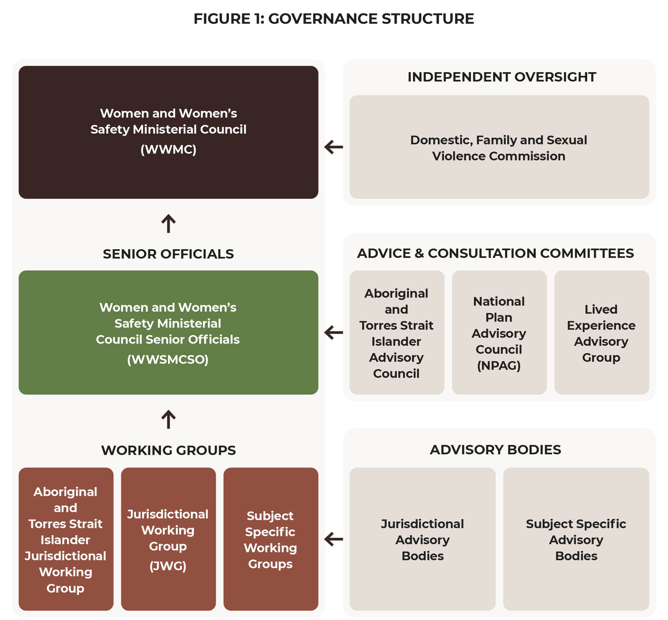

Monitoring and reporting
A performance management framework will identify the indicators required to monitor and assess performance towards the achievement of the outcomes. It will link outcomes, performance indicators, measures and data sources together.
The components of the performance measurement plan include:
- Outcomes – the change the National Plan aims to achieve, which is described in the Outcomes Framework.
- Indicators and measures – the indicators will be chosen with regards to what we are aiming to measure and how best this can be achieved.
- Targets – the objectives the National Plan is working towards, expressed as a measurable value.
- Data sources – what available sources can be used to demonstrate progress against the indicators or measures, noting there is still more work required to develop data sources to robustly measure change.
- Frequency for reporting and/or data collection – how often the indictors and measures are able to be reported against.
- Baseline (if known).
A mixed method approach to measurement and evaluation will be used, in recognition of the complexity of the outcomes. This approach would likely include quantitative trend data supported by more detailed qualitative analysis. Indicators and measures will continue to be reviewed and refined over the life of the National Plan as work continues to improve data and links between datasets.
There is still more to achieve in regard to data and evidence development to robustly measure and monitor sustained population level changes towards ending violence against women and children. A focus over the life of the National Plan, through the underpinning Actions Plans, will be on continuing to support key national survey collections, and identifying opportunities to implement new data collections and data development projects, including from the private sector.

Public reporting
Public reporting will support accountability and transparency. The Department of Social Services will report against the progress of the National Plan on an annual basis.
The First Action Plan Activities Addendum will be updated annually to track implementation of the activities that governments have committed to deliver under each Action in the First Action Plan and to add new activities.
Public reporting will also occur through existing mechanisms, such as through relevant government department’s annual reports and annual Closing the Gap reports.
The DFSV Commission will also provide annual reports to Federal Parliament measuring progress against the National Plan.

Outcomes Framework
The Outcomes Framework interprets the vision of the National Plan. It paves the way, for the next 10 years, to achieving our goal where Australia is a country where all people live free from gender-based violence and are safe in all settings including at home, at work, at school, in the community, and online.
The Outcomes Framework helps link what we do (actions/activities) with what we want to achieve (outcomes). It not only increases our ability to track, monitor, and report change over the life of the National Plan but also guides investment, informs the strategic direction for policy and program design and unifies governments across all jurisdictions through a shared vision and direction for change. It provides a focus for continuous improvement and ensures an interdependent relationship to the National Plan and Action Plans.
The Outcomes Framework, as shown in Figure 4, consists of 5 rotating layers with our goal in the centre. Working from the inside out, the second layer identifies six long-term outcomes drawn from the National Plan. Each segment represents change for individuals, services, systems and institutions and communities. These long-term outcomes are supported by a number of sub-outcomes that assist in mapping incremental change across the short, medium, and long-term through the performance measurement plan (currently under development). This will be the primary mechanism to monitor whether change is occurring, holding us accountable.
The third layer details the diverse population groups within our community as described in the National Plan. It also includes men and boys, as without their engagement, transformational change is not possible.
The fourth layer identifies the reform areas articulated in the Aboriginal and Torres Strait Islander Action Plan Framework. While the outcomes within the Aboriginal and Torres Strait Islander Action Plan align with the overarching Outcomes Framework, the development of the Aboriginal and Torres Strait Islander outcomes have been led by the Aboriginal and Torres Strait Islander Advisory Council and reflects the voices and experiences of Aboriginal and Torres Strait Islander peoples.
The final layer displays the 4 domains of the National Plan. This illustrates how change across the individual, service, system, and community levels applies to all domains. This reinforces that no single long-term outcome applies only to one domain and that effort is required across all domains to achieve our goal.
The structure of the Outcomes Framework is underpinned by an intersectional approach that is embedded throughout. As described in the National Plan, women and children are not a homogenous group. They have many and varied personal identities that lead to overlapping forms of discrimination or disadvantage based on attributes such as age, culture, gender, race, religion, location, income, disability and education. The Outcomes Framework, by simultaneously addressing individual, system, service, and community level change, works to address the multiple inequalities experienced by people within the diverse population groups articulated in the third layer.
Figure 4: National Plan Outcomes Framework - ending gender-based violence in one generation

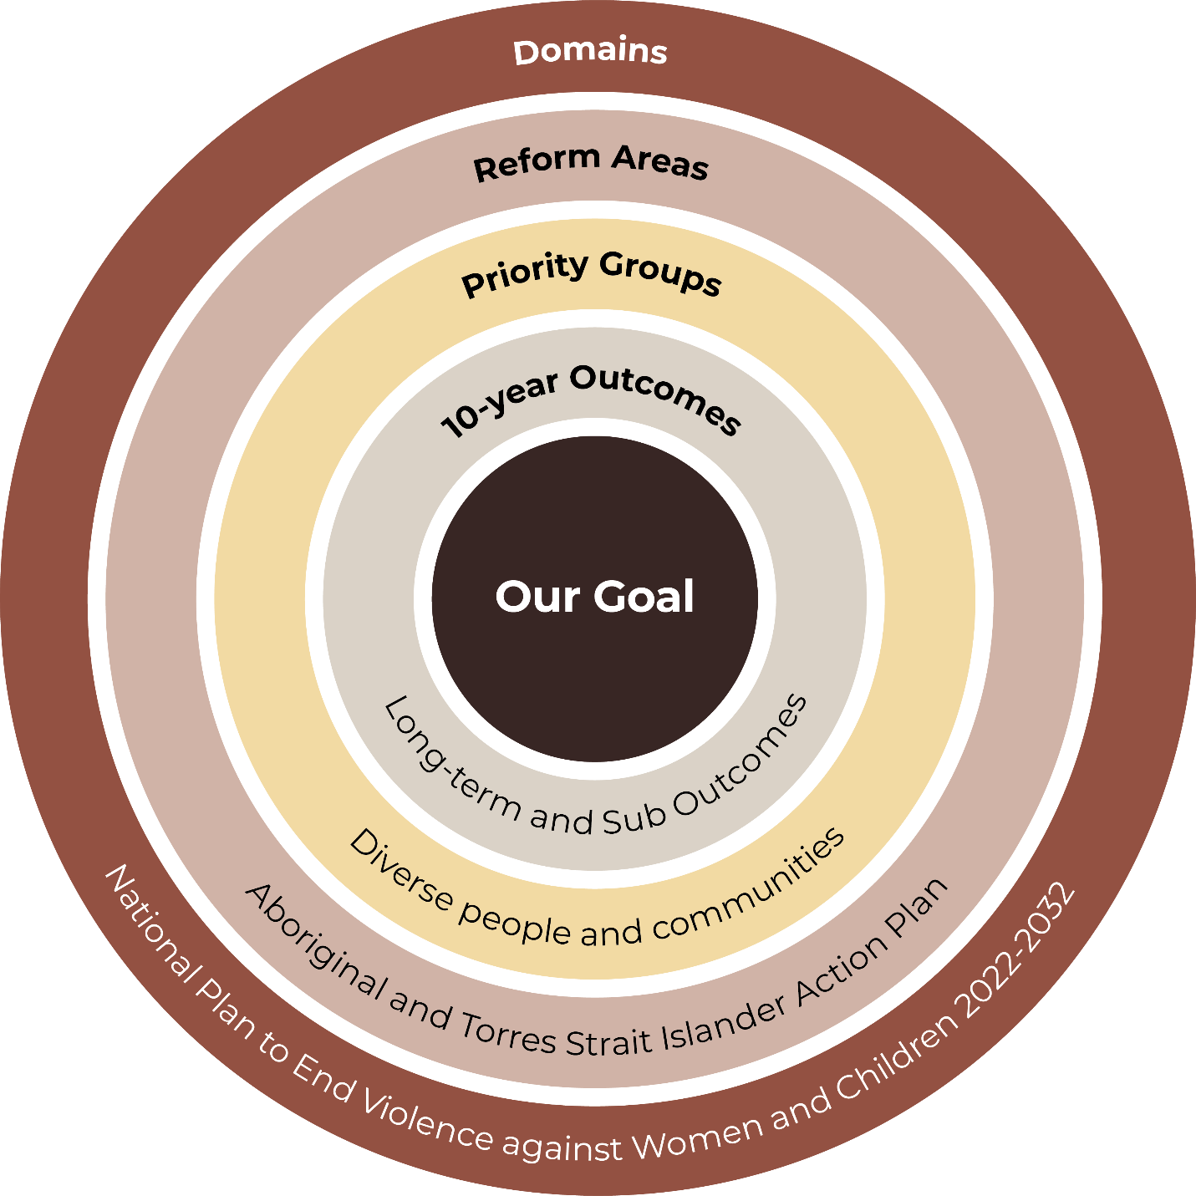

Our Goal
All Australians live free from gender-based violence and are safe in all settings including at home, at work, at school, in the community and online.
10-year Outcomes
- Systems and institutions are effective, safe, trauma informed, integrated, culturally competent and inclusive in how they support people and hold perpetrators to account
- Family and Domestic Violence Services and programs are effective, culturally competent and accessible; providing holistic, integrated and tailored responses
- Community attitudes and beliefs embrace gender equality and condemn all forms of gendered violence without exception
- People who choose to use violence are accountable for their actions and stop their violent, coercive and abusive behaviours
- Children and young people are safe in all settings and are effectively supported by systems and services
- Women are safe and experience economic, political, cultural and social equality
Priority Groups
- Culturally diverse, migrant and refugee women & children
- Children & young people
- Rural & remote women & children
- LGBTQIA+ people
- Aboriginal and Torres Strait Islander women & children
- Older women
- People with disability
- Men and boys
Reform Areas
- Voice, self-determination and agency
- Strength, resilience and therapeutic healing
- Reform institutions and systems
- Inclusion and intersectionality
- Evidence and data eco-systems – understanding our stories
Domains
- Prevention
- Early Intervention
- Response
- Recovery and Healing

Appendix A: State Support Services
Australian Capital Territory
Support Service | Contact Details
Domestic Violence Crisis Service. Available 24/7 | 02 6280 0900  Domestic Violence Crisis Service
Australian Capital Territory and New South Wales
Support Service | Contact Details
Aboriginal Legal Service (NSW/ACT) | 1800 765 767 for police charges and court matters  1800 733 233 for care and protection and family matters  Aboriginal Legal Service
New South Wales
Support Service | Contact Details
Thiyama-li Family Violence Service Inc. NSW NT Sexual Assault and Referral Centre | 02 6752 1188  Thiyama-li Family Violence Service
Warra-Warra Family Violence Prevention Legal Service (Broken Hill) | 08 8087 6766  Warra-Warra Family Violence Prevention Legal Service
Many Rivers Family Violence Prevention Legal Service (Kempsey) | 02 6562 5856  Many Rivers Family Violence Prevention Legal Service
Binaal Billa Family Violence Prevention Legal Service (Forbes) | 1800 700 218  Binaal Billa Family Violence Prevention Legal Service
NSW Sexual Violence Helpline. Available 24/7 | 1800 424 017  Fullstop
NSW Health Sexual Assault Services | 1800 656 643  Domestic Violence NSW  NSW Health Sexual Assault Services
Women’s Domestic Violence Court Advocacy Service (WDVCAS) | 1800 938 227  Women’s Domestic Violence Court Advocacy Service
Northern Territory
Support Service | Contact Details
Ngaanyatjarra Pitjantjatjara Yankunytjatjara Women’s Council Domestic and Family Violence Service (Alice Springs, NPY Tri-state Region) | 1800 180 840  NPY Women’s Council
Central Australian Aboriginal Family Legal Unit (Alice Springs HO, Tennant Creek) | 1800 088 884  Central Australian Aboriginal Family Legal Unit
North Australian Aboriginal Family Legal Service (Darwin, Katherine) | (Darwin): 08 8923 8200  (Katherine): 08 8972 3200  North Australian Aboriginal Family Legal Service
Darwin Aboriginal and Torres Strait Islander Women’s Shelter and Outreach (Darwin) | 08 8945 2284
Darwin Indigenous Men’s Service (Darwin) | 08 8947 7188  Darwin Indigenous Men’s Service
Tangentyere Council Aboriginal Corporation (Alice Springs) | 08 8952 1430  Tangentyere Council Aboriginal Corporation
Sexual Assault and Referral Centre (Darwin, Katherine, Tennant Creek, Alice Springs) | Darwin: 08 8922 6472  Alice Springs: 08 8955 4500  Katherine: 08 8973 8524  Tennant Creek: 08 8962 4361
See website for services in your area. | NT Domestic, family and sexual violence supports

Queensland
Support Service | Contact Details
Queensland Indigenous Family Violence Legal Service (Cairns HO, Townsville, Rockhampton, Mount Isa, Brisbane) | 07 4045 7500  Queensland Indigenous Family Violence Legal Service
Aboriginal Family Legal Service Southern Queensland (Roma) | 1800 185 950  Aboriginal Family Legal Service Southern Queensland
DVConnect provides the Queensland-wide domestic and family violence helplines, Womensline and Mensline. Available 24/7 | Womensline: 1800 811 811  Mensline: 1800 600 636  DV Connect
Queensland Elder Abuse Helpline | 1300 651 192  Elder Abuse Prevention Unit
South Australia
Support Service | Contact Details
Family Violence Legal Service Aboriginal Corporation (Port Augusta HO, Ceduna, Pt Lincoln) | 1800 111 052  Family Violence Legal Service Aboriginal Corporation
Domestic Violence Crisis Line | 1800 800 098  SA Domestic family violence and sexual assault support services
Tasmania
Support Service | Contact Details
Tasmanian Aboriginal Legal Services (TALS) | 1800 595 162  Tasmanian Aboriginal Legal Services
Support Information + Strength (SiS), a program of TALS | 1800 747 827  Support Information and Strength, Tasmania
Family Violence Counselling and Support Service  9am–Midnight (Monday to Friday)  4pm–Midnight (Weekends & Public Holidays) | 1800 608 122  Family Violence Counselling and Support Service Tasmania
Victoria
Support Service | Contact Details
Djirra is a state-wide service with office locations in: Melbourne HO, Mildura, Gippsland, Barwon South West and Melton | 1800 105 303  Djirra
Safe Steps Family Violence Response Centre. Available 24/7 | 1800 015 188  Safe Steps Family Violence Response Centre
1800 Options  Information service for sexual and reproductive health  Available Mondays–Fridays 10am–4pm | 1800 696 784  1800 options
Western Australia
Support Service | Contact Details
Aboriginal Family Legal Services | (08) 9355 1502  Aboriginal Family Legal Services
Marninwarntikura Family Violence Prevention Unit | (08) 9191 5284  Marninwarntikura Family Violence Prevention Unit
Southern Aboriginal Corporation | (08) 9842 7777  Southern Aboriginal Corporation
See website for services in your area. | WA Family and Domestic Violence Support and Advice

Appendix B: Glossary of Terms
Term | Definition
Aboriginal and Torres Strait Islander community-controlled organisation | Under the National Agreement on Closing the Gap, an Aboriginal and/or Torres Strait Islander community-controlled organisation delivers services, including land and resource management, that build the strength and empowerment of Aboriginal and Torres Strait Islander communities and peoples and is:  - incorporated under relevant legislation and not-for-profit  - controlled and operated by Aboriginal and/or Torres Strait Islander peoples  - connected to the community, or communities, in which they deliver the services  - governed by a majority Aboriginal and/or Torres Strait Islander governing body.
Brotherboy | A term used by Aboriginal and Torres Strait Islander peoples to describe gender diverse people who have a male spirit and take on male roles within  the community.
Cis-gender | A term used to describe people who identify their gender as the same as what was presumed for them at birth (male or female). ‘Cis’ is a Latin term meaning ‘on the same side as’.
Cis-normativity | The assumption that everyone is cis-gender and that all people will continue to identify with the gender they were assigned at birth. Cis-normativity erases the existence of trans people.
Coercive control | Coercive control is almost always an underpinning dynamic of family and domestic violence and describes someone’s exertion of power and dominance against another person, using patterns of abusive behaviours over time, with the effect of creating fear and denying liberty and autonomy.  Abusive behaviours that perpetrators can use as part of their pattern of abuse include physical abuse, monitoring a victim-survivor’s actions, restricting a victim-survivor’s freedom or independence, regulating and micromanaging victim-survivor actions, social abuse, using threats and intimidation, emotional or psychological abuse, cultural, spiritual and religious abuse, financial abuse, sexual violence and coercion, reproductive coercion, lateral violence, systems abuse, technology-facilitated abuse and animal abuse. Understanding coercive control requires a shift from a focus on physical violence and single or episodic acts of violence in isolation to a consideration of patterns of abusive behaviour and their cumulative impact.
Cultural safety | Cultural safety is about overcoming the power imbalances of places, people and policies that occur between the majority non-Indigenous position and the minority Aboriginal and Torres Strait Islander person so that there is no assault, challenge or denial of the Aboriginal and Torres Strait Islander person’s identity, who they are and what they need. Cultural safety is met through actions from the majority position that recognise, respect, and nurture the unique cultural identity of Aboriginal and Torres Strait Islander peoples. Only the Aboriginal and Torres Strait Islander person who is recipient of a service or interaction can determine whether it is culturally safe.
Elder | For Aboriginal and Torres Strait Islander peoples, Elders are recognised community representatives and custodians of culture, history, the Dreaming and storylines.
Evidence-based | Models, approaches or practices found to be effective through evaluation or peer-reviewed research. Evidence is usually published and may be found in full or summarised in academic research documents, organisational reports, program evaluations, policy papers and submissions.
Family | The use of the term ‘family’ acknowledges the variety of relationships and structures that can make up family units and kinship networks. It can include current or former partners, children (including adolescent or adult children), siblings, parents, grandparents, extended family and kinship networks and carers.
Family violence | The range of violence that takes place in Indigenous communities, across extended families, kinship networks, and broader relationships.
Gender | Refers to the economic, social, political, and cultural attributes and opportunities associated with being women and men. The social definitions of what it means to be a woman or a man vary among cultures and change over time. Gender is a sociocultural expression of particular characteristics and roles that are associated with certain groups of people with reference to their sex and sexuality. Rigid gender roles leave no space for acknowledgement or celebration of gender diversity.
Gendered drivers of violence | The underlying causes that are required to create the necessary conditions in which violence against women, children and LGBTIQA+ people occur. They relate to the particular structures, norms and practices arising from gender inequality in public and private life, but which must always be considered in the context of other forms of social discrimination and disadvantage.
Gender equality | The equal distribution of rights, opportunities and responsibilities between people of different genders. Gender equality does not mean erasing gender differences, but that people’s rights, responsibilities and opportunities are not dependent on their gender.
Gender norms | A set of dominant beliefs and rules of conduct that are learned and reinforced by a social group, and that determine the types of roles, interests, behaviours and contributions expected from boys and girls, men and women. Norms are not neutral in their effect, but rather create and maintain unequal relations of power.
Healing | Healing enables Aboriginal and Torres Strait Islander peoples to overcome trauma and restore wellbeing. It is a holistic process that addresses mental, physical, emotional and spiritual needs. Effective ways to support healing include reconnecting with culture, strengthening identity, restoring safe and enduring relationships, supporting communities to understand the impacts of their experiences on behaviour, and supporting communities to create and lead change. For Stolen Generations, healing also means keeping children safe with family, and addressing the rates of out-of-home care and juvenile detention.
Healing-informed | Refers to care principles that are strengths-based and specific to cultures and communities. The common ground that underlies these principles are found in the Indigenous worldview, ways of knowing, and cultural practices. Healing-informed care principles for Aboriginal and Torres Strait Islander peoples and communities are tied to holistic views of health, connection to kinship and Country, and should address the sociocultural determinants of health.
Heteronormativity | Refers to a general perspective that sees heterosexual experiences as the only, or central, view of the world, and assumes a linear relationship between sex, gender and sexuality (for example, that all men are heterosexual and cisgendered). This includes the unquestioned assumption that all people fall into one of two distinct and complementary genders (man and woman), which corresponds to their sex assigned at birth. It also assumes that heterosexual is the only ‘normal’ sexual orientation, and that sexual and marital relations are only appropriate between a man and a woman.
Homophobia | Refers to the fear and hatred of lesbians and gay men and of their sexual desires and practices that often leads to discriminatory behaviour or abuse.
Image-based abuse | When an intimate image or video is shared, or threatened to be shared, without the consent of the person shown. This includes images or videos that have been digitally altered.
Intergenerational trauma | A form of historical trauma transmitted across generations. Survivors of the initial experience who have not healed may pass on their trauma to further generations. In Australia, intergenerational trauma particularly affects Aboriginal and Torres Strait Islander peoples, especially the children, grandchildren and future generations of the Stolen Generations.
Intersectional approach | In the context of addressing violence against women and children, an intersectional approach recognises that the way women experience gender and inequality can be different based on a range of other cultural, individual, historical, environmental or structural factors including (but not limited to) race, age, geographic location, sexual orientation, ability or class. This approach also recognises that the drivers, dynamics and impacts of violence women experience can be compounded and magnified by their experience of other forms of oppression and inequality, resulting in some groups of women experiencing higher rates and/or more severe forms of violence, or facing barriers to support and safety that other women do not experience.
Justice Policy Partnership | The Justice Policy Partnership brings together representatives from the Coalition of Peaks, Aboriginal and Torres Strait Islander experts, and Australian, state and territory governments to take a joined-up approach to Aboriginal and Torres Strait Islander justice policy.  It is the first of 5 policy partnerships to be established under Priority Reform One of the National Agreement on Closing the Gap.
Mainstream sector/services | Organisations that deliver services to all Australians, including Aboriginal and Torres Strait Islander peoples.
LGBTIQA+ | An acronym used to describe members of the lesbian, gay, bisexual, trans, intersex, queer and asexual community. Other acronyms used to describe this community include LGBTIQ, or LGBTIQ+.
National Agreement on Closing the Gap | The National Agreement on Closing the Gap was developed in formal partnership between all Australian governments and the Coalition of Aboriginal and Torres Strait Islander Peak Organisations. There are 4 Priority Reforms and 19 socio-economic targets across 17 socio-economic outcome areas.  The objective of the National Agreement on Closing the Gap is to enable Aboriginal and Torres Strait Islander peoples and governments to work together to overcome the inequality experienced by Aboriginal and Torres Strait Islander peoples, and achieve life outcomes equal to all Australians.
Perpetrator | People who use family and domestic violence or commit sexual violence. This term is used regardless of whether the person has ever been arrested, charged with a crime, or had an intervention order issued against them.
Personal safety survey | Refers to the survey conducted by the Australian Bureau of Statistics collecting information from men and women aged 18 years and over about the nature and extent of violence experienced since the age of 15.
Respectful relationships | Refers to relationships among intimate, romantic, or dating partners that are characterised by non-violence, equality, mutual respect, consideration and trust.
Self-determination | Self-determination is concerned with the fundamental right of people to shape their own lives. In a practical sense, self-determination means that Aboriginal and Torres Strait Islander peoples have the freedom to live well, and to determine what it means to live well according to their own values and beliefs.  Specifically, self-determination means that Aboriginal and Torres Strait Islander peoples:  - have choice in determining how their lives are governed and their development paths  - participate in decisions that affect their lives  - have control over their lives and future including their economic, social and cultural development.
Sexism | Discrimination based on gender, and the attitudes, stereotypes and cultural elements that promote this discrimination.
Sexual assault | Sexual assault is an act of a sexual nature carried out against a person’s will through the use of physical force, intimidation or coercion, including any attempts to do this. This includes rape, attempted rape, aggravated sexual assault (assault with a weapon), indecent assault, penetration by objects, forced sexual activity that did not end in penetration and attempts to force a person into sexual activity. Note sexual assault occurs when a person is forced, coerced or tricked into sexual acts against their will or without their consent, including when they have withdrawn their consent.
Sexual harassment | An unwelcome sexual advance or request for sexual favours, or other unwelcome conduct of a sexual nature, which makes a person feel offended, humiliated and/or intimidated, where it is reasonable to expect that there is a possibility that the person being harassed would be offended, humiliated or intimidated by the behaviour.
Sexuality | Refers to the component of identity that includes a person’s sexual and emotional attraction to another person. A person may be attracted to men, women, both, neither, and/or to people who are non-binary, or have other gender identities.
Sistergirl | A term used by Aboriginal and Torres Strait Islander peoples to describe gender diverse people who have a female spirit and take on female roles within the community.
Structural inequality | A term that describes the power imbalances embedded in institutions and systems, especially where institutions carry unequal and unjust historical legacies. In the Australian context, racialised structural inequality has created a situation where social, economic and political privilege, power, resources and opportunities are concentrated with non-Indigenous people.
Technology-facilitated abuse | A wide-ranging term that encompasses abuse that occurs across any internet-enabled platform or device. The types of technology-facilitated abuse are wide-ranging and encompass harassment, monitoring and stalking, impersonation, and threats and punishment, including image-based abuse.
Trauma | Trauma occurs when someone’s ability to cope is overwhelmed. It can have a significant effect on someone’s physical, emotional and psychological wellbeing. The impacts of trauma, whether resolved or acknowledged, may surface at any time, particularly when victim-survivors tell or repeat their experiences, or when they encounter similar experiences that are shared by others.  Trauma looks different for people depending on their experience of trauma and other factors such as exposure to previous traumatic events, access to support and mental health status.
Trauma-informed | Trauma-informed care and practice recognises the prevalence of trauma and its impacts on the emotional, psychological and social wellbeing of people and communities.  Trauma-informed practice means integrating an understanding of past and current experiences of violence and trauma in all aspects of service delivery. The goal of trauma-informed systems is to avoid re-traumatising individuals and support safety, choice and control to promote healing.
Victim-survivor | People who have experienced family and domestic violence or gender-based violence. This term is understood to acknowledge the strength and resilience shown by people who have experienced or are currently living with violence. People who have experienced violence have different preferences about how they would like to be identified and may choose to use ‘victim’ or ‘survivor’ separately, or another term altogether. Some people prefer to use ‘people who experience, or are at risk of experiencing, violence’.

Appendix C: References

K Usher, D Jackson, R Walker, J Durkin, R Smallwood, M Robinson, UN Sampson, I Adams, CPorter, and R Marriott, ‘Indigenous resilience in Australia: A scoping review using a reflective decolonizing collective dialogue’, Frontiers in Public Health, 9, 2021, doi.org/10.3389/fpubh.2021.630601.
Yoorrook Justice Commission (2023) Yoorrook Justice Commission, [website] Home, n.d., accessed 10 January 2023.
Australian Institute of Health and Welfare (2022) Family, domestic and sexual violence data in Australia, AIHW, Australian Government, accessed 1 July 2023.
A Moreton-Robinson, ‘Towards an Australian Indigenous Women’s Standpoint Theory’, Australian Feminist Studies, 2014, 28(78):331–347, doi:10.1080/08164649.2013.876664.
M Langton, K Smith, T Eastman, L O'Neill, E Cheesman, and M Rose ‘Improving family violence legal and support services for Aboriginal and Torres Strait Islander women’, ANROWS, 2020, accessed 10 July 2023.
National Inquiry into Missing and Murdered Indigenous Women and Girls (Canada). Reclaiming Power and Place: The Final Report of the National Inquiry into Missing and Murdered Indigenous Women and Girls, 2019, accessed 1 July 2023.
Filev, A., Pedersen, J., Oscar, J., Hunter, K., & Spry, S. (2022). Wiyi Yani U Thangani (Women's voices): First Nations Women’s Safety Policy Forum Outcomes Report November 2022. Australian Human Rights Commission, accessed 1 July 2023.
K Cripps and H McGlade, ‘Indigenous family violence and sexual abuse: Considering pathways forward’, Journal of Family Studies, 2008, 14(2-3):240–253, doi:10.5172/jfs.327.14.2-3.240; Our Watch, Changing the picture, Background paper: Understanding violence against Aboriginal and Torres Strait Islander women, Our Watch, 2018, accessed 17 January 2023.
Australian Institute of Health and Welfare (2022) Family, domestic and sexual violence data in Australia, AIHW, Australian Government, accessed 1 July 2023.
Australian Institute of Health and Welfare (2018) Family, domestic and sexual violence in Australia, 2018, AIHW, Australian Government, accessed 1 July 2023. doi:10.25816/5ebcc144fa7e6.
Bricknell S 2023. Homicide in Australia 2020–21. Statistical Report no. 42. Canberra: Australian Institute of Criminology. doi.org/10.52922/sr78979.
McGlade, Hannah, and Stella Tarrant. ‘Say her name: Naming Aboriginal women in the justice system’." Mapping Deathscapes. Routledge, 2021. 106-126.
Blagg, H., Williams, E., Cummings, E., Hovane, V., Torres, M., & Woodley, K. N. (2018). Innovative models in addressing violence against Indigenous women: Final report, ANROWS, 2018, accessed 10 January 2023.
Australian Bureau of Statistics (ABS), ‘Aboriginal and Torres Strait Islander women’s experiences of family and domestic violence’, National Aboriginal and Torres Strait Islander Social Survey, 2014-15, ABS, Australian Government, 2019, accessed 27 January 2023.
M Langton, K Smith, T Eastman, L O’Neill, E Cheesman and M Rose, ‘Improving family violence legal and support services for Aboriginal and Torres Strait Islander women’, Research report 25/2020, ANROWS, 2020, accessed 1 July 2023.
Our Watch, Challenging misconceptions about violence against Aboriginal and Torres Strait Islander women, Our Watch website, n.d., accessed 26 May 2023.
Australian Institute of Health and Welfare (2022) Family, domestic and sexual violence data in Australia, AIHW, Australian Government, accessed 1 July 2023.
Australian Institute of Health and Welfare (2022) Family, domestic and sexual violence data in Australia, AIHW, Australian Government, accessed 1 July 2023.
eSafety Commissioner, Cool, beautiful, strange and scary: The online experiences of Aboriginal and Torres Strait Islander children and their parents and caregivers, eSafety Commissioner, Australian Government, 2022, accessed 19 May 2023.
Australia Bureau of Statistics (ABS), Aboriginal and Torres Strait Islander women’s experiences of family and domestic violence, accessed 11 May 2023.
Based off data from NSW, QLD, SA and the NT.
Australia Bureau of Statistics (ABS), Recorded Crime - Victims, 2021, ABS website, 28 July 2022, accessed 26 May 2023.
Australia Bureau of Statistics (ABS), Disability and Violence - In Focus: Crime and Justice Statistics, ABS website, 13 April 2021, accessed 26 May 2023.
J Atkinson, Trauma Trails, Recreating Song Lines: The Transgenerational Effects of Trauma in Indigenous Australia, Spinifex Press, Melbourne, 2002.
United Nations Human Rights (UNHR), General recommendation No.39 (2022) on the rights of Indigeneous women and Girls, UNHR website, 26 October 2022, accessed 10 July 2023.
World Health Organisation (WHO), Violence against women, WHO website, 9 March 2021, accessed 26 May 2023; Australian Institute of Health and Welfare (2018) Family, domestic and sexual violence in Australia, 2018, AIHW, Australian Government, accessed 1 July 2023. doi:10.25816/5ebcc144fa7e6.
Australian Institute of Health and Welfare (2018) Family, domestic and sexual violence in Australia, 2018, AIHW, Australian Government, accessed 1 July 2023. doi:10.25816/5ebcc144fa7e6.
K Cripps (2023) Indigenous domestic and family violence, mental health and suicide, AIHW, accessed 6 July 2023.
H McGlade Our greatest challenge: Aboriginal children and human rights. Aboriginal Studies Press. Canberra, 2012.
Anderson et al., Bringing Them Home 20 years on: an action plan for healing; K Cripps and M Davis, Communities working to reduce Indigenous family violence, Indigenous Justice Clearinghouse, 2012, accessed 17 January 2023.
T Gillum, ‘The intersection of intimate partner violence and poverty in Black communities’, Aggression and violent behavior, 2019, 46:37–44. doi: 10.1016/j.avb.2019.01.008.
M Langton, K Smith, T Eastman, L O'Neill, E Cheesman, and M Rose. ‘Improving family violence legal and support services for Aboriginal and Torres Strait Islander women’, ANROWS, 2020, accessed 10 July 2023.
K Cripps, and H McGlade, ‘Indigenous family violence and sexual abuse: Considering pathways forward’, Journal of Family Studies, 2008, 14(2-3):240–253, doi:10.5172/jfs.327.14.2-3.240; Our Watch, Changing the picture, Background paper: Understanding violence against Aboriginal and Torres Strait Islander women, Our Watch, 2018, accessed 17 January 2023.
Lowitja Institute. ‘The first response project: Trauma and culturally informed approaches to primary health care for women who experience violence’. Summary Report (May), (2019); Cullen, Patricia, et al. ‘Integrating trauma and violence informed care in primary health care settings for First Nations women experiencing violence: a systematic review.’ Trauma, Violence, & Abuse 23.4 (2022): 1204–1219.
AIHW, Specialist homelessness services annual report 2021–22, AIHW, Australian Government, 2022, accessed 26 May 2023.
Australia Bureau of Statistics (ABS), Aboriginal and Torres Strait Islander women’s experiences of family and domestic violence, accessed 11 May 2023.
M Langton., K Smith., T Eastman., L O'Neill., E Cheesman., & M Rose. ‘Improving family violence legal and support services for Aboriginal and Torres Strait Islander women’, ANROWS, 2020, accessed 10 July 2023.
R Cant, M O’Donnell, S Sims and M Harries, ‘Overcrowded housing: One of a constellation of vulnerabilities for child sexual abuse’, Child abuse & neglect, 2019, 93:239–248; G Morris, R Groom, E Schuberg, S Dowden-Parker, M Ungunmerr-Baumann, A McTaggart and B Carlson, ‘I want to video it, so people will respect me’: Nauiyu community, digital platforms and trauma, Media International Australia, 183(1):139–157, doi.org/10.1177/1329878X211038005; S Rayment-McHugh, ‘The uneven distribution of child sexual abuse’, in I Bryce and W Petherick (eds), Child Sexual Abuse: Forensic Issues in Evidence, Impact, and Management, Academic Press, 2020, pp 375–390.
K Cripps and D Habibis ‘Another stolen generation looms unless Indigenous women fleeing violence can find safe housing’, The Conversation, 20 September 2019,
AIHW, Child protection Australia 2019–20, AIHW, Australian Government, 2021, accessed 26 May 2023.
Productivity Commission, Overcoming Indigenous Advantage: Key Indicators 2016, report to the Steering Committee for the Review of Government Service Provision, Productivity Commission, Australian Government, 2016, cited in Our Watch, Changing the picture, Background paper, p 74, accessed 17 January 2023.
Office of the United Nations High Commissioner for Human Rights (OHCHR), Climate change exacerbates violence against women and girls, OHCHR website, 12 July 2022, accessed 30 May 2023.
H Blagg, T Tulich, V Hovane, D Raye, T Worrigal and S May, Understanding the role of Law and Culture in Aboriginal and Torres Strait Islander communities in responding to and preventing family violence, Research report 19/2020, ANROWS, 2020.
B Carlson and R Frazer, Social Media Mob: Being Indigenous Online, Macquarie University, Sydney, 2018.
B Carlson and R Frazer, Social Media Mob: Being Indigenous Online, Macquarie University, Sydney, 2018.
C Brown, M Yap, A Thomassin, M Murray and E Yu, “Can I just share my story?” Experiences of technology-facilitated abuse among Aboriginal and Torres Strait Islander women in regional and remote Australia’, Journal of Global Indigeneity, 2021, 5(2); B Carlson and R Frazer, Indigenous Digital Life: The Practice and Politics of Being Indigenous on Social Media, Palgrave Macmillan, Basingstoke, 2021; B Carlson and M Day, ‘Love, hate and sovereign bodies: The exigencies of Aboriginal online dating’, in A Powell, A Flynn and L Sugiura (eds), The Palgrave Handbook of Gendered Violence and Technology, Palgrave Macmillan, 2021, pp 181–201.
G Morris, R Groom, E Schuberg, S Dowden-Parker, M Ungunmerr-Baumann, A McTaggart and B Carlson, ‘I want to video it, so people will respect me’: Nauiyu community, digital platforms and trauma, Media International Australia, 183(1):139–157, doi.org/10.1177/1329878X211038005.
Gendered Violence Research Network, Understanding Economic and Financial Abuse in First Nations Communities, UNSW Sydney, 2021, accessed 17 January 2023.
ABS, ‘Aboriginal and Torres Strait Islander women’s experiences of family and domestic violence’, accessed 11 May 2023.
AIHW, Screening for domestic violence during pregnancy: options for future reporting in the National Perinatal Data Collection, AIHW, Australian Government, 2015, accessed 26 May 2023.
M Campo, Children’s exposure to domestic and family violence: Key issues and responses, CFCA Paper No. 36, Child Family Community Australia Information Exchange, Australian Institute of Family Studies, 2015, accessed 16 February 2017.
eSafety Commissioner, Cool, beautiful, strange and scary: The online experiences of Aboriginal and Torres Strait Islander children and their parents and caregivers.
G Morgan, C Butler, R French, R Creamer, L Hillan, E Ruggiero, J Parsons, G Prior, L Idagi, R Bruce, T Gray, T Jia, M Hostalek, J Gibson, B Mitchell, T Lea, K Clancy, U Barber, D Higgins, A Cahill and S Trew, New Ways for Our Families: Designing an Aboriginal and Torres Strait Islander cultural practice framework and system responses to address the impacts of domestic and family violence on children and young people, Research report 06/2022, ANROWS, 2022, accessed 1 July 2023
J Miller, and E Berger, (2022). ‘Supporting First Nations students with a trauma background in schools’’ School mental health, 14(3), 485-497.
S Avery, Culture Is Inclusion: A Narrative of Aboriginal and Torres Strait Islander People with Disability, First Peoples Disability Network Australia, Sydney, 2018.
AIHW, People with disability in Australia 2022, AIHW, Australian Government, 2022, accessed 16 February 2023.
AIHW, People with disability in Australia 2022, AIHW, Australian Government, 2022, accessed 16 February 2023.
D Griffis, ‘Disability in Indigenous communities; addressing the disadvantage’, ABC Ramp Up, 20 April 2012, accessed 16 February 2023.
Our Watch, Change the story: A shared framework for the primary prevention of violence against women in Australia, 2nd edition, Our Watch, 2021, accessed 16 February 2023.
M Day, B Carlson, D Bonson, and T Farrelly Aboriginal & Torres Strait Islander LGBTQIASB+ people and mental health and wellbeing, AIHW, accessed 6 July 2023.
AIHW, New reports spotlight hospitalisations due to family, domestic and sexual violence and service responses in the time of COVID-19 [media release], AIHW, 16 December 2021, accessed 26 May 2023.
M Adams, Working towards changing the negative image of Aboriginal and Torres Strait Islander males, Grey paper, Proceedings, Victims of Crime Conference, Darwin, 2006, cited in M Adams, G Bani, H Blagg, J Bullman, D Higgins, B Hodges, V Hovane, M Martin-Pederson, A Porter, G Sarra, A Thorpe and M Wenitong, Towards an Aboriginal and Torres Strait Islander violence prevention framework for men and boys, The Healing Foundation and White Ribbon Australia, 2017.
B Carlson, M Day, and T Farrelly, (2021). What works? Exploring the literature on Aboriginal and Torres Strait Islander healing programs that respond to family violence. ANROWS, 2020, accessed 6 May 2023.
Australian Government, National Agreement on Closing the Gap, Australian Government, 2020. accessed 14 June 2023.
ACON, Trans mob, TransHub website, ACON, 2021. accessed 14 June 2023.
ACON, Language, TransHub website, ACON, 2021, accessed 14 June 2023.
Australian Institute of Family Studies (AIFS), LGBTIQA+ glossary of common terms, Resource Sheet, AIFS, 2022.
Department of Communities and Justice, Coercive control - Discussion paper, DCJ, NSW Government, 2020.
Australian Government, National Agreement on Closing the Gap, Australian Government, 2020, accessed 14 June 2023.
SA Health, Elder abuse and people from an Aboriginal background, SA Health, Government of South Australia, 2021, accessed 14 June 2023.
Our Watch and Universities Australia, Educating for equality: Glossary of key terms and definitions, Our Watch, 2021.
John Hopkins University Affilate (jhpiego), Gender concepts and definitions, jhpiego Website, 2020, accessed 14 June 2023.
Domestic Violence Resource Centre Victoria (DVRCV), Key terms in the prevention of violence against women, Partners in Prevention, Victoria State Government and DVRCV, 2019, accessed 15 June 2023.
DVRCV, Key terms in the prevention of violence against women, Partners in Prevention, Victoria State Government and DVRCV, 2019, accessed 15 June 2023.
Our Watch and Universities Australia, Educating for equality: Glossary of key terms and definitions, Our Watch website, n.d., accessed 6 June 2023.
The Healing Foundation, Make Healing Happen – It’s Time to Act, The Healing Foundation, 2021, accessed 14 June 2023; The Healing Foundation, Community Healing, The Healing Foundation website, 2023, accessed 14 June 2023.
The Healing Foundation, The Healing Foundation – Annual Report 2020–2021, The Healing Foundation, 2021, accessed 18 May 2023; The Healing Foundation, Healing Strategies, The Healing Foundation website, 2023, accessed 18 May 2023; AIHW and NIAA, 1.18 Social and Emotional Wellbeing, Aboriginal and Torres Strait Islander Health Performance Framework website, AIHW and NIAA, 2023, accessed 18 May 2023.
Our Watch and Universities Australia, Educating for equality: Glossary of key terms and definitions, Our Watch website, n.d., accessed 6 June 2023.
L Hillier, T Jones, M Monagle, N Overton, L Gahan, J Blackman, and A Mitchell, Writing themselves in 3: The third national study on the sexual health and well- being of same sex attracted and gender questioning young people, Australian Research Centre in Sex, Health and Society, La Trobe University, 2010, accessed 14 June 2023.
eSafety, Image-based abuse, eSafety website, n.d., accessed 14 June 2023.
The Healing Foundation, Intergenerational trauma, The Healing Foundation website, 2022, accessed 14 June 2023.
DVRCV, Key terms in the prevention of violence against women, Partners in Prevention, Victoria State Government and DVRCV, 2019, accessed 15 June 2023.
Attorney-General’s Department, Justice Policy Partnership, AGD website, n.d., accessed 15 June 2023.
Our Watch and Universities Australia, Educating for equality: Glossary of key terms and definitions, Our Watch website, n.d., accessed 6 June 2023.
Australian Government, National Agreement on Closing the Gap, Australian Government, 2020, accessed 14 June 2023.
Our Watch and Universities Australia, Educating for equality: Glossary of key terms and definitions, Our Watch website, n.d., accessed 6 June 2023.
ABS, Personal Safety, Australia methodology, ABS website, 8 November 2017, accessed 15 June 2023.
Our Watch and Universities Australia, Educating for equality: Glossary of key terms and definitions. Our Watch website, n.d., accessed 6 June 2023.
Australian Human Rights Commission, Self-determination, AHRC website, n.d., accessed 15 June 2023.
Our Watch and Universities Australia, Educating for equality: Glossary of key terms and definitions, Our Watch website, n.d., accessed 6 June 2023.
AHRC, Set the standard: Report on the Independent Review into Commonwealth Parliamentary Workplaces, AHRC, Australian Government, 2021, accessed 15 June 2023.
Fair Work Ombudsman, Sexual harassment in the workplace, Fair Work Ombudsman website, n.d., accessed 15 June 2023.
ACON, Trans mob, TransHub website, ACON, 2021. accessed 14 June 2023.
S Morris, R Murphy and W Partlett, ‘Australia’s Constitutional Answer to Structural Racism’, Pursuit, University of Melbourne, 28 June 2020, accessed 15 June 2023; Our Watch, Changing the picture, Background paper: Understanding violence against Aboriginal and Torres Strait Islander women, Our Watch, 2018, accessed 17 January 2023.
Our Watch and Universities Australia, Educating for equality: Glossary of key terms and definitions, Our Watch website, n.d., accessed 6 June 2023.
AHRC and Full Stop Australia, Support and self-care guide: Trauma informed guidance to accompany the release of Set the standard: Report on the Independent Review into Commonwealth Parliamentary Workplaces, AHRC website, Australian Government, 2021, accessed 1 July 2023.
Centre of Excellence for Women’s Health (CEWH), Trauma Informed Practice Principles in Action: Reflective Questions, CEWH, n.d., accessed 15 June 2023.
Our Watch and Universities Australia, Educating for equality: Glossary of key terms and definitions, Our Watch website, n.d., accessed 6 June 2023.

