CURTIN DEMENTIA VILLAGE PROJECT
LISTENING Report on What We Heard

The ACT Government has committed to enabling a new best practice residential care development with a focus on accommodating residents with a diagnosis of dementia. To achieve this, the Suburban Land Agency (SLA) intends to release Block 14 Section 99 Curtin (the Site) through a competitive tender process in 2023-2024 for development as dementia care residences and associated amenities.
The intent is for the new development to offer a best practice, ‘village-style’ model of care, with potential for complementary shared community uses that contribute to an inclusive community hub for residents, their families and visitors.
Before releasing the site, SLA has been engaging with the local Curtin community, people with lived experience of dementia and with dementia care experts on the requirements for the development, including design objectives and potential co-located services/uses on the site.

THE CONVERSATION
From November 2023 to February 2024 SLA undertook a collaborative engagement process to inform the preparation of a Place Development Brief (the Brief), which forms part of the land sale tender documentation. Engagement activities included:
Stakeholder Advisory Panel
A Stakeholder Advisory Panel including 25 participants was established to provide advice and feedback to inform the drafting of the Brief. Three interactive panel workshops were conducted. Workshops held on 1 and 22 November were conducted in the evening over 3 hours (including a site ‘walk and talk’ on 1 November). On 6 December 2023 the Panel met online for 2 hours.
Conversations with people with lived experience of dementia
During November and December 2023, four sessions were held (one group session and three individual conversations) with people with lived experience of dementia (as carers for loved ones with diagnosis of dementia).
One-on-one discussions
Engagement included five discussions with other experts in dementia and health care, together with specialist training with Dementia Australia (Educational Dementia Immersive Experience – EDIE)
‘Pop up’ information session
Members of the local Curtin community were invited to offer their views and ask questions at the Curtin Group Centre on Saturday 3 February 2024. Approximately 106 people provided their input.

Online community engagement
A public YourSay page was open from 13 November 2023 to 7 February 2024, providing information about the project, seeking input via an online survey and/or ‘share your ideas’ page, and inviting participation in the focus group discussions with people with lived experience of dementia. A total of 46 surveys were completed and two comments / ideas were shared online.
The community also had opportunity to engage via the SLA Facebook page. Four posts about the project reached 4001 people. 148 people engaged with the posts, including 19 likes, 2 shares and 7 comments.
Presentations and discussions
Presentations were made to the Woden Valley Community Council (on 4 October 2023 and 7 February 2024), to the Curtin Residents Association (on 26 November 2023 and 18 February 2024) and to the Ministerial Advisory Council on Ageing (on 5 December 2023).

WHO WE ENGAGED
Engagement on the project encouraged input from industry experts and dementia specialist organisations, community, special interest and peak representative groups, neighbouring Curtin residents and local community, representatives from the First Nations community and the Commonwealth Government. The breadth of experience and interest was appropriate to the specialised nature of the use proposed on the site, and the significant context within the Curtin community (and associated impact on neighbours).
The Stakeholder Advisory Panel included representatives from:
- ACT Ministerial Advisory Council on Ageing
- ACT Ministerial Advisory Council for Multiculturalism
- Aged & Community Care Providers Association
- Australian Government Department of Health and Aged Care
- Australian Institute of Architects
- Council on the Ageing
- Curtin Residents Association (CRA)
- Dementia Training Australia
- Early Childhood Australia
- Health Care Consumers’ Association
- Housing Industry Association
- Master Builders Association
- Neighbouring residents (4 residents living on Storey and Predergast Streets and in Storey Gardens)
- Playgroups ACT
- Planning Institute of Australia
- Property Council of Australia
- Tresillian QEII
- University of Canberra
- University of Wollongong
- Woden Valley Community Council (WVCC)
Discussions with people with lived experiences of dementia included conversations with people who either currently are caring for a loved one experiencing dementia or who have cared for a loved one who has passed away. Experiences included caring for people with diagnoses of early onset dementia, and provided insights into home care as well as experiences in aged care residential settings (and palliative care.)
Additional one-on-one discussions enabled insights from:
- The Neighbourhood Canberra (advisory group with special interest in dementia village model)
- Winnunga Nimmityjah Aboriginal Health and Community Services (holistic Aboriginal and Torres Strait Islander health care provider)
- The National Aboriginal and Torres Strait Islander Ageing and Aged Care Council (NATSIAACC)
- Dementia Training Australia (with specialist advice on implementation on Draft National Aged Care Principles and Guidelines)
- The University of Canberra
Community YourSay and Curtin Group Centre pop up, and presentations to the WVCC and CRA provided an opportunity to interact with local Curtin residents and the broader Canberra community:
- Nearly 70% of people completing the survey lived near the site. 8% work near or visit the area regularly.
- 41% of survey participants were aged between 45-64 years. One-fifth of respondents were aged 75 years or older (20%). Nearly 22% represented people aged between 25 and 44 years.
- 72% of survey participants were female.
- 85% of people surveyed said they did not have any concerns about living close to a dementia village. 9% were unsure. Those with concerns (7%) were worried about the safety of community and residents, village residents making excessive noise or wandering on streets, extra traffic in the area, loss of established trees and building heights.
- More than 120 Curtin residents attended the face to face CRA meeting in November, and around 40 people attended the meeting in February.
Around 150 flyers were delivered by letterbox drop in the local area surrounding the site advertising the YourSay website engagement and online survey. Additional flyers were handed out to local residents at the CRA meetings and at the Curtin Group Centre ‘pop up’.

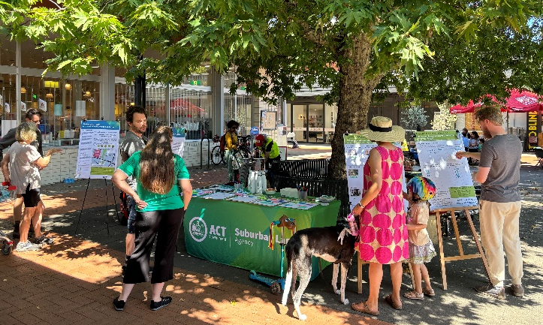
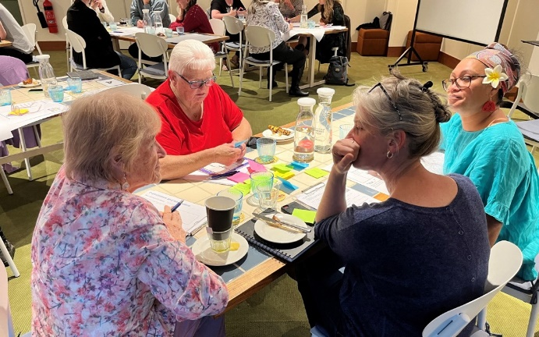

Key insights from the engagement
Three core themes
We have heard from the consultation that a successful dementia village outcome will need to:
- apply site planning, landscape and building design that enable a best practice dementia care environment
- foster connection to community
- support an innovative and holistic model of care

The following themes and key points emerged during the consultation:
The new village should include buildings and landscape design that enable people with dementia to live their best life
- Residents living with dementia should be able to live with dignity and independence with the potential to connect with the local community.
- The design of the buildings and gardens should ‘feel like home’, not a hotel. Spaces should be human scale, feel like personal residences with spaces that enable the potential for self-reliance within levels of ability.
- The village design should incorporate best-practice design principles, including the national Draft Principles and Guidelines for Residential Aged Care and the Dementia Enabling Environments Principles.
- The village ideally would support residents as their care needs evolve
Local neighbours value green spaces and a connected community
- Curtin residents value their community as a friendly, safe, well-located suburb that offers a walkable and green environment with good access to quality shops.
- The community highly values the existing established trees on the site, the site’s access to nearby public green spaces and good footpath connections to the Curtin shops.
- The village should create opportunities for a broad range of the community to interact with village residents, including children and young people.
A safe and welcoming place
- The village should establish a culturally safe environment where people of varied backgrounds feel acknowledged and welcomed and can develop a sense of belonging.
- The safety of residents is important, and the design should consider how to enable them to have independence while remaining safe within the community.
- First Nations’ culture and the other varied cultural backgrounds of village residents could be reflected within the building and landscape.
Part of the Curtin ‘fabric’
- The dementia village should integrate with the existing community, enhancing connections to surrounding streets and green spaces and maintaining the low density residential ‘look and feel’.
- Footpaths and landscape (within the site and beyond) should support safe but independent ‘strolling’ and exercise for residents with dementia.
- The dementia village should create potential for the local community to naturally visit and use spaces within the village, and spaces should support organic interaction and incidental social connections.
- There’s an opportunity to showcase the story of the local history (First Nations, early European, contemporary history of the site and the building, to the Village campus).
There is scope for a range of potential shared uses for both the community and dementia village residents
- The community is interested in a range of co-located uses on the site. Some preferred uses include a communal garden, a café, community classes or allied health (as shared uses with village residents).
Traffic and parking should not impact on the residential character of Storey and Jenkins Streets
- Primary vehicle access from Carruthers Street is preferred to minimise traffic and street parking on Storey and Jenkins Street.
- Public parking for visitors to the village (and for community members using the shared facilities) needs to be adequate to meet demand.

What’s Next?
Based on what we have heard from the community and stakeholders, we have prepared a draft Place Development Brief, including site-specific Vision, Place Themes, Principles and Objectives that will need to be considered by proponents in preparing their design proposal as part of tender submission for purchase of the site.
The draft Brief is available at https://yoursayconversations.act.gov.au/curtin-dementia-village-site for public comment until Monday 16 April.

Key Timings
November to December 2023: Stakeholder Advisory Panel and Focus Groups
November 2023 to February 2024: Engaging with the community (YourSay open)
February 2024: Drafting Place Development Brief based on what we’ve heard from the community and stakeholders.
March 2024: Seeking feedback from the community and stakeholders on the Draft Place Development Brief (We are here.)
March 2024: Final Place Development Brief released on YourSay
April 2024: Request for Tender (RFT) released to market

THANK YOU FOR YOUR FEEDBACK
527  We reached 527 people over 855 visits via YourSay | 106  We spoke to 106 individuals at a community pop up | 200  We delivered 4 community presentations to 200+ people | 7  We spoke to 7 people with lived experience of dementia
210  We delivered more than 200 YourSay flyers to local residents | 4001  We reached a social media audience of more than 4000 people, with 148 engagements and 19 likes. | 30  We spoke to representatives of 30 organisations (through the advisory panel and one on one discussions) | 85%  people engaged did not have concerns about living close to a dementia village

