Comments on the Provisional Registration of Tharwa School, Tharwa.

The Council has provisionally registered Tharwa School as a way to indicate that it intends to make a decision on whether or not to permanently put it on the ACT Heritage Register. The provisional registration sets out what it is about the place that the Council thinks is important to the ACT and why. This public consultation aims to find out the views of the ACT community.

Please read the Provisional Registration Decision and the Background Information documents before starting.

Privacy Statement
This survey fulfils the role of public consultation under section 37 of the Heritage Act 2004 (the Act), and the collection of personal information as authorised by the Act. If you make a comment using this form, you will be considered an interested person under section 13 of the Act. For this reason, the survey requires respondents to provide contact details so functions under the Act relating to notification of interested persons can be fulfilled. If you do not provide your identity or contact details then the ACT Heritage Council will be unable to give you notice of decisions as an interested person under the Act. Also, you may not be able to be identified as an interested person entitled to appeal rights under the Act.
The personal information on this survey is collected by the Environment, Planning and Sustainable Development Directorate (EPSDD) and provided to the ACT Heritage Council. All personal information provided will be collected, used and stored in accordance with the Information Privacy Act 2014 and EPSDD’s Information Privacy Policy, which contains information about how you may access or seek to correct your personal information held by EPSDD and how you may complain about an alleged breach of the Territory Privacy Principles.

Section 1 - ACT Heritage Council considerations - place
The boundary on the map (Figure 1) and the attributes listed below are what the ACT Heritage Council considers to capture the proposed heritage significance of the Tharwa School. Do you agree or do you have suggested changes you want the Council to consider?
Tharwa School has the following attributes:
- the 1912 weatherboard schoolhouse, incorporating the 1947 and 1957 extensions and the water tanks;
- the 1963 toilet block;
- the 1967 classroom and walkway, incorporating the 1983 extension; and
- the school grounds consisting of the remaining 1930s border plantings of trees and shrubs; and open areas for school activities and equipment such as, but not limited to, grass, paved areas, gardens, soft landscaping, educational or play equipment.
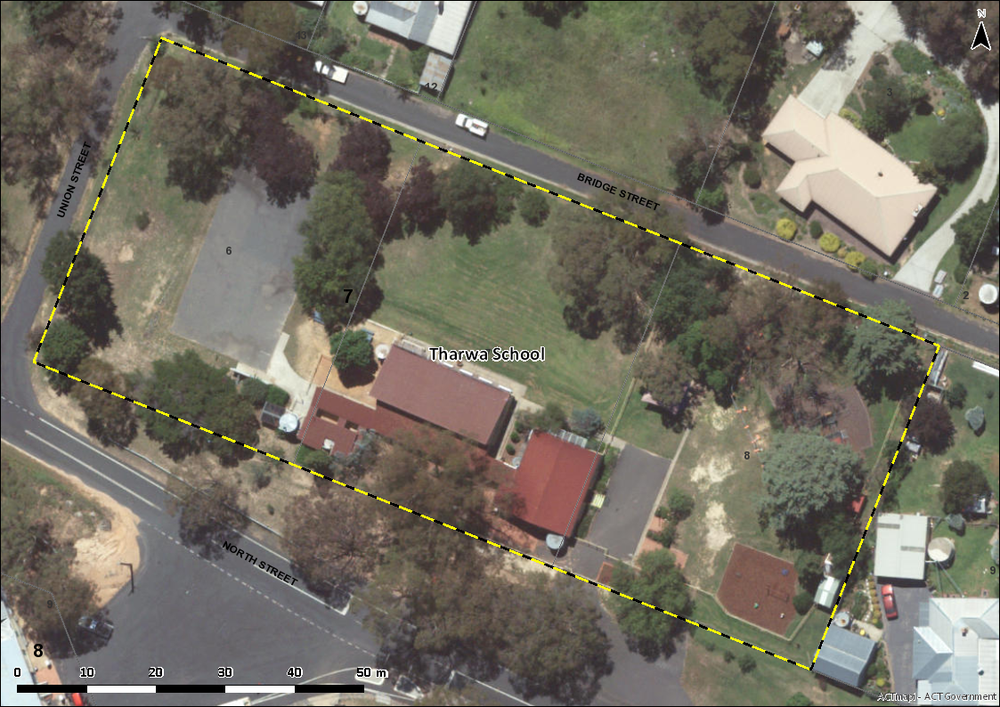
Figure 1 – Proposed Heritage Boundary
Your Comments on the proposed boundary and features that describe the significant attributes of the place:
Click here to enter text.

Section 2 - ACT Heritage Council considerations - significance
A place or object has heritage significance if it meets with one or more of the eight heritage significance criteria as defined under section 10 of the Heritage Act 2004.
The heritage significance criteria are labelled (a) to (h), and your comments are most useful when addressed against each of these criteria, or you could focus on the ones relevant to your argument. However, you may choose to only leave a general comment by skipping to the General Comments section.
The ACT Heritage Council has determined that Tharwa School is likely to have heritage significance under criteria (a), (b) and (d) only. The criteria that are not met can also be commented on.
While the Council will independently assess and research any claims you make against the criteria, it may be helpful to refer to the Heritage Assessment Policy as a guide to providing the strongest argument with appropriate evidence.

(a) importance to the course or pattern of the ACT’s cultural or natural history;
The Council has assessed Tharwa School against criterion (a) and is satisfied that the place is likely to meet this criterion.
Schooling in the Canberra region greatly expanded in the later part of the 19th century due to changes in legislation that made it easier to qualify for funding. This was partly designed to distribute schools more widely across the country allowing the widely dispersed population access to an education. Tharwa School is an important part of this history as it provided access to education for children in rural communities that would not otherwise be able to attend school in the more populated areas. This occurred during a period when small schools were being encouraged so that education could be taken to the children, whereas nowadays school sites are chosen based on the largest numbers of children that could attend. As Tharwa School started in this period, and was centrally located in the rural area, it was able to continue its functions while surrounding small rural schools like Naas and Church Rock Valley closed.
Additionally, Tharwa School shows important changes to educational practices for well over a century as a practically continually running school that has expanded its facilities as needs and requirement changed over the years. While the community-supplied slab building is non-extant, the place does demonstrate the standard of government supplied facilities of the early 20th century that has then been sympathetically added to the 1912 weatherboard building and then continues this theme with the later mid- to late-20th century building which has a design that is reflective of the changing attitude to educational facilities of that time.
Your Comments on criterion (a):
Click here to enter text.

(b) has uncommon, rare or endangered aspects of the ACT’s cultural or natural history;
The Council has assessed Tharwa School against criterion (b) and is satisfied that the place is likely to meet this criterion.
Tharwa School is a rare and endangered early school. There have been over thirty small rural schools in the ACT area, and even more in the surrounding region that serviced the area, however there are only five that are still remaining.
Tharwa School is one of the few extant schools in the area that represent the early period of public education in Australia, particularly relating to small rural areas. The other extant schools from this period are St Johns Schoolhouse, Hall School, Tuggeranong School and Ginninderry School (Gungahleen Schoolhouse has been reconstructed and is not considered to be an extant example); of these, only Hall and Tharwa schools are part of a continually functioning school complex. They are a part of the education system that does not exist anymore and given the density of the ACT now and the ease of transport, it is unlikely to ever be seen in the region again.
Your Comments on criterion (b):
Click here to enter text.

(c) potential to yield important information that will contribute to an understanding of the ACT’s cultural or natural history;
The Council has assessed Tharwa School against criterion (c) and is satisfied that the place is not likely to meet this criterion.
Tharwa School has kept many records since 1899, many of which may have some potential to yield important information that will contribute to an understanding of the ACT’s cultural or natural history. Records that may contribute the an understanding of the ACTs cultural history include student enrolments, performance over time, and punishment books; while natural history may be represented in other school records kept as a part of the classes unique to Tharwa School such as rainfall records and other records of farm and rural studies (bee-keeping, agricultural studies, the Young farmers program, etc.). These records may be able to provide empirical evidence of the effects of changing curriculum, changes in demographics for the region, and information on environmental conditions and changes over time. However, these records, while an important part of the history of the place and not an integral part of the place itself. They may, however, be considered as a heritage object, which if registered should be encouraged to be kept at the school.
The school and grounds may provide some more information about changes over time, however, it is unlikely that this information will be of a significant nature given the amount of archaeological and historical research already conducted around NSW that has already provided an excellent record of early schools in Australia.
Your Comments on criterion (c):
Click here to enter text.

(d) importance in demonstrating the principal characteristics of a class of cultural or natural places or objects;
The Council has assessed Tharwa School against criterion (d) and is satisfied that the place is likely to meet this criterion.
Tharwa School is important in demonstrating the principle characteristics of early schools in the region. It retains the original 1912 school building, which was a standard government design, as well as demonstrating how this was then added to as the school grew. The 1912 building shows the basic level of support that was provided for small rural areas, while the extensions show the growth of the region by proxy of increased enrolments. The later buildings and additions are also important evidence of the school adapting to change over the years by expanding and adding to the buildings and grounds. The 1967 building and its 1983 extension, with its more open and light design, shows the more progressive educational standards of the middle to late 20th century.
Australian rural schools, i.e. part-time, provisional schools or smaller public schools, have their origins in the Public Schools Act 1866 and the Public Instruction Act 1880, which allowed schools to be formed (by receiving government funding and support) in areas with a fairly small catchment. This had the effect of a proliferation of small schools in the more rural and remote areas of NSW in the late 19th century and early 20th century. The smallest schools required the local community to provide the facilities for the new school, which would often be in the form of a small slab building that could be erected quickly and cheaply by unskilled workers. These initial buildings were often quickly outgrown and the Department of Public Instruction would be requested by parents and teachers alike to provide more adequate facilities, which would often take the form of a basic weatherboard single room building with an enclosed verandah/wash room/cloak room. When these buildings proved to be inadequate for a growing population, they would be added to as required, until eventually an entirely new, larger main building would be required.
Tharwa School demonstrates many of the principal characteristics of Australian rural schools including:
- non-extant, original low-quality community-provided building (exists only as historical value and archaeological potential);
- initial government supplied building, consisting of:
  - a single room building with enclosed verandah as a washroom/cloakroom;
  - weatherboard construction;
  - corrugated iron roof;
  - simple open gable roof (although larger schools would have a hipped roof)
  - Simple geometry/Georgian style architecture, original section rectangular in plan;
  - several extensions added on to original building as required; and
  - shelter sheds added on.
- water tanks;
- school grounds, often with garden and later additions including play equipment and paved areas; and
- later additional buildings taking over as the main classroom, extended as needs expanded.

Your Comments on criterion (d):
Click here to enter text.

(e) importance in exhibiting particular aesthetic characteristics valued by the ACT community or a cultural group in the ACT;
The Council has assessed Tharwa School against criterion (e) and is satisfied that the place is not likely to meet this criterion.
While the Tharwa School has a rural character and charm and has had sympathetic extensions that are likely valued by the local Tharwa and catchment residents, there is no evidence to show that it is important in exhibiting particular aesthetic characteristics valued by the wider ACT community or a cultural group in the ACT.
Your Comments on criterion (e):
Click here to enter text.

(f) importance in demonstrating a high degree of creative or technical achievement for a particular period;
The Council has assessed Tharwa School against criterion (f) and is satisfied that the place is not likely to meet this criterion.
Tharwa School has various elements that are standard designs and extensions for the periods that they were built and, as such, is not considered to be important in demonstrating a high degree of creative or technical achievement for a particular period.
Your Comments on criterion (f):
Click here to enter text.

(g) has a strong or special association with the ACT community, or a cultural group in the ACT for social, cultural or spiritual reasons;
The Council has assessed Tharwa School against criterion (g) and is satisfied that the place is not likely to meet this criterion.
Tharwa School is likely to have very strong and special associations with the residents of Tharwa and the school’s catchment area as evidenced by successive generations being enrolled as well as community involvement in fundraising and other campaigns. However, the association required in this criterion must be with the wider ACT community or a cultural group in the ACT, which has not been demonstrated.
Your Comments on criterion (g):
Click here to enter text.

(h) has a special association with the life or work of a person, or people, important to the history of the ACT.
The Council has assessed Tharwa School against criterion (h) and is satisfied that the place is not likely to meet this criterion.
There have been many people that are prominent in the history of the region that have an association with Tharwa School, but it cannot demonstrated that they have a special association, i.e. one that is above the ordinary, with the school, or that what has made them important to the history of the ACT is directly related to that special association with the school.
Your Comments on criterion (h):
Click here to enter text.

Section 3 – General Comments
I support the proposed heritage registration? Choose an item.
Please include any further comments to your submission:
Click here to enter text.

Section 4 - Demographics
Your personal details are confidential and will not be publicly visible, but this is required for you to be kept informed and to be counted as an ‘interested person’ (refer to the Privacy Statement at the beginning of the document).
If you do not provide your identity or contact details then the ACT Heritage Council will be unable to give you notice of decisions as an interested person under the Act. Also, you may not be able to be identified as an interested person entitled to appeal rights under the Act.
First Name: Click here to enter given name.
Last Name: Click here to enter surname.
Preferred contact details (phone, email, postal address):
Click here to enter address.
Age range: Click to choose an age range.
Relationship to the place: Click to choose a category.
Have you ever provided comments on other heritage registrations? Click to select.

What next?
After you are happy with your comments and have saved this form it can be emailed to heritage@act.gov.au or printed out and mailed to:
The Secretary
ACT Heritage Council
GPO Box 158
Canberra City ACT 2601

