

chief minister, treasury and economic development directorate

January 2018

ACTGov_inline_black.wmf

Hughes Shops Artwork

Community Consultation Report

Content

acknowledgement of country 3

Introduction 4

What We Wanted To Know 5

How We Did It 5

Your Say Survey 5

Online Submissions: 5

Hard Copy Submissions: 6

Face to face Engagement Stalls 6

Public Notification 6

Social Media 6

What We Heard 7

What do we love and celebrate about Hughes? 7

Social Connections: 7

What did *Stepping Out (Lady in Pearls)* mean to the people of Hughes: 8

What do residents imagine for a new artwork at the Hughes shops: 8

What We Will Do 9

Conclusions 9

# acknowledgement of country

The Australian Capital Territory is Ngun(n)awal Country. The ACT Government acknowledges the Ngun(n)awal people as the traditional custodians of the Canberra region. The region was also an important meeting place and significant to other Aboriginal groups. Ngun(n)awal culture is an important part of the identity of the ACT. The ACT Government acknowledges the historical dispossession and its continuing legacy for Aboriginal and Torres Strait Islander peoples.

# Introduction

The public artwork *Stepping Out (Lady in Pearls),* by artists Giovanna Ianniello and Gerard Murphy, was a bronze sculpture located at the Hughes shops from 1997 - 2016. The work was a life size sculpture of an older lady, affectionately known as “Mabel” and was much loved by the local community. *Stepping Out (Lady in Pearls)* was part of celebrations and events within Hughes and residents frequently dressed Mabel in hats, scarves and jumpers as the seasons changed.

hughes002 copy.tif

Image: *Stepping Out (Lady in Pearls)*

In May 2016 *Stepping Out (Lady in Pearls)* was stolen from the Hughes shops. The theft of the artwork received considerable media attention as well as community anger and sadness. There was a strong response from the Hughes community, with some suggestions that if the work was not recovered, it be recast. However, the original moulds have been destroyed and an identical replica of the artwork cannot be remade.

artsACT invited feedback from the community on what they liked about the original artwork and what they valued and enjoyed about Hughes. The themes from the consultation will inform the artist’s brief for a replacement artwork at the Hughes shops.

One of the original artists, Giovanna Ianniello, was involved in the police investigation and media coverage of the theft. Giovanna told artsACT that the intention behind *Stepping Out (Lady in Pearls)* was to recognise and celebrate the contribution that “everyday” women make to our communities as historically women have held fewer positions of stature in the public or private domain. *Stepping Out (Lady in Pearls)* was human-scaled and encouraged interaction. It was fabricated in bronze as a material traditionally used in sculptures of male statesmen and public figures.

# What We Wanted To Know

The purpose of the community consultation was to ask Hughes residents and visitors to the Hughes shops what *Stepping Out (Lady in Pearls)* meant to them and what they value and enjoy about the Hughes community. The themes from the consultation will inform the artist’s brief for a replacement artwork at the Hughes shops.

# How We Did It

The Minister for the Arts and Community Events, Mr Gordon Ramsay, launched the community consultation at the Hughes shops on 4 August 2017.

The community consultation was designed to give all Hughes residents appropriate notification about the opportunity to participate and provide feedback to inform the artist’s brief for a replacement artwork. The following activities were undertaken as part of the community consultation:

## Your Say Survey

### Online Submissions:

Submissions on the Your Say website were open for a period of six weeks from 31 July – 11 September 2017.

The survey asked participants the following questions

* What are the things that you like and/or value about Hughes?
* What are some of the characteristics about Hughes you think should be celebrated?
* What did the artwork *Stepping Out (Lady in Pearls)* mean to you?
* Imagine the qualities that you would like to see in the replacement artwork at the Hughes shops i.e. I would like the replacement artwork to be**:**
  + Imaginative
  + Bold
  + Playful
  + Interactive
  + Nostalgic
  + Thought provoking
  + Admired
  + Other (please specify)

A total of 45 submissions were received on the Your Say website. A range of comments from respondents has been included in this report.

The survey also included an interactive map where participants could drop a pin and post comments on their favourite place in Hughes. A total of 10 pins were dropped on the interactive map.

### Hard Copy Submissions:

Hard copy submissions of the Your Say survey were left at Council of the Aging (COTA) and at the Hughes IGA. Hard copy submissions were collected in a comments box at the IGA and a total of 11 submissions were received.

## Face to face Engagement Stalls

Face to face engagement stalls were held at the Hughes shops on 22 August (2:00pm - 4:00pm) and on 26 August (10:00am - 12:00pm). The face to face engagement stalls were attend by two staff from artsACT and the original lead artist for *Stepping Out (Lady in Pearls),* Giovanna Ianniello**.**

The face to face engagement stalls provided residents and visitors to the Hughes shops with the opportunity to complete the Your Say survey (online and hard copies). A total of 26 Your Say surveys were completed.

The stalls included an A1 printed mood board where residents could post images and comment on the places that they like and value in Hughes. Participants also had the opportunity share with artsACT staff and the artist what *Stepping Out (Lady in Pearls)* meant to them and to discuss the process involved in replacing the artwork.

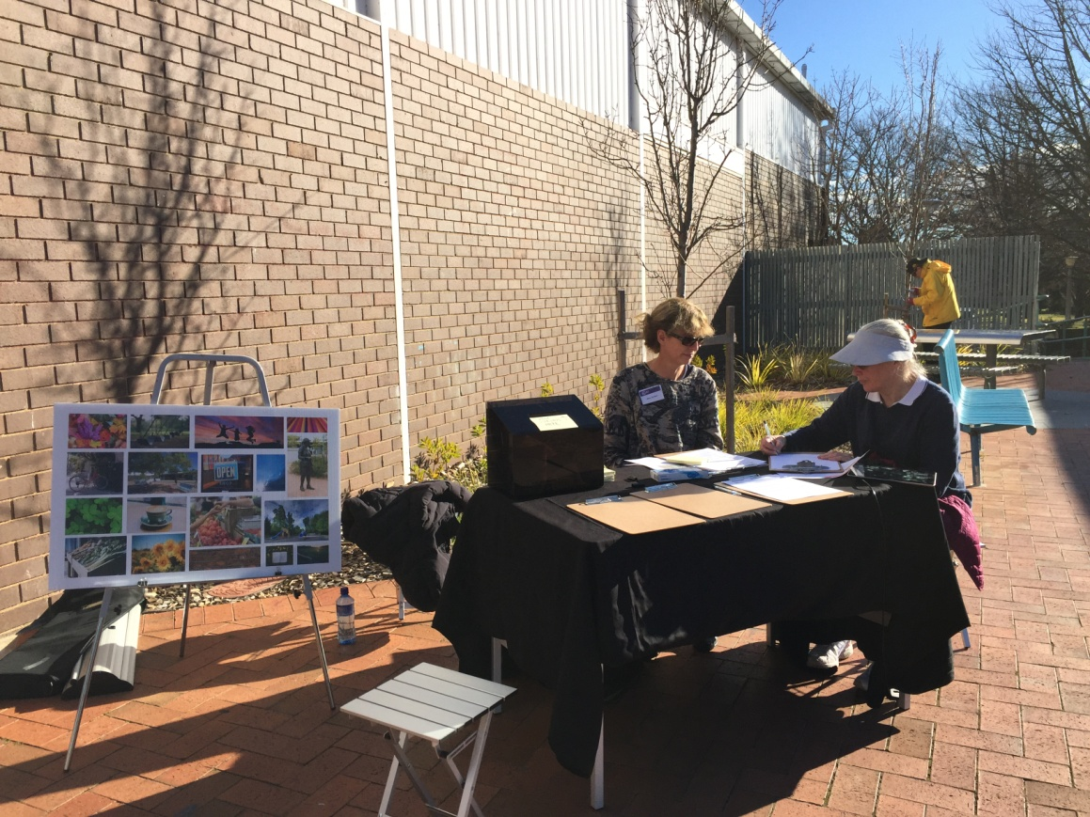

Image: Hughes replacement public artwork community consultation 22 August 2017.

## Public Notification

Flyers with information about the face to face engagement stalls and Your Say survey were left with local businesses at the Hughes shops on 3 August 2017.

## Social Media

The consultation was advertised on the ACT Government Facebook Page on 8 August 2017.

artsACT tweets promoted the consultation on 24 August 2017, 22 August 2017 and 16 August 2017. The Minister for the Arts and Community Events, Mr Gordon Ramsay, re-tweeted artsACT tweet on 24 August 2017 and re-tweeted artsACT tweet on 16 August 2017to promote the consultation.

# What We Heard

We heard that Hughes residents are proud of their suburb and that they value the close knit community, the leafy and green environment and the distinct modernist architecture. Residents told us that *Stepping Out (Lady in Pearls)* was a much loved and iconic part of the community and that a replacement artwork should capture the values that the artwork represented.

A summary of the themes from the community consultation is provided below.

## What do You love and want to celebrate about Hughes?

### Social Connections:

Participants said that they valued Hughes as it is a diverse and inclusive community with a mix of cultures and ages. Participants told us that Hughes is a welcoming community where families, young people and older residents feel safe and connected to one another.

*“Our small community - people are friendly and kind.”*

Participants told us that the local shops were an important part of the suburb where people could come together and enjoy coffee with friends, talk with local traders, and access community services.

The Natural Environment:

Participants told us that they value Hughes because it is a peaceful and quiet suburb with beautiful natural surroundings

*“I love driving along the tree-lined streets and how the changing seasons are reflected in everyone's gardens.”*

We heard that residents feel a strong connection to the leafy and green character of Hughes. People like to walk their dogs on the shady streets and in the local parks. Hughes residents told us that they are connected to nature and enjoy access to surrounding bushland, native plants and animals, the undulating landscape and views of the Brindabella mountain ranges.

The Urban Form

Hughes residents told us that they are proud of the suburb’s unique modernist architecture and its history as one of the first suburbs in the Woden Valley.

*“It's been established long enough to have a sense of texture - a bit worn in places, a bit new in others - a sense of evolution over time.”*

Residents recognised the Indigenous history of the land that Hughes is built on and asked that this history be recognised and celebrated in the community.

We also heard that residents appreciate Hughes is a quiet suburb, still within close proximity to schools, services (including the Canberra Hospital), Civic and surrounding suburbs.

## What did *Stepping Out (Lady in Pearls)* mean to the people of Hughes?:

Residents told us that *Stepping Out (Lady in Pearls),* or *“*Mabel” as she was affectionately known, was a much loved part of the Hughes community.

*“She was a friendly, nostalgic and dignified reminder of the importance of a small, close-knit community - just like Hughes.”*

Many residents told us that they saw themselves or loved ones reflected in Mable’s gentle demeanour. Residents said that they valued Mable because she represented the everyday citizens of Hughes and celebrated the contribution that women made to the Hughes community.

*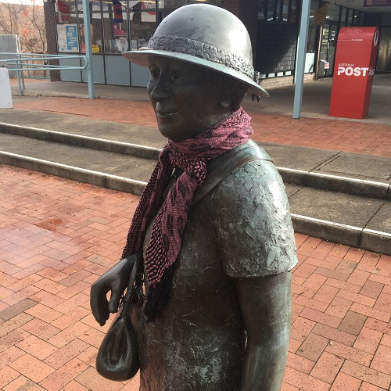“She was so ordinary but so special, she reminded me of my grandmother, my neighbour, my mother....and me.”*

Residents told us that Mable was a friend to the entire community and was much loved by children visiting the shops. Participants told us that they had fun dressing up Mabel for the different seasons. The scarves, hats and jumpers with which residents decorated *Stepping Out (Lady in Pearls)* demonstrated the wider community values of taking care of one another. We heard that Mabel was an iconic part of the community and that Hughes residents felt grief and loss when she was stolen.

*“She was always there, like a neighbour who keeps an eye on what's happening around her area and is always a friendly face.”*

## What do residents imagine for a new artwork at the Hughes SHOPS?

Many residents stated that they would like Mabel to be remade, and if this is not possible, for a similar artwork to be installed at the Hughes shops.

*“I would like the figure of a lady-along the lines of Mabel. Perhaps sitting on a rock or a seat so we can sit beside her.”*

Some residents told us that they would like a non-figurative sculpture that referenced the modernist architecture and aesthetic of Hughes.

*“Something "modern" - that reflects the Hughes environment - the 1960's - Great architecture and art.”*

Some residents also asked for the replacement artwork to acknowledge the Indigenous history of the land in Hughes and to respond to the valued characteristics of the surrounding natural environment.

*“I would like this new artwork to be an amalgam of cultures celebrating, with an aboriginal style binding it together.”*

The top four qualities that residents identified that they would like to see in the replacement artwork were:

* Playful
* Interactive
* Nostalgic
* Imaginative

Residents also wanted the replacement artwork to include possible materials such as concrete, steel or recycled goods. Residents proposed ideas for interactive elements in the replacement artwork that included bike racks, seating, audio recordings, water features and landscaping.

# What We Will Do

## Conclusions

The information from the consultation will be used to inform the artist’s brief for the replacement artwork, in accordance with the 2015 ACT Government Public Art Guidelines.

An indicative timeframe for the replacement artwork is provided below:

* Community Consultation – 31 July 2017-11 September 2017
* Complete consultation report – January 2018
* Issue artist’s brief – February 2018
* Appoint artist – March 2018
* Finalise artwork design – April 2018
* Commence artwork fabrication – May 2018
* Commence artwork installation – September 2018
* Project complete – October 2018

## ACTGov_inline_black.wmfArts ACT-cover background.jpg

chief minister, Treasury and economic development directorate

january 2018