Comments on the Provisional Registration of

Red Hill Historic Plantings, Red Hill.

The Council has provisionally registered Red Hill Historic Plantings as a way to indicate that it intends to make a decision on whether or not to permanently put it on the ACT Heritage Register. The provisional registration sets out what it is about the place that the Council thinks is important to the ACT and why. This public consultation aims to find out the views of the ACT community.

Please read the Provisional Registration Decision and the Background Information documents before starting.

Privacy Statement
This survey fulfils the role of public consultation under section 37 of the Heritage Act 2004 (the Act), and the collection of personal information as authorised by the Act. If you make a comment using this form, you will be considered an interested person under section 13 of the Act. For this reason, the survey requires respondents to provide contact details so functions under the Act relating to notification of interested persons can be fulfilled. If you do not provide your identity or contact details then the ACT Heritage Council will be unable to give you notice of decisions as an interested person under the Act. Also, you may not be able to be identified as an interested person entitled to appeal rights under the Act.
The personal information on this survey is collected by the Environment, Planning and Sustainable Development Directorate (EPSDD) and provided to the ACT Heritage Council. All personal information provided will be collected, used and stored in accordance with the Information Privacy Act 2014 and EPSDD’s Information Privacy Policy, which contains information about how you may access or seek to correct your personal information held by EPSDD and how you may complain about an alleged breach of the Territory Privacy Principles.

Section 1 - ACT Heritage Council considerations - place
The boundary on the map (Figure 1) and the attributes listed below are what the ACT Heritage Council considers to capture the proposed heritage significance of the Red Hill Historic Plantings. Do you agree or do you have suggested changes you want the Council to consider?
Red Hill Historic Plantings consist of the following attributes:
- Callistemon citrinus (723 plants); Grevillea rosmarinifolia (1700 plants); and Swainsona galegifolia (>6) and;
- noting the need for continued horticultural care and maintenance of the plantings (such as replacement of plantings and pruning); and;
- the surviving Callistemon citrinus historic planting rows.
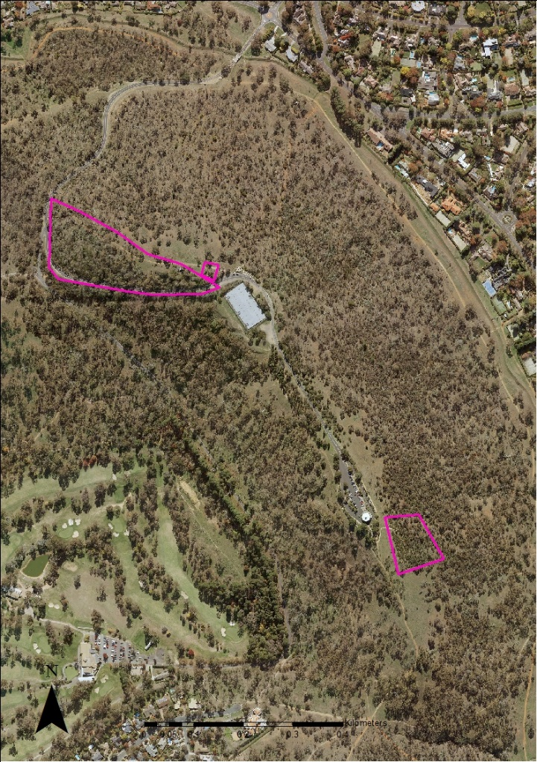
Figure 1 – Proposed Heritage Boundary
Your Comments on the proposed boundary and features that describe the significant attributes of the place:
Click here to enter text.

Section 2 - ACT Heritage Council considerations - significance
A place or object has heritage significance if it meets with one or more of the eight heritage significance criteria as defined under section 10 of the Heritage Act 2004.
The heritage significance criteria are labelled (a) to (h), and your comments are most useful when addressed against each of these criteria, or you could focus on the ones relevant to your argument. However, you may choose to only leave a general comment by skipping to the General Comments section.
The ACT Heritage Council has determined that Red Hill Historic Plantings is likely to have heritage significance under criteria (a, b, h) only. The criteria that are not met can also be commented on.
While the Council will independently assess and research any claims you make against the criteria, it may be helpful to refer to the Heritage Assessment Policy as a guide to providing the strongest argument with appropriate evidence.

(a) importance to the course or pattern of the ACT’s cultural or natural history;
The Council has assessed Red Hill Historic Plantings against criterion (a) and is satisfied that the place is likely to meet this criterion.
The Red Hill Historic Plantings are a unique response to environmental, conservation and city design challenges, resulting in the innovative plantings realised by the then Officer in Charge of Afforestation, Thomas Charles George Weston. Weston used exceptional propagation and planting approaches that have resulted in the survival of these plantings for over a century. The plantings are amongst the earliest plantings in Australia that were undertaken for the reason of landscape restoration. An innovative approach to environmental degradation that became mainstream activity fifty years later.
They are also the last vestiges of Walter Burley Griffin’s audacious scheme to ‘paint’ the hills surrounding his planned city by revegetating the denuded hills with various coloured flowering plants. This was a part of his and Marion Mahoney Griffin’s wider plan for the ACT region.
Your Comments on criterion (a):
Click here to enter text.

(b) has uncommon, rare or endangered aspects of the ACT’s cultural or natural history;
The Council has assessed Red Hill Historic Plantings against criterion (b) and is satisfied that the place is likely to meet this criterion.
The Red Hill Historic Plantings are considered uncommon and endangered aspects of the ACT’s cultural history. The extraordinary vision expressed by the Griffins’ to paint Canberra’s hills with coloured flowering plants was a unique and no longer practiced arboricultural process, which reflected both a desire to revegetate the denuded hills, and their desire that Canberra should ‘unite nature and culture’.
This partially completed vision is most readily observed and most easily accessible on Red Hill, especially when the Callistemon citrinus, Grevillea rosmarinifolia and Swainsona galegifolia plants exhibit their red flowers. The original plantings of Callistemon citrinus can still be observed in rows on the summit of Red Hill. Whilst other partial plantings were attempted on Mt Pleasant and Mt Mugga, they survive as inferior examples in both size and distribution.
The unique plantings by Weston over a century ago, in response to the vision of the Griffins’, and the survival and comparative intactness of these historic plantings make them a rare, living example of historical horticultural planting practices and the only example where this vision was realised in Australia.
Your Comments on criterion (b):
Click here to enter text.

(c) potential to yield important information that will contribute to an understanding of the ACT’s cultural or natural history;
The Council has assessed Red Hill Historic Plantings against criterion (c) and is satisfied that the place is not likely to meet this criterion.
As the partial realisation of a much broader, grand vision that never eventuated there is little potential for the Red Hill Historic Plantings to yield important information that will contribute to an understanding of the ACT’s cultural history. The Council notes that important information on the landscape design of the plantings is better represented by the planning documents and design of the Griffins’ vision for these plantings in the ACT.
Your Comments on criterion (c):
Click here to enter text.

(d) importance in demonstrating the principal characteristics of a class of cultural or natural places or objects;
The Council has assessed Red Hill Historic Plantings against criterion (d) and is satisfied that the place is not likely to meet this criterion.
The Red Hill Historic Plantings are notable as the most intact surviving example of the Griffins’ unique response to the environmental, conservation and city design challenges that the ACT presented at that time.
They demonstrate a living representation of the Griffins’ plan to ‘paint’ the denuded Canberra Hills. There were minor plantings at Mount Pleasant and Mt Mugga Mugga, but the Red Hill plantings are the only site where this vision was realised. It is also the only place at which the original planting rows can still be seen today. In this way they are important as a place that demonstrates the principle characteristics of the painted hills schema.
As a unique response to the revegetation movement that was beginning to gain acceptance in Australia at the time, the plantings are a significant early example of landscape architecture undertaken in the ACT for the purpose of landscape restoration. However, as a revegetation concept, the uncommon practice of colour coding planting for revegetation in itself is far too narrow a definition to meet the current standards of diversity in revegetation planting. And does not therefore meet the principle characteristics of class as required by this criterion.
Your Comments on criterion (d):
Click here to enter text.

(e) importance in exhibiting particular aesthetic characteristics valued by the ACT community or a cultural group in the ACT;
The Council has assessed Red Hill Historic Plantings against criterion (e) and is satisfied that the place is not likely to meet this criterion.
The historic plantings on Red Hill provide a living example of the Griffins’ outstanding landscape design, which embodied aesthetic principles in addition to horticultural and arboricultural principles.
Whilst these plantings are valued by members of special interest groups, including the Red Hill Regeneration Group, Walter Burley Griffin Society, Australian Garden History Society, Institute of Landscape Architects and local residents, there is insufficient evidence before Council to suggest that this site is valued by the ACT community as a whole. Further, despite its prominent position, the Red Hill Historic Plantings are not widely known by the ACT community.
The Council notes that the ‘ACT community’ encompasses the broad community of the ACT, across the full geographical context, and a broad spectrum of society; while ‘a cultural group’ has a narrower focus, taken to be a ‘group of people within a society with a shared ethnic or cultural background’ or ‘a group of people connected through the same way of living, which has been transmitted from one generation to another’. The definition specifically precludes professional organisations or special interest groups.
Your Comments on criterion (e):
Click here to enter text.

(f) importance in demonstrating a high degree of creative or technical achievement for a particular period;
The Council has assessed Red Hill Historic Plantings against criterion (f) and is satisfied that the place is not likely to meet this criterion.
The Red Hill historic plantings demonstrate a degree of horticultural design which was inspired by the Griffins’ grand vision to ‘paint’ the hills of Canberra each in a single colour of flowering plants. By responding to the extensive clearing which had degraded the hills around Canberra, the plantings represent an innovative solution to revegetation that was in contrast to established practices.
Weston’s experience and horticultural knowledge led to propagation and planting approaches, including experimental seedling trials to test for the suitability of plantings on the summit of Red Hill, which were relatively uncommon for their time and certainly uncommon with regard to the use of native species.
The Griffins’ incorporation of landforms and geological features into their planning design created something unique to the ACT region. The use of red flowering plants on Red Hill was in response to the geological make-up of Red Hill and the red coloured formations of weathered Hornfels which make up the hill.
Yes, despite the originality and innovation associated with this concept, the plan itself never fully eventuated and therefore cannot be seen as complete enough for it to reach the high threshold that is required for classification under this criterion.
Your Comments on criterion (f):
Click here to enter text.

(g) has a strong or special association with the ACT community, or a cultural group in the ACT for social, cultural or spiritual reasons;
The Council has assessed Red Hill Historic Plantings against criterion (g) and is satisfied that the place is not likely to meet this criterion.
While the Red Hill Historic Plantings may be held in high regard and be visited by community groups, such as the Red Hill Regenerators, there is no evidence that the place has a strong or special association with the ACT community as a whole, or a cultural group in the ACT for social, cultural or spiritual reasons.
The Council notes that the ‘ACT community’ encompasses the broad community of the ACT, across the full geographical context, and a broad spectrum of society; while ‘a cultural group’ has a narrower focus, taken to be a ‘group of people within a society with a shared ethnic or cultural background’ or ‘a group of people connected through the same way of living, which has been transmitted from one generation to another’. The definition specifically precludes professional organisations or special interest groups.
Your Comments on criterion (g):
Click here to enter text.

(h) has a special association with the life or work of a person, or people, important to the history of the ACT.
The Council has assessed Red Hill Historic Plantings against criterion (h) and is satisfied that the place is likely to meet this criterion.
The Red Hill historic plantings have a strong association with Walter Burley Griffin and Marion Mahony Griffin in relation to their grand visionary design to make Canberra an important example of city garden planning principles. The Griffin legacy resulted in the inclusion of the ACT’s integral hills and landscape elements in the region’s planning principles. Further, they exemplify the planning intentions of the ACT from the earliest days of Canberra’s inception.
Weston, Officer in charge of Afforestation, was instrumental in the development of this vision on Red Hill. He was responsible for the acquisition and cultivation of seeds and was directly involved in establishing the plantings on Red Hill. Not only did Weston take instruction from the Griffins, but he used his extensive horticultural knowledge and experience to foster an experimental phase of testing plant suitability.
Clear evidence can be found in communications between Burley Griffin and Weston accounting for the documentation of the location and flower colour of proposed plantings. The Yarralumla Nursery plant cards and Weston’s planting records (of the surviving historic red flowering plantings on Red Hill of Callistemon citrinus, Grevillea rosmarinifolia and Swainsona galegifolia are directly and strongly associated with the brief tenure of the Griffins in establishing significant urban and landscape design principles in Canberra over a century ago.
The Griffins’ personal reverence for nature and appreciation for conservation informed their planning of Canberra as a city designed to suit the landscape. This is evidenced by Marion Mahony Griffin’s compilation of her own botanical notebooks on Australian native flora. Their bold vision to ‘paint the hills’ of Canberra each in a single colour of flowering plants was both innovative urban and landscape planning and signaled the beginning of the ACT’s foray into nature conservation.
Your Comments on criterion (h):
Click here to enter text.

Section 3 – General Comments
I support the proposed heritage registration? Choose an item.
Please include any further comments to your submission:
Click here to enter text.

Section 4 - Demographics
Your personal details are confidential and will not be publicly visible, but this is required for you to be kept informed and to be counted as an ‘interested person’ (refer to the Privacy Statement at the beginning of the document).
If you do not provide your identity or contact details then the ACT Heritage Council will be unable to give you notice of decisions as an interested person under the Act. Also, you may not be able to be identified as an interested person entitled to appeal rights under the Act.
First Name: Click here to enter given name.
Last Name: Click here to enter surname.
Preferred contact details (phone, email, postal address):
Click here to enter address.
Age range: Click to choose an age range.
Relationship to the place: Click to choose a category.
Have you ever provided comments on other heritage registrations? Click to select.

What next?
After you are happy with your comments and have saved this form it can be emailed to heritage@act.gov.au or printed out and mailed to:
The Secretary
ACT Heritage Council
GPO Box 158
Canberra City ACT 2601

