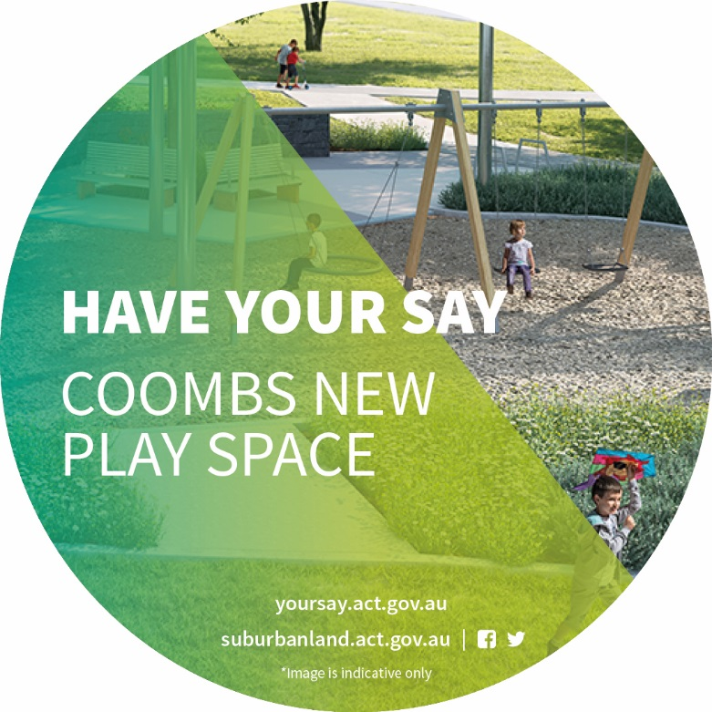
The project

The new Coombs play space will be a local park for children of all ages.
The play space will be built on Edgeworth Parade in Coombs off the Holden Creek Pond. It is intended to be an inclusive play space which has something of interest for people living in the Molonglo Valley.
The Suburban Land Agency held conversations with the community about how the park will be designed and how it will look and feel. The results of those conversations will be used during the design and construction of the Coombs play space.
The engagement questions are available at Attachment A.

THE CONVERSATION
The Suburban Land Agency engaged the Coombs and Wright community through various means.
These included face-to-face meetings with local residents, through Mingle events and initiatives, on social media, mailouts and an online engagement on the ACT Government YourSay website.

THANK YOU FOR YOUR FEEDBACK
809  We reached 809 people via YourSay | 201  We attracted 201 individual responses on YourSay | 5000  We delivered 5000 flyers to homes in Coombs and Wright | 7000  We reached 7000 people through a social media campaign
4735  We communicated with 4735 people through e-newsletters | 3455  We reached 3455 people on the Molonglo Valley Mingle Facebook page | 1  We received 1 written submission from a resident group | 100  We engaged 100 people through the student parliament and Molonglo Valley Playgroup

WHO ENGAGED on yoursay
The consultation aimed to gain feedback from residents living within Coombs and Wright who would directly benefit from the play space.
The YourSay website survey attracted 1133 views from 809 visitors with 201 individual contributions provided. Other commentary included:
- 79% reported to be parents or grandparents of children who would use the future Coombs play space
- 46% of these children were aged 0 to 5 years; 31% were aged 6 to 10 years; 17% were aged 11 to 15 years and 7% aged 16 to 19 years
- 80% of respondents live in the Molonglo Valley
- 68% of respondents were female
- 41% were aged between 35 and 44 and 31% were aged between 25 and 34.
- Most people said they would use active travel to access the play space including: walking - 152 votes and cycling - 83 votes.

A separate residents’ submission was also received during the engagement process. It was generally supportive of the development of the play space. However, there was strong opposition to the inclusion of public toilets and the suggestion that additional car parking be limited. The residents’ submission drew heavily on ACT Government design standards used to inform the inclusion of infrastructure like toilets and car parks at playgrounds.

Charles weston school parliament engagement
The Suburban Land Agency conducted a workshop with the Charles Weston School Parliament to discover the interests of children who will most regularly visit the play space.
Largely, the student’s representations mirrored the findings of the YourSay engagement. Students were asked to vote on the first two questions of the YourSay engagement using the same preference system of 1-7 for Q1 and 1-5 for Q2.
Toilets were the most important piece of infrastructure listed by the students with 29 votes of the 60 students who voted, while car parking ranked fourth with 20 votes.
Also high on the students’ lists for consideration was areas for games and sport, with basketball courts (16 votes), kick-about areas (13 votes), ping pong tables (16 votes) and large chess boards (18 votes) all attracting attention. The students voted mini in-ground trampolines (48 votes) and double-swing set (35 votes) as their most important play elements to be considered.
During the designing exercise, students suggested several other inclusions not previously listed in the online engagement. These included skate-boarding infrastructure, flying foxes and separate areas for pets.

Key insights from the community
Most people would like public toilets
❶ There was general concensus that toilets should be included on the site, with only a small minority (about 10%) opposed to their inclusion. Toilets were the most popular inclusion from a list of larger infrastructure with 68 weighted votes. The next two most popular items were a basketball court (64.4 votes) and a water play area (62.6 votes). Additional car parking was least popular with 7.8 votes.
❷ About 20% of extended responses spoke about toilets. Of these, 57% were positive. Reasons for not including toilets included security risks, aesthetic concerns and increased traffic.
❸ People listed convenience and a lack of other public toilets in the area as their reason to include the infrastructure. There are currently no other public toilets in Coombs or Wright and toilets at the Coombs shops, once opened, are about a kilometre away from the play space. Toilets were described as an essential requirement for people visiting with children.
Basketball courts were a popular inclusion
❹ There was strong support for the inclusion of equipment and infrastructure for older children and teenagers. Basketball courts were the second most popular item in the ‘larger facilities’ section while 20% referred to older children and basketball courts in their extended responses. A learn to ride track (56.4 votes) and kickaround area (52 votes) ranked fourth and fifth respectively from the list of larger facilities.
Inclusion of equipment for older and younger children, and the inclusion of shade structures
❺ Responses indicated that most children visiting the site will be younger than 11. About a quarter of children likely to visit the site would be aged between 11-19 years. The most popular items of play equipment were double swings (92.5 votes), slides (87.5 votes), miniature trampolines 78.7 (votes) and a climbing wall (73 votes). Nature play spaces (59.2 votes) and monkey bars (50.4 votes) were also popular.
❼ Consideration for shade was also a primary concern from respondents. More than 20% indicated this was an important part of the play space experience in their extended responses. Additional shade ranked 5th with 40 votes in the ‘larger facilities’ section.
Other insights
❽ Other repeated themes and considerations included:
- Water safety due to the close proximity of the Holdens Creek pond
- Drink stations
- Cycling infrastructure
- Blending the design of the play space into the natural environment
- Segregated areas for younger/older children
- Areas where dogs can be left/entertained/secured short term

Key timings
Step 1 – May/June 2018 – engage the community on play space inclusions (complete)
Step 2 – July/August 2018 – assess the data which has been collected (complete)
The data received from the YourSay engagement has been assessed to determine what items are most valued by the community and what should be included in the play space.
Step 3 – September/October/November 2018 – decide what will be included in the play space
The Suburban Land Agency undertakes design and approval of the play space. A Development Application (DA) detailing the design and inclusions will be lodged to the Environment, Planning and Sustainable Development Directorate for formal approval as part of this process.
Step 4 – September 2018
The Suburban Land Agency will inform the community of the play space design during the DA notification period. The community will be kept informed throughout this process via social media, mailouts, email and face-to-face meetings with residents and community groups.
Step 5 – November/December/January – tenders called
The Suburban Land Agency will request tenders for a construction company to build the play space. The site will be prepared for construction.

Step 6 – Early 2019 – construction begins. It is estimated to take approximately six months for construction.

Please note: these timeframes are indicative only and are subject to change.

A comprehensive report of the findings of the YourSay engagement can be found at Attachment A.

If you have any questions regarding the Coombs play space engagement please contact the
Suburban Land Agency:

• Phone: 1800 777 952
• Email: suburbanland@act.gov.au
• Social: www.facebook.com.au/suburbanland

