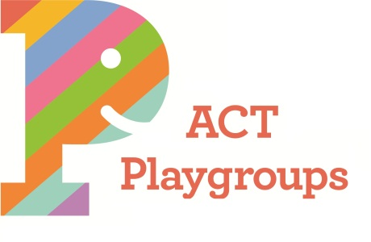 | Mail: PO Box 513  JAMISON CENTRE ACT 2614  ABN: 75 749 847 915  play@playgroupact.org.au  www.playgroupact.org.au  www.facebook.com/PlaygroupsACT | Office: 41 Templeton St, Cook, ACT  Hours: 9.30am - 2.30pm Mon – Fri  school terms only  Ph: 1800 171 882 (Free in ACT region)  Outside ACT region ph: (02) 6251 0261  Fax: (02) 6251 9887

Better Suburbs: Play Spaces Forum – August 2018

ACT Playgroups Association is a not-for-profit community organisation servicing the ACT and has been delivering a range of high quality, playgroup family support services to children and their families for over 40 years. ACT Playgroups supports more than 2,000 families through playgroup each year including families with children with additional needs, different cultural backgrounds and different levels of mobility.

ACT Playgroups sees the importance of outdoor play and connection with natural environments from birth as critically important. This opportunity is most readily found by accessing local parks or playgrounds. Canberra has an excellent range of parks and playgrounds but not all are fully inclusive of the needs of all residents and this is particularly noticeable in relation to the needs of people with some form of disability. Playgrounds should provide space and structure for children’s socialisation, imaginative play and physical activity. However, not all playgrounds are equal, and it seems that some ACT playground spaces have been unsuccessful in meeting children’s needs or expectations in relation to outdoor play.

We believe that the key elements of outdoor play spaces should include:

- Access – parents with small children need to have parking and access close by. Ideally this should be in designated parking lots that are safer for children getting in and out of cars.

- Facilities – playgrounds need access to water, shade (sails or leafy trees) and toilets. Young children in early toileting cannot be expected to “hang on” while they are driven 10 minutes away to the nearest shops or walked home.

- Fencing – suburban playgrounds are (by their nature) in smaller spaces, surrounded by houses and roads. Distances to roads and other hazards are a big concern for young families. This is especially true for those with additional needs (either children or adults with reduced mobility). It is vital for many families that they have access to safe and enjoyable fully fenced play spaces in their local region.

- Nature – When new play areas are being considered, we would like to encourage designers to think about incorporating the natural environment in the play area. Too often we see trees, bushes, shrubs, logs, uneven ground, dirt piles and rocks moved aside to build a play area – whereas these things are the best basis for play for children of any age.

- Loose parts/flexible – where possible, play equipment should be multi-purpose and multi-functional. Equipment and layout should encourage creativity in children and reduce linear suggested use. In addition, moveable pieces are to be encouraged for children to direct their own play.

- Age appropriate – play areas and equipment should be designed for all ages (including babies). Grassed hills and sand pits are great all ages spaces, as is equipment with interest at lower levels and those appropriate for crawling/toddling.

- Pesticide/allergy – many families have concerns about use of pesticides and allergens in public spaces. Perhaps a designated park or two that are certified as free of pesticides and also have allergy aware planting and equipment would be useful for many young Canberran families.

ACT Playgroups believes that all children and families should have the availability of safe, secure playspaces where they can feel included and able to play without and engage with their peers and access age appropriate supports and activities. We would be happy to expand further on any aspect of this submission.

Kirsten Cross, Executive Officer

