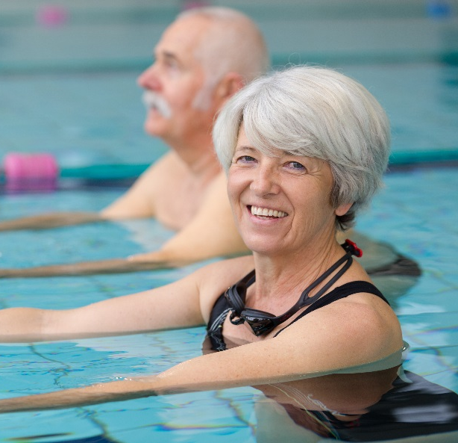
Age Friendly City Survey
We asked the community what is important for the continued establishment of Canberra as an Age Friendly City

We are getting ready for a city which will be home to 500,000 people by 2030. We’re growing rapidly with 7,000 new Canberrans and 5,800 reaching seniority every year.
We have more senior Canberrans now than at any other time in our history. Canberra is one of the best places to become a senior Australian - senior Canberrans are more likely to volunteer, stay employed and connected, socialise and remain active than senior Australians in other cities.
Over the last three years the ACT Active Ageing Framework has set the priorities for our work to promote Canberra as an age friendly city. As this Framework is finalised we wanted to hear from senior Canberrans about what makes Canberra age friendly and what is needed to ensure that as our city expands, Canberra continues to develop as an age friendly city - a city Canberrans are proud to call home, no matter what their age may be.

THE CONVERSATION
To capture the views of senior Canberrans, the Age Friendly City Survey was run over March and April 2018. The design of the survey was built on the priorities identified by the Ministerial Advisory Council on Ageing:
- Safe and secure housing;
- Access to information; and
- Being valued as wise and energetic.

WHO ENGAGED
Hard copy surveys were delivered to key community locations and were available at Senior’s Week events. The survey was also available online through the YourSay Website. There was a strong response, with 768 community members expressing their views. One third of responses were online, and two thirds were received in hard copy.
80% of those who responded were over the age of 60, and 47% were over the age of 70.

Key insights from the community
Senior Canberrans have an important role in the community
❶ 99% of respondents indicated they are involved in community activities and/ or in assisting others
❷ 70% ‘help family and friends’
❸ 53% ‘volunteer their time and skills’
Most senior Canberrans are able to stay active and healthy
❹92% of respondents indicated they have the support and information they need to stay connected and healthy
❺73% of respondents indicated they are able to ‘stay active and healthy’
❻72% of respondents indicated they ‘have secure accommodation/ housing’.
We need to ensure senior Canberrans are valued, treated with respect and not subject to aged based discrimination
❼ 29% of respondents indicated they had been subject to age based discrimination, with comments received about senior Canberrans being made to feel invisible or underestimated, often when shopping. The second most common situation of discrimination described was in the workplace.
❽ The importance of the need for senior Canberrans to be treated with respect was highlighted as an important factor to Canberra as an age friendly city.
There needs to be the right housing mix for senior Canberrans
❾ Many respondents commented on a need for more ground level, single story, smaller-scale properties; and affordable housing, including public and social housing.
❿ The need for housing options to be close to transport and amenities was highlighted.
The city’s infrastructure needs to support the active participation of senior Canberrans
⓫ Respondents were provided an opportunity to describe other areas they felt were important to Canberra as an age friendly city. The highest number of comments received were about ensuring public transport and parking were readily available and that walkways were safe.
We need to ensure senior Canberrans have the information and access to needed services.
⓬ 92% of respondents indicated they had the information they needed to stay connected and socially active and respondents were most likely to select searching online as their most preferred information source. However, there were also a number of comments received about difficulties with access to services and the need for better information on services for senior Canberrans.

What’s Next?
The results of the Age Friendly City Survey have provided us with information on key areas for further exploration and areas to address as the next stages of our work on supporting the continued development of Canberra as an age friendly city progresses.
The views expressed by senior Canberrans will inform the development of an Age Friendly Statement of Commitment to be announced in February 2019.
You can register to receive project updates at : communityparticipation@act.gov.au
To find out more about the and other initiatives, policies and projects in Canberra visit www.yoursay.act.gov.au or follow us on Facebook or Twitter.

Key Timings
August to September 2018
Ministerial Advisory Council on Ageing builds on survey results to provide recommendations on priorities for the development of an Age Friendly Statement of Commitment.
October 2018
What We Heard report released

February 2019
Age Friendly Statement of Commitment announced

THANK YOU FOR YOUR FEEDBACK
582  We interacted with 582 people through YourSay | 768  We received responses from 768 individuals | 4,000  People attended the Seniors Expo where the survey was distributed | 3,000  We distributed 3,000 hard copy surveys to locations throughout the community

