Comments on the Provisional Registration of Cinema Center, City.
***please note that only comments received during the public consultation period will be valid for certain provisions under section 13 and/or review under part 17 of the Heritage Act 2004. This includes comments received no earlier than 12am on 17 November 2020 and no later than 11:59pm on 14 December 2020***
The Council has provisionally registered Cinema Center as a way to indicate that it intends to make a decision on whether or not to permanently put it on the ACT Heritage Register. The provisional registration sets out what it is about the place that the Council thinks is important to the ACT and why. This public consultation aims to find out the views of the ACT community.
Please read the Provisional Registration Decision and the Background Information documents before starting.

Privacy Statement
This survey fulfils the role of public consultation under section 37 of the Heritage Act 2004 (the Act), and the collection of personal information as authorised by the Act. If you make a comment using this form, you will be considered an interested person under section 13 of the Act. For this reason, the survey requires respondents to provide contact details so functions under the Act relating to notification of interested persons can be fulfilled. If you do not provide your identity or contact details then the ACT Heritage Council will be unable to give you notice of decisions as an interested person under the Act. Also, you may not be able to be identified as an interested person entitled to appeal rights under the Act.
The personal information on this survey is collected by the Environment, Planning and Sustainable Development Directorate (EPSDD) and provided to the ACT Heritage Council. All personal information provided will be collected, used and stored in accordance with the Information Privacy Act 2014 and EPSDD’s Information Privacy Policy, which contains information about how you may access or seek to correct your personal information held by EPSDD and how you may complain about an alleged breach of the Territory Privacy Principles.

Section 1 - ACT Heritage Council considerations - place
The boundary on the map (Figure 1) and the attributes listed below are what the ACT Heritage Council considers to capture the proposed heritage significance of the Cinema Center. Do you agree or do you have suggested changes you want the Council to consider?
Cinema Center has the following attributes:
The original free standing mixed-use commercial building, including:
- The asymmetrical form of geometric shaped components;
- roof-top plant tower with sloping fin wall;
- the original form of the balconies cantilevering over the public footpath/verge, noting that along the Bunda Street frontage the two lower balconies extend vertically at their ends in asymmetrical geometric shapes;
- recessed entry way and deep ground floor awning, characteristic of cinema entrances in the mid-20th century, including original welded metal panelling to awning soffit;
- four storeys of retail and office space;
- open plan basement with mezzanine level as a single open space reflecting the past use as a cinema and the achievement of the Vierendeel truss that allows the large span;
- the three concrete and steel Vierendeel trusses at the ground floor supporting the floors above, and allowing for a free span basement below; and
- The original metal letter and logo ‘Cinema Center’ signage on the northern elevation of the building.
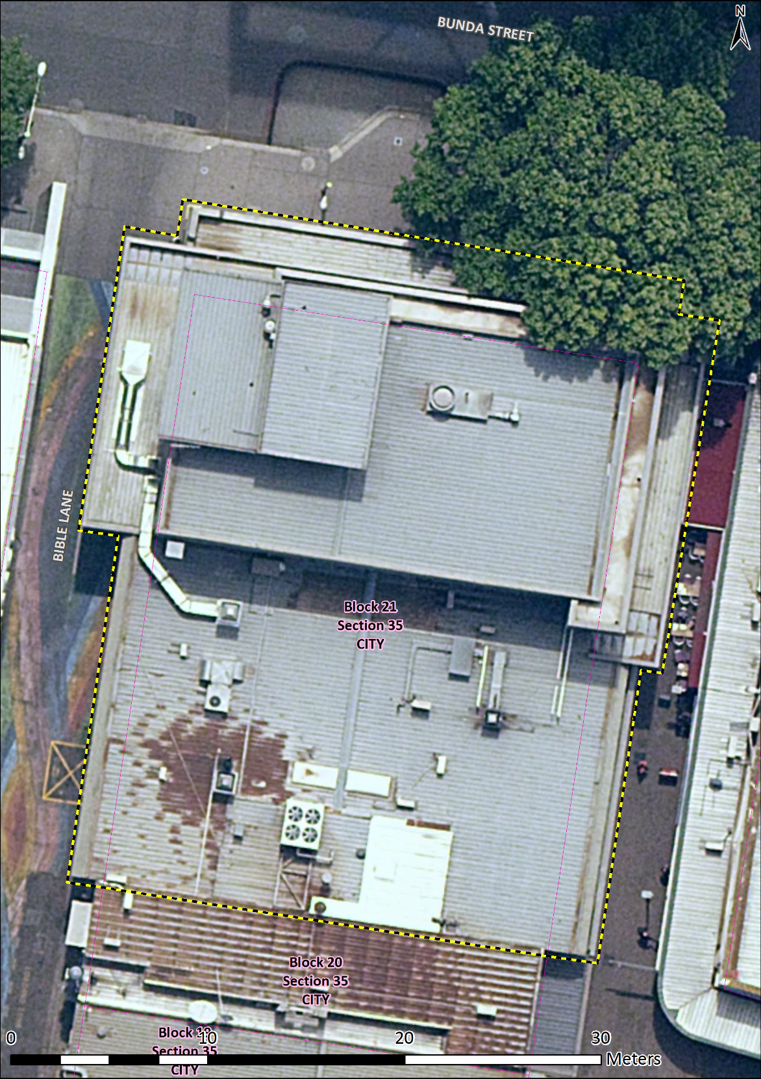
Figure 1 – Proposed Heritage Boundary
Your Comments on the proposed boundary and features that describe the significant attributes of the place:
Click here to enter text.

Section 2 - ACT Heritage Council considerations - significance
A place or object has heritage significance if it meets with one or more of the eight heritage significance criteria as defined under section 10 of the Heritage Act 2004.
The heritage significance criteria are labelled (a) to (h), and your comments are most useful when addressed against each of these criteria, or you could focus on the ones relevant to your argument. However, you may choose to only leave a general comment by skipping to the General Comments section.
The ACT Heritage Council has determined that Cinema Center is likely to have heritage significance under criteria (a, f and h) only. The criteria that are not met can also be commented on.
While the Council will independently assess and research any claims you make against the criteria, it may be helpful to refer to the Heritage Assessment Policy as a guide to providing the strongest argument with appropriate evidence.

(a) importance to the course or pattern of the ACT’s cultural or natural history;
The Council has assessed Cinema Center against criterion (a) and is satisfied that the place is likely to meet this criterion.
Built in 1965 to accommodate restaurants, retail, a gallery, offices and an independent cinema, Cinema Center was a distinctively modern cultural hub and well-known meeting place in the City. The purpose built cinema (Center Cinema) located in the building’s basement, art gallery on the first floor, and variety of retail and dining options provided at the ground floor level of the building, provided a cosmopolitan entertainment experience, previously unavailable in Canberra at the time.
Cinema Center has a strong association with the development of cinema entertainment and attendance as a cultural activity in the ACT. Showing high quality International films sourced directly from Hollywood, Europe, and later films from Hong Kong and Taiwan and local cinema, not otherwise available in Canberra; the building enriched cultural life in the ACT.
With government support stimulating growth of an Australian national film industry in the 1960s and 70s, Center Cinema provided a platform for the ‘renaissance’ of Australian film to reach Canberra audiences. The cinema was the venue for film premieres attended by a cross section of Canberra society, including world premieres of independent Australian films ‘Journey Out of Darkness’ in 1967, and ‘We of the Never Never’ in 1982. These premieres were widely publicised and reviewed in Australian media and established the Cinema Center as a prominent cultural venue in the ACT.
Cinema Center was influential in the development of an independent cinema industry in the ACT. Its commercial success led directly to development of the Boulevard Red and Blue Cinemas (later Electric Shadows) in 1973, an independent cinema which followed a similar business model with a focus on quality films.
The cinema auditorium, box office, showings signage and projection room are no longer extant. However, the building name, ‘Cinema Center’ signage, recessed front entry, and deep ground floor awning characterise mid twentieth century cinema buildings, and serve as a visual reminder of important role of the Cinema Center in the cultural life of the ACT. Additionally, several items from the Centre Cinema have been preserved as part of the Canberra Museum and Gallery collection, including selected programs, signage and seating as being representative items of an important part of the Canberra’s cultural history.
Your Comments on criterion (a):
Click here to enter text.

(b) has uncommon, rare or endangered aspects of the ACT’s cultural or natural history;
The Council has assessed Cinema Center against criterion (b) and is satisfied that the place is not likely to meet this criterion.
Cinema Centre is not considered to be rare in the context of the ACT. The cinema auditorium at Cinema Center was the fourth purpose built cinema space in the ACT. Although, the three purpose built cinemas constructed prior to Cinema Center (Capitol Theatre Manuka, Civic Theatre Braddon and Starlight Drive-in Watson) have been demolished, a number of purpose built cinemas have since been constructed and remain extant with higher integrity than Cinema Center. Dr Taglietti also designed the Sundown Drive-in in Narrabundah (designed 1968, built 1969), which has many elements, like the main kiosk/projection booth/admin building, still intact, but its conversion into a caravan park and motel has altered the landscape and other drive-in features such as the screen, parking bays and speaker stands.
Your Comments on criterion (b):
Click here to enter text.

(c) potential to yield important information that will contribute to an understanding of the ACT’s cultural or natural history;
The Council has assessed Cinema Center against criterion (c) and is satisfied that the place is not likely to meet this criterion.
Cinema Center does not contain substantial new physical evidence of archaeological or other research interest. Detailed study of the Verindeel trusses supporting the upper levels of the building may yield information about structural efficiency of this design solution, of interest to structural engineers. However, this information is likely to replicate or confirm evidence provided by existing published resources.
Your Comments on criterion (c):
Click here to enter text.

(d) importance in demonstrating the principal characteristics of a class of cultural or natural places or objects;
The Council has assessed Cinema Center against criterion (d) and is satisfied that the place is not likely to meet this criterion.
Cinema Center is not a representative example of a class of cultural or natural places or objects. Designed by architect Enrico Taglietti, Cinema Center is an example of a commercial building exhibiting some characteristics of the Late Twentieth-Century Organic architectural style. The extant free asymmetric massing, complex geometries and horizontal roof planes are characteristic of the architectural style. While unsympathetic modifications to the exterior have affected other key characteristics of the style, including horizontally boarded fascia, horizontally boarded balustrade and expressed timber that have been painted over or replaced; these are mostly cosmetic changes that could easily be reinstated to original, so the integrity of the place has not been lost.
Your Comments on criterion (d):
Click here to enter text.

(e) importance in exhibiting particular aesthetic characteristics valued by the ACT community or a cultural group in the ACT;
The Council has assessed Cinema Center against criterion (e) and is satisfied that the place is not likely to meet this criterion.
When constructed, the Cinema Center was celebrated as a place with evocative aesthetic qualities. The building’s distinctive silhouette, with deep cantilevered balconies wrapped around a bold asymmetrical form, and cavernous recessed entry drawing visitors into its interior, distinguished the Cinema Center in the Bunda Street streetscape. Reviews from the time describe the building as luxurious and modern, with a sense of grandeur created by the large lobby space, grand staircase and first floor rotunda in the interior. However, the interior of the building has since been modified to such an extent that the interior no longer displays aesthetic characteristics that are likely to evoke a strong human response.
The exterior of the building retains its distinctive silhouette and dramatic architectural form. These qualities are common to Enrico Taglietti’s architecture and are widely appreciated by members of the architectural profession (represented by the Australian Institute of Architects) and those in the ACT community who appreciate late 20th century architecture.
The exterior of Cinema Center displays aesthetic characteristics that are appreciated by professional architectural bodies and interest groups. That these characteristics are valued by the greater ACT community or cultural groups in the ACT has not been tested, although this may emerge more clearly in the futureWhen constructed, the Cinema Center was celebrated as a place with evocative aesthetic qualities. The building’s distinctive silhouette, with deep cantilevered balconies wrapped around a bold asymmetrical form, and cavernous recessed entry drawing visitors into its interior, distinguished the Cinema Center in the Bunda Street streetscape. Reviews from the time describe the building as luxurious and modern, with a sense of grandeur created by the large lobby space, grand staircase and first floor rotunda in the interior. However, the interior of the building has since been modified to such an extent that the interior no longer displays aesthetic characteristics that are likely to evoke a strong human response.
The exterior of the building retains its distinctive silhouette and dramatic architectural form. These qualities are common to Enrico Taglietti’s architecture and are widely appreciated by members of the architectural profession (represented by the Australian Institute of Architects) and those in the ACT community who appreciate late 20th century architecture.
The exterior of Cinema Center displays aesthetic characteristics that are appreciated by professional architectural bodies and interest groups. That these characteristics are valued by the greater ACT community or cultural groups in the ACT has not been tested, although this may emerge more clearly in the future.
Your Comments on criterion (e):
Click here to enter text.

(f) importance in demonstrating a high degree of creative or technical achievement for a particular period;
The Council has assessed Cinema Center against criterion (f) and is satisfied that the place is likely to meet this criterion.
The basement design of Cinema Center demonstrates an innovative architectural and structural solution to overcome the difficulties of a demanding brief for a mixed use complex of shops, offices and a cinema on a small site with height restrictions. Architect Enrico Taglietti and structural engineer Keith Sellick developed a particularly appropriate design solution where a cinema space could be located underground to free the upper floors for the remaining programme and maximise commercial viability of the complex. The design solution is innovative in its use of three concrete and steel Vierendeel trusses, with a depth of over 4m, to achieve a free span basement space required for the cinema.
Cinema Center is an early, possibly the first, example of the use of Vierendeel trusses to achieve a large free span basement in Australia. This structural solution had been applied to bridge and factory roof construction in Australia and internationally in commercial and institutional buildings. However, no other local examples of use of the Vierendeel trusses to create a free span basement have been found. Basement cinemas previously constructed in Australia were constrained by the limitations of steel beam and column construction. The structural solution at Cinema Center allowed for a larger open space to meet international modern cinema standards and a commercially viable ground floor.
The Vierendeel trusses supporting the upper floors of the building remain intact, the basement level a free span space and the building structurally dependent upon the innovative design solution to function as a viable commercial premises. The physical evidence at Cinema Center continues to demonstrate a high level of creative and technical achievement.
Your Comments on criterion (f):
Click here to enter text.

(g) has a strong or special association with the ACT community, or a cultural group in the ACT for social, cultural or spiritual reasons;
The Council has assessed Cinema Center against criterion (g) and is satisfied that the place is not likely to meet this criterion.
Cinema Center was a popular entertainment venue and many people in the ACT are likely to have fond memories of the place. However, there is insufficient evidence before the Council at this time to suggest that Cinema Center is highly valued by the ACT community.
Your Comments on criterion (g):
Click here to enter text.

(h) has a special association with the life or work of a person, or people, important to the history of the ACT.
The Council has assessed Cinema Center against criterion (h) and is satisfied that the place is likely to meet this criterion.
Architect Dr Enrico Taglietti AO played a significant role in Canberra’s cultural history, being one of the most critically acclaimed architects to practice in the Capital. In the design of Cinema Center, Taglietti, drew upon design schema from previous projects including the Sant-Erasmo theatre in Milan, and stylistic expressions developed for the Town House Motels (Young and Wagga Wagga).
His first commissions in Canberra included commercial buildings that were associated with a distinct, entrepreneurial phase of the city’s development in terms of tourism, hospitality and services. The buildings represented (and were recognised for) the broadening image of the city as an innovative cultural centre. The first of these, the Town House Motel (1961) included a restaurant annex (‘Noahs’) and sculptural elements (by Clement Meadmore) that exemplified these transitions. Other such commissions included the Captain James Cook Hotel (Narrabundah, 1970) and the ACMA Convention Centre (Barton, 1967).
The two hotels have been demolished; the convention centre much modified. While Taglietti’s contribution to government-commissioned architecture has been recognised in heritage listings, his private and commercial commissions have not. Given its place as one of the most substantial of these commissions, the Cinema Center has a special association with Taglietti. It is emblematic of his role in the entrepreneurial commitment to and cultural synthesis of the national capital in a major formative period of its development.
On 26 January 2020, Dr Taglietti was posthumously awarded an Officer of the Order of Australia for distinguished service to architecture, particularly in the Australian Capital Territory, to education, and to professional organisations
The building is associated with the work of local developer and entrepreneur Dr Darrel Killen, who established an independent cinema industry in the ACT, and developed important new cultural institutions and tourist accommodation in Canberra in the 1960s and 70s. At Cinema Center, Dr Killen, a film enthusiast himself, provided a high quality cinema experience rivalling overseas examples and a platform for the Australian film industry to reach Canberra audiences.
Your Comments on criterion (h):
Click here to enter text.

Section 3 – General Comments
I support the proposed heritage registration? Choose an item.
Please include any further comments to your submission:
Click here to enter text.

Section 4 - Demographics
Your personal details are confidential and will not be publicly visible, but this is required for you to be kept informed and to be counted as an ‘interested person’ (refer to the Privacy Statement at the beginning of the document).
If you do not provide your identity or contact details then the ACT Heritage Council will be unable to give you notice of decisions as an interested person under the Act. Also, you may not be able to be identified as an interested person entitled to appeal rights under the Act.
First Name: Click here to enter given name.
Last Name: Click here to enter surname.
Preferred contact details (phone, email, postal address):
Click here to enter address.
Age range: Click to choose an age range.
Relationship to the place: Click to choose a category.
Have you ever provided comments on other heritage registrations? Click to select.

What next?
After you are happy with your comments and have saved this form it can be emailed to heritage@act.gov.au or printed out and mailed to:
The Secretary
ACT Heritage Council
GPO Box 158
Canberra City ACT 2601

