Comments on the Provisional Registration of Ginninderra Creek Corroboree Ground Cultural Gathering Place, Belconnen.

***please note that only comments received during the public consultation period will be valid for certain provisions under section 13 and/or review under part 17 of the Heritage Act 2004. This includes comments received no earlier than 12am on 16 February 2021 and no later than 11:59pm on 15 March 2021***

The Council has provisionally registered Ginninderra Creek Corroboree Ground Cultural Gathering Place as a way to indicate that it intends to make a decision on whether or not to permanently put it on the ACT Heritage Register. The provisional registration sets out what it is about the place that the Council thinks is important to the ACT and why. This public consultation aims to find out the views of the ACT community.

Please read the Provisional Registration Decision and the Background Information documents before starting.

Privacy Statement
This survey fulfils the role of public consultation under section 37 of the Heritage Act 2004 (the Act), and the collection of personal information as authorised by the Act. If you make a comment using this form, you will be considered an interested person under section 13 of the Act. For this reason, the survey requires respondents to provide contact details so functions under the Act relating to notification of interested persons can be fulfilled. If you do not provide your identity or contact details then the ACT Heritage Council will be unable to give you notice of decisions as an interested person under the Act. Also, you may not be able to be identified as an interested person entitled to appeal rights under the Act.
The personal information on this survey is collected by the Environment, Planning and Sustainable Development Directorate (EPSDD) and provided to the ACT Heritage Council. All personal information provided will be collected, used and stored in accordance with the Information Privacy Act 2014 and EPSDD’s Information Privacy Policy, which contains information about how you may access or seek to correct your personal information held by EPSDD and how you may complain about an alleged breach of the Territory Privacy Principles.

Section 1 - ACT Heritage Council considerations - place
The boundary on the map (Figure 1) and the attributes listed below are what the ACT Heritage Council considers to capture the proposed heritage significance of the Ginninderra Creek Corroboree Ground Cultural Gathering Place. Do you agree or do you have suggested changes you want the Council to consider?
Ginninderra Creek Corroboree Ground Cultural Gathering Place has the following attributes:
- It is associated with intangible heritage values relating to corroborees;
- Preservation of this locality as open space, as close to the natural state as can be managed.
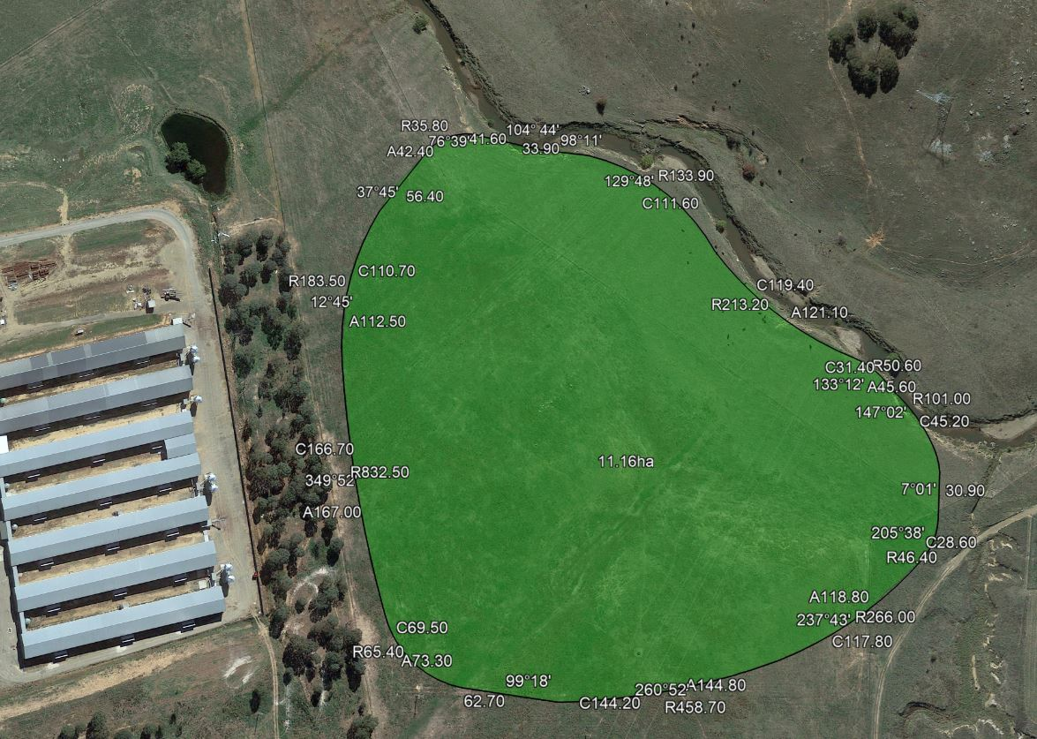
Figure 1 – Proposed Heritage Boundary
Your Comments on the proposed boundary and features that describe the significant attributes of the place:
Click here to enter text.

Section 2 - ACT Heritage Council considerations - significance
A place or object has heritage significance if it meets with one or more of the eight heritage significance criteria as defined under section 10 of the Heritage Act 2004.
The heritage significance criteria are labelled (a) to (h), and your comments are most useful when addressed against each of these criteria, or you could focus on the ones relevant to your argument. However, you may choose to only leave a general comment by skipping to the General Comments section.
The ACT Heritage Council has determined that Ginninderra Creek Corroboree Ground Cultural Gathering Place is likely to have heritage significance under criteria (a, c, g) only. The criteria that are not met can also be commented on.
While the Council will independently assess and research any claims you make against the criteria, it may be helpful to refer to the Heritage Assessment Policy as a guide to providing the strongest argument with appropriate evidence.

(a) importance to the course or pattern of the ACT’s cultural or natural history;
The Council has assessed Ginninderra Creek Corroboree Ground Cultural Gathering Place against criterion (a) and is satisfied that the place is likely to meet this criterion.
This place bears a strong association in the collective memory of Aboriginal people with corroborees, an important aspect of ceremony embedded within the Aboriginal culture practised in the ACT. The importance of the place also relates to the fact that it is a node embedded within a broader associative cultural landscape. This represents cultural interpretations associated with the movements of Aboriginal people along pathways and songlines and the associated cultural interpretation of landscape features.
Your Comments on criterion (a):
Click here to enter text.

(b) has uncommon, rare or endangered aspects of the ACT’s cultural or natural history;
The Council has assessed Ginninderra Creek Corroboree Ground Cultural Gathering Place against criterion (b) and is not satisfied that the place is likely to meet this criterion.
Although this place represents a rare aspect of the ACT’s cultural history that is no longer practised, this association is not evident in the physical fabric of the place.
Your Comments on criterion (b):
Click here to enter text.

(c) potential to yield important information that will contribute to an understanding of the ACT’s cultural or natural history;
The Council has assessed Ginninderra Creek Corroboree Ground Cultural Gathering Place against criterion (c) and is satisfied that the place is likely to meet this criterion.
Due to its location next to the Ginninderra Creek, the fact that archaeological sites that have yielded important information are located nearby, and as a known hub of cultural activity, this place has a high potential to yield information regarding the cultural history of Aboriginal people in the ACT. The place is located immediately adjacent to the archaeological site MW5. The excavation of MW5 revealed one of the highest density sites excavated to date in the ACT and some rarely observed artefact attributes. MW5 also had clearly defined cultural activity areas thus demonstrating that locations along the Ginninderra Creek potentially retain some archaeological integrity. It has also been noted that, in general, locations near the Ginninderra Creek are more likely to possess higher densities of artefacts and be the focus of cultural activities.
Your Comments on criterion (c):
Click here to enter text.

(d) importance in demonstrating the principal characteristics of a class of cultural or natural places or objects;
The Council has assessed Ginninderra Creek Corroboree Ground Cultural Gathering Place against criterion (d) and is not satisfied that the place is likely to meet this criterion.
Although this place could be considered representative of a relatively rare class of Aboriginal culture ‘corroboree grounds,’ this characteristic is not evident in the physical fabric of the place.
Your Comments on criterion (d):
Click here to enter text.

(e) importance in exhibiting particular aesthetic characteristics valued by the ACT community or a cultural group in the ACT;
The Council has assessed Ginninderra Creek Corroboree Ground Cultural Gathering Place against criterion (e) and is not satisfied that the place is likely to meet this criterion.
There are no known aesthetic characteristics associated with the significance of this place.
Your Comments on criterion (e):
Click here to enter text.

(f) importance in demonstrating a high degree of creative or technical achievement for a particular period;
The Council has assessed Ginninderra Creek Corroboree Ground Cultural Gathering Place against criterion (f) and is not satisfied that the place is likely to meet this criterion.
To date there are no known physical features of this place that relate to a high degree of creative or technical achievement. However, there is potential for this to change. This place is a known hub of cultural activity located adjacent to site MW5 and it is known that some of the artefact attributes recorded in the analysis of artefacts from MW5 were rare in the ACT.
Your Comments on criterion (f):
Click here to enter text.

(g) has a strong or special association with the ACT community, or a cultural group in the ACT for social, cultural or spiritual reasons;
The Council has assessed Ginninderra Creek Corroboree Ground Cultural Gathering Place against criterion (g) and is satisfied that the place is likely to meet this criterion.
This place has a special association for the Aboriginal people as a place where corroborees were held. Because corroborees were special community events the memory of this place has endured in oral resources and collective conscious. Although corroborees are no longer held at this location, the place has a strong association for the Aboriginal community in the ACT with their cultural practises that were disrupted by colonisation thus contributing to their sense of cultural continuity and identity.
Your Comments on criterion (g):
Click here to enter text.

(h) has a special association with the life or work of a person, or people, important to the history of the ACT.
The Council has assessed Ginninderra Creek Corroboree Ground Cultural Gathering Place against criterion (h) and is not satisfied that the place is likely to meet this criterion.
To date there are no known associations between this place and specific achievements of an Aboriginal person or people.
Your Comments on criterion (h):
Click here to enter text.

Section 3 – General Comments
I support the proposed heritage registration? Choose an item.
Please include any further comments to your submission:
Click here to enter text.

Section 4 - Demographics
Your personal details are confidential and will not be publicly visible, but this is required for you to be kept informed and to be counted as an ‘interested person’ (refer to the Privacy Statement at the beginning of the document).
If you do not provide your identity or contact details then the ACT Heritage Council will be unable to give you notice of decisions as an interested person under the Act. Also, you may not be able to be identified as an interested person entitled to appeal rights under the Act.
First Name: Click here to enter given name.
Last Name: Click here to enter surname.
Preferred contact details (phone, email, postal address):
Click here to enter address.
Age range: Click to choose an age range.
Relationship to the place: Click to choose a category.
Have you ever provided comments on other heritage registrations? Click to select.

What next?
After you are happy with your comments and have saved this form it can be emailed to heritage@act.gov.au or printed out and mailed to:
The Secretary
ACT Heritage Council
GPO Box 158
Canberra City ACT 2601

