Comments on the Provisional Registration of Yeddung Dhaura, Forde.

***please note that only comments received during the public consultation period will be valid for certain provisions under section 13 and/or review under part 17 of the Heritage Act 2004. This includes comments received no earlier than 12am on 2 June and no later than 11:59pm on 29 June ***

The Council has provisionally registered Yeddung Dhaura as a way to indicate that it intends to make a decision on whether or not to permanently put it on the ACT Heritage Register. The provisional registration sets out what it is about the place that the Council thinks is important to the ACT and why. This public consultation aims to find out the views of the ACT community.

Please read the Provisional Registration Decision and the Background Information documents before starting.

Privacy Statement
This survey fulfils the role of public consultation under section 37 of the Heritage Act 2004 (the Act), and the collection of personal information as authorised by the Act. If you make a comment using this form, you will be considered an interested person under section 13 of the Act. For this reason, the survey requires respondents to provide contact details so functions under the Act relating to notification of interested persons can be fulfilled. If you do not provide your identity or contact details then the ACT Heritage Council will be unable to give you notice of decisions as an interested person under the Act. Also, you may not be able to be identified as an interested person entitled to appeal rights under the Act.
The personal information on this survey is collected by the Environment, Planning and Sustainable Development Directorate (EPSDD) and provided to the ACT Heritage Council. All personal information provided will be collected, used and stored in accordance with the Information Privacy Act 2014 and EPSDD’s Information Privacy Policy, which contains information about how you may access or seek to correct your personal information held by EPSDD and how you may complain about an alleged breach of the Territory Privacy Principles.

Section 1 - ACT Heritage Council considerations - place
The boundary on the map (Figure 1) and the attributes listed below are what the ACT Heritage Council considers to capture the proposed heritage significance of the Yeddung Dhaura. Do you agree or do you have suggested changes you want the Council to consider?
Yeddung Dhaura has the following attributes:
- Yeddung Dhaura contains sub-surface archaeological deposits associated with traditional Aboriginal campsite activities.
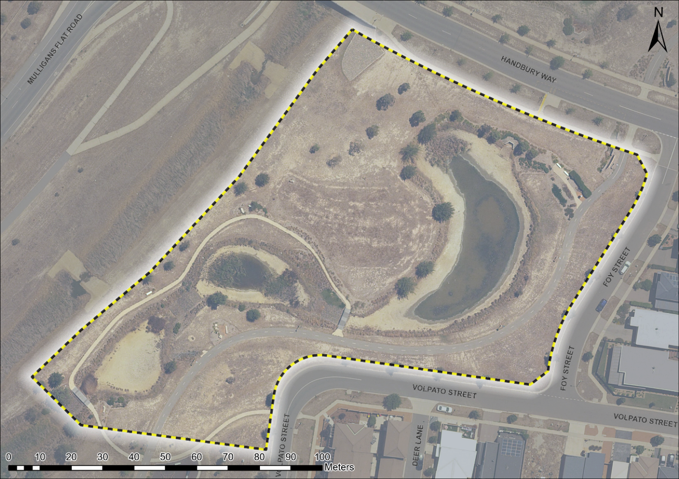
Figure 1 – Proposed Heritage Boundary
Your Comments on the proposed boundary and features that describe the significant attributes of the place:
Click here to enter text.

Section 2 - ACT Heritage Council considerations - significance
A place or object has heritage significance if it meets with one or more of the eight heritage significance criteria as defined under section 10 of the Heritage Act 2004.
The heritage significance criteria are labelled (a) to (h), and your comments are most useful when addressed against each of these criteria, or you could focus on the ones relevant to your argument. However, you may choose to only leave a general comment by skipping to the General Comments section.
The ACT Heritage Council has determined that Yeddung Dhaura is likely to have heritage significance under criteria (a, b, c, d, and g) only. The criteria that are not met can also be commented on.
While the Council will independently assess and research any claims you make against the criteria, it may be helpful to refer to the Heritage Assessment Policy as a guide to providing the strongest argument with appropriate evidence.

(a) importance to the course or pattern of the ACT’s cultural or natural history;
The Council has assessed Yeddung Dhaura against criterion (a) and is satisfied that the place is likely to meet this criterion.
The location, landscape setting and artefact assemblages relating of the Yeddung Dhaura site provide evidence for the traditional Aboriginal lifeways in the ACT that were disrupted by colonisation. The place is a campsite located close to the headwaters of the Ginninderra Creek. The Ginninderra Creek is a pathway known to have been used by Aboriginal people and its significance is linked to a number of prominent locations, both in the immediate area as well as downstream. With its proximity to several known stone and ochre sources, the broader area surrounding Yeddung Dhaura was a regional location for the collection of resources. The Place has one of the highest concentrations of excavated stone artefacts in the ACT. Aboriginal peoples returned to this Place on multiple occasions possibly using it as an itinerant campsite when collecting resources and moving in the cultural corridor along Ginninderra Creek pathway nearby.
Your Comments on criterion (a):
Click here to enter text.

(b) has uncommon, rare or endangered aspects of the ACT’s cultural or natural history;
The Council has assessed Yeddung Dhaura against criterion (b) and is satisfied that the place is likely to meet this criterion.
The in situ nature of the remains within the landscape and relatively high density of the stone remnants contained therein make the Yeddung Dhaura assemblage uncommon, with regards to other stone artefact scatters in the ACT. These attributes demonstrate that this area was a focal point for Aboriginal cultural activities in the ACT.
Your Comments on criterion (b):
Click here to enter text.

(c) potential to yield important information that will contribute to an understanding of the ACT’s cultural or natural history;
The Council has assessed Yeddung Dhaura against criterion (c) and is satisfied that the place is likely to meet this criterion.
As a result of proposed developmental impacts, Yeddung Dhaura was partially excavated and analysed. These activities helped establish its importance as a campsite. However, a substantial portion of the site has been preserved in situ. Therefore, future research could potentially reveal new information regarding Aboriginal land use and connections across the broader landscape.
Your Comments on criterion (c):
Click here to enter text.

(d) importance in demonstrating the principal characteristics of a class of cultural or natural places or objects;
The Council has assessed Yeddung Dhaura against criterion (d) and is satisfied that the place is likely to meet this criterion.
Yeddung Dhaura is a notable example of Aboriginal campsites in the ACT. It is one of only a few known archaeological artefact assemblages in this region with comparably high artefact densities, which implies the relative intensity of Aboriginal presence, and the only one located in proximity to the headwaters of the Ginninderra Creek pathway. Much of the site has been preserved in situ within the nominated area meaning that it is far more intact than other known campsites containing high densities of artefacts, such as Pialligo or Macgregor West.
Your Comments on criterion (d):
Click here to enter text.

(e) importance in exhibiting particular aesthetic characteristics valued by the ACT community or a cultural group in the ACT;
The Council has assessed Yeddung Dhaura against criterion (e) and is not satisfied that the place is likely to meet this criterion.
There are no known aesthetic characteristics associated with the significance of this place.
Your Comments on criterion (e):
Click here to enter text.

(f) importance in demonstrating a high degree of creative or technical achievement for a particular period;
The Council has assessed Yeddung Dhaura against criterion (f) and is not satisfied that the place is likely to meet this criterion.
Although this place is a good example of campsites in the ACT, the artefact collection is fairly typical of material objects that are found in many other known Aboriginal campsites. The significance of the site lies not in the creative and technical achievement of the artefacts contained therein, but rather in their density, intactness and location.
Your Comments on criterion (f):
Click here to enter text.

(g) has a strong or special association with the ACT community, or a cultural group in the ACT for social, cultural or spiritual reasons;
The Council has assessed Yeddung Dhaura against criterion (g) and is satisfied that the place is likely to meet this criterion.
The in situ preservation of material artefacts within this place is significant to the Aboriginal community for the role for demonstrating an enduring physical record and spiritual connection with the traditional Aboriginal way of life, since disrupted by colonisation. Although the precise location of the artefacts were not known to the Aboriginal community prior to the archaeological works they are in fact evidence of a known attachment to this region for the collection of resources and pathways of movement along the Ginninderra Creek. Once identified, the preservation of this locality became a priority for the Aboriginal community, who also advocated strongly for a return to country of the excavated artefacts in order to maintain the on-going social, cultural and spiritual associations to this place in perpetuity.
Your Comments on criterion (g):
Click here to enter text.

(h) has a special association with the life or work of a person, or people, important to the history of the ACT.
The Council has assessed Yeddung Dhaura against criterion (h) and is not satisfied that the place is likely to meet this criterion.
There are no known associations between this place and specific achievements of an Aboriginal person or people.
Your Comments on criterion (h):
Click here to enter text.

Section 3 – General Comments
I support the proposed heritage registration? Choose an item.
Please include any further comments to your submission:
Click here to enter text.

Section 4 - Demographics
Your personal details are confidential and will not be publicly visible, but this is required for you to be kept informed and to be counted as an ‘interested person’ (refer to the Privacy Statement at the beginning of the document).
If you do not provide your identity or contact details then the ACT Heritage Council will be unable to give you notice of decisions as an interested person under the Act. Also, you may not be able to be identified as an interested person entitled to appeal rights under the Act.
First Name: Click here to enter given name.
Last Name: Click here to enter surname.
Preferred contact details (phone, email, postal address):
Click here to enter address.
Age range: Click to choose an age range.
Relationship to the place: Click to choose a category.
Have you ever provided comments on other heritage registrations? Click to select.

What next?
After you are happy with your comments and have saved this form it can be emailed to heritage@act.gov.au or printed out and mailed to:
The Secretary
ACT Heritage Council
GPO Box 158
Canberra City ACT 2601

