Comments on the Provisional Registration of Belconnen Library and Pedestrian Plaza, Belconnen.

***please note that only comments received during the public consultation period will be valid for certain provisions under section 13 and/or review under part 17 of the Heritage Act 2004. This includes comments received no earlier than 12am on 15 February 2022 and no later than 11:59pm on 15 March 2022***

The Council has provisionally registered Belconnen Library and Pedestrian Plaza as a way to indicate that it intends to make a decision on whether or not to permanently put it on the ACT Heritage Register. The provisional registration sets out what it is about the place that the Council thinks is important to the ACT and why. This public consultation aims to find out the views of the ACT community.

Please read the Provisional Registration Decision and the Background Information documents before starting.

Privacy Statement
This survey fulfils the role of public consultation under section 37 of the Heritage Act 2004 (the Act), and the collection of personal information as authorised by the Act. If you make a comment using this form, you will be considered an interested person under section 13 of the Act. For this reason, the survey requires respondents to provide contact details so functions under the Act relating to notification of interested persons can be fulfilled. If you do not provide your identity or contact details then the ACT Heritage Council will be unable to give you notice of decisions as an interested person under the Act. Also, you may not be able to be identified as an interested person entitled to appeal rights under the Act.
The personal information on this survey is collected by the Environment, Planning and Sustainable Development Directorate (EPSDD) and provided to the ACT Heritage Council. All personal information provided will be collected, used and stored in accordance with the Information Privacy Act 2014 and EPSDD’s Information Privacy Policy, which contains information about how you may access or seek to correct your personal information held by EPSDD and how you may complain about an alleged breach of the Territory Privacy Principles.

Section 1 - ACT Heritage Council considerations - place
The boundary on the map (Figure 1) and the attributes listed below are what the ACT Heritage Council considers to capture the proposed heritage significance of the Belconnen Library and Pedestrian Plaza. Do you agree or do you have suggested changes you want the Council to consider?
Belconnen Library and Pedestrian Plaza has the following attributes:

Belconnen Library:
- The off-white sandblasted exposed aggregate concrete surfaces of the original walls and fascias, including original internal concrete surfaces;
- The use of frameless glazing throughout;
- The high level of finish, most notably where different surfaces abut presented as flush surfaces with sharp, clean lines;
- The double height foyer with plate glass entry;
- The linking bridge over the foyer and the corner terrace open to the outside with original steel railings;
- The separated access to the community rooms and bathrooms allowing for after hours entry;
- The open-plan reading room;
- The white ribbed ceiling with original ducting and integrated light fixtures;
- The raised ceiling sections creating voids with clerestory windows around the perimeter that act as light wells (noted as “roof light” in Gibson’s drawings);
- The plain smooth surfaces arranged to juxtapose curved and right-angled surfaces/corners
- The internal display wall on the north side of the foyer;
- The external cantilevered overhangs providing shelter for pedestrian paths;
- The overall horizontal form emphasised by the long, uninterrupted, deep eaves along the vertical plane of the square building boundary, the horizontal slit windows and Corbusian window motifs.

The pedestrian plaza:
- cast concrete retaining walls with angular projections to break up long uninterrupted blank walls;
- the mature original tree from the Emu Bank homestead forming a prominent feature along the eastern boundary;
- the angular amphitheatre stairs;
- the two original ramps;
- original concrete walls and rectangular plinths around garden beds;
- the central flagpole;
- the terraced planter beds with soft landscaping;
- Access to Chandler Street as well as the underpass to the east and the wide footpath leading to Margaret Timpson Park and Belconnen Mall to the west;
Artworks, sculptures and landscaping within the Library and Plaza add to the character of the place and are considered to be complimentary to the heritage significance of the place provided as they do not conflict with any of the features noted in the description of the place above.
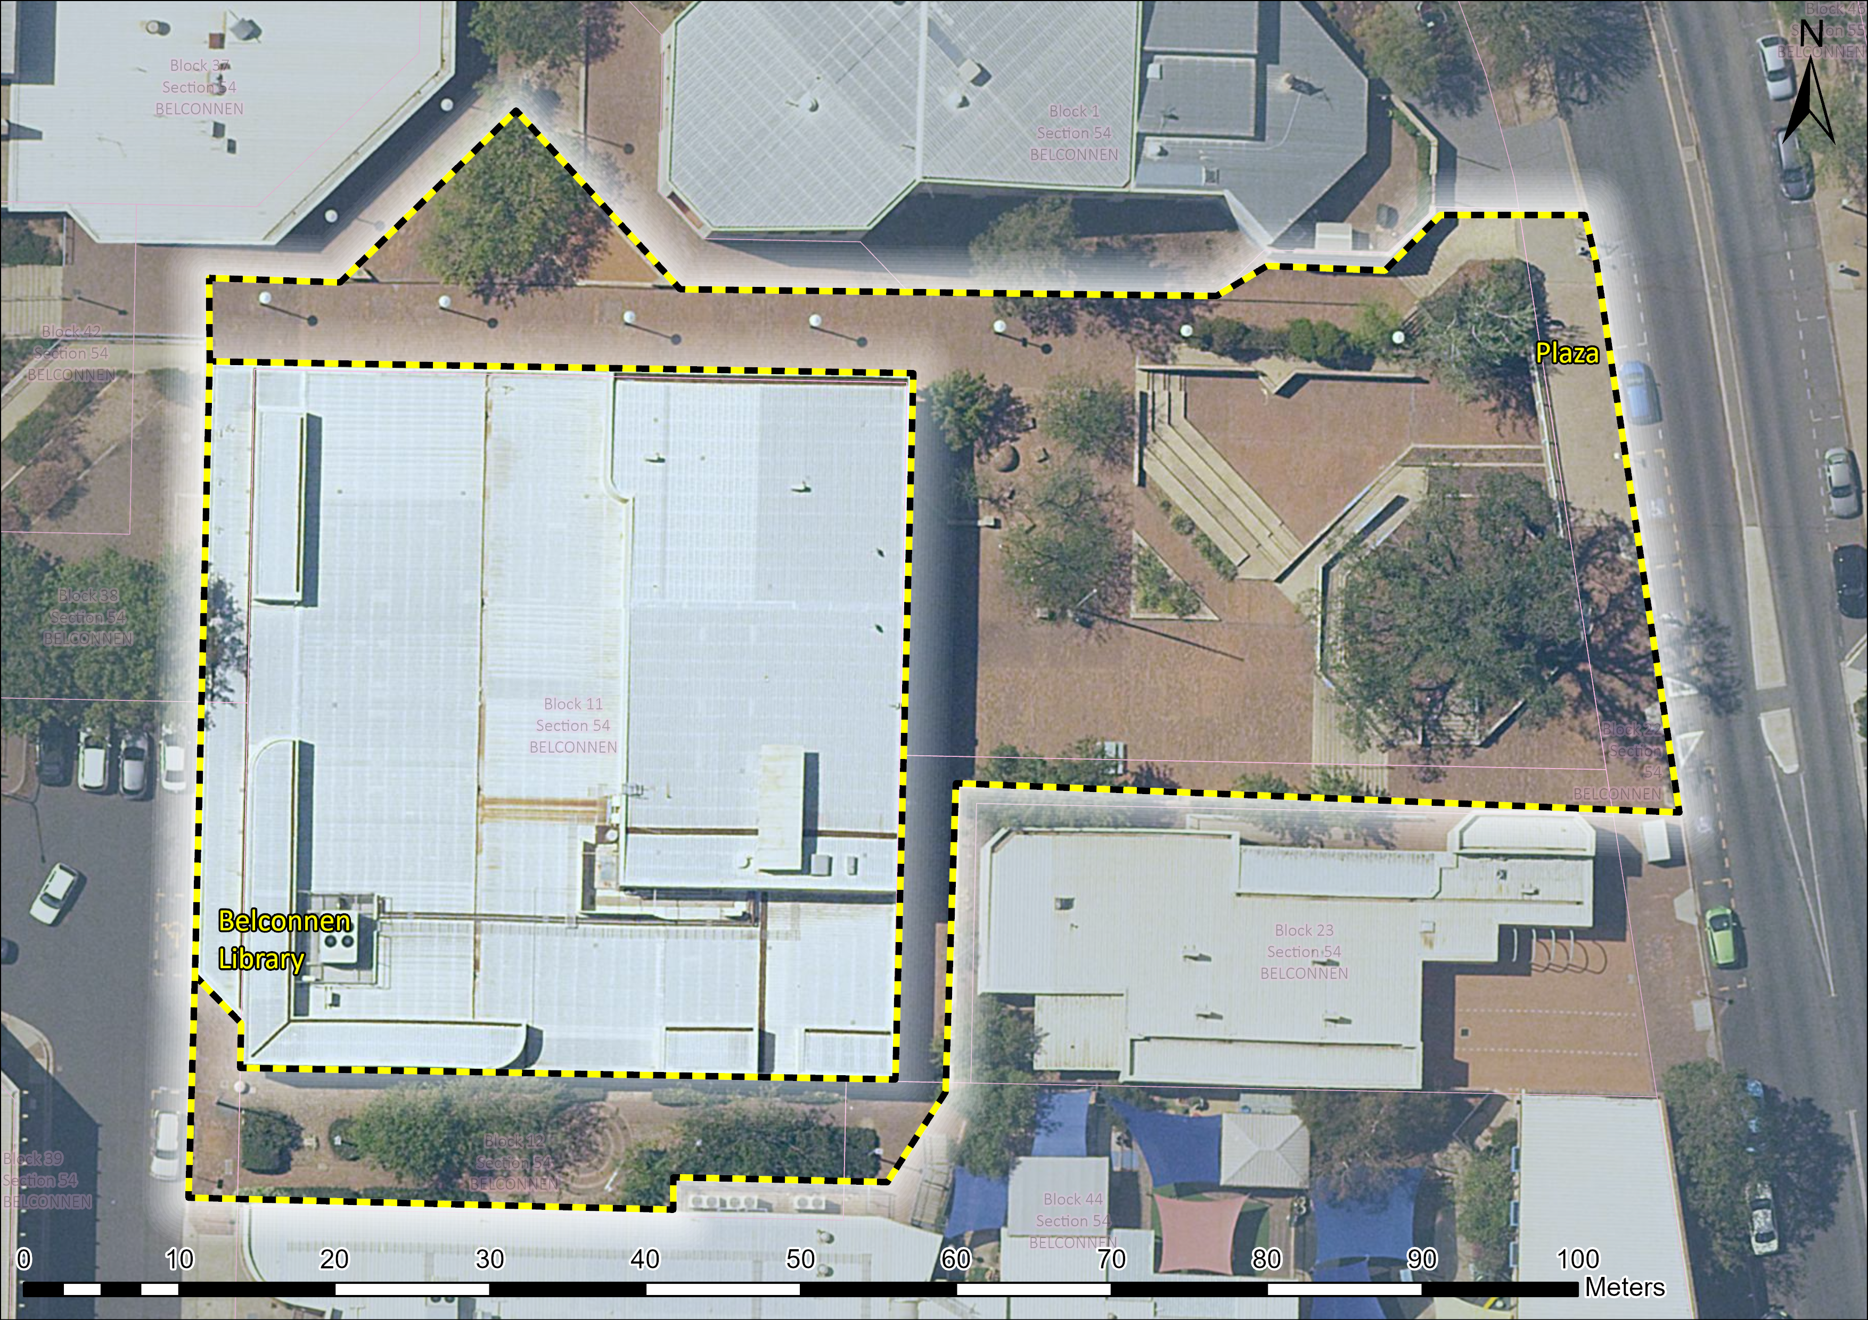
Figure 1 – Proposed Heritage Boundary
Your Comments on the proposed boundary and features that describe the significant attributes of the place:
Click here to enter text.

Section 2 - ACT Heritage Council considerations - significance
A place or object has heritage significance if it meets with one or more of the eight heritage significance criteria as defined under section 10 of the Heritage Act 2004.
The heritage significance criteria are labelled (a) to (h), and your comments are most useful when addressed against each of these criteria, or you could focus on the ones relevant to your argument. However, you may choose to only leave a general comment by skipping to the General Comments section.
The ACT Heritage Council has determined that Belconnen Library and Pedestrian Plaza is likely to have heritage significance under criterion (a) only. The criteria that are not met can also be commented on.
While the Council will independently assess and research any claims you make against the criteria, it may be helpful to refer to the Heritage Assessment Policy as a guide to providing the strongest argument with appropriate evidence.

(a) importance to the course or pattern of the ACT’s cultural or natural history;
The Council has assessed Belconnen Library and Pedestrian Plaza against criterion (a) and is satisfied that the place is likely to meet this criterion.
The Belconnen Library and Pedestrian Plaza is associated with the development of the Belconnen Town centre as an essential community resource serving the Belconnen area since development during the 1970s and 1980s. It set the intent of the town centre planning around the provision of community services. These principles have proved of enduring value, as departures from original schemes for the location of the commercial centre have been rectified in more recent attention to higher density accommodation provision in the immediate vicinity of the Library, better movement connections and commercial development during the 2010s.
Its modernist style of architecture and incorporation into concepts of community-based public space are illustrative of the NCDC’s planning philosophies of town centres serving integrated and balanced communities. The NCDC’s philosophy of commissioning the best architects from around Australia to achieve a broad representation of the country’s architectural talent resulted in Robin Gibson’s only ACT building that also helped to demonstrate leading edge of public architecture.
The library formed an integral part of the Belconnen Town Centre with the NCDC planners expending a great deal of time and effort balancing the needs of the community with that of the Canberra Public Library Service, the Belconnen Mall, the Revival Centre, the Bus Interchange, the Cameron Offices and the surrounding business, educational and residential areas via the pedestrian network and linked Plaza.
The planning of the Belconnen Town Centre did not initially develop as intended, leading to weak connections and a reliance on cars that worked against the Library’s need for co-location to attract users with multi-purpose visits. The Belconnen Mall moved development sites to the west of Benjamin Way and the dense residential and commercial development envisaged along Emu Bank was altered due to community action calling for the waterfront to be left undeveloped, this reduction in density, in turn, led to a greater reliance on cars, exacerbating the poor pedestrian access to the area.
From the mid-2010s, the character of the Belconnen Town Centre has slowly been changing with higher density buildings being developed and the pedestrian and other transport connections reconsidered to better accommodate a growing population. Section 54 is at the heart of planning for the area, which already includes better connections to Emu Bank through the underpass and increasing density from nearby multistorey buildings and recognition of the need to improve movement through the Town Centre. All of these improvements are reinforcing the original design intent of the Library and Plaza that has been retained since its inception under the NCDC in the 1970s.
Your Comments on criterion (a):
Click here to enter text.

(b) has uncommon, rare or endangered aspects of the ACT’s cultural or natural history;
The Council has assessed Belconnen Library and Pedestrian Plaza against criterion (b) and is satisfied that the place is no] likely to meet this criterion.
As noted in criterion (a) above, the Council recognises the role of the Belconnen Library and Pedestrian Plaza in the development of the Belconnen community. The place is also a well-preserved example of Late Twentieth Century International Design, an important style of architecture in the development of the ACT and its public buildings. However, regardless of the aspect of the ACT’s cultural history, whether it is libraries or Late Twentieth Century International style buildings or public buildings/spaces, the Belconnen Library and Pedestrian Plaza are not considered to be sufficiently rare, uncommon, or endangered to the degree required to meet thresholds against this criterion.
Your Comments on criterion (b):
Click here to enter text.

(c) potential to yield important information that will contribute to an understanding of the ACT’s cultural or natural history;
The Council has assessed Belconnen Library and Pedestrian Plaza against criterion (c) and is satisfied that the place is not likely to meet this criterion.
The Council acknowledges the potential of all sound examples of modern architecture to act as teaching sites and sources of information on the history of the ACT. However, any information the Belconnen Library and Pedestrian Plaza is likely to yield on the architect, the style of architecture, or the planning history of the ACT, is already present in the building itself, and the readily accessible documentary record.
Your Comments on criterion (c):
Click here to enter text.

(d) importance in demonstrating the principal characteristics of a class of cultural or natural places or objects;
The Council has assessed Belconnen Library and Pedestrian Plaza against criterion (d) and is satisfied that the place is not likely to meet this criterion.
The Belconnen Library and Pedestrian Plaza are common public places and good examples of their types; however, the Council does not consider that they are important in demonstrating the characteristics of their type; i.e. a particularly fine or pivotal example which is beyond the ordinary so as to pass the threshold for inclusion under this criterion.
It demonstrates and is a good example of the Late Twentieth Century International Style of architecture as evidenced by it being awarded the RAIA ACT Chapter Canberra Medallion in 1982 and then the Australian Institute of Architects ACT Chapter 25 Year Award for Enduring Architecture in 2010.
As a public building, the Library has proven to be flexible enough to adapt to changing trends in library services and has not required any major alterations to accommodate them (e.g. computer cataloguing, RFID systems, various internal refurbishments in response to changes in libraries best practice, etc.). The Plaza has had little change and, while use data is lacking, appears to continue to be an effective space for movement through the area, although it does not appear to be used much for passive recreation.
Your Comments on criterion (d):
Click here to enter text.

(e) importance in exhibiting particular aesthetic characteristics valued by the ACT community or a cultural group in the ACT;
The Council has assessed Belconnen Library and Pedestrian Plaza against criterion (e) and is satisfied that the place is not likely to meet this criterion.
There is insufficient evidence that Belconnen Library and Pedestrian Plaza exhibits design or aesthetic qualities that are valued by the ACT community or a cultural group in the ACT. The Council acknowledges that Belconnen Library and Pedestrian Plaza is valued by the Australian Institute of Architects (AIA) and other architects for reasons relating to its design and aesthetic qualities, however, they do not constitute a cultural group or represent of the ACT community as a whole. The Council-endorsed Heritage Assessment Policy interprets a cultural group as a ‘group of people within a society with a shared ethnic or cultural background’ or ‘a group of people connected through the same way of living, which has been transmitted from one generation to another’. While the Library is clearly valued for its amenity value and is an attractive place the evidence of broader community values specifically related to particular aesthetic values have not been identified to a strong enough level to meet this criterion.
Your Comments on criterion (e):
Click here to enter text.

(f) importance in demonstrating a high degree of creative or technical achievement for a particular period;
The Council has assessed Belconnen Library and Pedestrian Plaza against criterion (f) and is satisfied that the place is not likely to meet this criterion.
The Belconnen Library and Pedestrian Plaza uses conventional building techniques and a suite of design cues for the Late Twentieth Century International style of architecture that were already well established at the time. While it does have some creative elements, such as the method of separating and accessing the community room and the integration of the pedestrian plaza design, these are not considered to be a high enough degree, in that they are not a formative use or so innovative or outside of normal use, that the place meets the threshold for inclusion under this criterion.
Your Comments on criterion (f):
Click here to enter text.

(g) has a strong or special association with the ACT community, or a cultural group in the ACT for social, cultural or spiritual reasons;
The Council has assessed Belconnen Library and Pedestrian Plaza against criterion (g) and is satisfied that the place is not likely to meet this criterion.
There is insufficient evidence that Belconnen Library and Pedestrian Plaza has a strong or special association with the ACT community, or a cultural group in the ACT for social, cultural or spiritual reasons. The Council acknowledges that Belconnen Library and Pedestrian Plaza is valued by the Australian Institute of Architects (AIA) and other architects, however, they do not constitute a cultural group or can be representative of the ACT community as a whole. The Council-endorsed Heritage Assessment Policy interprets a cultural group as a ‘group of people within a society with a shared ethnic or cultural background’ or ‘a group of people connected through the same way of living, which has been transmitted from one generation to another’. While the Library is clearly valued for its amenity value, particularly for the provision of community rooms and a meeting place, and is an important service in general the evidence of broader community or a cultural group having a strong or special association have not been identified to a strong enough level to meet this criterion.
Your Comments on criterion (g):
Click here to enter text.

(h) has a special association with the life or work of a person, or people, important to the history of the ACT.
The Council has assessed Belconnen Library and Pedestrian Plaza against criterion (h) and is satisfied that the place is not likely to meet this criterion.
While Robin Gibson is an important Australian architect, his work is most closely associated with his hometown of Brisbane and greater Queensland. The Belconnen Library and Pedestrian Plaza is representative of the NCDC bringing in a broad range of architects reflecting talent from other states and is the only public building designed by Robin Gibson in the ACT however, there is no evidence to suggest that his association with the place was any more special than with any of his other works and that this association was any more important than any other fine architects that were commissioned by the NCDC at the time leading to a lasting impact on the history of the ACT.
Your Comments on criterion (h):
Click here to enter text.

Section 3 – General Comments
I support the proposed heritage registration? Choose an item.
Please include any further comments to your submission:
Click here to enter text.

Section 4 - Demographics
Your personal details are confidential and will not be publicly visible, but this is required for you to be kept informed and to be counted as an ‘interested person’ (refer to the Privacy Statement at the beginning of the document).
If you do not provide your identity or contact details then the ACT Heritage Council will be unable to give you notice of decisions as an interested person under the Act. Also, you may not be able to be identified as an interested person entitled to appeal rights under the Act.
First Name: Click here to enter given name.
Last Name: Click here to enter surname.
Preferred contact details (phone, email, postal address):
Click here to enter address.
Age range: Click to choose an age range.
Relationship to the place: Click to choose a category.
Have you ever provided comments on other heritage registrations? Click to select.

What next?
After you are happy with your comments and have saved this form it can be emailed to heritage@act.gov.au or printed out and mailed to:
The Secretary
ACT Heritage Council
GPO Box 158
Canberra City ACT 2601

