ACT Disability Policy - where we’ve been and where we’re going
The ACT Government is committed to improving the lives of the more than 80,000 Canberrans who identify as people with disability, by creating a more welcoming and inclusive community.
To guide this commitment over the next 10 years, the ACT Government is developing a Disability Strategy for the ACT. The development of the Strategy will be based on the social model of disability, which is recognised under the United Nations Convention on the Rights of Persons with Disabilities (CRPD).
The social model of disability sees ‘disability’ as an evolving concept and that disability results when people living with impairments interact with an environment filled with physical, attitudinal, communication and social barriers, which hinder their full and effective participation in society on an equal basis with others. The social model of disability seeks to change society in order to remove barriers for people with disability; it does not seek to change people with disability to accommodate society.
From early March 2022 we will start consultations across the whole community through a public listening campaign, to understand what our community wants to see included in the ACT Disability Strategy. We want to hear your ideas, experiences and how you believe the ACT should implement inclusive actions and activities which create change in our community.
We know that change takes a long time, but we are not starting from scratch. Outlined below are actions and activities we have undertaken over the last 10 years to improve the life experiences of people with disability and create a more inclusive Canberra.
Our Foundation - New Australia’s Disability Strategy
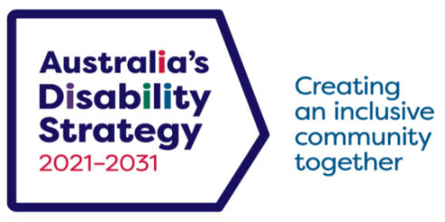
The Australian Government launched Australia’s Disability Strategy 2021-2031 on 3 December 2021. It was developed by all levels of government with people with disability, their families, carers and supporters. The Strategy will drive change over the next decade to uphold the rights, inclusion and participation of people with disability in all areas of Australian life. The Strategy has seven Outcome Areas which are:

- Employment and Financial Security;
- Inclusive Homes and Communities;
- Safety, Rights and Justice;
- Personal and Community Support;
- Education and Learning;
- Health and Wellbeing; and
- Community Attitudes.

During the Australian Government consultations to develop the new Strategy the ACT Disability Reference Group provided a submission after seeking the views of Canberrans and you can read the submission here.
The Australia’s Disability Strategy 2021-31 and supporting documents are available on Australia’s Disability Strategy Hub on the Disability Gateway. A range of Easy Read documents, Auslan interpreted videos and audio descriptions are available on the Disability Gateway.
Disability Policy - Where We’ve Been
Future Directions 2009-2014
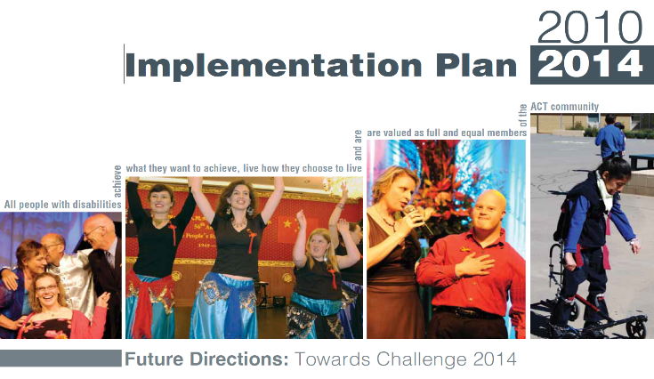
Future Directions 2009-2014 was the ACT Government’s five-year policy framework, focusing actions across the ACT Government and business, sports, arts, and community sectors, to improve outcomes and opportunities for people with disability.
The priorities set out in the framework are the things community told us needed to be improved to fulfil their vision that “All people with disability achieve what they want to achieve, live how they choose to live and are valued as full and equal members of the ACT Community”.
An Implementation Plan 2010–14, set out 22 specific actions delivered by ACT Government agencies and partners to address the six strategic priorities which guided our work:

- I Want the Right Support, Right Time, Right Place;
- I Want to Contribute to the Community;
- I Want to Socialise and Engage in the Community;
- I Want to Know What I Need to Know;
- I Want to Tell My Story Once; and
- I Want a Quality Service System.

Transition to the National Disability Insurance Scheme
In 2011 the Council of Australian Governments (COAG) agreed on the need to reform disability services across Australia through a National Disability Insurance Scheme (NDIS). The ACT began preparation for the implementation of the NDIS from October 2012 and was the first state or territory to sign up as an NDIS trial site, which commenced in the ACT on 1 July 2014.
The NDIS directly funds eligible Australians with disability for reasonable and necessary supports and services that relate to a person's disability which help achieve their goals. The core principle of the NDIS is choice and control for people with disability over the care and support they receive over their lifetime.
As at 31 December 2021, there are 9,101 active NDIS participants with approved plans in the ACT and 1,361 active NDIS support providers. The ACT Government continues to make significant financial contributions to the Scheme and works with the Australian Government to ensure the core NDIS principles of choice and control are upheld and advocates for the removal of barriers, aiming to ensure the NDIS continues to improve the lives of its participants.
INVOLVE 2015-2018 – Canberra Disability Commitment
Picking up where Future Directions left off, Canberra’s Disability Commitment INVOLVE was the ACT Government’s implementation of the National Disability Strategy 2010–20. The campaign focused on community ambitions to achieve change and promote positive outcomes for Canberran’s with disability through the collaborative action of government, business and community. In 2015–16, the priorities were housing, employment and NDIS implementation. In 2016–17 the priorities were justice, health and accessible communities. INVOLVE was supported by a website, www.involvecbr.com.au, where people were able to make a personal pledge on how they would strive to create a more inclusive Canberra.
INVOLVED 2019 – today
The INVOLVED web platform reshaped the focus of INVOLVE from ambitions and pledges for inclusion to actions and achievements. Inclusive Government programs, business and community events and initiatives are highlighted on the website under a set of headings that represent the outcome areas under the previous National Disability Strategy:

- Inclusive and accessible communities
- Learning and skills
- Rights protection, justice and legislation
- Health and wellbeing
- Housing
- Employment and volunteering
- Personal and community support
- Transport

ACT Disability Justice Strategy 2019-29
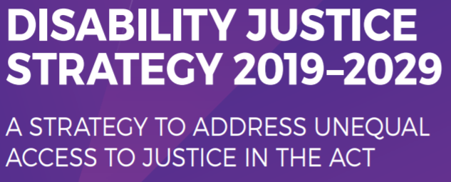
The ACT Disability Justice Strategy 2019–2029 is a ten-year plan which aims to ensure people with disability in the ACT have equal access to justice and support for their right to equality before the law. The Strategy recognises that people with disability experience a greater need for legal support than many other people and also face a range of disadvantages that make them more likely to come into contact with the justice system. The Strategy aims to ensure people with disability understand their rights and more importantly ensure their rights are respected. The Strategy is supported by a series of action plans and review points. The First Action Plan 2019-2023 supports the strategy's five focus areas:

- Information and communication
- Education and guidance
- Identification, screening and assessment
- Better service delivery
- Data, research and review

Where We Are Going
ACT Disability Strategy 2022-32
The ACT Government is starting to develop the 10-year ACT Disability Strategy, to support Australia’s Disability Strategy 2021-31. The new ACT Disability Strategy will aim to:
- Create a blueprint as to how we work to an inclusive future
- Strengthen and consolidate the ACT’s commitment to Australia’s Disability Strategy 2021-31;
- Support the priorities of the national strategy whilst incorporating a local viewpoint which supports Canberran’s with disability plus the broader community; and
- Build on the achievements of previous ACT disability commitments outlined above.
The Strategy will be co-designed with people with disability and the disability sector. This will ensure the voices of people with disability are central to the design, consultation, development and implementation of the Strategy.

The ten-year Strategy will support our commitments under the Australia’s Disability Strategy by aligning with its seven outcome areas and will also include the priorities of Canberran’s with disability.

Commencing in early March 2022 the ACT will begin extensive consultation through a public listening campaign, to understand what the ACT community wants to see included in the Strategy.

The ACT Disability Reference Group has provided advice to the ACT Government on the planning for the Strategy, and all conversations throughout the community consultation will be led by people with disability.

