Comments on the Provisional Registration of Former Commonwealth Bank Building, City.

***please note that only comments received during the public consultation period will be valid for certain provisions under section 13 and/or review under part 17 of the Heritage Act 2004. This includes comments received no earlier than 12am on 7 June and no later than 11:59pm on 4 July ***

The Council has provisionally registered Former Commonwealth Bank Building as a way to indicate that it intends to make a decision on whether or not to permanently put it on the ACT Heritage Register. The provisional registration sets out what it is about the place that the Council thinks is important to the ACT and why. This public consultation aims to find out the views of the ACT community.

Please read the Provisional Registration Decision and the Background Information documents before starting.

Privacy Statement
This survey fulfils the role of public consultation under section 37 of the Heritage Act 2004 (the Act), and the collection of personal information as authorised by the Act. If you make a comment using this form, you will be considered an interested person under section 13 of the Act. For this reason, the survey requires respondents to provide contact details so functions under the Act relating to notification of interested persons can be fulfilled. If you do not provide your identity or contact details then the ACT Heritage Council will be unable to give you notice of decisions as an interested person under the Act. Also, you may not be able to be identified as an interested person entitled to appeal rights under the Act.
The personal information on this survey is collected by the Environment, Planning and Sustainable Development Directorate (EPSDD) and provided to the ACT Heritage Council. All personal information provided will be collected, used and stored in accordance with the Information Privacy Act 2014 and EPSDD’s Information Privacy Policy, which contains information about how you may access or seek to correct your personal information held by EPSDD and how you may complain about an alleged breach of the Territory Privacy Principles.

Section 1 - ACT Heritage Council considerations - place
The boundary on the map (Figure 1) and the attributes listed below are what the ACT Heritage Council considers to capture the proposed heritage significance of the Former Commonwealth Bank Building. Do you agree or do you have suggested changes you want the Council to consider?
The Former Commonwealth Bank Building has the following attributes:
The two façades facing the public domain, not including the door canopy. Particular features of note include:
- The scale, massing and street presence of the building, including the height as related to Ainslie Place and the neighbouring Civic Square Precinct;
- The vertical emphasis created by the fins on the facade;
- The artworks incorporated into the façade at street level, within the pedestrian view; and
- The materials and neutral palette.
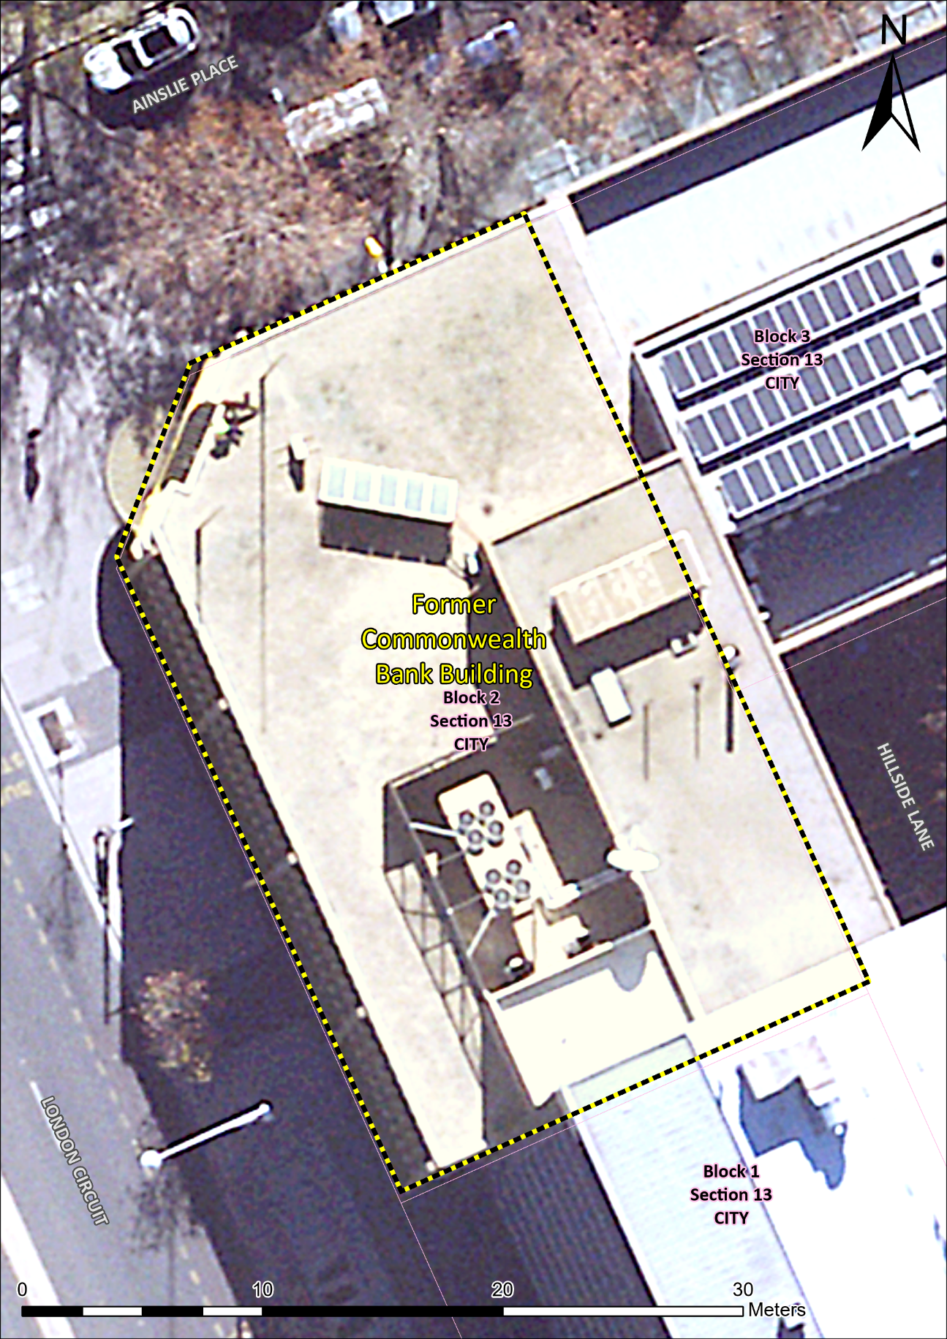
Figure 1 – Proposed Heritage Boundary
Your Comments on the proposed boundary and features that describe the significant attributes of the place:
Click here to enter text.

Section 2 - ACT Heritage Council considerations - significance
A place or object has heritage significance if it meets with one or more of the eight heritage significance criteria as defined under section 10 of the Heritage Act 2004.
The heritage significance criteria are labelled (a) to (h), and your comments are most useful when addressed against each of these criteria, or you could focus on the ones relevant to your argument. However, you may choose to only leave a general comment by skipping to the General Comments section.
The ACT Heritage Council has determined that Former Commonwealth Bank Building is likely to have heritage significance under criteria (a, b, c, d, and g) only. The criteria that are not met can also be commented on.
While the Council will independently assess and research any claims you make against the criteria, it may be helpful to refer to the Heritage Assessment Policy as a guide to providing the strongest argument with appropriate evidence.

(a) importance to the course or pattern of the ACT’s cultural or natural history;
The Council has assessed the Former Commonwealth Bank Building (FCBB) against criterion (a) and is satisfied that the place meets this criterion.
Approved by the National Capital Planning Committee (NCPC) in 1965, and opened in 1967, the FCBB is associated with a significant period of development of the city centre under the direction of the National Capital Development Commission (NCDC).
The external presentation of the FCBB exemplifies the NCDC’s planning and design intentions in the 1960s, which were imposed on the building design through the requirements set out in the lease of the land. These required features and design intentions include:
- The use of distinctive architectural design elements, including the ‘form, silhouette and the colours and textures of the finishing materials’, as well as an emphasis on strong horizontal elements softened by rhythmic vertical lines;
- The coordination of these features and the building height with nearby buildings in Sections 13, 14 and, particularly in the Civic Square precinct, to achieve a coherent design composition;
- The presentation of FCBB as a ‘portal’ building to balance road access and amenity, and to achieve a sense of balance and proportion between it and its neighbouring buildings;
- The FCBB reflects the NCDC’s encouragement of private enterprise investment in the achievement of its planning intentions, in which they assessed the designs put forward by eminent private architects for their conformity to their standards; and
- The encouragement of the inclusion of sculptural works within new buildings as a part of projecting an appropriately sophisticated and progressive image for the city of Canberra.
The siting, external form and façade of the FCBB relate directly to each of these elements and provide a largely intact and well-preserved representation of these values. It is these elements of the FCBB that Council judges to have direct reference to a crucial period in the cultural history of ACT, and especially in the planning of and investment in its inner-city development and functions.
In recommending approval for the building in September 1965, the NCPC noted its ‘high standard’ of design. This endorsement should be seen in the context of the NCDC’s commitment to anchoring its approach to ‘civic design’ not only in individual buildings but in a spatial and visual aesthetic applied in several areas of the city. The FCBB was integral to this approach and practice, including – most immediately – in the Civic Square/Ainslie Avenue precinct already recognised by the Council, and to the west on London Circuit in Hobart Place.
NCDC concepts for the further development of the city centre at that time reflect the considered management of issues of height, bulk, scale, form. Multistorey office developments were proposed to the east of the Civic Square area achieving a tiered affect with lower-level buildings defining the Ainslie Avenue axis off London Circuit graduating to higher buildings further back. The portal and street level elements of the FCBB were integral to this graduated planning, and the symmetry in brought to experience and development of the city.
The investment by the Commonwealth Bank in commissioning a building, designed by then prominent, award-winning firm of Peddle Thorp and Walker, also reflects not only the NCDC’s encouragement of other investment in construction beyond the housing sector but also the desire of the commercial, professional and financial sectors to be more fully represented in the city.
The sculptural panels confirm the NCDC’s intention to promote the inclusion of art in construction projects throughout Canberra at the time of construction. From this perspective, it is primarily the inclusion of those panels in the FCBB that indicates an important dimension of Canberra’s cultural history, rather than the quality of the panels themselves.
Your Comments on criterion (a):
Click here to enter text.

(b) has uncommon, rare or endangered aspects of the ACT’s cultural or natural history;
The Council has assessed the Former Commonwealth Bank Building (FCBB) against criterion (b) and is not satisfied that the place meets this criterion.
The FCBB does not appear to be uncommon or rare as post-war bank building in Canberra. While the contextual history of bank buildings in the ACT is not well documented, at least a number of other surviving examples in the City and elsewhere.
The FCBB is not an uncommon or rare example of the Late Twentieth Century International style. A number of other examples are known to survive, including major examples such as the Cameron Offices and the Edmund Barton Building.
In pursuing its design objectives in planning and building the national capital, the NCDC promoted and encouraged the incorporation of artworks in public spaces and as part of buildings. While many of the known examples are government buildings, the practice was also occasionally extended to other buildings, including commercial buildings. The importance of the artworks is not in their uncommon, rare or endangered aspects, but in the contribution of these to the building’s presentation and the way in which this appearance reflects the urban planning intentions of the NCDC at the time of the building’s construction, rather than in any particular merit of the artworks outside of the context of the building.
Your Comments on criterion (b):
Click here to enter text.

(c) potential to yield important information that will contribute to an understanding of the ACT’s cultural or natural history;
The Council has assessed the Former Commonwealth Bank Building against criterion (c) and is not satisfied that the place meets this criterion.
There is no evidence before the Council that the building has the potential to yield information that will contribute significantly to a wider understanding of the cultural history of the ACT. Any information the place may provide has already been obtained from the documentary and physical evidence and it is unlikely that any further significant evidence could be gained from the physical fabric of the place.
Your Comments on criterion (c):
Click here to enter text.

(d) importance in demonstrating the principal characteristics of a class of cultural or natural places or objects;
The Council has assessed the Former Commonwealth Bank Building (FCBB) against criterion (d) and is not satisfied that the place meets this criterion.
The FCBB displays several features characteristic of the Late Twentieth Century International style. These key features include cubiform overall shape, structural frame expressed (by the columns and beams on the façade) and plain, smooth wall surface (at the splayed corner). Other features are external sun control devices (fins and louvres) and contrasting texture (between the stone cladding and the decorative panels). The expression of these characteristics on the façade of the place are relatively intact. However, there are other examples of this style in Canberra; it has not been shown that this building is comparatively distinctive or recognised (for example, by architectural awards) as important in Late Twentieth Century International architecture.
The FCBB is an example of a post-war and 1960s commercial building and there are some distinctive design features, such as the strong room, that are directly relevant to its use as a bank. However, there is no known type profile for either commercial or banking buildings as a class of place that would enable a meaningful assessment. The range of examples of such buildings in Canberra is also relatively large. In this context, it is not possible to assess any significant values at this time.
Your Comments on criterion (d):
Click here to enter text.

(e) importance in exhibiting particular aesthetic characteristics valued by the ACT community or a cultural group in the ACT;
The Council has assessed the Former Commonwealth Bank Building (FCBB) against criterion (e) and is not satisfied that the place meets this criterion.
The FCBB is an example of the Late Twentieth Century International style and is appreciated for aesthetic characteristics associated with this style by the architectural profession as represented by the Australia Institute of Architects (the Nominator). It also contributes to the urban environment in proximity to the Civic Square precinct. However, the Council does not consider the architectural community to be a cultural group for the purposes of this criterion. The Council’s Heritage Assessment Policy interprets a cultural group as a ‘group of people within a society with a shared ethnic or cultural background’ or ‘a group of people connected through the same way of living, which has been transmitted from one generation to another’. There is no evidence that it is valued for in aesthetic characteristics by the wider ACT community or a cultural group.
Your Comments on criterion (e):
Click here to enter text.

(f) importance in demonstrating a high degree of creative or technical achievement for a particular period;
The Council has assessed the Former Commonwealth Bank Building (FCBB) against criterion (f) and is not satisfied that the place meets this criterion.
There are two elements of the FCBB that could be considered within the context of creative or technical achievements, the decorative panels and the use of the Celdek flooring system. However, neither achieve the high standards necessary for meeting the thresholds of this criterion.
The decorative panels by Mariti on the ground floor façade display creativity, being abstract in form and in keeping with the progressive architectural style of the building. However, neither the artist not the artworks themselves have been specially recognised for their artistic merit, such as being referenced in art publications. Their integrity has been affected by the loss of one panel, possibly two, and overpainting. As discussed in Criterion a, the artworks’ contribution to the heritage significance of the FCBB is in the context of their integration of the artworks into the street presence of the building, and the way in which this reflects the urban planning context at the time the building was constructed.
This building was possibly the first in Canberra to use Celdek cellular steel decking for the upper floor structures. The decking provided ducting for wiring and services, as well as a permanent formwork for the concrete floor slabs of the building. Limited historical information has been found about this flooring system, including the extent of its use in Canberra. However, it was being used in major and much larger multi-story office buildings elsewhere in Australia, such as the AMP Building in Sydney from 1959. In this context, it does not appear that the use of the Celdek system represents a high degree of technical achievement.
Your Comments on criterion (f):
Click here to enter text.

(g) has a strong or special association with the ACT community, or a cultural group in the ACT for social, cultural or spiritual reasons;
The Council has assessed the Former Commonwealth Bank Building against criterion (g) and is not satisfied that the place meets this criterion.
Although the building was the branch of a major bank for over 50 years, including providing foreign currency exchange, there is no substantial research into, or evidence, of a strong or special association with the ACT community, or a cultural group in the ACT for social, cultural or spiritual reasons. The closure of the branch in 2020 seems to have passed without public comment or community concern.
Your Comments on criterion (g):
Click here to enter text.

(h) has a special association with the life or work of a person, or people, important to the history of the ACT.
The Council has assessed the Former Commonwealth Bank Building (FCBB) against criterion (h) and is not satisfied that the place meets this criterion.
The building could potentially be associated with the architects Peddle, Thorp and Walker, the artist responsible for the decorative panels, Silvano Mariti, the Commonwealth Savings Bank of Australia and, given the heritage significance of the building under Criterion a, the National Capital Development Commission (NCDC).
Peddle, Thorp and Walker (now known as PTW Architects) are a prominent architectural firm that has a long history of practise in Australia since 1924. Designs, such as the AMP Building in Sydney (1962), have brought them much attention and they have received many design awards. In Canberra, Peddle, Thorp and Walker designed the Swedish Embassy (a project undertaken in association with E G H Lundquist, 1951, and awarded the Sulman Medal in 1952), the Former Commonwealth Bank Building (1967), 221 London (former Electricity House, 1968), QT Canberra (former Lakeside International Hotel, 1972), and National Gallery of Australia extensions (1997 and 2010). However, in the case of the FCBB, there is nothing to suggest a special association with Peddle, Thorp and Walker: the building was not an early example of its work, it does not appear to be a seminal example and did not achieve wider acknowledgement such as through winning any design awards.
The panels on the façade of the FCBB are the only known examples in Canberra of the work of the artist Silvano Mariti. Outside of Canberra, Mariti appears to have made only modest artistic contributions in Sydney. He was not a prominently recognised artist, was not the focus of critical acclaim or attention, and his works of art are not represented in major collections. Consequently, Mariti is not considered an artist of note in the history of the ACT.
The FCBB was constructed to house the commercial operations of the Commonwealth Savings Bank of Australia, an entity that operated in the building from the time that it was opened in 1967 until its sale in 2020. However, the branch of the bank located nearby, on the corner of London Circuit and Northbourne Avenue, was earlier and its length of association at that location existed for a longer period of time.
Your Comments on criterion (h):
Click here to enter text.

Section 3 – General Comments
I support the proposed heritage registration? Choose an item.
Please include any further comments to your submission:
Click here to enter text.

Section 4 - Demographics
Your personal details are confidential and will not be publicly visible, but this is required for you to be kept informed and to be counted as an ‘interested person’ (refer to the Privacy Statement at the beginning of the document).
If you do not provide your identity or contact details then the ACT Heritage Council will be unable to give you notice of decisions as an interested person under the Act. Also, you may not be able to be identified as an interested person entitled to appeal rights under the Act.
First Name: Click here to enter given name.
Last Name: Click here to enter surname.
Preferred contact details (phone, email, postal address):
Click here to enter address.
Age range: Click to choose an age range.
Relationship to the place: Click to choose a category.
Have you ever provided comments on other heritage registrations? Click to select.

What next?
After you are happy with your comments and have saved this form it can be emailed to heritage@act.gov.au or printed out and mailed to:
The Secretary
ACT Heritage Council
GPO Box 158
Canberra City ACT 2601

