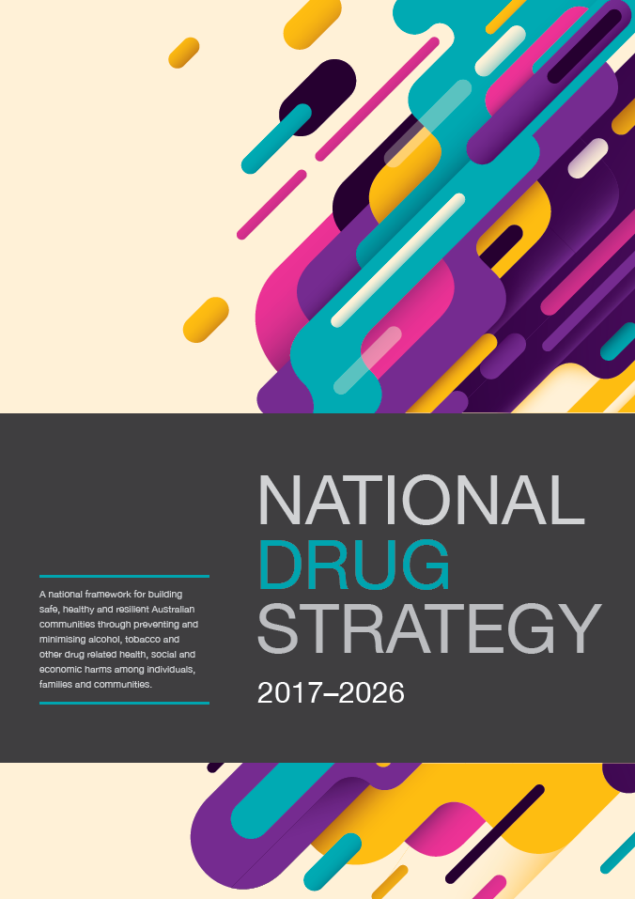

NATIONAL DRUG STRATEGY 2017-2026
A national framework for building safe, healthy and resilient Australian communities through preventing and minimising alcohol, tobacco and other drug related health, social and economic harms among individuals, families and communities.
© Commonwealth of Australia as represented by the Department of Health 2017
National Drug Strategy 2017-2026
Publications Number: 11814
Creative Commons Licence
This publication is licensed under the Creative Commons Attribution 4.0 International Public License available from https://creativecommons.org/licenses/by/4.0/legalcode (“Licence”). You must read and understand the Licence before using any material from this publication.
Restrictions
The Licence may not give you all the permissions necessary for your intended use. For example, other rights (such as publicity, privacy and moral rights) may limit how you use the material found in this publication.
The Licence does not cover, and there is no permission given for, use of any of the following material found in this publication:
- the Commonwealth Coat of Arms. (by way of information, the terms under which the Coat of Arms may be used can be found at www.itsanhonour.gov.au);
- any logos and trademarks;
- any photographs and images;
- any signatures; and
- any material belonging to third parties.
Attribution
Without limiting your obligations under the Licence, the Department of Health requests that you attribute this publication in your work. Any reasonable form of words may be used provided that you:
- include a reference to this publication and where, practicable, the relevant page numbers;
- make it clear that you have permission to use the material under the Creative Commons Attribution
- 4.0 International Public License;
- make it clear whether or not you have changed the material used from this publication;
- include a copyright notice in relation to the material used. In the case of no change to the material, the words “© Commonwealth of Australia (Department of Health) 2017” may be used. In the case where the material has been changed or adapted, the words: “Based on Commonwealth of Australia (Department of Health) material” may be used; and
- do not suggest that the Department of Health endorses you or your use of the material.
Enquiries
Enquiries regarding any other use of this publication should be addressed to the Branch Manager, Communication Branch, Department of Health, GPO Box 9848, Canberra ACT 2601,or via e-mail to corporatecomms@health.gov.au.
Contents
THE NATIONAL DRUG STRATEGY 2017-2026 AT A GLANCE 4
INTRODUCTION 6
POLICY CONTEXT 9
UNDERPINNING PRINCIPLES 16
PRIORITY AREAS OF FOCUS 18
GOVERNANCE 33
MONITORING AND REPORTING PROGRESS 36
APPENDIX – EXAMPLES OF EVIDENCE-BASED AND PRACTICE-INFORMED APPROACHES TO HARM MINIMISATION 38

THE NATIONAL DRUG STRATEGY 2017-2026 AT A GLANCE

Purpose
To provide a national framework which identifies national priorities relating to alcohol, tobacco and other drugs, guides action by governments in partnership with service providers and the community, and outlines a national commitment to harm minimisation through balanced adoption of effective demand, supply and harm reduction strategies.

Aim
To build safe, healthy and resilient Australian communities through preventing and minimising alcohol, tobacco and other drug-related health, social, cultural and economic harms among individuals, families and communities.

A balanced approach across the three pillars of harm minimisation
Demand Reduction | Supply Reduction | Harm Reduction
Preventing the uptake and/ or delaying the onset of use of alcohol, tobacco and other drugs; reducing the misuse of alcohol, tobacco and other drugs in the community; and supporting people to recover from dependence through evidence- informed treatment. | Preventing, stopping, disrupting or otherwise reducing the production and supply of illegal drugs; and controlling, managing and/or regulating the availability of legal drugs. | Reducing the adverse health, social and economic consequences of the use of drugs, for the user, their families and the wider community.
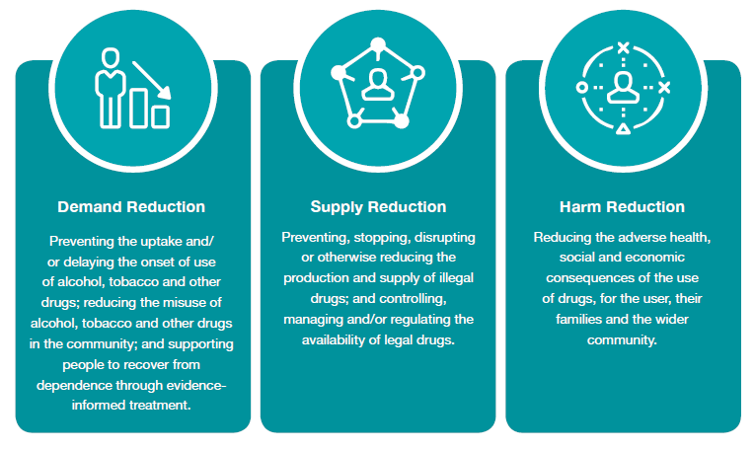

Underpinning strategic principles
- Partnerships
- Coordination and Collaboration
- National direction, jurisdictional implementation
- Evidence-informed responses
Priority Actions | Priority Populations | Priority Substances
Enhance access to evidence informed, effective and affordable treatment  Develop and share data and research, measure performance and outcomes  Develop new and innovative responses to prevent uptake, delay first use and reduce alcohol, tobacco and other drug problems  Increase participatory processes  Reduce adverse consequences  Restrict and/or regulate Availability  - Improve national coordination | Aboriginal and Torres Strait Islander people  People with mental health conditions  Young people  Older people  People in contact with the criminal justice system  Culturally and linguistically diverse populations  People identifying as lesbian, gay, bisexual, transgender, and/or intersex | Methamphetamines and  other stimulants  Alcohol  Tobacco  Cannabis  Non-medical use of pharmaceuticals  Opioids  New psychoactive substances
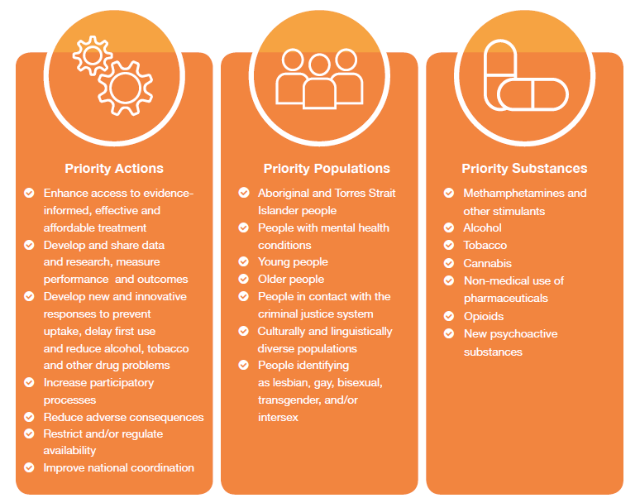

Measuring success
Assess progress by reviewing and reporting against the following headline indicators, using existing published and well-established data sources:
- average age of uptake of drugs, by drug type;
- recent use of any drug (people living in households);
- arrestees’ illicit drug use in the month before committing an offence;
- victims of drug related incidents; and
- drug-related burden of disease (including mortality).
- Reporting will also consider new and emerging data sources, research and evaluation findings both nationally and internationally to ensure progress is monitored according to best available evidence.

INTRODUCTION
A national framework for building safe, healthy and resilient Australian communities through preventing and minimising alcohol, tobacco and other drug-related health, social and economic harms among individuals, families and communities.
Since its first iteration in 1985, Australia’s National Drug Strategy has been underpinned by an objective of minimising the harms associated with alcohol, tobacco, illicit drug and pharmaceutical drug use. Throughout the Strategy, the term ‘other drugs’ is used in reference to illicit drugs and pharmaceutical drugs.
The concept of harm minimisation is again central to this, the seventh iteration of the National Drug Strategy (the Strategy).
This consistent approach to the national drug policy framework has earned high international regard for its progressive, balanced and comprehensive approach and has made considerable achievements. However, alcohol, tobacco and other drug problems continue to impact individuals, families and communities through negative health, legal, social and economic outcomes.
Importantly, for the first time, the Strategy will have a ten-year lifespan, reflecting Australia’s consistent and ongoing approach to national alcohol, tobacco and other drug policy.
The Strategy provides a national framework for action that is able to accommodate new and emerging alcohol, tobacco and other drug issues when they arise, and provides a guide for jurisdictions in developing their individual responses to local alcohol, tobacco and other drug issues. It is expected that each jurisdiction will develop their own accompanying strategy action plan which details the local priorities and activities to be progressed during the Strategy lifespan.
The ongoing cooperation between the law enforcement and health sectors is a key success of the previous National Drug Strategy. In addition to providing a national framework to guide coordinated action to minimise the harms to all from alcohol, tobacco and other drugs, this iteration saw the development of a number of sub-strategies to provide direction and context for specific issues.
During the period of the National Drug Strategy 2010-2015, evidence-informed demand, supply and harm reduction strategies yielded positive results. Some examples include:
In 2014-15, police reported a record 105,862 national illicit drug seizures, and issued 11, 809 diversions for cannabis-related offences1;
- The 2014 survey of Australian secondary students shows that the prevalence of smoking in the past month, past week and on at least three of the past seven days among
- 12- to 15-year-olds was the lowest it has been since 19842; and
- The National Drug Strategy Household Survey reported a decline in the proportion of people exceeding lifetime risk guidelines for consuming alcohol from 20.5% in 2010 to 17.1% in 2016, and declines in the use of some illicit drugs between 2010 and 2016, including
- methamphetamine and ecstasy and a decrease in the proportion of people injecting drugs during this period.

Why do we need a National Drug Strategy?
The harms from alcohol, tobacco and other drugs impact (directly and/or indirectly) on all Australian communities, families and individuals.
Impacts can include:
Health Harms such as:
- injury;
- chronic conditions and preventable diseases (including lung and other cancers; cardiovascular disease; liver cirrhosis);
- mental health problems; and
- road trauma.
Social Harms including:
- violence and other crime;
- engagement with the criminal justice system more broadly;
- unhealthy childhood development and trauma;
- intergenerational trauma;
- contribution to domestic and family violence;
- child protection issues; and
- child/family wellbeing.
Economic Harms associated with:
- healthcare and law enforcement costs;
- decreased productivity;
- associated criminal activity; and
- reinforcement of marginalisation and disadvantage.
Alcohol, tobacco and other drug problems are also associated with social and health determinants, such as discrimination, unemployment, homelessness, poverty and family breakdown.
The Strategy recognises this whole of government impact and while driving cooperation between law enforcement/policing/justice and health sectors to deliver effective responses, it also reflects the need to build and improve the collaboration between agencies responsible for alcohol, tobacco and other drug policy and service delivery, with agencies and providers working in other social service areas working with vulnerable people, including family intervention, child protection and out-of-home-care agencies.
The Strategy identifies nationally agreed priorities which governments will work collaboratively in coordinated, multi-agency approaches to develop and deliver jurisdictional responses that seek to prevent and minimise the harms from alcohol, tobacco and other drugs.

Alcohol & other drugs impact everyone
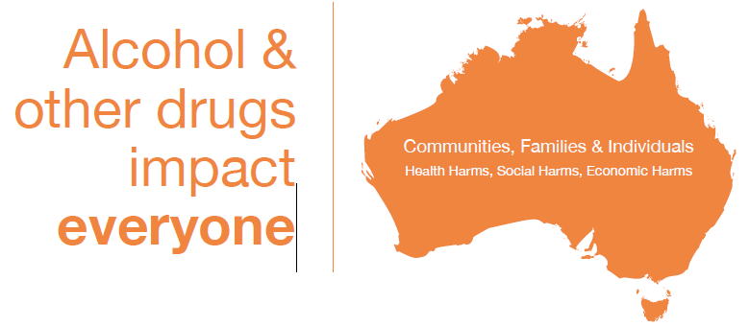

POLICY CONTEXT

Development of the strategy
The Strategy was informed by a national consultation process throughout 2015, which included key informant interviews, online survey feedback and stakeholder forums. The consultation process was invaluable in shaping the direction and priorities for the Strategy, as well as confirming strong support for Australia continuing its commitment to harm minimisation underpinning its national drug policy approach.

Harm minimization
Australia’s long standing commitment to harm minimisation considers the health, social and economic consequences of drug use on individuals, families and communities as a whole and is based on the following considerations:
- drug use occurs across a continuum, from occasional use to dependent use;
- a range of harms are associated with different types and patterns of drug use; and
- the response to these harms requires a multifaceted response.
A harm minimisation policy approach recognises the clear recognition that drug use carries substantial risks, and that drug-users require a range of supports to progressively reduce drug-related harm to themselves and the general community, including families. This policy approach does not condone drug use.
Implementation of the approach presented in this strategy, including funding, legislation and programs, is the responsibility of relevant agencies in Commonwealth, state and territory jurisdictions. The mix of actions adopted in individual jurisdictions and the details of their implementation may vary to reflect local and/or national circumstances and priorities.
This approach reduces the harms of use through coordinated, multi-agency responses that address the three pillars of harm minimisation. These pillars are demand reduction, supply reduction and harm reduction. Strategies to prevent and minimise alcohol, tobacco and other drug problems should be balanced across the three pillars.
Harm minimisation includes a range of approaches to help prevent and reduce drug related problems, and help people experiencing problems (including dependence) address these problems, including a focus on abstinence-oriented strategies.
The relative impact of strategies implemented under demand reduction, supply reduction and harm reduction varies for alcohol, tobacco and other drugs, due to differences in legality and regulation, prevalence of demand and usage behaviours. Strategies are also more effective in combination than separately, and should be tailored to meet the varied needs of individuals, families, communities, and specific population groups.
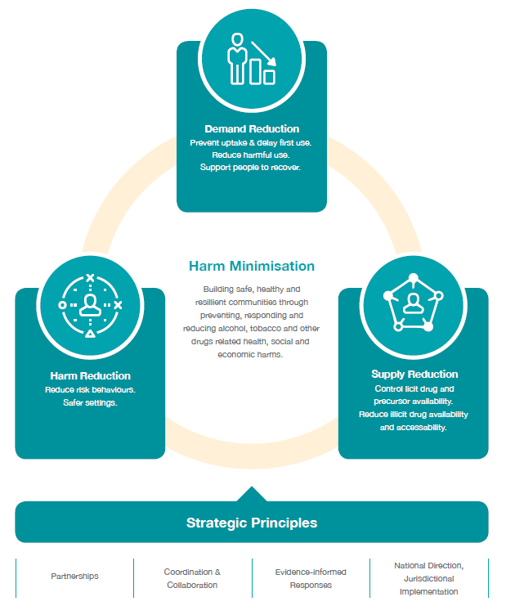

DEMAND REDUCTION
Alcohol, tobacco and other drug use is a multi-determined behaviour, influenced by a range of biological, psychosocial and environmental factors, including socialising, experimentation, excessive availability, coping with stress or difficult life situations, trauma, peer pressure and/ or acceptability, desire to enhance pleasure experiences or intensify feelings and behaviours. Demand reduction strategies influence these factors to delay, prevent or reduce use.
While the percentage of Australians reporting using any illicit drug in the last year has reduced since 1998, 15.6% of the population have used at least one illicit drug in the last year.

Prevent uptake and delay first use
Prevention of uptake reduces personal, family and community harms, allows better use of health and law enforcement resources, generates substantial social and economic benefits and produces a healthier workforce. Demand reduction strategies that prevent drug use are more cost-effective than treating established drug-related problems.
Delaying first use can also lead to improved health and social outcomes. The earlier a person commences use, the greater their risk of harm. This includes mental and physical health problems and a greater risk of continued drug use. Strategies that delay the onset of use prevent longer term harms and costs to the community.
[from 1995 to 2016] The average age that young people smoked their first full cigarette increased from 14.2 to 16.3 years, for the first full drink of alcohol from 14.8 to 16.1 years and initiation into illicit drug use from 18.9 to 19.7 years.

Reduce harmful use
Effective demand reduction approaches that reduce harmful consumption levels over time, or the amount taken on one occasion, can reduce harms. Harmful consumption can arise with the volume consumed, the nature of the drug, the way in which it is used, frequency of use, the context of that use and individual risk factors such as health conditions and age.

Support people to recover from drug related problems
Treatment options and support services have shown to be highly effective in helping reduce risky alcohol, tobacco and other drug use as well as related problems for individuals and the broader community. Alcohol, tobacco and other drug services and support are available within a wide spectrum ranging from peer-based community support, to brief interventions in primary care and hospital services through more intensive specialist treatment services. The best course of action is determined on the nature, complexity and severity of problems. It is critical, therefore, to ensure a range of services and agencies that are appropriately connected through established referral pathways.
It is critical that Australia’s strategy enhances and maintains access to quality evidence-informed treatment. Integrated care is critical to Australia’s response and this includes approaches that allow individuals to connect to services which will address barriers to recovery, which might lead to issues such as physical and mental health needs, social, economic, legal or accommodation considerations. It is important that these services are accessible and tailored
to the diverse needs of individuals affected by drug use.
It is important to also ensure that there is investment in strategies that are critical to long term maintenance of recovery.
Evidence indicates that maintenance of recovery is strongly associated with quality of life. Quality of life factors include issues such as family life, connection to community, employment and recreational opportunities. Therefore, investing in strategies to enhance social engagement, and where indicated, re-integration with community, is central to successful interventions that can reduce alcohol and drug demand and related problems, including dependence.
Approaches that seek to build protective factors and address issues underpinning social determinants of health in order to prevent the initial uptake of drugs can also enhance community health and wellbeing and reduce health inequalities among population groups who experience disproportionate risk of harm from alcohol, tobacco and other drugs. This includes social services and community groups collaborating to improve access to housing, education, vocational and employment support, as well as developing and enhancing family and social connectedness, and strategies to reduce the availability, accessibility and demand for drugs.

Evidence of good practice
Demand reduction requires a comprehensive approach involving a mixture of regulation, government initiatives, community services and treatment services. Strategies that affect demand include:
- reducing the availability and accessibility (such as price mechanisms for alcohol and tobacco);
- improving community understanding and knowledge, reducing stigma and promoting help seeking;
- restrictions on marketing, including advertising and promotion;
- programs focused on building protective factors and social engagement;
- treatment services and brief intervention;
- targeted and culturally appropriate approaches to high prevalence population groups and regions at increased risk of exposure to and harm from alcohol, tobacco and other drugs;
- addressing underlying social, health and economic determinants of use; and
- diversion initiatives.
The Appendix to the Strategy provides a more comprehensive summary of demand reduction approaches.

SUPPLY REDUCTION
Supply reduction strategies aim to restrict availability and access to alcohol, tobacco and other drugs in order to prevent or reduce alcohol, tobacco and other drug problems. Controlling who can use, as well as when, where and how use occurs reduces the harm experienced by both the consumer and the broader community.
More than 17.1% of Australians consume alcohol at a level that puts them at risk of harm from alcohol-related disease or injury over their lifetime and 25.5% drink at levels on a monthly basis that pose a risk in terms of short-term harms, such as injury.

Control licit drug and precursor availability
Harm from alcohol, tobacco and other drug use is associated with when, where and how it occurs and who is using it. The harm from products that are legally available, including tobacco, alcohol and pharmaceuticals, can be reduced by regulating supply. This can include working with industry and informing communities to prevent misuse, enforcing existing regulations, and introducing new restrictions or conditions where required.
Regulating supply also includes ensuring that substances such as pharmaceuticals, precursors, and volatiles are available for legitimate uses, but not diverted for illicit uses.

Prevent and reduce illicit drug availability and accessibility
Preventing or disrupting illicit supply of drugs and precursors reduces availability, leading to a reduction of use and consequential harms. Illicit supply of drugs includes drugs that are prohibited, such as cannabis, heroin, cocaine and methamphetamine, and those diverted from legitimate use, such as pharmaceuticals. It also includes illicit supply of substances that are legitimately available, such as alcohol, tobacco, solvents and those precursors used in illicit drug manufacture.
Preventing illicit supply includes dismantling or disruption of distribution networks and manufacturing and cultivation facilities or locations. It can be closely associated with policing activities aimed at organised crime.
Over the last five years there has been an increase in the availability and purity of methamphetamine (as indicated by more domestic seizures, border detections and arrests). As a consequence, states and territories are reporting an increase in the harms associated with its use including increased presentations to drug treatment services, ambulance attendances and presentations / admissions to Australian public hospitals.

Evidence of good practice
Supply reduction requires regulation, working with industry, intelligence and coordination between enforcement agencies, within jurisdictions, across jurisdictions, nationally and internationally.
Strategies that affect supply include:
- regulating retail and wholesale sale;
- age restrictions;
- border control;
- regulating or disrupting production and distribution; and
- implementation of real-time monitoring of prescription medications so that prescribers can prevent patients inappropriately accessing harmful and substantial quantities of medications.
The Appendix to the Strategy provides a comprehensive summary of examples of supply reduction approaches.
Alcohol has become more affordable and available in Australia with the number of liquor licences increasing around the country over the last 15 years. Increases in the density of liquor outlets have been shown to elevate rates of violence and other alcohol-related harm.

HARM REDUCTION
Harm reduction strategies identify specific risks that arise from drug use. These are risks that can affect the individual who is using drugs, but also others such as family members, friends and the broader community. Harm reduction strategies encourage safer behaviours, reduce preventable risk factors and can contribute to a reduction in health and social inequalities among specific population groups.
The cost to Australian society of alcohol and other drug use in 2004–05 was estimated at $55.2 billion, including costs to the health and hospitals system, lost workplace productivity, road accidents and crime. Of this, tobacco accounted for $31.5 billion (56.2%), alcohol accounted for $15.3 billion (27.3%) and illegal drugs accounted for $8.2 billion (14.6%).

Reduce risk behaviours
Harms from alcohol, tobacco and other drugs can arise from risky behaviours associated with drug use in addition to directly from use. These behaviours can be positively influenced through public policy and programs. Strategies that encourage safer behaviours reduce harm to individuals, families and communities.
Effective public policy has included drink driving laws that have reduced the incidence of driving while intoxicated, smoke-free area laws that have reduced exposure to second hand smoke and needle and syringe programs that have reduced the incidence of people sharing injecting equipment.

Safer settings
Environmental changes can reduce the impacts of alcohol, tobacco and other drug use. Examples include smoke-free areas, chill out spaces, providing food and free water at licensed venues and the opportunity for the safe disposal of needles and syringes. Strategies that create safer settings reduce harm.

Evidence of good practice
Harm reduction requires commitment from government and non-government programs, industry regulation and standards, and targeted communication strategies. Strategies that affect harm reduction include:
- reducing risks associated with particular context, including creating safer settings;
- safe transport and sobering up services;
- protecting children from another’s drug use;
- protecting the community from infectious disease including blood borne virus prevention;
- reducing driving under the influence of alcohol or other drugs; and
- availability of opioid treatment programs.
The Appendix to the Strategy provides a comprehensive summary of examples of harm reduction approaches.
Although Australia has achieved significant reductions in drink driving since the 1980s, it continues to be one of the main causes of road accidents, responsible for 28% of the burden due to road traffic injuries in Australia. Research shows between 20-30% of drink drivers reoffend and contribute disproportionately to road trauma. Alcohol-attributable road accidents in Australia cost an estimated $3.1 billion in 2004-05.

UNDERPINNING PRINCIPLES
In addition to reaffirming Australia’s commitment to a harm minimisation approach as the central basis for national alcohol and drug policy, a number of core underpinning strategic principles have been identified. Any actions or policy directions that are implemented under the National Drug Strategy should reflect these agreed principles.

Evidence-informed responses
Funding, resource allocation and implementation of strategies should be informed by evidence based practice. The Strategy is informed by current evidence; however, evidence is constantly improving and priorities and effective responses will develop during the term of the Strategy.
Innovation and leadership in the development of new approaches is encouraged within the framework of harm minimisation. Supporting research and building and sharing evidence is a key mechanism that allows a national approach to leverage better outcomes from local implementation. Where evidence is not available or limited, effective policy may still be implemented, if it is considered to have strong potential to achieve the desired outcomes, and can be used to expand the knowledge base.

Partnerships
The strong partnership between health and law enforcement has been a key strength of Australia’s National Drug Strategy, and is central to the harm minimisation approach. However, in recognition of the social determinants of alcohol, tobacco and other drug problems and that the age and stage of life issues associated with substance use can result in different risks and harms require integrated, holistic and systems based partnerships. This includes partnerships between both government and non-government agencies in areas such as education, treatment and services, primary health care, justice, child protection, social welfare, fiscal policy, trade, consumer policy, road safety and employment. It also includes partnerships with researchers, families and communities, peer educators, drug user organisations, Aboriginal and Torres Strait Islander communities, and other priority populations.
Jurisdictional engagement with consumers, families and communities is critical to the success of the Strategy. Processes to support appropriate, effective and sustained engagement with all partners are one of the Strategy’s priorities.

Coordination and collaboration
Coordination and collaboration at the international level, nationally and within jurisdictions leads to improved outcomes, innovative responses and better use of resources. The Strategy coordinates the national response to alcohol, tobacco and other drugs by providing a framework for identifying agreed priorities and consistent approaches at a local and national level. The Strategy also facilitates collaboration by describing the wide variety of responsibilities within the harm minimisation approach and their interdependence, as well as through the Strategy’s governance structure.

National direction, jurisdictional implementation
The Strategy describes the nationally agreed goal of harm minimisation for reducing alcohol, tobacco and other drug problems. Examples of evidence-informed approaches are described in the Strategy. However, funding and implementation occurs at all levels of government.
Commonwealth, state and territory governments and local governments are all responsible for regulation and the funding of programs that reduce alcohol, tobacco and other drug problems.
Jurisdictional implementation allows for governments to take action relevant to their jurisdiction with a national harm minimisation approach and strategies should reflect local circumstances and address emerging issues and drug types. Coordination and collaboration supports jurisdictions to develop better responses and innovations within the national approach that can inform and benefit all jurisdictions by sharing practices and learning.

PRIORITY AREAS OF FOCUS
The National Drug Strategy 2017-2026 identifies three different types of priority areas of focus for consideration in implementation: actions, populations and substances. These priorities reflect current available evidence of harms, as well as the views presented through the consultation processes undertaken to support the development of the Strategy.
This is not to say that only the actions, populations and substances identified will be addressed over the lifespan of this strategy, but rather that any policy responses aimed at minimizing the harms of alcohol and drugs should have reference to these priority areas of focus as they represent the areas where it is agreed the biggest gains can be delivered and the largest risk of harm currently exists.
It is also important to note that the examples of evidence-informed approaches highlighted against the priority actions is not exhaustive (a more comprehensive summary is provided in the Appendix to the Strategy), but are provided as an illustration of the types of approaches that could be considered, potentially enhanced and/or further promoted in implementing this Strategy through national collaboration and/or individual jurisdictional implementation. Where relevant, these example activities have been mapped to the applicable harm minimisation pillar.
The priority actions for the Strategy have been identified for specific coordinated action between and across jurisdictions. To achieve the goal of the Strategy, jurisdictions will work together
The priorities for the Strategy are complementary to this approach. They have been identified through a series of national consultations and by reviewing available data and evidence.

Actions
- enhance access to evidence-informed, effective and affordable treatment services and support;
- develop and share data and research, measure ep
- develop new and innovative responses to prevent uptake,
- delay first use and reduce alcohol, tobacco and other drug problems;
- increase participatory processes;
- reduce adverse consequences;
- restrict and/or regulate availability; and
- improve national coordination.

Populations
- Aboriginal and Torres Strait Islander people;
- people with mental health conditions;
- young people;
- older people;
- people in contact with the criminal justice system;
- culturally and linguistically diverse populations; and
- people identifying as lesbian, gay, bisexual, transgender and/or intersex.

Substances
- methamphetamines and other stimulants;
- alcohol;
- tobacco;
- cannabis;
- non-medical use of pharmaceuticals;
- opioids; and
- new psychoactive substances.

PRIORITY: ENHANCING ACCESS TO SERVICES AND SUPPORT
Enhance access to evidence-informed, effective and affordable treatment and support services for the whole population and for the priority populations under this strategy. This includes increasing access to interventions demonstrated to reduce drug dependence, and encourage treatment engagement and compliance.

Evidence-informed approaches relevant to this priority
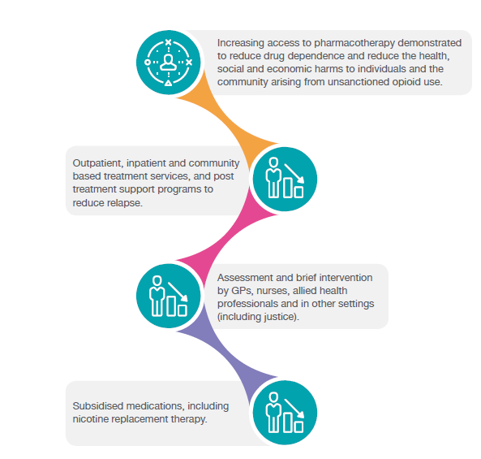

PRIORITY: DEVELOP AND SHARE DATA AND MEASURE PERFORMANCE
Develop new data collections and share data across jurisdictions and research that support evidence-informed approaches, early warning of emerging priorities and measure performance and evaluate outcomes.

Evidence-informed approaches relevant to this priority
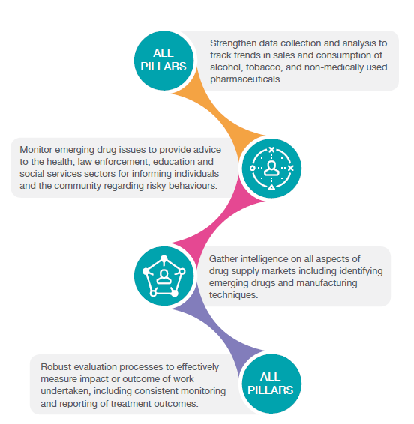

PRIORITY: PREVENTING UPTAKE, DELAYING FIRST USE AND REDUCING USE.
Develop new and innovative responses to prevent uptake, delay the first use and reduce alcohol, tobacco and other drug problems.

Evidence-informed approaches relevant to this priority
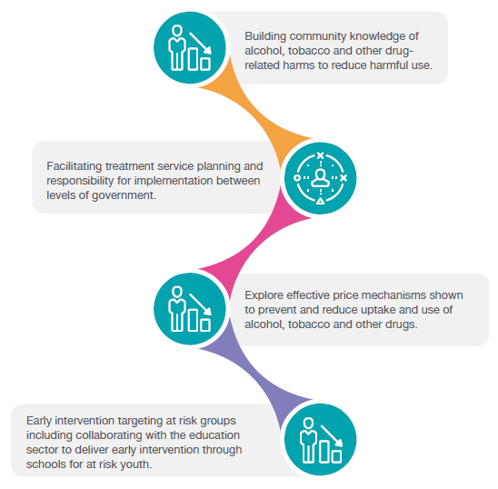

PRIORITY: SUPPORTING COMMUNITY ENGAGEMENT IN IDENTIFYING AND RESPONDING TO ALCOHOL, TOBACCO AND OTHER DRUG ISSUES
Increase participatory processes that facilitate collaboration between governments, the community and non-government sector for greater engagement, integration and involvement in identifying and responding to the key national and international alcohol, tobacco and other drug issues.

Evidence-informed approaches relevant to this priority
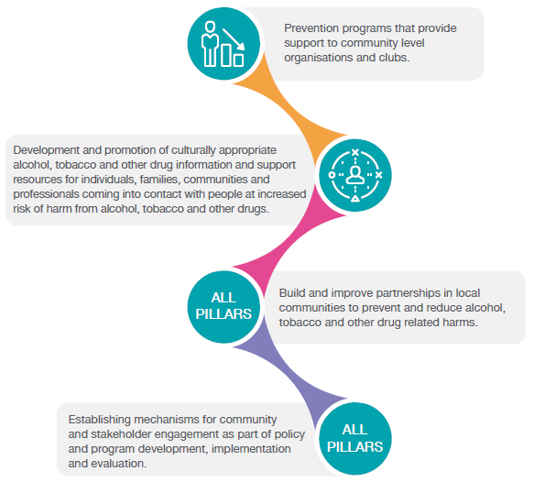

PRIORITY: REDUCING ADVERSE HEALTH, SOCIAL AND ECONOMIC CONSEQUENCES
Prevent and reduce the adverse health, social and economic consequences associated with alcohol, tobacco and other drug problems by enhancing harm reduction approaches.

Evidence-informed approaches relevant to this priority
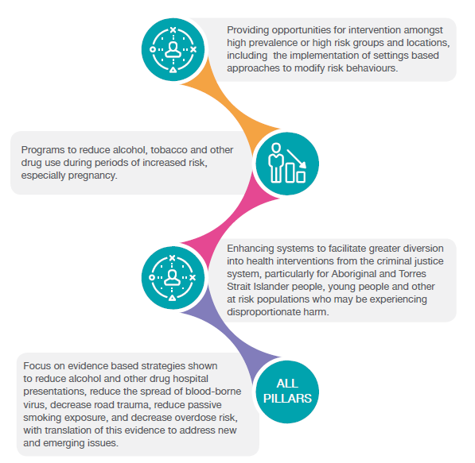

PRIORITY: ADDRESSING AVAILABILITY OF ALCOHOL, TOBACCO AND OTHER DRUGS
Develop responses that restrict or regulate the availability of alcohol, tobacco and other drugs.

Evidence-informed approaches relevant to this priority
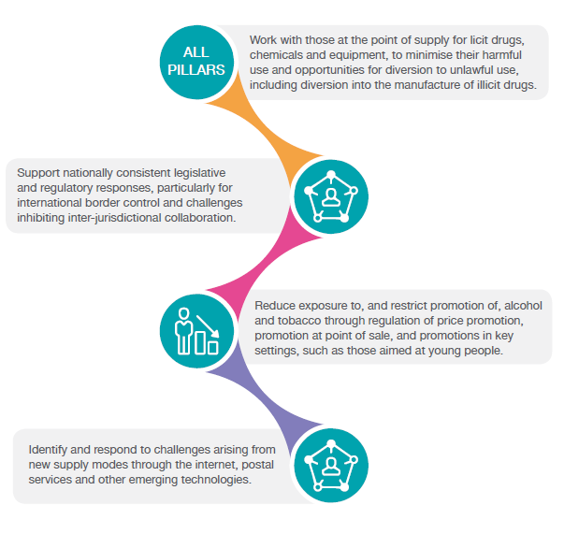

PRIORITY: IMPROVING NATIONAL COORDINATION
Improve national coordination for identifying and addressing alcohol, tobacco and other drug problems, sharing jurisdictional information on innovative approaches, and developing effective responses.

Approaches relevant to this priority
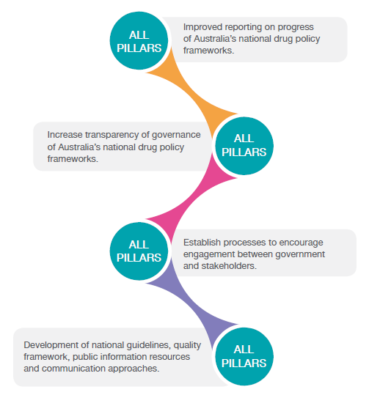

PRIORITY POPULATIONS
Whole of population strategies can be very effective at reducing total harm and social impact of alcohol and drug use. However, there are specific priority population groups who have higher risk of experiencing disproportionate harms (direct and indirect) associated with alcohol, tobacco and other drugs. Policy responses designed to prevent and minimise the harms of alcohol, tobacco and other drugs should have particular reference to these priority populations, to ensure that new efforts will benefit those most at risk of harm, marginalisation and disadvantage.
This does not diminish the importance of providing appropriate and effective responses for any community members who may not fit within one of these particular population groups who require support and resources relating to alcohol, tobacco and other drug harms, as well as improving awareness and understanding of alcohol, tobacco and other drug issues across the broader community.
It is also important to note some of the most effective population strategies, such as pricing mechanisms, have their greatest impact on those who consume the most and young people. Therefore, although they may apply to everyone, they impact the most on populations experiencing disproportionate harms and/or at increased risk of harm.
Further, priority populations can change over time and differ due to local circumstances. Approaches and policy responses aimed at reducing alcohol, tobacco and other drug harms in priority populations should be informed by evidence as it develops and should be reviewed regularly. It is also important that any responses do not inadvertently or unintentionally further marginalise or stigmatise people who are at higher risk of experiencing alcohol, tobacco and other drug related harm.
The Strategy identifies the following priority population groups:

Aboriginal and Torres Strait Islander people
The prevalence of alcohol, tobacco and other drug use among Aboriginal and Torres Strait Islander people is of major concern. Compared to other Australians Aboriginal and Torres Strait Islander people suffer more harm from alcohol, tobacco and other drug use.
There are reasons why this is so, not the least being cultural deprivation and disconnection to cultural values, and traditions, trauma, poverty, discrimination and lack of adequate access to services.
It is critical to ensure that any efforts to reduce the disproportionate harms experienced by Aboriginal and Torres Strait Islander people are culturally responsive and appropriately reflect the broader social, cultural and emotional wellbeing needs of Aboriginal and Torres Strait Islander people. Planning and delivery of services should have strong community engagement including joint planning and evaluation of prevention programs and services provided to Aboriginal and Torres Strait Islander communities taking place at the regional level.
Wherever possible, interventions should be based on evidence of what works specifically for Indigenous people.

People with co-morbid mental health conditions
The use of alcohol, tobacco and other drugs can interact with mental health in ways that create serious adverse effects on many areas of functioning, including work, relationships, health and safety. People with mental health conditions use alcohol, tobacco and other drugs for the same reasons as other people. However, they may also use because the immediate effect can provide an escape from symptoms.
Co-morbidity, or the co-occurrence of an alcohol, tobacco and other drug use disorder with one or more mental health conditions, complicates treatment and services for both conditions. They can also co-occur with physical health conditions (e.g., cirrhosis, hepatitis, heart disease, and diabetes), intellectual and learning disabilities, cognitive impairment, and chronic pain.
Given the strong relationship between mental health and alcohol, tobacco and other drugs, it is imperative to improve the collaboration and coordination between services to ensure that the most appropriate treatment and supports is being made available to the individual.

Young people
Young people (between the ages of 10 and 24) face specific risks in relation to alcohol, tobacco and other drug problems. Rates of risky behaviours are generally higher among young people than the broader population. Some drug use has higher prevalence among young people and associated harm can be reduced by delaying initiation.
The young brain is more susceptible to permanent damage from alcohol, tobacco and other drug use which also makes this group a core priority.

Older people
Harmful use of prescription medications, effects of illicit drug use and alcohol is increasing in older people (ages 60 or over) in Australia. Older people can be more susceptible to alcohol, tobacco and other drug problems as a result of difficulties with pain and medication management, isolation, poor health, significant life events and loss of independent living.

People in contact with the criminal justice system
People in contact with the criminal justice system in Australia have high underlying rates of alcohol, tobacco and other drug problems. In 2015, 67% of prison entrants reported using an illicit drug in the 12 months prior to entering prison, and half of all prison entrants reported using methamphetamine (50%). In 2013–14, 45% of adult detainees interviewed as part of the Drug Use Monitoring in Australia program reported that their alcohol and other drug use contributed to their current detention by police.
Close relationships exist between imprisonment, illicit and injecting drug use, and the prevalence of blood borne virus infections in prisoners. In 2015, blood borne virus prevalence among prison entrants were 31% for hepatitis C, and prevalence was considerably higher among people who inject drugs (57%).
While smoking has been decreasing among the general community in Australia, the same is not true of prisoners, whose smoking rates have remained high. Excluding smoke free prisons, 90% of prisoners report they are current tobacco smokers.

Culturally and linguistically diverse populations
Some culturally and linguistically diverse (CALD) populations have higher rates of, or are at higher risk of, alcohol, tobacco and other drug problems. For example, some members of new migrant populations from countries where alcohol is not commonly used may be at greater risk when they come into contact with Australia’s more liberal drinking culture. Some types of drugs specific to cultural groups, such as kava and khat, can also contribute to problems in the Australian setting and some individuals may have experienced torture, trauma, grief and loss, making them vulnerable to alcohol, tobacco and other drug problems. Other factors that may make CALD groups susceptible to alcohol, tobacco and other drug problems include family stressors, unemployment, language barriers, lack of awareness of programs available, and limited access to programs that are culturally appropriate.

People identifying as gay, lesbian, bisexual, transgender or intersex
People who identify as lesbian, gay, bisexual, transgender and/or intersex (LGBTI) can be at an increased risk of alcohol, tobacco and other drug problems. In 2013, use of licit and illicit drugs was more common in people who identified as homosexual or bisexual in Australia than for those identifying as heterosexual. These risks can be increased by stigma and discrimination, familial issues, marginalisation within their own community as a result of sexually transmitted infections (STIs) and blood borne viruses (BBVs), fear of identification or visibility of LGBTI and a lack of support.

PRIORITY SUBSTANCES
The Strategy also identifies a number of specific priority drug types. These priorities are not just as a result of prevalence among the population, but also the increased harms that these substances bring to an individual and/or the community.
Identifying these substances should not imply that all other drugs should be ignored. It is important for governments and communities to maintain strong surveillance and data collection efforts to stay aware of emerging trends or drugs with concentrated use in specific communities.
It is also important to remember that priority drug types change over time and differ due to local circumstances. Priority drug types should be reviewed and policy responses informed by evidence as it develops. Poly-drug use is also a significant concern and strategies that address this can be very effective at reducing harm.
Current priority drug types include alcohol; tobacco; cannabis; methamphetamines and other stimulants; new psychoactive substances; opioids including heroin; and the non-medical use of pharmaceuticals. These are the drug types associated with the most harm in Australia.

Methamphetamines and other stimulants
Methamphetamine comes in a range of forms, including powder, paste, liquid, tablets and crystalline. Methamphetamines are part of a broader category of stimulants that also includes cocaine, and 3,4-Methylenedioxymethamphetamine (MDMA). Stimulants can be taken orally, smoked, snorted/inhaled and dissolved in water and injected. Some of the harms that can arise from the use of methamphetamines and other stimulants include mental illness, cognitive impairment, cardiovascular problems and overdose.
According to the 2016 National Drug Strategy Household Survey, 1.4% of Australians aged 14 years and over had used methamphetamine in the past 12 months. However, among those who use meth/amphetamine, the use of powder as the main form of the drug used decreased significantly from 50.6% in 2010 to 20.2% in 2016, while the use of crystal-methamphetamine more than doubled since 2010 (from 21.7% to 57.3% in 2016). There was also a significant increase in the percentage of users consuming methamphetamine daily or weekly (from 9.3% in 2010 to 20.4% in 2016). In addition, 39.8% of Australians identified methamphetamine as the illicit drug of most concern to the community (an increase from 16.1% in 2013). Violent behaviour is also more than six times as likely to occur among methamphetamine dependent people when they are using the drug, compared to when they are not using the drug.
In 2015, the Council of Australian Governments (COAG) released the National Ice Action Strategy (NIAS). The oversight of the implementation of the NIAS and the impact of measures will need to be a key priority of governments over the lifespan of the National Drug Strategy.

Alcohol
Alcohol consumption has resulted in significant fiscal and health costs in Australia. In 2010, the cost of alcohol-related harm (including harm to others) was reported to be $36 billion. Alcohol is also associated with over 5,000 deaths and more than 150,000 hospitalisations every year.
Alcohol related harm has a significant impact on Australian society with almost 250,000 Australians estimated to have been the victims of an alcohol-related physical assault in 2015-16. Alcohol also has an impact on frontline police and health workers, for example in Victoria in 2014-15 alcohol was by far the most common substance recorded for alcohol and drug related ambulance attendances with more than double the number of cases for all illicit drugs combined.
The consumption of alcohol during pregnancy can result in birth defects and behavioural and neurodevelopmental abnormalities known as Fetal Alcohol Spectrum Disorder (FASD).
The symptoms of FASD can persist into adulthood and can vary between individuals. The relationship between the consumption of alcohol during pregnancy and the expression of FASD is complicated as not all children exposed to high levels of alcohol during gestation are affected to the same extent. There is no accurate data available on the prevalence of FASD, and it is likely
that current estimates underestimate the prevalence in Australia. Research indicates that there are higher rates among Aboriginal people than non-Indigenous Australians and that certain groups such as children in out-of-home care and children in contact with youth justice services have higher rates of undetected FASD than the rest of the community.
Heavy alcohol use amongst parents is a significant cause of child neglect, lack of responsive care and understimulation. This is one of the major cause of unhealthy early childhood development for many children.
A new National Alcohol Strategy is under development, and is expected to provide a guide for governments, communities, organisations and industry for reducing the harms of alcohol on the Australian community.

Tobacco and nicotine
Tobacco remains a significant cause of death and disability in Australia. Around 2.6 million Australians smoke and each year, smoking is estimated to kill almost 19,000 people. Tobacco smoking also carries the highest burden of drug-related costs on the Australian community.
Australia’s implementation of a range of multifaceted tobacco control measures has been effective in reducing smoking rates over recent decades, with daily smoking for those aged 18 years or older declining in Australia from 16.1% in 2011-12 to 14.5% in 2014-15. This decrease is a continuation of the trend over the past two decades.
However, challenges remain for tobacco, including addressing the inequality in smoking rates between some disadvantaged populations and the broader community. In 2014-15, 21.4% of people living in areas of most disadvantage smoked daily, compared with 8% of people living in areas of the least disadvantage. Recent estimates show that tobacco use is the greatest contributor (23%) to the gap in the disease burden between Indigenous and non-Indigenous Australians. Indigenous Australians were 2.5 times more likely to smoke daily (32% compared to 12.4% for non-Indigenous Australians) and approximately 32% of people reporting a common mental illness smoked daily, more than double the rate in the total Australian population.

Cannabis
Cannabis is a group of substances from the plant cannabis sativa and is available in three main forms: flowering heads, cannabis resin (hashish) and cannabis oil. It is usually smoked, either in a hand-rolled cigarette or through a water-pipe.
In 2016, 10.4% of Australians over the age of 14 had used cannabis in the last 12 months and 34.8% had used cannabis in their lifetime. As the most widely used of the illicit drugs in Australia, cannabis carries a significant burden of disease. The use of cannabis can result in various health impacts, including mental illness, respiratory illness, and cognitive defects. In particular, cannabis dependence among young adults is correlated with, and probably contributes to, mental disorders such as psychosis.

Non-Medical use of pharmaceuticals
The range of pharmaceutical drugs commonly used for non-medical reasons include opioids (such as oxycodone, fentanyl, morphine, methadone, pethidine and codeine), benzodiazepines (such as diazepam, temazepam and alprazolam), and other analgesics (such as paracetamol and ibuprofen in preparations combined with codeine) and performance and image enhancing drugs (such as anabolic steroids, phentermine and human growth hormones). The harms that can arise as a result of the use of pharmaceutical drugs depend on the drug used, but can include fatal and non-fatal overdose. Harms also include infection and blood vessel occlusion from problematic routes of administration, memory lapses, coordination impairments and aggression.

Opioids including heroin
The negative health consequences of heroin and other opioids use include dependence, infectious disease transmission (primarily through risky injecting practice) and death from overdose.
Heroin use ‘in the last 12 months’ has declined from 0.8% in 1998 to 0.2% in 2016. However, Australia has seen an increase in the prescription and use of licit opioids. In particular, the supply of oxycodone and fentanyl increased 22-fold and 46-fold respectively between 1997 and 2012 and the number of prescriptions for opioid prescriptions subsidised by the Pharmaceutical Benefits Scheme increased from 2.4 million to 7 million between 1992 and 2007. Consistent with these trends, hospital separations associated with prescription opioid poisoning have increased substantially.

New psychoactive substances
New psychoactive substances (NPS) are a range of drugs that have been manufactured to mimic other illicit drugs such as cannabis, cocaine, ecstasy and lysergic acid diethylamide (LSD). They include, but are not limited to, synthetic cannabis, mephedrone and methylenedioxypyrovalerone (MDPV). While the effect of the drugs may be similar to other illicit drugs, their chemical structure is different and the effects are not always well known.
One of the principal concerns with the use of NPS is that the products, and their chemical compounds or makeup, are constantly evolving. The rate at which NPS are emerging poses challenges for health and law enforcement responses, as well as traditional scheduling methods for illicit drugs.
The toxicity of each drug is also not often well understood and can be harmful in microgram quantities. The use of NPS is often linked to health problems. NPS users have frequently been hospitalized with severe intoxications. There have also been a number of unexplained suicides associated with preceding use of NPS. In addition, substances like 4-methylmethcathinone (mephedrone), methylenedioxypyrovalerone (MDPV), 4-methylamphetamine (4-MA) have been associated with fatalities.Domestically, several Australian states have moved quickly to place controls on the manufacture, sale and marketing of NPS, in light of the identified risks to public health.
In 2015, the Australian Government introduced laws to ban the importation of NPS on the basis of their psychoactive effect or appearance, rather than their chemical structure. These laws protect against untested and potentially dangerous substances being imported into Australia for use as alternatives to other illicit drugs.

GOVERNANCE
Australia’s alcohol, tobacco and other drug governance arrangements reflect a shared responsibility between justice and law enforcement and the health portfolios.
The Council of Australian Governments (COAG) agreed to reform the governance arrangements responsible for the oversight, development, implementation and monitoring of Australia’s national drug policy frameworks as part of the implementation of the National Ice Action Strategy inlate 2015.
The new governance arrangements have been designed in recognition of the high priority on issues relating to alcohol, tobacco and other drugs by all governments and the need for improved responsiveness in dealing with the national policy challenges associated with this complex area. Importantly, these new arrangements reaffirm Australia’s commitment to a balanced approach to national drug policy built on the strong partnership between health and law enforcement/justice portfolios.
These governance arrangements are depicted in the Figure 1.

The Ministerial Drug and Alcohol Forum
The Ministerial Drug and Alcohol Forum (MDAF) is ultimately responsible for the oversight, implementation and monitoring of Australia’s national drug policy frameworks. It’s membership consists of Ministers from across Australia with responsibility for alcohol and other drug policy from the health and justice/law enforcement portfolios from each jurisdiction. The MDAF reports directly to COAG, and also provides information which may be of assistance to the COAG Health Council and the COAG Law, Crime and Community Safety Council.
The Terms of Reference for the MDAF and summary of the work undertaken can be on the Ministerial Drug and Alcohol Forum under the Department of Health website

The National Drug Strategy Committee
The National Drug Strategy Committee (NDSC) supports the work of the MDAF and consists of senior officials from the Government agencies responsible for alcohol and other drug policy from the health and justice/law enforcement portfolios from each jurisdiction.
The work of the NDSC relies on partnerships and linkages to a number of committees, including Australian Health Ministers Advisory Council (AHMAC), Mental Health Principal Committee and National Justice and Policing Senior Officials Group (NJPSOG).

Time Limited Working Groups and Expert Working Groups
The NDSC has the ability to establish Time Limited Working Groups to undertake work on particular projects or issues and/or establish Expert Working Groups to provide ongoing policy and implementation advice on a broad topic (such as the Tobacco Reference Group).
Membership of these groups is not restricted to representatives of Government agencies, and the NDSC is expected to look for opportunities for involvement in these groups for the participation of expert members from Non-Government Organisations, the research, treatment, intelligence and public health sectors as is appropriate (depending on the project and/or issue being considered).
Many jurisdictions also utilise their own jurisdictional non-government experts, professional networks, and advisory committees to help inform and shape the work being undertaken by the NDSC and the advice being provided to the MDAF.
Over the life of the Strategy, the NDSC will continue to look at opportunities to build and develop more partnerships with the non-government sectors in implementing and considering the progress of the Strategy.
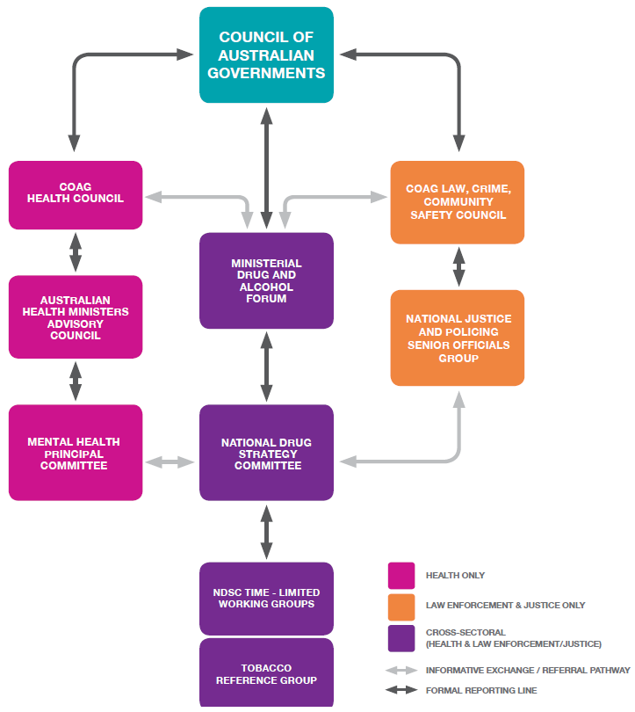
Figure 1. Governance arrangement diagram

Sub-Strategies
There are a number of sub-strategies that sit under the National Drug Strategy 2017-2026. These sub-strategies provide direction and context for specific issues, while maintaining the overarching consistent and coordinated approach to addressing alcohol, tobacco and other drug problems:
- National Ice Action Strategy
- National Aboriginal Torres Strait Islander Peoples Drug Strategy 2014–2019
- National Alcohol and other Drug Workforce Development Strategy 2015–2018
- National Tobacco Strategy 2012–2018
It is intended that Australia’s next National Alcohol Strategy will be finalised in 2017, and will act as a sub-strategy of this National Drug Strategy.
In implementing the National Drug Strategy, governments should also consider the National Pharmaceutical Misuse Framework for Action (which expired in 2015).
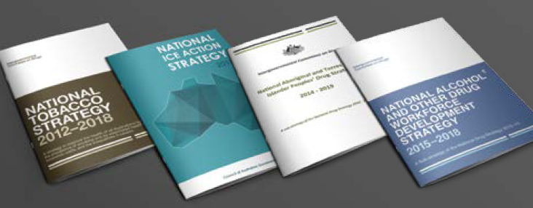

Other relevant national frameworks
In recognition that the impacts and harms related to alcohol, tobacco and other drugs are far reaching across many sectors, it is important for the aims, priorities and principles of the National Drug Strategy to be reflected and considered in the implementation of other key relevant national frameworks and policies, including:
- The 5th National Mental Health Plan;
- The Indigenous Advancement Strategy;
- National Aboriginal and Torres Strait Islander Health Plan 2013–2023;
- The Closing the Gap program;
- National Strategic Framework for Aboriginal and Torres Strait Islander Mental Health and Social Emotional Wellbeing (2017–2023);
- Family and Domestic Violence Strategy;
- National Homelessness Strategy;
- National Organised Crime Response Plan 2015–2018;
- National Road Safety Strategy 2011–2020;
- National Ageing and Aged Care strategies;
- National Disability Strategy; and
- WHO Framework Convention on Tobacco Control.

MONITORING AND REPORTING PROGRESS
The measurement of how effective the Strategy is requiring a coordinated national effort. Under this Strategy, the NDSC will coordinate an annual progress report for the MDAF which will provide an update on jurisdictional and national activity, identify trends and emerging issues based on the best available data (examples of some of the current data sources from which the annual report may draw from are indicated below). These annual reports will be published by the MDAF on Ministerial Drug and Alcohol Forum webpage on the Department of Health site.
A more detailed progress report will be prepared by the NDSC for the MDAF to submit to COAG in line with the release of the findings of the National Drug Strategy Household Survey against the key measures of success outlined below. The schedule for these progress reports to be provided to COAG is 2018, 2021, 2024 and a final report in 2027.
Given that, for the first time, Australia has a ten-year Strategy, the NDSC will undertake a mid- point review of the Strategy in 2021-22 to provide an opportunity to identify any new priorities, emerging issues or challenges.

Measures of Success
In order to measure the success of the Strategy, five headline indicators will be monitored to illustrate progress which the MDAF will report to COAG in line with the release of the findings from the National Drug Strategy Household Survey.
Most of these measures are taken from the Evaluation and Monitoring of the National Drug Strategy 2004–2009 Final Report. The proposed measures use existing published data sources to help ensure continuity.
The performance measures are high-level, as data are not always comprehensive enough to provide robust national measures of activity and progress. It is not possible to directly match the objectives of the Strategy, or each drug type, to a performance measure.
Developing improved datasets to measure performance and outcomes for ongoing monitoring are one of the Strategy’s priorities.
- Increasing the average age of uptake of drugs, by drug type
National Drug Strategy Household Survey Baseline (2016):
- Average age of uptake of: illicit drugs 19.7 years; alcohol: 17.3 years; smoking: 16.4 years
- Reduction of the recent use of any drug, people living in households
National Drug Strategy Household Survey Baseline (2016):
- Use of illicit drugs in the last 12 months: 15.6%
- Harmful use of alcohol: lifetime: 17.1%; short-term: 37.3%
- Use of tobacco daily (14+ years): 12.2%
- Reduction in arrestees’ illicit drug use in the month before committing an offence for which charged
Drug Use Monitoring in Australia Baseline 2013-14:
- Detainees who tested positive for drug use based on urinalysis: 73%
- Reduction in the number of victims of drug-related incidents
National Drug Strategy Household Survey Baseline (2016):
- Victims of illicit drug-related incidents in the last 12 months: 9.3%
- Victims of alcohol-related incidents in the last 12 months: 22.2%
- Reduction in the drug-related burden of disease, including mortality
Australian Burden of Disease Study Baseline (2011):
- Ilicit drugs: 1.8%
- Alcohol: 5.1%
- Tobacco: 9.0%

Supplementary indicators
In addition to the findings from the National Drug Strategy Household Survey and regular COAG reporting, the NDSC will prepare an annual progress report for MDAF which utilises the following indicators (and any new data sources that might be developed over the lifespan of the Strategy) to monitor implementation, progress and emerging issues.
- Illicit drugs and precursors seized;
- The availability of illegal drugs, as perceived by people who use illegal drugs;
- The purity of illegal drugs;
- Evaluation data from current policy interventions, programs and projects;
- Hepatitis C virus (HCV) and HIV/AIDS incidence;
- Opioid pharmacotherapy clients;
- Drug treatment episodes;
- Diversion of licit drugs e.g. pharmaceuticals;
- Coronial data sources;
- Wastewater analysis;
- The Illicit Drug Data Report; and
- Alcohol and other drug attributable hospital admissions and ambulance attendances.

APPENDIX – EXAMPLES OF EVIDENCE-BASED AND PRACTICE-INFORMED APPROACHES TO HARM MINIMISATION

DEMAND REDUCTION

TOBACCO
Approach | Strategies
Price mechanisms | Excise tax increases
Build community knowledge and change acceptability of use | Sustained, high volume social marketing campaigns that encourage tobacco cessation  Labelling and health warnings
Restrictions on promotion | Plain packaging  Advertising bans  Retail display bans
Treatment | Cessation support counselling  Pharmacotherapies  Subsidised medications, including smoking cessation aids

ALCOHOL
Approach | Strategies
Price mechanisms | Excise tax increases  Volumetric excise tax  Minimum floor price  Regulate price discounting and bundling
Build community knowledge and change acceptability of use | Social marketing strategies, including campaigns, as part of a comprehensive response  Promotion of National Health and Medical Research Council’s Australian Guidelines to Reduce Health Risks from Drinking Alcohol
Restrictions on promotion | Enforced advertising standards and restrictions  Regulate price promotion  Regulate promotion at point of sale  Regulate promotions in key settings, such as those aimed at young people
Treatment | Outpatient, inpatient and community based treatment services  Medication assisted treatment for alcohol dependence  Family-support programs that can positively impact on patterns of drug use (including intergenerational patterns)  Post treatment support programs to reduce relapse

ILLICIT AND ILLICITLY USED
Approach | Strategies
Price mechanisms | Influence the market price of illicit drugs by law enforcement and border control activities
Build community knowledge and change acceptability of use | Targeted social marketing campaigns as part of a comprehensive response  Peer education networks
Treatment | Outpatient, inpatient and community based treatment services  Medication assisted treatment of opioid and other drug dependence  Access to community pharmacies and GPs for drug treatment to support both community participation and long term treatment outcomes  Family-support programs that can prevent patterns of drug use (including intergenerational patterns)
Diversion | Diversion from the criminal justice system to treatment services

ALL DRUGS
Approach | Strategies
Build community knowledge and change acceptability of use | School programs, policies and curriculum  Support programs targeting life transition points  Build parenting and family capacity to support the positive development of children  Social competence training  Increased engagement in community activity (education, employment, cultural, sporting)
Treatment | Assessment and brief intervention by GPs, nurses, allied health professionals and in other settings  Treatment guidelines that support evidence based approaches
Targeted approaches to priority populations, including Aboriginal and Torres Strait Islander people | Supporting the Aboriginal Community Controlled sector to provide treatment services within and for Aboriginal communities  Capacity building for health services and training for key workers  Targeted social marketing strategies
Social determinants of health | Address underlying determinants of alcohol, tobacco and other drug problems for individuals, communities and priority populations
Workforce | Building the capacity of the workforce to deliver services and respond to emerging issues

SUPPLY REDUCTION

TOBACCO
Approach | Strategies
Regulating retail sale | Retail licensing schemes, supported by strong enforcement and retailer education  Restrictions on temporary outlets and vending machines  Detect and disrupt sales of prohibited products
Age restrictions | Ban sales to people under 18
Border control | Interrupt illegal importation and enforce payment of excise tax  Duty free restrictions
Regulating or disrupting production and distribution | Regulating production  Regulating wholesaler distribution  Detect and disrupt illegally grown or produced products

ALCOHOL
Approach | Strategies
Regulating retail sale | Retail licensing schemes supported by strong enforcement and retailer education Coordinated medication management system  Restricting the type of retailers or venues that can sell  Limiting the density of licensed retailers and venues  Limiting trading hours  Responsible alcohol service schemes  Liquor licensing restrictions  Detect and disrupt sales of prohibited products  Declaration of dry communities  Lower strength alcohol sale requirements
Age restrictions | Ban sale to people under 18  Secondary supply restrictions
Border control | Interrupt illegal importation and enforce payment of excise tax  Duty free restrictions
Regulating or disrupting production and distribution | Regulating production  Regulating wholesaler distribution  Detect and disrupt illegally produced products

ILLICIT AND ILLICITLY USED
Approach | Strategies
Regulating retail sale | Licensing schemes for pharmacists, veterinarians and other health professionals that sell pharmaceuticals  Coordinated medication management system  Electronic prescriptions to minimise the risk of dispensing errors and fraudulent alteration of prescriptions  Substitution of low aromatic fuel in vulnerable locations for volatile substance abuse
Supporting workers at the point of supply | Supporting workers at the point of supply of licit drugs, chemicals and equipment to reduce their misuse or diversion  Real time reporting of prescribing and dispensing events
Age restrictions | Restricting sale of volatiles to people under 18
Supporting prescribers and dispensers | National guidelines for treatment of conditions commonly indicated in problematic use  Professional peer review mechanisms  Increase training and support for prescribers and those at the point of supply of pharmaceutical drugs to reduce the inappropriate supply, misuse and diversion  Provide and promote use of Medicare Benefits Schedule items that remunerate and target medication review and non-pharmacological management of certain conditions  Increase training and support for those at the point of supply of pharmaceutical drugs to reduce the inappropriate supply, misuse and diversion  Real time national monitoring of precursor chemicals and equipment
Border control | Prevent or disrupt transnational supply of prohibited substances and precursors
Regulating or disrupting production and distribution | Prevent, stop, disrupt or reduce production and supply  Disrupt and dismantle criminal groups involved in production, trafficking and supply of illicit drugs and precursors  Target financial proceeds and the confiscation of assets arising from illicit supply activities  Regulate the legitimate trade of pharmaceuticals, precursors and equipment used in the manufacture of illicit drugs
Enforcing legislation | Asset confiscation  Search, seize and destruction powers

ALL DRUGS
Approach | Strategies
Regulating or disrupting production and distribution | Regularly review legislation and scheduling to capture emerging substances, production mechanisms, devices and distribution methods  Timely enforcement of legislation with meaningful penalties  Implement Australia’s obligations under international treaties
Intelligence | Cooperation and collaboration between law enforcement and forensic agencies, across jurisdictions  Build and maintain strong relationships with international partner agencies and bodies  Gather intelligence on all aspects of drug supply markets including identifying emerging drugs and manufacturing techniques  Effectively utilising trend monitoring and data collection
Workforce | Building the capacity of the workforce to deliver services and respond to emerging issues

HARM REDUCTION

TOBACCO
Approach | Strategies
Safer settings | Smoke-free areas
Smoking cessation aids | Nicotine Replacement Therapy

ALCOHOL
Approach | Strategies
Safe transport and sobering up services | Sobering up facilities  Mobile assistance patrols  Access to public transport
Safer settings | Promotion of responsible venue operations  Dry areas  Mandatory plastic glassware in high risk venues  Availability of free water at licensed venues  Lock out times  Emergency services responses to critical Incidents  Maintenance of public safety

ILLICIT AND ILLICITLY USED
Approach | Strategies
Safer settings | Chill-out spaces  Availability of free water at licensed venues  Information and peer education  Emergency services responses to critical incidents  Maintenance of public safety
Diversion | Diversion from the criminal justice system to treatment services
Blood borne virus prevention | Hepatitis B vaccination  BBV and STI testing, prevention, counselling and  Treatment  Peer education
Safer injecting practices | Diversity and accessibility of needle and syringe  programs  Medically supervised injection centres and drug  consumption rooms  Peer education  Prevent and respond to overdose including increased  access to naloxone  Police policy to exercise discretion when attending  drug overdoses  Non-injecting routes of administration
Replacement therapies | Pharmacotherapy for opioid maintenance and other drug use

ALL DRUGS
Approaches | Strategies
Periods of increased risk | Programs to reduce alcohol, tobacco and other drug use during pregnancy  Peer education and support
Reduce driving under the influence of alcohol or other drugs | Random drink and drug driver testing  Zero blood alcohol concentration requirements on novice drivers  Penalties and intervention programs for recidivist drink or drug drivers
Workforce | Building the capacity of the workforce to deliver services and respond to emerging issues
Ministerial Drug and Alcohol Forum (www.health.gov.au/drugstrategy)
All information in this publication is correct as of June 2017

Australian Criminal Intelligence Commission (ACIC) Illicit Drug Data Report 2014–15
Tobacco use among Australian secondary school students 2014
AIHW 2017. NDSHS 2016 key findings. Table 16: Lifetime and single occasion risk, people aged 14 years or older, by 2009 NHMRC guidelines, 2001 to 2016 (per cent)
AIHW 2017. NDSHS 2016 key findings. Table 25: Summary of recent drug use, people aged 14 years or older, 1993 to 2016 (per cent)
AIHW 2017. NDSHS 2016 key findings. Table 25: Summary of recent drug use, people aged 14 years or older, 1993 to 2016 (per cent)
AIHW 2017. NDSHS 2016 key findings. Table 6: Age of initiation of tobacco use, people aged 14–24 years, 1995 to 2016 (per cent)
AIHW 2017. NDSHS 2016 key findings.Table 21: Age of initiation, recent drinkers and ex–drinkers aged 14 to 24 years, 1995 to 2016 (years)
AIHW 2017. NDSHS 2016 key findings. Table 27: Average age of initiation of lifetime drug use, people aged 14 years and older, 1995 to 2016 (years)
AIHW 2017. NDSHS 2016 key findings. Table 16: Lifetime and single occasion risk, people aged 14 years or older,by 2009 NHMRC guidelines, 2001 to 2016 (per cent)
Australian Crime Commission, (2015) Methylamphetamine. Available at: https://www.crimecommission.gov.au/sites/default/files/ METH-FACT-SHEET-201314.pdf
Trifonoff, A., Andrew, R., Steenson, T., Nicholas, R. and Roche, A.M. (2011). Liquor Licensing Legislation in Australia: A Jurisdictional Breakdown. National Centre for Education and Training on Addiction (NCETA). Flinders University, Adelaide, SA. Available at http://nceta.flinders.edu.au/files/2613/5226/7674/EN457_LLReport2.pdf
Collins, D. & Lapsley, H. (2008). The costs of tobacco, alcohol and illicit drug abuse to Australian society in 2004-05. National Drug Strategy Monograph Series No 66. Canberra: Australian Government Department of Health and Ageing. Available at http://www.health.gov.au/internet/drugstrategy/publishing.nsf/Content/34F55AF632F67B70CA2573F60005D42B/$File/mono64.pdf
AIHW 2016. Australian Burden of Disease Study: impact and causes of illness and death in Australia 2011. Australian Burden of Disease Study series no. 3. Cat. no. BOD 4. Canberra: AIHW
Freeman, James and Watson, Barry (2006) An application of Stafford and Warr’s reconceptualization of deterrence to a group of recidivist drink drivers. Accident Analysis and Prevention 38(3):pp. 462-471
Collins D, Lapsley H, 2008, The Costs of Tobacco, Alcohol and Illicit Drug Abuse to Australian Society in 2004-2005. Canberra: Commonwealth of Australia, 2008
Australian Institute of Health and Welfare 2015. The health of Australia’s prisoners 2015. Cat. no. PHE 207. Canberra: AIHW
Sarah Coghlan, Alexandra Gannoni, Susan Goldsmid, Eileen Patterson, Matthew Willis, 2015, Drug use monitoring in Australia: 2013–14 report on drug use among police detainees, Australian Institute of Criminology
Australian Institute of Health and Welfare 2015. The health of Australia’s prisoners 2015. Cat. no. PHE 207. Canberra: AIHW
Butler, T, Callander, D, & Simpson, M. Report 2004, 2007, 2010 and 2013. Kirby Institute (UNSW Australia). 2015. ISBN: 978-0-7334-3532-4
AIHW 2012b. Risk factors contributing to chronic disease. Cat. no. PHE 157. Canberra: AIHW
Butler, T, Callander, D, & Simpson, M.Report 2004, 2007, 2010 and 2013. Kirby Institute (UNSW Australia). 2015. ISBN: 978-0-7334-3532-4
AIHW 2014. National Drug Strategy Household Survey detailed report: 2013. Drug statistics series no. 28. Cat. no. PHE 183. Canberra: AIHW
AIHW 2017. NDSHS 2016 key findings. Table 25: Summary of recent drug use, people aged 14 years or older, 1993 to 2016 (per cent)
AIHW 2017. NDSHS 2016 key findings. Table 32: Form of meth/amphetamine used, recent users aged 14 years or older, 2007 to 2016 (per cent) – Main form used in the last 12 months)
AIHW 2017. NDSHS 2016 key findings. Table 34: Frequency of meth/amphetamine use, recent users aged 14 years or older, 2007 to 2016 (per cent)
AIHW 2017. NDSHS 2016 key findings. Table 42: Drug thought to be of most concern for the general community, people aged 14 years or older, 2007 to 2016 (per cent)
McKetin et al. (2014) Does methamphetamine use increase violent behaviour? Evidence from a prospective longitudinal study. Addiction 109(5): 798-806
Laslett, A-M., Catalano, P., Chikritzhs, Y., Dale, C., Doran, C., Ferris, J., Jainullabudeen, T., Livingston, M, Matthews, S., Mugavin, J., Room, R., Schlotterlein, M. and Wilkinson, C. (2010) The Range and Magnitude of Alcohol’s Harm to Others. Fitzroy, Victoria: AER Centre for Alcohol Policy Research, Turning Point Alcohol and Drug Centre, Eastern Health
Gao, C., Ogeil, R.P., & Lloyd, B. (2014). Alcohol’s burden of disease in Australia. Canberra: FARE and VicHealth in collaboration with Turning Point
Australian Bureau of Statistics’ (ABS) 2015–16 national Crime Victimisation Survey)
Ambo Project: Alcohol and Drug Related Ambulance Attendances, details figures for the period 2014-2015
Australian Institute of Health and Welfare 2016. Australian Burden of Disease Study: impact and causes of illness and death in Australia 2011. Australian Burden of Disease Study series no. 3. Cat. no. BOD 4. Canberra: AIHW
Australian Institute of Health and Welfare 2016, Australian Burden of Disease Study: Impact and causes of illness and death in Aboriginal and Torres Strait Islander people 2011, Australian Burden of Disease Study series no. 6. Cat. no. BOD 7. Canberra: AIHW.
Australian Institute of Health and Welfare 2014. National Drug Strategy Household Survey detailed report 2013. Drug statistics series no. 28. Cat. no. PHE 183. Canberra: AIHW.
Australian Bureau of Statistics National Health Survey First Results Australia 2014-15
AIHW 2017. NDSHS 2016 key findings. Table 25: Summary of recent drug use, people aged 14 years or older, 1993 to 2016 (per cent)
AIHW 2017. NDSHS 2016 key findings. Table 24: Summary of lifetime drug use, people aged 14 years or older, 1993 to 2016 (per cent)
AIHW 2017. NDSHS 2016 key findings. Table 25: Summary of recent drug use, people aged 14 years or older, 1993 to 2016 (per cent)
Dobbin, M. (2014) Pharmaceutical drug misuse in Australia, Australian Prescriber, 37:3
Siggins Miller, (2009) Evaluation and Monitoring of the National Drug Strategy 2004-2009 Final Report. Online: http://www. nationaldrugstrategy.gov.au/internet/drugstrategy/Publishing.nsf/content/FD973BE3A786C9B0CA257682000E70DC/$File/eval1.pdf
AIHW 2017. NDSHS 2016 key findings. Table 27: Average age of initiation of lifetime drug use, people aged 14
AIHW 2017. Customised data request of the 2016 NDSHS
AIHW 2017. Customised data request of the 2016 NDSHS
AIHW 2017. NDSHS 2016 key findings. Table 25: Summary of recent drug use, people aged 14 years or older, 1993 to 2016 (per cent) – Illicit use of any drug (including misuse of pharmaceuticals)
AIHW 2017. NDSHS 2016 key findings. Table 16: Lifetime and single occasion risk, people aged 14 years or older, by 2009 NHMRC guidelines, 2001 to 2016 (per cent)
AIHW 2017. NDSHS 2016 key findings. Table 18: Alcohol consumption (2009 guidelines), people aged 12 years or older at risk of injury on a single occasion of drinking, at least monthly, by age and sex, 2007 to 2016 (per cent) – Persons aged 14 and over; At least yearly but not monthly and At least monthly
AIHW 2017. NDSHS 2016 key findings. Table 1: Tobacco smoking status, people aged 14 years or older, 1991 to 2016 (per cent)
AIHW 2017. NDSHS 2016 key findings. Table 39: Victims of illicit drug-related incidents in the previous 12 months, people aged 14 years or older, by sex, 2007 to 2016 (per cent)
AIHW 2017. NDSHS 2016 key findings. Table 22: Victims of alcohol-related incidents in the previous 12 months, people aged 14 years or older, by sex, 2007 and 2016 (per cent)

