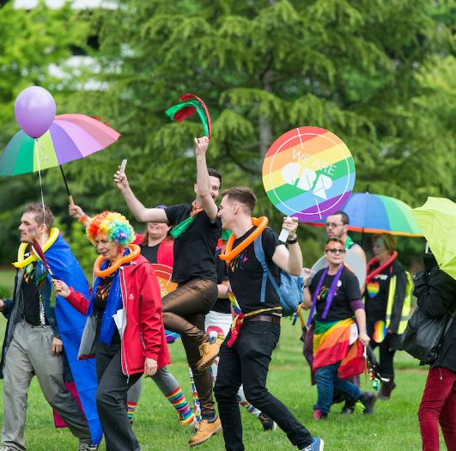
DEVELOPING the ACT’S FIRST LGBTIQ STRATEGY
The new Strategy will advance the rights of people who are lesbian, gay, bisexual, trans, intersex or queer (LGBTIQ), acknowledge their contribution to the Canberra community, and improve the way public services work for them.

To develop the Strategy we wanted to understand how we can ensure LGBTIQ Canberrans feel included and equal in our city.
Why the LGBTIQ Strategy is needed
The ACT Government wants Canberra to continue to be Australia’s most LGBTIQ welcoming and inclusive city. Over the past decade we have advanced the rights of LGBTIQ people through changes to our laws and practices, and by supporting peer-led community-based organisations. We’re committed to building on these advances and doing more to improve outcomes for LGBTIQ people.
The rights of LGBTIQ people are not yet fully respected, protected or realised. LGBTIQ people continue to experience various forms of rejection, discrimination, harassment and violence. As a consequence, LGBTIQ people are more likely than the wider population to experience poorer mental and physical health, unemployment, poverty, homelessness, and social exclusion, and they are more likely to use alcohol and other drugs.

the conversation
We held conversations online, face to face and directly with stakeholders throughout 2018 and early 2019. Although there are many common experiences, each individual is different and has their own personal experience, so we appreciated hearing from a range of people throughout this consultation.
We extend a warm thank you to everyone who gave their views during community consultation and who supported people to have a say. In particular, thank you to those who have been impacted by discrimination and provided personal insights on what is working well and what can be improved.
The ACT Government is committed to introducing an LGBTIQ Strategy and your experiences are an important contribution to shaping this.

WHO ENGAGED
We received 79 responses to our questions on YourSay, providing valuable perspectives in addition to those we have heard through direct engagement with more than 50 service providers and entities across Canberra. We also received four detailed written contributions by email. Responses were intersectional, accounting for the multiple, distinct, overlapping identities and experiences of people in the Canberra community. We also heard from numerous respondents who consider that LGBTIQ issues do not need attention and some who shared hostile views about LGBTIQ people.

Key insights from the community: Change people want to see
People want clear pathways to services and support, as well as choice
- People have different experiences and want to decide for themselves what support they need.
- Public and mainstream services need to be more LGBTIQ responsive and competent.
- There is strong support for targeted, peer-led community services to address the needs of people in specific LGBTIQ communities.
People want the ‘LGBTIQ’ acronym to be broadened in government communication, to reflect a fuller diversity of gender identities and sexual orientations
- Some respondents identified that ‘LGBTIQ’ does not represent all diverse sexuality and gender identities, such as the asexual and pansexual communities.
- Responses indicated a need to promote greater understanding and awareness about the differences within the LGBTIQ acronym, and the needs of different individuals and communities.
- There were specific recommendations for enhanced LGBTIQ awareness training for government employees.
People have concerns about physical and mental health care for LGBTIQ people
- People want appropriate health care delivered by LGBTIQ-competent health professionals.
- Responses highlighted the importance of peer-led support for trans people going through gender affirmation and people born with variations in sex characteristics, as well as the parents and families of these individuals.
Supporting young people and students is a priority
- Respondents stressed the importance of supporting LGBTIQ youth and students, particularly those who have unsupportive families; are at risk of, or are experiencing, homelessness; or are in care.
- There was strong support for the Safe and Inclusive Schools Initiative and upskilling teachers and institutions to ensure the safefy and wellbeing of every LGBTIQ student.
Older LGBTIQ people have been there for us – we must be there for them
- Several respondents recognised the vital role older LGBTIQ people have played in helping to realise advances in LGBTIQ rights and called for more opportunities to celebrate the strengths, achievements and ongoing contribution of older LGBTIQ people.
- People want more support for LGBTIQ people in public and private aged care facilities, in independent living and in home care environments.
People want respect and support for chosen families, rainbow families and people wanting to become parents
- Respondents highlighted that LGBTIQ families are just like any other - they come in all shapes and sizes. It is important for government and service providers to respect chosen families and include them in decision making. People want equal recognition under the law and in its implementation.
- Some people called for reforms to enable single men to access surrogacy regardless of their sexuality.
- Support for children of rainbow families and their parents was highlighted as a priority.
Action is needed to make sure LGBTIQ people can participate fully in work
- Many respondents called for action to assist LGBTIQ Canberrans to enter and stay in the paid workforce.

Creating a safe society is the bedrock of a welcoming city
- Some people told us about their experiences of violence. Respondents said LGBTIQ people must be safe in public, at work and in family settings so they can fully participate in the community, in our democracy, and fulfil their potential.
- People acknowledged that safety is upheld by a wide range of activities and services, but visible signs of LGBTIQ inclusion across the community and in public spaces are vital to creating a sense of safety.
LGBTIQ people are at greater risk of homelessness
- Respondents want to see more support provided for LGBTIQ people experiencing homelessness. This includes ensuring the accessibility and safety of shelters/housing options for those at particular risk: youth, non-binary people, trans people, and older lesbians.
People want to see equal rights reflected in law, data and policies
- People want further review and reform of ACT laws, policies, forms and data collection to ensure LGBTIQ human rights are supported.
LGBTIQ people from minority groups must not be left behind
- Several respondents highlighted the specific needs and aspirations of LGBTIQ people from minority groups, such as Aboriginal and Torres Strait Islander LGBTIQ peoples.
- Choice is especially important for diverse community members who may feel particularly vulnerable.
LGBTIQ people who are religious may feel isolated
- We heard from people at intersections of multiple identities - including LGBTIQ people who felt excluded from both their place of religion and the LGBTIQ community.
- Provision of oversight/reporting mechanisms for abuse and discrimination in religious settings was requested, as was support for people who have been subjected to conversion therapy.
Participation in sport and recreation builds confidence and creates belonging
- People want to see LGBTIQ inclusion and participation in sport, and public sporting facilities that are inclusive spaces for trans and gender diverse people.
Without data LGBTIQ people are rendered invisible
- Many respondents highlighted that sexual orientation, gender identity and variations in sex characteristics should be included in population research and data collection.

What’s Next?
The ACT Government is finalising the LGBTIQ Strategy, and the first Action Plan, based on what we’ve heard. If you haven’t already, you can register to receive project updates by emailing LGBTIQOffice@act.gov.au.
To find out more about the Strategy and other initiatives, policies and projects in Canberra visit www.yoursay.act.gov.au or follow the ACT Government on Facebook or Twitter.
Key Timings
Step 1 – Throughout 2018 and early 2019
Community consultation on YourSay, at several stakeholder forums and individual meetings with organisations and groups whose services or activities benefit LGBTIQ people.
Step 2 – April 2019
What We Heard Report released, summarising key insights from community consultation.
Step 3 – September 2018 to May 2019
ACT Government develops the LGBTIQ Strategy.
Step 4 – June 2019
Release of ACT LGBTIQ Strategy (2019-2023): Delivering equitable outcomes for LGBTIQ people.
Step 5 – July 2019 to December 2020
Implementation of first phase of the Strategy.

THANK YOU FOR YOUR FEEDBACK
1,086  Over 1000 unique visitors to YourSay | 79  79 contributions were submitted to YourSay | 4  4 detailed written contributions were emailed to us | 50+  More than 50 organisations have participated in discussions

