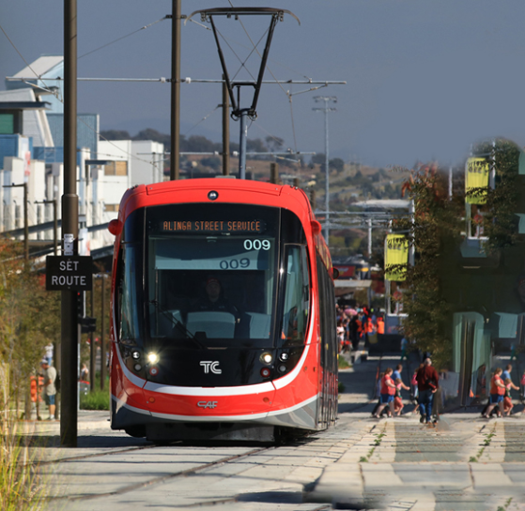
2020-21 ACT BUDGET CONSULTATION
The annual Budget Consultation process provides an important opportunity for the community to have their say on where spending should be targeted and how government services can be improved.
Canberra today is a great place to live, work, start a business and raise your family. We want to make sure it keeps getting even better into the coming decade.
The 2019-20 Budget invested in the services and infrastructure that will grow and meet our community’s needs in the years ahead. Canberra is one of the fastest growing communities in Australia, so we are investing now to make sure our hospitals and healthcare centres, our schools, social infrastructure and transport networks are ready in the new decade.
Looking ahead to the 2020-21 Budget, we are committed to listening to and considering the priorities of the Canberra community. Learning from the diverse experiences of the Territory’s population, we can ensure that our resources are put to their best use for all Canberrans.

THE CONVERSATION
We asked the community to share their ideas for the 2020-21 Budget.
Between 4 September and 30 October 2019, we invited community members, businesses, and local organisations to share their ideas for the 2020-21 Budget via an online survey or providing written submissions through the Budget Consultation project page on www.yoursay.act.gov.au.

We published the submissions, except those provided in confidence, on the Budget Consultation webpage at: budgetconsultation.act.gov.au/input-received.

WhO ENGAGED?
Written submissions were provided by 116 ACT residents, community and business groups, unions and other stakeholders, while 138 people responded to the survey questions.
The submissions and survey responses covered a diverse range of issues, including arts and entertainment, community services, disability, education, our environment and sustainability, health, public infrastructure and transport, as well as matters relating to the Territory’s finances.

Key insights from the community
Health services
- Health services received the highest level of commentary and was considered to be the most important area of government service delivery. The number of topics raised highlighted the broad range of services required by the Territory’s population.
- We heard that mental health and aged care support services were important, while a number of organisations and individuals raised the importance of health-related education programs and early intervention services. Needs in relation to specialist services (e.g. a neuromuscular disorder clinic) and additional capacity for existing services were also identified.
Government policy
- A significant number of survey responses/submissions suggested ways the Government’s existing policy framework could be changed or enhanced.
- Feedback indicated the community’s preference for engagement on new ACT Government projects, and recognising our city’s growth, commentary highlighted the need for well-developed planning and regulation frameworks (particularly in relation to building and construction).
Public infrastructure and roads
- We received a range of feedback on the services that improve the amenity of our city, particularly those related to public infrastructure.
- Commentary highlighted the importance of maintaining an efficient road and transport network, and feedback noted that active travel (e.g. cycling and footpath networks) should be a focus of design and planning considerations.
Community services
- We received feedback across the broad range of community services provided by the ACT Government and it is clear that disability support services and early intervention programs remain important to the Territory’s population.
- Similar to recent years, a broad range of community sector organisations provided valuable input on opportunities for service delivery improvement, and also highlighted the services they provide, ranging from disability education and assistance, to crisis response, through to advocacy and engagement activities.
Public transport
- Consultation participants expressed their concerns about the Territory’s public transport networks, particularly in relation to service changes arising from introducing light rail services.
- Feedback generally requested extensions or expansions to the service network, and also raised the importance of access to the public transport network for the elderly and people with disability.
Education
- Feedback indicated the importance of the ACT Government providing a strong education system (from early childhood through to higher education), to ensure our children can learn, develop, and reach their potential.
- Respondents indicated the government should be working to ensure that teachers are supported in performing their duties, and students have similar access to support services (e.g. mental health and counselling).
City amenity and environment
- Respondents said the general amenity of our city and its surrounds is important, and that ready access to green spaces and recreational areas should be a focus of planning and development.
- Participants noted the government should be actively working to promote sustainability and reduce our environmental impacts, and ensure that our regional biodiversity, waterways, and local catchments are protected.
Other topics
- Other topics raised include housing affordability and land release, arts, entertainment and cultural facilities, emergency services, and reminders of the range of valuable services available through non-government organisations.

What’s Next?
We are using your ideas to help inform the priorities for the Budget for 2020-21.
Thank you to everyone who provided feedback. We are reviewing the submissions as we prepare the 2020-21 Budget. The 2020-21 Budget will be released in June 2020.

THANK YOU FOR YOUR FEEDBACK
116  written submissions received* | 138  responses to the online survey*
1,391
unique visitors reviewed our Input Received page*
Submissions published online on 2020-21 Budget Consultation: Input Received
* At the time of publication of this report

