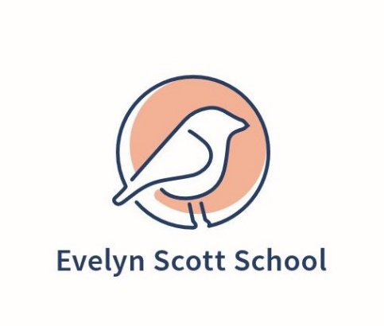
nEW PUBLIC SCHOOL IN MOLONGLO
The Molonglo Valley’s new public school in Denman Prospect will provide the community with a state-of-the-art education facility focusing on 21st century education philosophies and offer both indoor and outdoor learning areas.
This modern school facility will cater for 88 preschool and 600 primary school students when it opens for Term 1 2021, providing capacity for quality public education in this high-growth region. Stage 2 of the construction will provide high school accommodation for an additional 600 year 7-10 students, ready for the start of the 2023 school year.
As an important facility for the Molonglo Valley community, we asked the community to tell us their preferred option for the name and the school uniform.
The community voted for:
School name: Evelyn Scott School
School uniform: Australian Reed Warbler concept

THE CONVERSATION
We held a conversation between 31 July to 23 August 2020 using the ACT Government’s Your Say online voting function, resident drop-in sessions, emails and social media and the feedback helped us finalise the different aspects of the school’s visual brand.

WHO ENGAGED?
The engagement process saw 5,068 views of the Your Say site, with 1979 unique visitors. 362 people voted on the name and uniform options. Six posts were made on Facebook and 29 people attended the two community sessions in in early August. Overall, 426 items of feedback/votes were received.

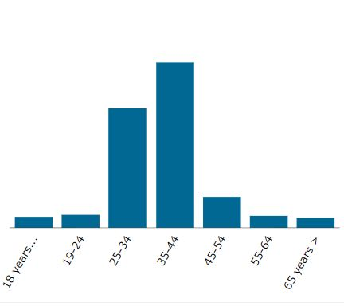
Gender of participants Age of Participants
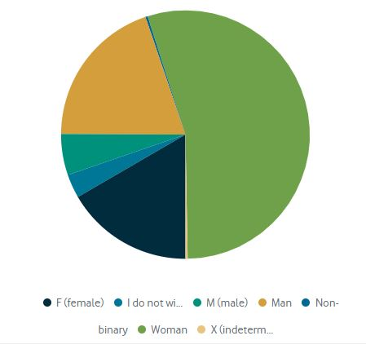

Key insights from the community
- Naming the new school

Evelyn Scott School was selected by the community as the favourite name for the new school.
At the request of the Minister for Education, the Directorate asked the Office of the Surveyor-General and Land Information and the Place Names Committee for school name options, including Indigenous females and others known for reform and activism.
Family members were consulted to obtain their support to have the name considered as one of the options for the new school.
The options were:
Evelyn Scott School 127
Isabel Coe School 85
Ngingali Cullen School 82
Arnold Hunter School 38
John Budby School 30

2. School Uniform
The blue based Australian Reed Warbler design was selected by the community as their favourite uniform.
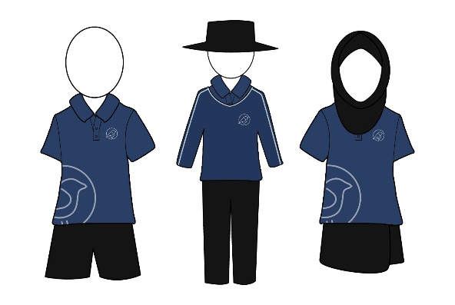
Australian Reed Warbler 126
Rolling Hills 114
Tree Bark Monogram 74
Sunrise over Molonglo 48

What’s Next?
The new school will open on Monday 1 February 2020. If you have any questions regarding the school or enrolling your child, please visit https://www.education.act.gov.au/Evelyn-Scott-School or phone 6205 9137.
THANK YOU FOR YOUR FEEDBACK
1979  We reached 1979 people via YourSay | 42  We spoke with 42 individuals | 2  We ran 2 community sessions for 29 people | 300  We visited businesses, community groups, shopping centres and distributed over 300 brochures and posters
11295  We reached an audience of 11,295 people through Twitter | 26757  We reached an audience of over 26,700 through Facebook posts | 426  We received 426 items of written feedback | 4  We made 4 posts to ACT Public Schools Facebook page

